FUTURES2020: European Researchers’ Night

Work Package 2: Activities report

Authors:
Joel Morley, FUTURES Project Coordinator; Dee Smart, Project Lead; Alison Rivett, Evaluation Officer; Diane Thorne, Events Coordinator, University of Bristol (UoB)
Dean Veall and Rob Cooper, University of Bath (UoBa)
Kayla Rose, Bath Spa University (BSU)
Kate Baker and John Puckey, University of Exeter/Agile Rabbit (UoE).
Ioanna Papanikolaou, University of Plymouth (UoP)

Contents
Activities Summary 3
Management of activities 3
Researcher Recruitment 4
Researcher Support 5
Changes to the original programme 7
FUTURES2020 programme 11
University of Bath activities 11
Global Science Show 11
FUTURES on Air 12
FUTURESXInstagram 12
Science Showoff presents: Never Explain 13
I’m A Researcher – Ask Me Anything 14
University of Bristol activities 14
Curiosity Carousel 14
Researchers’ Tales 16
Discovery Talks: Sustainable Food: Thinking, Knowing; Doing 17
Discovery Talks: Bubbles, Butterflies, Beetles and the Optics of Fruit 17
Discovery Talks: History from home 17
Discovery Talks: Music for the Shy? 18
Discovery Talks: Quantum parallel worlds 18
Discovery Talks: A Short History of the Future of Work 18
Discovery Talks: How will STEMM research affect the daily lives of Bristolians in the future? 18
Discovery Talks: A Matter of Life and Breath 19
Discovery Talks: Understanding COVID 20
Discover and Discuss 20
I’m an EU Scientist, Get Me Out of Here! 21
Do Try This At Home 22
FUTURES Exhibits: Bristol Botanic Garden – An unusual spring and summer 22
FUTURES Exhibits: Health and Creativity 23
FUTURES Exhibits: Art of Science 24
FUTURES Exhibits: Picture This – A Research Without Borders Virtual Showcase 25
University of Exeter activities 26
How the Ancient Greeks can improve your health 26
Talking about Mindfulness Therapy for Young People 26
Who do we think you are? Online social identity detection 26
Serious Games: learn by doing 27
Lockdown Blues 27
Why is Climate Change so Hard? 28
Gathering for a Future 28
How to fix a broken planet 29
University of Plymouth activities 29
The Big Family Quiz 29
Discovery Talks: Expedition Earth: An Explorer’s Guide to a Planet in Peril. 30
Research on your doorstep: online science for schools 30
Maritime History and Heritage : Land Ahoy! 31
Bath Spa University activities 31
Writing Futures! Dare to Write? On Tour with FUTURES 2020 31
FUTURES Snap It Share It Photography competition 32
EU Corner Activities 32
EU Corner European Discovery Map 32
EU Corner The South West and Europe 33
EU Corner Twitter Takeover 33
EU Corner: Day in the Life of a Researcher 33
EU Corner mural 34
Table 1: Overview of activities 35

Activities Summary
FUTURES2020 ultimately comprised 42 different activities and events, designed to enable a wide range of people interesting, accessible, and appropriate opportunities to engage with research, and 260 researchers took part. The Covid-19 pandemic prevented us from conducting in-person activities, so we adapted the programme to make all the activities remote. This included events that were delivered online such as talks; written Q and As; a quiz; a research fair; story telling; and comedy, and activities delivered online including exhibitions; demonstrations; social media takeovers; online resources; and a competition. It also included activities that were off-line, such as radio shows; a mural; and hands-on experiments, and events that involved practical activities, such as art workshops and schools’ workshops. This combination of activities and methods of delivery helped to mitigate against digital inequalities and provided varied ways to engage with research. To increase accessibility and inclusivity, all pre-recorded video material had closed captions, and where possible captioning was provided for live video. In total, at least 44,500 people engaged with FUTURES activities. The engagement with individual activities is described in the summary of the FUTURES2020 programme below, and in Table 1: Overview of activities.

Management of activities
Activities were coordinated by the University of Bristol (UoB) and developed in collaboration with the University of Bath (UoBa), the University of Exeter (UoE) the University of Plymouth (UoP), and Bath Spa University (BSU).

The consortium Steering Group met regularly to discuss the development and evolution of the activities. The Steering Group also regularly considered how to respond appropriately to the COVID-19 pandemic, informed by regular updates from the project coordinator on the implications of national restrictions and government guidance to universities. The project risk register was regularly updated. UoB provided feedback from MSCA Fellows who had volunteered to be advisors about the proposed format of the events in relation to COVID-19. Ultimately all activities were delivered remotely. The consortium developed a strong collaborative ethos and all consortium members shared their understandings of how online delivery platforms and other methods could be utilised to provide effective engagement. To help with the adapting the FUTURES2020 programme for remote and online delivery, all event coordinators were invited to attend 1 of 2 training sessions about Online Public Engagement run by Jamie Gallagher and organised by UoB. The consortium also held three online meetings with representatives from the ADIFF ERN (955277). We exchanged knowledge and ideas about potential solutions to the uncertainty created by COVID-19, how activities could be adapted for remote delivery, and useful technology to enable remote engagement.

The FUTURES2020 project coordinator liaised regularly with staff coordinating activities for each consortium member and ensured appropriate EU Corner activities were delivered in the most effective way possible given the restrictions related to COVID-19. UoB provided consortium members with PowerPoint slides displaying statistics and information that could be used in EU corner activities.

Event coordinators were in regular communication with external partners involved in delivering activities. These partners included the SS Great Britain in Bristol, ‘I’m A Scientist’, 4 artists and 7 creative practitioners, 10 social media content creators, and 5 radio stations. External advice was sought where appropriate. For example, when developing new activities intended to reach school children UoB received advice from Curiosity Connections, an expert network supporting the promotion of STEM education in primary schools.

Researcher Recruitment
Calls to action to recruit researchers were distributed as widely as possible to reach researchers from all faculties and career stages. At UoB, UoBa, BSU and UoE, calls to action were circulated within university-wide newsletters and networks, through university faculties and research institutes, and through groups like the Bristol Doctoral College. UoB, UoP and UoE approached specific researchers about involvement in specific appropriate events. UoB and UoBa also sent direct emails to all participants in previous FUTURES events, and disseminated calls to action using their Public Engagement Team websites, university websites and social media. In addition, UoBa advertised training activities through the Public Engagement Unit webpage, blog, staff homepage and through social media. This helped recruit researchers who were interested in professional development opportunities. UoB circulated calls to action to recruit researchers through the GW4 Alliance, which brings together four of the most research-intensive and innovative universities in the UK: Bath, Bristol, Cardiff and Exeter. Calls to action for specific activities, such as UoB’s ‘I’m An EU Scientist’ activity and UoBa’s ‘Global Science Show’, were circulated by consortium partners and beneficiaries. Bath Spa sought to recruit researchers for activities organised by other partners, particularly Bath and Bristol (because of their geographical proximity). UoB and UoBA public engagement staff also promoted FUTURES2020 to researchers who they interacted with in their day-to-day work and used their working relationships with research institutes and their knowledge of on-going projects to recruit researchers.
Specific, direct approaches were also made to recruit Marie Skłodowska-Curie Fellows (MSCA Fellows). UoBa contacted MSCA Fellows by email in collaboration with staff from the Research and Innovation Services team and offered an online information session. UoB contacted Bristol’s MSCA Fellows and members of Bristol’s Innovative Training Networks. UoE emailed MSCA fellows. UoP invited previous MSCA Fellows to take part in A Day in the Life of an EU Researcher, and EU funded researchers were encouraged to take part in FUTURES2020 through communications from the Innovative Training Network coordinator and UoP’s European Structural and Investment Funds Network.
In total, 260 researchers took part in FUTURES2020: 154 from UoB, 27 from UoBa, 26 from UoE, 31 from UoP, 10 from BSU and 12 from other institutions. Of these, 13 were MSCA Fellows and 23 others were receiving European funding; all were supported to take part in all activities and particularly to develop plans for the EU Corners. 58% of the participating researchers were female; 41% were male.

Across the consortium we worked hard to recruit researchers for FUTURES2020; it proved challenging due to three specific factors:
1) The uncertainty about the trajectory of COVID-19 made it difficult for researchers to plan and resulted in changes to our events. In some cases researchers’ engagement ideas were not suitable for the adapted events.
2) COVID-19 disrupted university teaching. This dramatically increased many researchers’ workloads, leaving less time available to commit to non-essential activity.
3) Because the ERN had to move to November due to COVID, the ERN took place at a less convenient point in the academic calendar. Researchers’ contracts often start or end at the end of September. As a result some established researchers who were coming to the end of a project told us that they would like to take part but would be at a different institution in November. Meanwhile some incoming researchers were not yet established enough in their research to take part. Several researchers told us that they were interested and would have taken part at the end of a summer, but (even without increased teaching workload due to COVID) could not do so in the middle of a teaching term and at the start of a period of heavy marking and administration.

Researcher Support
Each partner offered a range of bespoke support and tailored advice to enable researchers to participate in their FUTURES2020 activities. Where relevant and practical partners extended this support to researchers taking part in other consortium members’ activities.

All researchers taking part in UoBa activities were provided 1:1 support by the UoBa Public Engagement Unit. For example, this included reviewing content made for the Global Science Show, and assisting with content planning for the EU Corner Twitter Takeover. UoBa also held a number of ‘surgeries’ for researchers who were taking part in the activities to get feedback and input on their activities as they were developing them in advance of delivery of the events. Public Engagement Unit staff were also available throughout the events to assist with any technical problems and support researchers if they had any questions. All researchers taking part in UoBa activities were able to access the Public Engagement Knowledge Hub, an online set of 8 e-learning resources, covering topics including ‘How do I manage my event?’ and ‘How can I facilitate a workshop?’, and they were offered Online Public Engagement training organised and delivered by UoBa. This online session focused on sharing how the researchers can engage public groups effectively online and how to create effective short videos using equipment that researchers would have at home. UoB, BSU, UoE and UoP researchers were also invited to attend.
All researchers taking part in UoB activities were given the opportunity to discuss and develop their engagement plans with the FUTURES2020 Project Coordinator and the UoB Public Engagement team. All researchers taking part in UoB activities were invited to take part in 1 of 2 training sessions designed for FUTURES2020 and delivered by experienced Public Engagement Associates which covered how to engage the public with research online. The sessions explored how to talk about your research with the public, finding the hook in your own research, and tools for online engagement. A set of accompanying slides was also provided. Researchers participating in UoB activities were also provided with a briefing document for the activity/ies they were participating in which explained the aims and structure of the activity and offered suggestions about how they might approach it/engage their audience. They were also provided with a technology guidance document, which included: links to a video about how to set up your technology and furniture for optimal web-cam use, produced by Jamie Gallagher; a list of useful free digital tools and resources; directions to specific How-to videos produced by Zoom; advice about how to produce captioned videos; and bespoke instructions about how to use Remo, an online conference hall platform.
All researchers taking part in UoE activities were given 1:1 support, including the opportunity to discuss and develop their engagement plans with the Agile Rabbit team, and they were provided with recordings of successful similar events and helped to shape own research into similar formats, and provided with written guides to help them develop their public engagement ideas. All researchers were offered the opportunity to attend practice sessions to learn how to use the online software; 5 sessions were delivered. UoE researchers were directed to online videos and written guides to help them with public engagement ideas.
At UoP extensive support to facilitate researchers’ activity was provided by the FUTURES events team and First Sight Media. They worked with researchers to develop content and scripts for the activities, and because each of UoP’s 4 activities required the creation of pre-recorded material, the researchers received pre-filming briefings and filming rehearsals. Once the pre-recorded material was produced, researchers also received training and event rehearsals to avoid technical problems and ensure seamless transitions when events were delivered.
Training and resources specific to particular activities were also offered to participating researchers:
- Participants in UoBa’s Global Science Show received training that explored how to create science demonstration videos and how to film and edit them. Researchers were sent tripods and ring lights to help them make high quality videos for the event.
- Participants in UoBa’s Science Showoff received a science comedy training session to help them prepare.
- Participants in UoBa’s FUTURESXInstagram activity received training on how to use the social media platform Instagram and covered basics around posting content and how to create engage video and photo-based content with professional Instagram content creators.
- Participants in UoBa’s Reddit AMA events were provided with a briefing explaining how Reddit AMA’s work and giving guidance on how to have productive interactions with Reddit users.
- Participants in the UoB Curiosity Carousel attended 1 (or more) of 4 training sessions that explained how the activity would work, what to expect, and how to use the platform’s tools to deliver engaging interactions with different publics.
- Participants in UoB Discovery Talks attended practice sessions to ensure they were familiar with Zoom and comfortable with the format and nature of the activity. The Public Engagement team facilitated 8 sessions, 1 for each individual or panel who wanted to attend. Researchers taking part in Discovery Talks organised by the Bristol Doctoral College received additional bespoke support from Doctoral College staff.
- Participatns in UoB’s Discover and Discuss activity were provided with guidance and templates for developing downloadable resources aimed at children and families.
- Participants in UoB’s Researcher’s Tales were required to attended two days of training with professional storyteller, Clare Murphy, to develop their confidence, speaking skills, and storytelling skills. They also took part in a practice session on Zoom in the days before the ERN. This was an opportunity to practice delivering their story and receive some feedback, and an opportunity to practice using Zoom.
- Participants in UoP’s “Day in the Life of a Researchers” event were provided with a Filming Guide that explained how to create a polished, professional video and improve the quality of a video, which included tips about light settings and backgrounds; a “Filming Techniques Remotely” Guide on how to use their phone to capture video footage; and a set of questions to structure their talks and ensure a consistent format.

Changes to the original programme
The activities that we delivered differed from the original programme in multiple ways. Most of these changes were due to COVID-19. The situation in the UK was constantly changing and our approach had to be reviewed frequently. Over the course of the summer the situation was improving and we expected that it would be possible to deliver a blended programme of online and socially-distanced activities. National restrictions in place at various points in 2020 made some venues unavailable, and closures of partner venues also prevented us from working collaboratively with some organisations, which resulted in changes to our original programme. By late September the trajectory of the pandemic in the UK shifted rapidly. Although it required significant adaptations to our programme, the decision was taken that most of our activities would take place online in order to safeguard researchers and audience members and to ensure consortium members were acting in accordance with their civic responsibilities. We redesigned activities for online delivery and remote delivery, and we designed new activities, including radio shows and social media takeovers, to replace activities that had to be cancelled. Ultimately, the British government imposed a National Lockdown that included the period of the ERN; as a result interactive in-person events were not possible, so some further adaptations were made to make the entire FUTURES2020 programme remote. The changes are summarised below.
The proposed activities at Brunel’s SS Great Britain were all redesigned because the SS Great Britain could not be used due to National Lockdown, and we had determined that it was not safe to hold the events in person. Researchers’ Tales and the Discovery Talks were modified from in-person events to online events. The best way to replicate the proposed format was to use Zoom to deliver the talks. This free and well-known platform offered a wide range and large number of people the opportunity to participate in the originally planned activity. Delivering the Discovery Talks online enabled us to expand the include a greater number of talks because time was not required for audiences to move in and out of a single room, and one talk could be set up while another was taking place. Modifying the Research Fair and Up Late for online delivery was more difficult. Rather than hosting both events – originally one designed for schools and one for families – we delivered three alternative activities. The activities and hands-on demonstrations that would be particularly engaging to young people and families and that would have been offered at the SS Great Britain research fairs were provided to the public online through Do Try This At Home. The opportunity to hear from and interact with a variety of researchers in a research-fair environment was provided online through the Curiosity Carousel. Both these activities also enabled us to retain the planned partnership with the SS Great Britain. A unique video guided tour was a highlight of the Curiosity Carousel, and the provided some resources for Do Try This At Home. The opportunity for school groups to interact with researchers and take part in related activities that would have been provided by the Research Fair was instead delivered through Discover and Discuss. The SS Great Britain Research Fair and Up Late were also intended to include an EU Corner. Two online activities were delivered via the FUTURES website instead: The European Discovery Map and The South West and Europe padlet.
A Night At the Museum – A Voyage of Discovery was scheduled to be held at The Box in Plymouth, but the venue was closed due to COVID-19. This event was replaced with two online events, and an online EU Corner event. The Big Family Quiz provided a fun and interactive way for a large audience of families to engage with a variety of UoP researchers online. STEAM themes were retained, and Arts topics were added. Professor Iain Stewart, who had been scheduled to compere A Night At the Museum, instead delivered a Discovery Talk: Expedition Earth: A Planet In Peril. This public lecture was pre-recorded allowing high quality film to be included, but was delivered “as live” and also had a long question and answer session via zoom to allow for full engagement. This meant it could have a large audience to compensate for the numbers expected to attend the Box, and it was suitable for all and utilised Prof Stewart’s experience in educational outreach and public engagement. The EU Corner that was intended to take place at the Box was replaced with A Day in the Life of A Researcher.

Bugs and Bottles at the National Marine Aquarium became Research on your Doorstep: Online science for schools and was delivered online because the NMA was closed due to COVID-19. As planned researchers from UoP’s Marine Institute and Medical Microbiology department delivered talks about anti-microbial resistance and marine plastics, and they were joined by researchers who delivered talks about climate change and the seas, and the solar system. Instead of the planned citizen science projects, each activity was accompanied by a 5 minute interactive online game to engage young people. This enabled more engaging online activity. The activity remained appropriate to school-age children.
Land Ahoy! Pirates, wrecks and sailors was renamed Maritime History and Heritage : Land Ahoy! Due to COVID-19 it was not possible to hold the event on a naval frigate as planned, and the event was delivered on Zoom Webinar instead. Rather than holding workshops, 4 pre-recorded talks addressed the topics - naval heritage - and each was followed by live Q and A and discussion. This was compered to ensure maximum interaction and engagement. The event was promoted to the intended groups but it was not possible to discuss the topic of marine careers. The event remained relevant for youth groups, and uniformed groups, and also had relevance to older people and those with an interest in or connection to the navy.
The proposed See, Hear and Smell activity with the University of Bristol Botanic Garden was redesigned. Because of COVID-19 disruption to the venue and the Botanic Gardens’ staff and workload, it was not possible to create or host the proposed event, and it would not have been possible for the public to visit it. Instead, the FUTURES Exhibits: Bristol Botanical Garden: An Unusual Spring and Summer online exhibition was created.

The planned Create to Collaborate workshops were adapted to deliver FUTURES Exhibits: Health and Creativity. Given the pandemic, it was no longer appropriate to attempt to host workshops at the Southmead Hospital. Ultimately workshops were conducted remotely using Zoom and telephone conversations. Different researchers were also involved due to researcher availability, but health remained the central topic. This was ultimately displayed as an online exhibition.

We took the opportunity to add the FUTURES Exhibits: Art of Science and FUTURES Exhibits: Picture This exhibitions to the programme at a stage when it was expected that they would be able to sit alongside the botanic garden and health and creativity exhibitions in a public space. They would have expanded the offering to the public without significantly affecting the cost of delivery. Ultimately these, like the other two exhibitions, had to become online activities.

The FUTURES Snap It Share It Photography competition, delivered via social media, was added to our activities because, without physical venues, there were limited opportunities to take photographs of the activities. We hoped this would act as a mechanism to create and collect images of the public participating in virtual and remote events.

The Science Showoff activity was intended to take place at the Edge Arts Centre. During the course of the COVID-19 emergency the Science Showoff team developed new formats for researchers to engage audiences on digital platforms. Working with them we commissioned a science comedy panel show they'd developed, Never Explain, which enabled an event as close to the original format of the event we'd planned as possible.

Both Pop-up Science at the Galleries shopping centre (Bristol) and at the Southgate Shopping Centre (Bath), were affected by concerns about in-person activities during COVID-19, and in the event National Lockdown meant the venues were unavailable. UoB researchers who had intended to participate in Pop-Up Science were encouraged to take part in the Curiosity Carousel which offered similar opportunities. UoBa modified the activity to create the Global Science Show; the demonstrations and talks that researchers were preparing were repurposed and delivered in the form of short videos on Twitter.

Over the summer of 2020 it was expected that it would be possible to deliver the proposed Walking with scientists and artists guided walks because they had been redesigned to comply with social distancing requirements and incorporate digital elements. We attempted to produce a wholly digital version, but increased restrictions prevented researchers, videographers and the theatre staff from working together to create the content. As a result it was not possible to deliver this activity.

Up Late at The Holbourne Museum was cancelled because the museum was closed and staff were not permitted to work (under the UK Government’s furlough scheme) and were therefore unable to collaborate with us.

The Sports Science Takeover could not be delivered because due to COVID-19 restrictions for sports venues Bath Rugby held all their games 'behind closed doors', with no spectators being present.

Because UoB was unable to run the Up Late at the Holbourne activity, they added two social media activities to the programme: the FUTURESXInstagram activity enabled researchers to share their research with a large and relatively young audience, and the EU Corner Twitter Takeover saw the Horizon2020 funded DisTerrMem project takeover the FUTURES2020 Twitter account to showcase their research.

To ensure the FUTURES2020 programme was diverse and mitigated against the accessibility challenges caused by digital inequalities, and because UoB were unable to run the Sports Science Takeover, UoE and UoBa collaborated to deliver FUTURES on Air (described below). This activity capitalised on Agile Rabbit’s existing relationship with radio producer Alice Armstrong, utilised community radio as an effective method of delivering public engagement.
It was not possible to hold the Research After Hours: Literature, Heritage and Wellbeing activity at Exeter Cathedral because of Covid-19. A new venue – the Make Tank in the centre of Exeter - was chosen because it would enable the component events to be held in sequence, with smaller numbers of simultaneous visitors attending at one time, thus social distancing could be maintained. Ultimately, due to the National Lockdown, this format was not possible, and the series of talks, workshops and interactive activities were delivered online instead. They became: How the Ancient Greeks Can Improve Your Health; Talking about Mindfulness Therapy for Young People; Who do we think you are? Online social identity detection; Serious Games: learn by doing; and Lockdown Blues. Researchers from the Livings Systems Institute developed activities that could be delivered in the Make Tank, but unfortunately these could not be adapted for online delivery. Researchers from the Exeter Medical School were included as planned and themes of health and wellbeing, tackling loneliness through writing were retained. The EU Corner activity was redesigned for delivery in the Make Tank; it ultimately took the form of a large mural in the Make Tank’s gallery window, which was informed by conversations with EU funded researchers. This mural was visible to people passing by, and it was displayed on the FUTURES website and on social media.
It was not possible to hold Asking the Big Questions or Are we living in a climate emergency? in the venues we had planned as they were closed due to COVID-19, nor was it possible to hold the interactive activities we had intended for Are we living in a climate emergency? Instead, we combined the former’s intended format of panel debate and interactive talk with a notable chair with the latter’s topic, to create our Why is Climate Change so hard? panel discussion activity. 2 researchers from Exeter’s Global Systems Institute took part as was originally planned.
Underworlds: Exploring Creativity and Sustainable Science at the Eden Project could not be delivered at the Eden Project because it was closed due to Covid-19. This event was renamed Gathering for a Future and was modified for online delivery. It remained a creative workshop facilitated by a researcher and an artist, and retained a focus on local Cornish communities. The European-funded Environment and Sustainability Institute’s ‘Creative Exchange” programme remained involved and, as was intended, the researcher involved is based at UoE’s Exeter campus and conducts research on the environment.
The Community Journal Club activity remained a collaboration with the Community Journal Club but the activity was renamed How to Fix a Broken Planet. It retained a focus on rural communities in Devon and Cornwall. Young people from rural communities are often underrepresented in Higher Education. The topic changed from homelessness to climate change because there was greater interest in this topic. We delivered two online workshops using Zoom Meeting instead of the one in-person workshop originally planned. This enabled the workshops to be smaller and therefore more effective.
The normal activities of schools, youth groups and community groups were disrupted by COVID-19. This made it more difficult to arrange their participation in activities. While schools in the England remained open for most of 2020, classes were often self-isolating at home due to COVID-19 cases. Teachers, timetables and IT resources have been under lots of pressure trying to complete their minimum necessary teaching activity. We extended the I’m An EU Scientist activity period to give schools greater opportunity to take part.

FUTURES2020 programme

University of Bath activities

Global Science Show
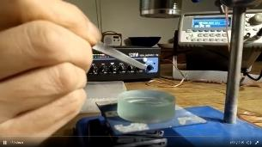
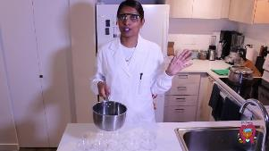
Families and adults (28 November, 12:00 - 18:00)

The Global Science Show was an event hosted on social media platform Twitter where 14 researchers from the universities of Bath, Bristol and Plymouth created and shared short (one to five minute) videos talking about their research and giving scientific demonstrations that audiences could do themselves at home. Each researcher had a 15-minute slot where they could post their video and interact with Twitter followers of the Global Science Show account. Over the course of the day in total 950 people engaged with the activity. Videos included sonic levitators that could be made at home, quizzes on fossil pollen and DNA extraction experiments that could be replicated at home. All videos included subtitles to make sure the activity was as accessible as possible.

FUTURES on Air
Young adults, adults and families (27-28 November, 19:00 – 22:00)
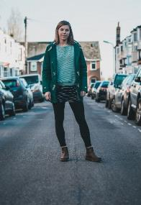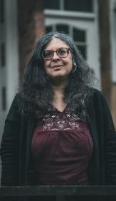
FUTURES on Air involved working with radio practitioners Stellaria Media and community groups from five community radio stations (Bath Radio; Devon Stream; Phonic FM, Exeter; Soundart Radio, Totnes & Radio St Austell Bay). The groups identified topics they were interested in from climate change, feminism and South Asian music and were matched to 14 researchers from the Universities of Exeter, Bath and Plymouth to co-produce shows. Over the course of broadcasts, it’s estimated 3,000 listeners tuned in to hear the seven one-hour long programmes broadcast on participating community radio stations across the South West. With the move to make FUTURES2020 a digital festival there was a real risk of excluding people who were unable to access the online content that was produced. Community radio is a space for people to make radio in their own way, talk about meaningful issues in their lives, and connect with others through respectful discussion, listening and collaboration. FUTURES on Air not only mitigated the risk of digital exclusion but allowed community groups to engage meaningfully with researchers. FUTURES on Air programmes are available to listen back to on the FUTURES on Air Mixcloud.

FUTURESXInstagram
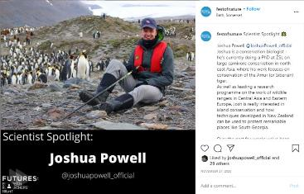
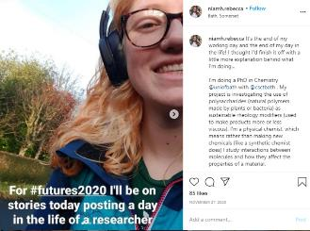
Young Adults (27 & 28 November, 10:00-19:00)

In collaboration with the Natural History Consortium, FUTURESxInstagram was a programme of engaging content that shared research with users of the social media platform Instagram over the 27 and 28 November. In the build up to the event environmental science researchers were paired with professional Instagram content creators to develop their skills in using social media to engage people with their research and them as researchers. Over the course of the event 27,813 people, (74% of whom were female and 61.4% were aged 18-34), engaged with (liked, viewed videos and commented) content created by 13 researchers and 10 content creators. Young adults, 18-34, are often overlooked in more traditional programmes that engage people with environmental science. In the UK Instagram has 24 million users, 24% aged 18-24 and 32% aged 25-34, the opportunity presented by FUTURES2020 becoming a digital event allowed us to experiment with a meaningful programme to engage this demographic in the social media spaces they use.

Science Showoff presents: Never Explain
Adults (27 November, 20:00-21:00)
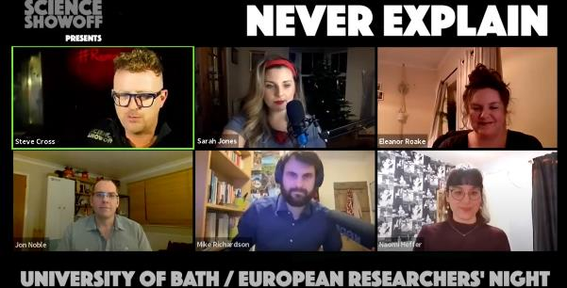
The Science Showoff team devised a brand-new format for their variety nights that brought their unique blend of science comedy to digital audiences, the panel gameshow Never Explain. Four researchers from the University of Bath participated in the event and made up two teams, one representing the Centre for Sustainable and Circular Technologies and another the Department of Psychology. Hosted by professional comedian Steve Cross, the teams competed for points to be crowned winners of this FUTURES edition of Never Explain. 73 people tuned in live to the YouTube broadcast and a further 200 watched since Friday 27 November. As a platform YouTube Live allowed users to interact directly as a live audience with the host and researchers through the onscreen comments.

I’m A Researcher – Ask Me Anything
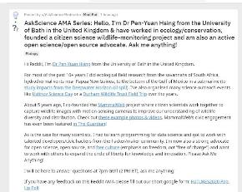
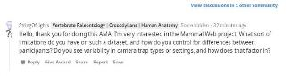
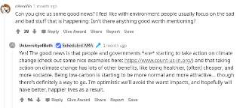
Adults (27 & 28 November, 17:00 - 19:00)

Users of the r/AskScience and r/IAMA Reddit pages were invited to ask researchers questions about their work in three sessions, two on Friday 27 November (17:00 -18:00 and 19:00 - 20:00) and one of Saturday 28 November (19:00 – 20:00). Researchers then logged in and spent one hour answering questions and having conversations with Reddit users. The three sessions focussed on climate change psychology, animal identification and citizen science and developmental language disorders in children. In total three researchers from UoBa participated. There were 6,221 engagements with their sessions (Upvotes and questions) from Reddit users. Using Reddit allowed researchers to engage people from across the world with their research and have direct two-way interaction through follow up questions and answers.

University of Bristol activities

Curiosity Carousel
Families, Adults (27 November, 18:00 – 20:00)
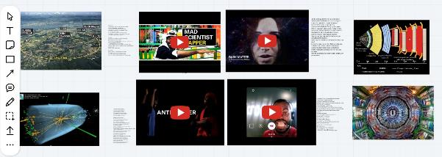
A “whiteboard” in Remo used to share music performances and images with attendees, which were then discussed. 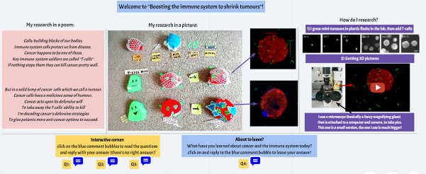
A “whiteboard” in Remo used like display stands at an in-person event. This display was used to engage audiences and as a starting point for discussion
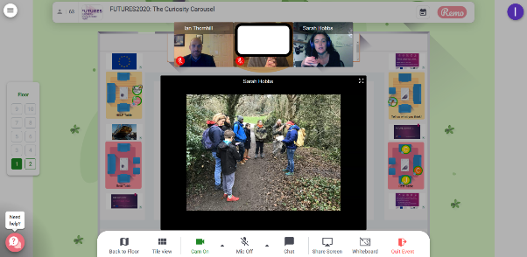
Two researchers screen sharing an image while speaking with a member of the public at the Curiosity Carousel.
This event was a virtual research fair, hosted in collaboration with the SS Great Britain. We used the online platform REMO to create a virtual conference hall containing 18 research stands, staffed by 33 researchers from the University of Bristol, Bath Spa Univeristy and an MSCF from the University of Birmingham. Attendees were able to move around the conference hall and stop at a research stand. Attendees and researchers could then see and hear each other, and researchers were able to share their research in various ways: they spoke to attendees, showed demonstrations or videos, ran a mini-quiz, and answered attendees’ questions. We encouraged attendees to switch tables approximately ten minutes. The research stands covered a huge range of topics, including how computers can help us feel better about our bodies; how you get a chick from an egg; how artificial intelligence can help us with arthritis; how we can fight bacteria; how big data can help health researchers; and how we can use Virtual Reality technology. In the middle of the event a specially made pre-recorded presentation from the SS Great Britain was delivered. In this presentation the ship’s conservation engineer – Nicola Grahamslaw – showed viewed various aspects of ship that visitors to the ship cannot normally see. Afterwards Nicola was available at a research stand to answer questions from the audience. The REMO platform was the only available digital platform that offered the key features we needed: it enabled us to replicate a conference hall style space; enabled researchers and attendees to participate in two-engagement via video and speech, as well as offering other ways researchers could showcase their research; and enabled attendees to move from research stand to research stand when they wanted to. It therefore had the capacity to facilitate high-quality engagement interactions. The platform was as free for attendees to use, though it required them to download Google Chrome internet browser for ideal performance, and although it is not a widely used platform it is intuitive to use. It did require access to a smart phone or computer, which may have made the event less accessible than we would have liked for disadvantaged families. We could not mitigate against the challenges of digital inequality within this single event, but sought to do so by providing other opportunities across the programme, such as FUTURES on Air. 36 family groups or individuals attended the event.

Researchers’ Tales
Families, Adults (27 November, 18:00 – 20:30)
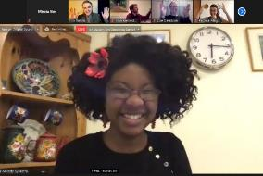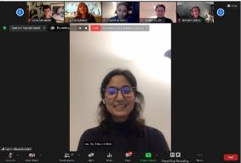
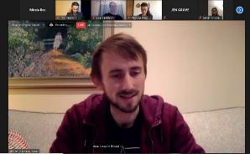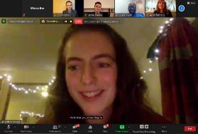
This event was comprised of a series of short stories delivered by researchers from the universities of Bristol, Bath and Bath Spa. After two days of training with a professional story teller, researchers shared their personal stories of what has inspired, surprised and encouraged them during their careers and what it is like to be a researcher. The event was presented by a compere who introduced each researcher who then spoke for around five minutes, and also answered questions from the audience. 12 researchers took part and they discussed varied topics, ranging from the 5G network, lasers, self-healing rubber, how we measure sea level rise or the atmosphere of planets, and climate change. The event was delivered using Zoom webinar because it is free to use, is widely known, and can be used on a computer or smart phone. As a result it is more accessible than many online platforms. Zoom webinar offered the key features of enabling an online audience to hear an in-depth talk from multiple speakers, and to see a single speaker and slides, while protecting the privacy of the audience. This platform also enabled the audience to engage in dialogue with the researcher by submitting questions using a text Q and A function. The chair could then select appropriate questions from those submitted (and remove any inappropriate questions) and share them with the speaker and the audience. We were also able to provide Closed Captions on Zoom, which made the talks accessible to people with hearing impairments. 55 families or individuals attended this event.

Discovery Talks: Sustainable Food: Thinking, Knowing; Doing
Young Adults, Adults (27 November, 19:30 – 21:00)
This interdisciplinary panel discussion, hosted by the Cabot Institute and chaired by Professor Taro Takahashi, brought together four doctoral researchers from the University of Bristol, working in Biological sciences; Policy Studies; Economics, Finance and Management; and Law. The panellists discussed how we can re-imagine our food systems and our relationship with food so that it becomes more sustainable and equitable, and how individual choices can cause this change. This talk was delivered on Zoom Webinar. Zoom webinar was selected because it is free to use, is widely known, and can be used on a computer or smart phone. As a result it is more accessible than many online platforms. Zoom webinar offered the key features of enabling an online audience to hear an in-depth talk from multiple speakers, and to see a single speaker and slides, and to answer polls, while protecting the privacy of the audience. This platform also enabled the audience to engage in dialogue with the researcher by submitting questions using a text Q and A function. The chair could then select appropriate questions from those submitted (and remove any inappropriate questions) and share them with the speaker and the audience. We were also able to provide Closed Captions on Zoom, which made the talks accessible to people with hearing impairments. 58 families or individuals attended this event.

Discovery Talks: Bubbles, Butterflies, Beetles and the Optics of Fruit
Young Adults, Adults (28 November, 12:00 – 12:30)
University of Bristol physicist Rox Middleton delivered a talk about light and how nature uses it to create colourful pigments, and then answered questions from the audience. This talk was delivered on Zoom Webinar. Zoom webinar was selected because it is free to use, is widely known, and can be used on a computer or smart phone. As a result it is more accessible than many online platforms. Zoom webinar offered the key features of enabling an online audience to hear an in-depth talk while seeing a speaker and slides, while protecting the privacy of the audience. This platform also enabled the audience to engage in dialogue with the researcher by submitting questions using a text Q and A function. The chair could then select appropriate questions from those submitted (and remove any inappropriate questions) and share them with the speaker and the audience. We were also able to provide Closed Captions on Zoom, which made the talks accessible to people with hearing impairments. 25 families or individuals attended this event.

Discovery Talks: History from home
Young Adults, Adults (28 November, 13:00 – 13:30)
University of Bristol historian, Professor Robert Bickers, delivered a talk that explained how family history can illustrate a wider British social and imperial history. This talk was delivered on Zoom Webinar. Zoom webinar was selected because it is free to use, is widely known, and can be used on a computer or smart phone. As a result it is more accessible than many online platforms. Zoom webinar offered the key features of enabling an online audience to hear an in-depth talk while seeing a speaker and slides, while protecting the privacy of the audience. This platform also enabled the audience to engage in dialogue with the researcher by submitting questions using a text Q and A function. The chair could then select appropriate questions from those submitted (and remove any inappropriate questions) and share them with the speaker and the audience. We were also able to provide Closed Captions on Zoom, which made the talks accessible to people with hearing impairments. 20 families or individuals attended this event.

Discovery Talks: Music for the Shy?
Young Adults, Adults (28 November, 13:30 – 14:00)
David Dewar, a doctoral candidate in Musicology at the University of Bristol, delivered a talk about how participation in music can enrich our lives and improve our health. David demonstrated how music is being utilised to improve health and wellbeing through Social Prescribing. The talk was followed by a Question-and-Answer session. This talk was delivered on Zoom Webinar. Zoom webinar was selected because it is free to use, is widely known, and can be used on a computer or smart phone. As a result it is more accessible than many online platforms. Zoom webinar offered the key features of enabling an online audience to hear an in-depth talk while seeing a speaker and slides, while protecting the privacy of the audience. This platform also enabled the speaker to engage the audience with a poll at the outset of the talk, and enabled the audience to engage in dialogue with the researcher by submitting questions using a text Q and A function. The chair could then select appropriate questions from those submitted (and remove any inappropriate questions) and share them with the speaker and the audience. We were also able to provide Closed Captions on Zoom, which made the talks accessible to people with hearing impairments. 14 families or individuals attended this event.

Discovery Talks: Quantum parallel worlds
Young Adults, Adults (28 November, 13:30 – 14:00)
Dr Tony Short, physicist at the University of Bristol, delivered a talk about the existence of parallel universes within our world at an atomic level, and questioned what this tells us about the existence of parallel universes at a larger scale. This talk was delivered on Zoom Webinar. Zoom webinar was selected because it is free to use, is widely known, and can be used on a computer or smart phone. As a result it is more accessible than many online platforms. Zoom webinar offered the key features of enabling an online audience to hear an in-depth talk while seeing a speaker and slides, while protecting the privacy of the audience. This platform also enabled the audience to engage in dialogue with the researcher by submitting questions using a text Q and A function. The chair could then select appropriate questions from those submitted (and remove any inappropriate questions) and share them with the speaker and the audience. We were also able to provide Closed Captions on Zoom, which made the talks accessible to people with hearing impairments. 50 families or individuals attended this event.

Discovery Talks: A Short History of the Future of Work
Young Adults, Adults (28 November, 14:00 – 14:30)
Dr Harry Pitts, lecturer in the School of Management at the University of Bristol, delivered a talk about our changing expectations of the Future of Work in the past – in particular the repeated and repeatedly unrealised expectation of radical change - and reflected on what this history suggests we should expect work to look like after the COVID-19 crisis. This talk was delivered on Zoom Webinar. Zoom webinar was selected because it is free to use, is widely known, and can be used on a computer or smart phone. As a result it is more accessible than many online platforms. Zoom webinar enabled an online audience to see and hear the delivery of an in-depth talk without requiring the audience to be visible on screen. This platform also enabled the audience to engage in dialogue with the researcher by submitting questions using a text Q and A function. The chair could then select appropriate questions from those submitted (and remove any inappropriate questions) and share them with the speaker and the audience. We were also able to provide Closed Captions on Zoom, which made the talks accessible to people with hearing impairments. 20 families or individuals attended this event.

Discovery Talks: How will STEMM research affect the daily lives of Bristolians in the future?
Young Adults, Adults (28 November, 14:30 – 15:15)
This panel discussion featured four University of Bristol Researchers (2 doctoral candidates and 2 established researchers from the School of Management) and Oliver Langdon of Kilter Theatre. The 2 doctoral candidates explained their research topics (protein design and using composite materials) and showcased videos approximately 10 minutes in length, produced in collaboration with Kilter Theatre and actors, that illustrated the applications and implications of their research in the future. The panel then participated in a discussion about responsible research practice and answered questions from the audience. This talk was delivered on Zoom Webinar. Zoom webinar was selected because it is free to use, is widely known, and can be used on a computer or smart phone. As a result it is more accessible than many online platforms. Zoom webinar offered the key features of enabling an online audience to hear an in-depth talk from multiple speakers, and to see a single speaker and slides, and to see and hear videos, while protecting the privacy of the audience. This platform also enabled the audience to engage in dialogue with the researcher by submitting questions using a text Q and A function. The chair could then select appropriate questions from those submitted (and remove any inappropriate questions) and share them with the speaker and the audience. We were also able to provide Closed Captions on Zoom, which made the talks accessible to people with hearing impairments. 8 families or individuals attended this event.

Discovery Talks: A Matter of Life and Breath
Young Adults, Adults (28 November, 15:00 – 16:30)
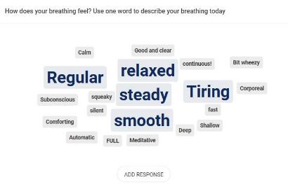
This panel discussion brought together five researchers from the University of Bristol: four doctoral researchers from the fields of English, Robotics and autonomous systems, and cellular and molecular medicine, and the chair, Professor Havi Carel from the Department of Philosophy. The panel discussed what their research tells us about the act of breathing, our relationship with breathing, and its relationship to our existence as humans. This talk was delivered on Zoom Webinar. Zoom webinar was selected because it is free to use, is widely known, and can be used on a computer or smart phone. As a result it is more accessible than many online platforms. Zoom webinar offered the key features of enabling an online audience to hear an in-depth talk from multiple speakers, and to see a single speaker and slides, while protecting the privacy of the audience. This platform also enabled the audience to engage in dialogue with the researcher by submitting questions using a text Q and A function. The chair could then select appropriate questions from those submitted (and remove any inappropriate questions) and share them with the speaker and the audience. We were also able to provide Closed Captions on Zoom, which made the talks accessible to people with hearing impairments. 30 families or individuals attended this event.

Discovery Talks: Understanding COVID
Young Adults, Adults (28 November, 16:30 – 18:00)
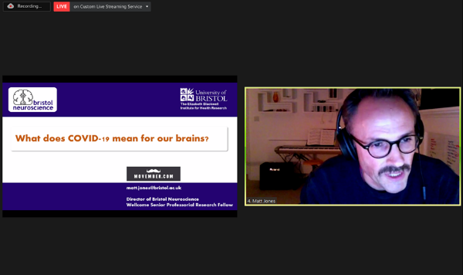
This series of short talks hosted by the Elizabeth Blackwell Institute and chaired by Rachael Gooberman-Hill, Professor of Health and Anthropology, featured six researchers from different fields: clinical medical research; neuroscience; biochemistry; chemistry; education; and management. Each spoke for ten minutes about their projects, addressing topics including what the coronavirus pandemic means for young people’s mental health, and how cutting edge microscopy is helping us to understand the surface of the virus. After each talk the speaker answered questions from the audience. This event was delivered on Zoom Webinar. Zoom webinar was selected because it is free to use, is widely known, and can be used on a computer or smart phone. As a result it is more accessible than many online platforms. Zoom webinar offered the key features of enabling an online audience to hear an in-depth talk from multiple speakers, and to see a single speaker and slides, while protecting the privacy of the audience. This platform also enabled the audience to engage in dialogue with the researcher by submitting questions using a text Q and A function. The chair could then select appropriate questions from those submitted (and remove any inappropriate questions) and share them with the speaker and the audience. We were also able to provide Closed Captions on Zoom, which made the talks accessible to people with hearing impairments. 34 families or individuals attended this event.

Discover and Discuss
School children in schools where there is a low uptake of higher education (27 November – 11 December)
Because we were unable to engage school groups with our research fair at the SS Great Britain due to COVID-19 we decided to offer remote engagement opportunities for schools. 23 researchers developed activities and resources on a range of topics that could be distributed to schools by post or electronically. Once school groups had completed the activities they were to be followed up with an online video chat with the researcher who designed them. These sessions were intended to provide school children with the opportunity to talk about what happened when they did the activity, to engage in asking and answering further questions about the activity, and to ask questions about how and why the researcher became a researcher and what that is like as a career. This interaction was designed to engage young people with research and to break down some of the stereotypical images of who researchers are. The opportunity to take part was offered to more than 50 schools, and teachers could select the topic that would be most interesting or relevant to their class. Three classes (89 students and 3 teachers) from disadvantaged schools in Bristol ultimately took part in Discover and Discuss events. The resources used were designed by 4 UoB researchers and covered were animal physiology, climate change, and eating a balanced diet.

I’m an EU Scientist, Get Me Out of Here!
School children (26 November – 11 December)
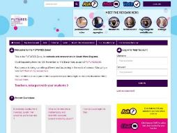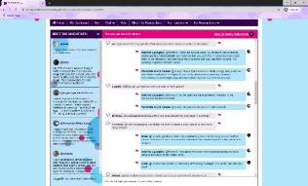
13 Scientists and technicians from the university of Bristol took part in I’m An EU Scientist. Schools from across the South West were given the opportunity to participate in online chats and Q&As with researchers, asking questions about their research, what it’s like to work in research and what the future might hold. Ultimately children voted for a winner, who received a £500 prize to conduct further public engagement work. 13 researchers created profiles in the online FUTURES Zone; they were from a broad range of fields, including animal physiology, chemical synthesis and conservation. 8 researchers took part in 4 live chats which were attended by 2 disadvantaged schools, and a minimum of 54 students and a maximum of 69 students, and 3 teachers. The I’m A Scientist platform was chosen because it is an established platform with a wide network of participant schools. Nevertheless, the pandemic resulted in reduced engagement in all their activities, and fewer schools participated in I’m an EU scientist than had been anticipated. Teacher feedback indicates that this was because having just returned to classroom teaching after 6 months of school closures and online teaching, they had to focus on core curriculum activities and many students were absent because they were isolating and it was more difficult to access IT equipment in school.

Do Try This At Home
Children (27 November – 11 December)
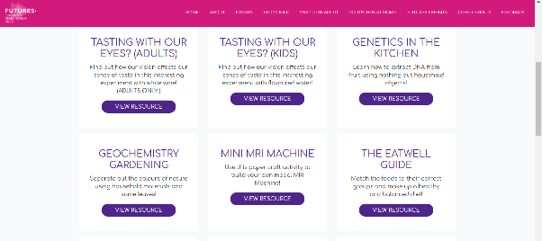 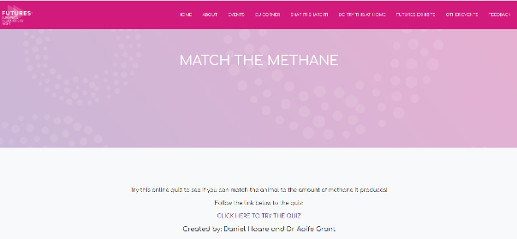
Because we were unable to engage school children and families with our research fair at the SS Great Britain due to COVID-19 we decided to offer remote engagement opportunities for families and young people that could be accessed via the FUTURES website. 20 researchers from the universities of Bristol and Bath Spa developed 13 resources that could be done online, downloaded and printed out, or that could be completed by families using everyday household items. 2 resources were contributed by the SS Great Britain. This collection of resources offered people the opportunity to take part in some of the hands-on engagement activities that they would have encountered at a research fair, and to learn about aspects of the research undertaken, even though we could not be with them in person. Resources were developed on a range of topics and included a range of activities. These included how the colour of food affects our perception of its taste; how we can extract DNA in the kitchen; Cookie Archaeology; and chemistry experiments to explore leaf pigments. These resources were accessed a total of 248 times.

FUTURES Exhibits: Bristol Botanic Garden – An unusual spring and summer
Young adults, adults (27 November – 11 December)
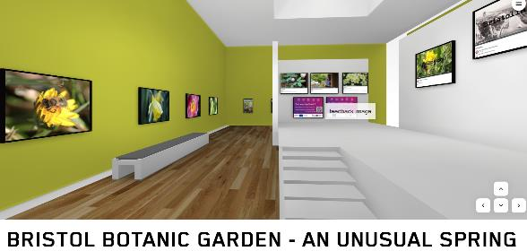
This online exhibition showcased images and videos created by staff at the University of Bristol Botanic Garden. The images depicted different aspects of the garden and were displayed in a chronological sequence so that the viewer saw the garden change from March 16th (when the UK’s first COVID-19 lockdown began) to July 14th (when restrictions were eased). Each image was accompanied by a paragraph of text that explained what the image represented. Videos presented tours of parts of the garden, and viewers could learn more about specific topics, such as pollinators. The exhibition was created using the Kunstmatrix platform. This enabled viewers to access the exhibition from the FUTURES website and in their internet browser, without needing to download any software. It gave viewers the experience of moving around a gallery space to view the images and videos. We also provided an accessible version of the exhibition with image descriptions – this made the exhibition more accessible to people with visual impairments. 84 viewers visited the exhibition.

FUTURES Exhibits: Health and Creativity
Young adults, adults (27 November – 11 December)
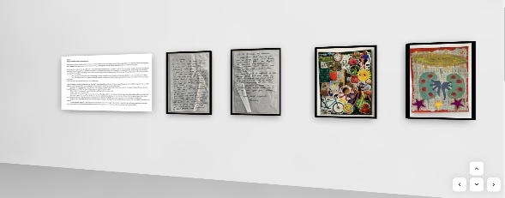
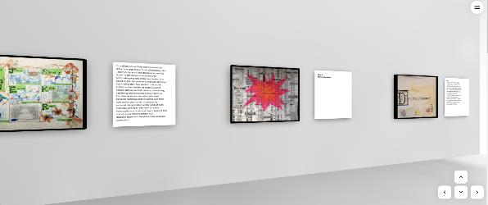
This online exhibition showcased images created by 19 local people through two collaborative workshop projects that brought together University of Bristol researchers and artists. Clinician and researcher Barny Hole and writer and arts-health facilitator Elspeth Penny worked with people with experience of kidney disease to write ‘Letters to My Kidneys’. Using phone calls and letter writing, participants were helped to produce a series of letters and artistic reflections on their experience of kidney disease and their relationship with their kidneys. The outcomes are displayed in the exhibition.
Rhiannon Daniels, Senior Lecturer in Italian, and artist Barbara Disney worked with a group of 9 artists and printmakers to produce responses to Boccaccio’s Decameron. The Decameron is a text about 10 people who isolated themselves in the countryside in response to a plague in 1348, an experience given contemporary relevance by COVID-19 and the associated social restrictions. The prints that were produced are displayed in the exhibition. The exhibition was created using the Kunstmatrix platform. This enabled viewers to access the exhibition from the FUTURES website and in their internet browser, without needing to download any software. It gave viewers the experience of moving around a gallery space to view the images. 228 viewers visited the exhibition.

FUTURES Exhibits: Art of Science
Young adults, adults (27 November – 11 December)
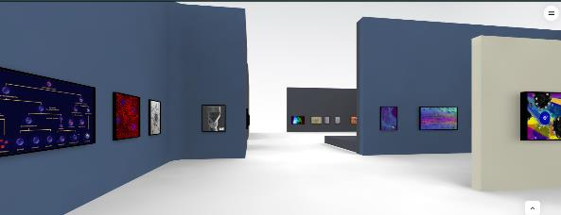
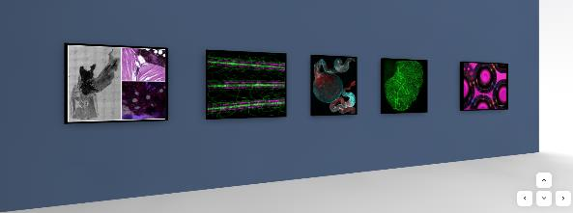
This online exhibition showcased images created by 33 University of Bristol researchers, and each was accompanied by a paragraph of text that explained what the image represented. The images were submitted to Art of Science organised by Dr Caroline McKinnon and Dr Holly Baum, and the FUTURES exhibition was created to share these images as widely as possible. The images spanned a range of subjects and media; some were creative interpretations and some were documentary. Many sparked curiosity and interest by sharing a viewpoint of aspects of science typically only researchers themselves would see, and they all demonstrated the beauty and creativity that can be found in, and in response to, the scientific research undertaken at the University of Bristol. The exhibition demonstrated the variety of topics and fields being researched at the University of Bristol. The exhibition was created using the Kunstmatrix platform. This enabled viewers to access the exhibition from the FUTURES website and in their internet browser, without needing to download any software. It gave viewers the experience of moving around a gallery space to view the images. We also provided an accessible version of the exhibition with image descriptions – this made the exhibition more accessible to people with visual impairments. 105 viewers visited the exhibition.

FUTURES Exhibits: Picture This – A Research Without Borders Virtual Showcase
Young adults, adults (27 November – 11 December)
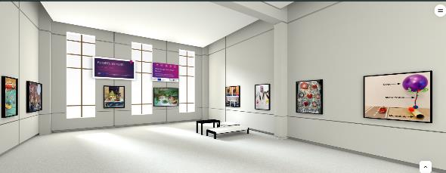
This online exhibition showcased images created by 14 University of Bristol doctoral students. The researchers had been challenged to tell the story of their research through a creative image made using materials from around the house (because of a national Lockdown). The exhibition presented 14 images, and each was accompanied by a paragraph of text that explained how the image reflected their research. The exhibition demonstrated the variety of topics and fields being researched at the University of Bristol. The exhibition was created using the Kunstmatrix platform. This enabled viewers to access the exhibition from the FUTURES website and in their internet browser, without needing to download any software. It gave viewers the experience of moving around a gallery space to view the images. We also provided an accessible version of the exhibition with image descriptions – this made the exhibition more accessible to people with visual impairments. 28 viewers visited the exhibition.

University of Exeter activities

How the Ancient Greeks can improve your health
Families and adults (28 November, 10:30 - 11:10)
This interactive session explored an ancient Greek’s programme for healthy living. The topic was Galen’s medical system - the basis of Western and Islamic Medicine for 1600 years. A passionate group of people discussed with the University of Exeter’s Emeritus Professor John Wilkins whether Galen’s healthy living is useful for us in the 21st century. The format was a talk with questions asked and invited as it progressed, with discussion. By relating Galen’s advice on the environment, eating and drinking, exercise, sleep, regulating the body, and mental health to contemporary living the researcher illustrated its relevance to the audience’s own lives. Using Zoom Meeting enabled audience members to interject and asked questions of the researcher, and it was hoped that using a platform that has been widely used during the pandemic would increase accessibility and interaction. At least 36 people participated in this activity.

Talking about Mindfulness Therapy for Young People
Families and adults (28 November, 11:00 - 11:30)
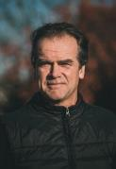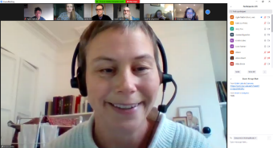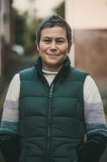
At this workshop, two University of Exeter researchers played some music before explaining their research. One explained how their research was about involving patients with decisions on treatment, in this particular case on a major clinical trial on using mindfulness to improve mental health in children and adolescents, and other spoke about the specific techniques used and demonstrated some of the exercises. A service-user shared their thoughts on their experience of working with the researchers and the three together had a conversation with diverse members of the audience who asked questions about collaborating closely with young people and their families in the community. Using Zoom Meeting enabled audience members to interject and asked questions of the researcher, and it was hoped that using a platform that has been widely used during the pandemic would increase accessibility and interaction. At least 26 people participated in this activity.

Who do we think you are? Online social identity detection
Families and adults (28 November, 13:00 - 13:40)
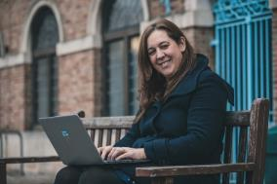
University of Exeter researcher Dr Miriam Koschate demonstrated how machine learning can be used by analysing the writing style of audience members. She explained what it can reveal about the influences upon their writing, discussed the world of digital fingerprints, style shifting, and identity deception and explained what your last social media post may reveal about you, and whether such machine learning models can be used for “good”. Questions were invited and a discussion on machine learning in general ensued. Zoom Meeting was chosen because of its wide usage during the pandemic with a hope this would widen interaction and online software was shared easily with this format, enabling interaction to appeal to younger people. At least 26 people participated in this activity.

Serious Games: learn by doing
Families and adults (28 November, 15:00 - 15:40)
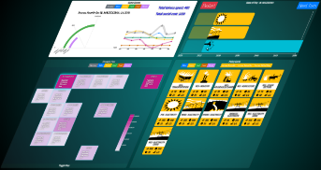
One researcher from the University of Exeter helped the audience to discover how computer games are used by engineers to simulate and solve problems. The event was delivered using Zoom Meeting. This enabled two-way dialogue between the audience and the researcher while the audience were also playing an online version of a Serious Game, which has been developed to connect complex scientific information and explore the interactions between water, energy, land, and food resources management in the context of Climate Change. The researcher chatted in an informal manner to engage young people with the relevance of his research while relating it to the playing of regular games. At least 22 people participated in this activity.

Lockdown Blues
Families and adults (27 November, 12:00 - 13:00)
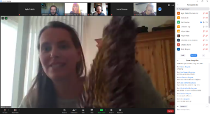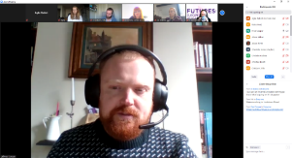
Three researchers from the Wellcome Centre for Cultures + Environments of Health at the University of Exeter talked briefly about the Beacon project on loneliness, showing the audience some things that other people have been making, drawing, and writing during Covid-19. They also led the audience through three activities, including writing and drawing. Audience members were invited to share what they had produced, which generated discussion about the research. Zoom Meeting was chosen because it enabled audience members to share their screens, to discuss and asked questions of the researcher, and because Zoom has been widely used during the pandemic it was hoped it would increase accessibility. At least 34 people participated in this activity.

Why is Climate Change so Hard?
Families and adults (27 November, 19:00 - 20:00)
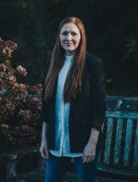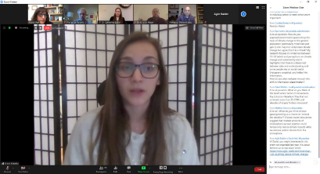
BBC journalist Ritula Shah put questions to a panel comprised of 2 University of Exeter researchers, 2 researchers from other universities, and Grace Blakely, Tribune journalist and regular contributor to BBC current affairs shows. The discussion looked at looked at how we communicate science, the psychology behind our actions, and the politics of Climate Change. The audience enjoyed hearing how scientists communicated their work to the public through the media and engaged politicians with their research to increase its impact. The event demonstrated unexpected areas of research in relation to Climate Change and showed how research in general moves from universities into the wider world, ultimately changing lives. Zoom was used and the event was simultaneously broadcast on Facebook live. The decision to use two formats was taken to increase the audience and impact of the event. The chat function enabled debate and the sharing of links to online resources and articles, including between audience members. At least 245 people participated in this activity.

Gathering for a Future
Families and adults from remote parts of Cornwall (28 November, 14:00 - 16:30)
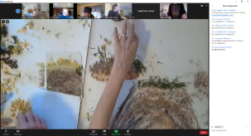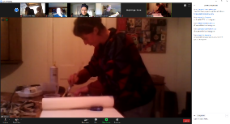
An artist and Dr Joanie Willett, co-director of the Institute for Cornish Studies at University of Exeter, collaborated to deliver a creative workshop online using Zoom Meeting. With a dynamic afternoon of guided activities, they explored the potential of the organic materials in Cornwall to re-imagine local communities and add their voices to the political process. The workshop culminated in a communal digital collage that represented the participants’ shared vision for the future. Using Zoom Meeting enabled audiences to share their screen to create this collage. We also hoped that using Zoom, a platform widely used during the pandemic, would increase accessibility and interaction. 9 people participated in this activity.

How to fix a broken planet
Community groups, adults (27 November, 14:00- 15:00, 28 November, 17:00-18:00)
At each workshop, two early career researchers from the University of Exeter shared recent research on issues related to the current Climate Emergency and discussed how it related to the communities the audience is part of. They considered how to ensure that we can all be involved in understanding and acting on the growing knowledge being developed on these vital issues. Small group work was enabled by using the Zoom breakout room function. 20 people participated in these two workshops.

University of Plymouth activities

The Big Family Quiz
Family with particular relevance for Plymouth and regional families - General audience (28 November, 18:00 - 19:00)
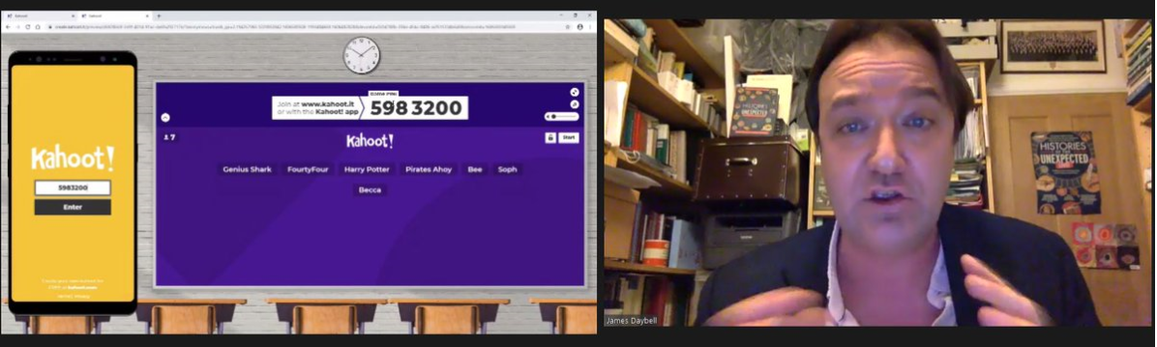
The Big Family Quiz was a fun evening of brain teasers hosted by historian Professor James Daybell Associate Dean of Research at the University of Plymouth and co-creator of acclaimed, alternative history podcast 'Histories of the Unexpected'. 8 researchers delivered questions featuring mind boggling facts about different research topics, so the audience could test their knowledge of the world around us in a funny and interactive way. Research questions presented included poetry, literature, history, human body, microscope pictures, environment and climate, volcanos and earthquakes and plants. The quiz was presented on Zoom webinar to increase audience interaction via Q&A, chat and answering the polling questions. Participants submitted their quiz answers using Kahoot, a game-based learning platform that made it easy to create the quiz and it was great way to keep the audience engaged because it focuses on social learning and makes it fun. 64 families or individuals attended this event.

Discovery Talks: Expedition Earth: An Explorer’s Guide to a Planet in Peril.
General Public (27 November, 18:00 - 19:15)
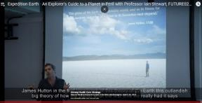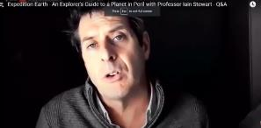
Professor Iain Stewart MBE, Director of the Sustainable Earth Institute and Professor of Geoscience Communication at the University of Plymouth delivered Discovery Talk: Expedition Earth: An Explorer’s Guide to a Planet in Peril. This pre-recorded talk followed by a live Q and A was suitable for all. Professor Iain Stewart presented the big picture story of that planet we call ‘home’ – its history, how it works and what that means for us living on it – through remarkable imagery and amazing science. The audience had the opportunity to explore the Earth’s natural violence, the un-natural shifts in our oceans and climate, and the resulting global challenges that threaten how we live on this extraordinary human planet. The event was delivered on Zoom webinar and the audience had the ability to interact via Chat, and answering polling questions. 211 families or individuals attended this talk live on Zoom, and 1689 viewed it on YouTube afterwards.

Research on your doorstep: online science for schools
Schools (27 November, 10:00 - 12:00)
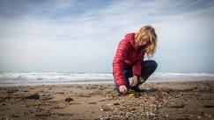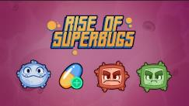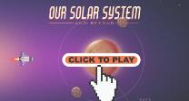
5 researchers from the University of Plymouth took part in Research on your doorstep: online science for schools. The activity was initially designed for schools (Year 5-6) but we redesigned the activity in order to reach a wider younger audience. The audience spent time with researchers from University of Plymouth as they investigate some of the biggest challenges in the science world today. The audience was invited to enjoy all of a selection of four 20-minutes talks, each accompanied by a 5-minute interactive game developed in i-DAT, the University’s Open Research Lab ( interactive games here: https://i-dat.org/marinelittergame/, https://i-dat.org/superbugsgame/, https://i-dat.org/solarsystemgame/ , https://i-dat.org/seasnailsandjellyfish/ ), and followed by a live Q & A for people to engage with working scientists. Research talks presented included the rise of superbugs, marine litter and how can we save the environment from the plastic in our seas, the exploration our solar system and how the climate will affect species of all shapes and sizes spanning from sea snails to jellyfish. The event was delivered on Zoom webinar which gave the audience the ability to interact via Chat and answering polling questions. 6 groups or individuals took part in this activity on Zoom, and 74 groups or individuals viewed the videos on YouTube.

Maritime History and Heritage : Land Ahoy!
Uniformed Youth Groups (scouts, guides, cadets), navy networks, older people (28 November, 10:00 - 11:35)
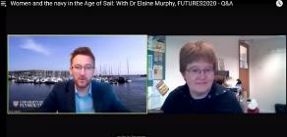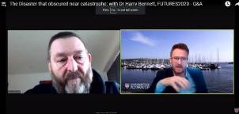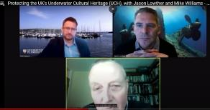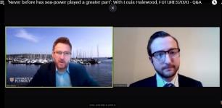
5 researchers from the University of Plymouth took part in Maritime History and Heritage: Land Ahoy! which was hosted by the Business Engagement Manager of the Enterprise Solution team. The event was suitable for people of all ages with an interest in naval history [Uniformed Youth Groups (scouts, guides, cadets), navy networks, older people]. The event comprised 4 pre-recorded talks followed by a live discussion/ Q&A. With experts from the University of Plymouth, the audience explored underwater heritage and naval history, including the history of naval women in the seventeenth and eighteenth centuries; the significance of the Navy in the First World War; preparations for the D-Day landings; and how we can protect our naval heritage. The event was delivered on Zoom webinar and the audience had the ability to interact via Chat, and answering polling questions. 77 groups, families or individuals attended this activity on Zoom and the YouTube videos have been viewed 105 times.

Bath Spa University activities

Writing Futures! Dare to Write? On Tour with FUTURES 2020
Schools, 27 November 2020, 9:10-11am
3 researchers associated with the MA Writing for Young People and MA in Children’s Publishing at BSU worked with Paper Nations, based at BSU’s Research Centre for Transnational Creativity and Education, to deliver online workshops for school groups that break down barriers to writing for young people. The Writing: Futures! workshops introduced school children to the concept of storytelling, empowering them to write their own simple short story or poem and share their work with their peers to improve their writing and confidence. The workshops were delivered using Crowdcast which enabled an online connection to groups within school classrooms. 66 pupils from the Roundhill Primary School in Bath, where a high proportion of pupils are disadvantaged, took part.

FUTURES Snap It Share It Photography competition
General Public (26 November – 6 December)
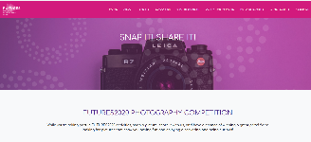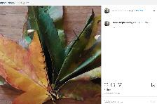
Participants in FUTURES events were encouraged to enter a photography competition by posting simple, easy “snaps” of people taking part in FUTURES activities from home on to Twitter or Instagram. These platforms are widely known and used, free, and accessible to anyone with a smartphone or computer. They were also important tools in our social media awareness raising campaign. The activity was intended to encourage participation in activities and to generate images that we could use to illustrate the public’s participation. In addition, posting images on social media would have encouraged others to take part and serve as awareness raising activity during the ERN. Prizes were offered (eg. a family ticket to the SS Great Britain in Bristol). Schools were also eligible to enter to win a prize of science kits. Despite awareness raising activity and a prominent position on the FUTURES website (and 97 page views), and despite being open to all, only one image was submitted.

EU Corner Activities

EU Corner European Discovery Map
General Public (27-28 November)
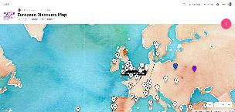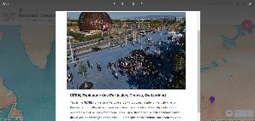
Researchers and the public were invited to contribute to an online map accessed through the EU Corner section of the FUTURES website. The map was created in Padlet. This easy-to-use, free platform is accessible to everyone through an internet browser. It enabled participants to place “pins” onto a map to highlight places in Europe that had inspired their curiosity or research. People could also view all the pins that others had dropped, and see the attached pictures and text explaining the significance of the place. The collection of pins illustrated to viewers how researchers from the South West were connected to Europe, and encouraged viewers to consider their own connections to Europe. The activity was promoted at other FUTURES events and using social media. 24 researchers from the universities of Bristol and Plymouth and Bath Spa University took part, and the page was visited 25 times. A total of 87 pins were dropped.

EU Corner The South West and Europe
General Public (27-28 November)
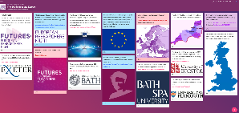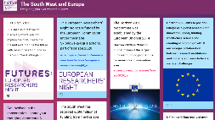
The public were invited to view to an online display of information and statistics about European Researchers’ Night and European Commission funding. This was hosted in the EU Corner section of the FUTURES website, and the display was created in Padlet. This easy-to-use, free platform is accessible to everyone through an internet browser and enabled us to produce a visually interesting display. The content stressed the extent to which the South West region and the consortium universities benefit from EU funding, the research that this enables, and provided information about the ERN and Horizon 2020. The activity was promoted at other FUTURES events and using social media. The page was visited 6 times.

EU Corner Twitter Takeover
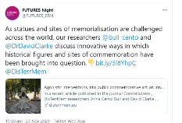
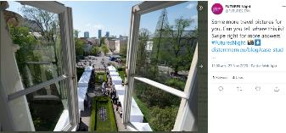
General Public (27-28 November 10.00 – 12.00)

For the University of Bath’s 2020 EU Corner, the DisTerrMem project team of five researchers (4 UoBa, 1 UoP) held a takeover of the FUTURES Twitter account. During this takeover EU funded researchers shared articles, images and posts about their research and how the project had been supported by European Commission funding. 373 users of the FUTURES social media platforms that were taken over by the researchers engaged with content. Posts included articles written by researchers discussing the recent Black Lives Matter protests in Bristol and around the world, research outputs and infographics from the DisTerrMem project and travel photos from historical European sites visited by the researchers.

EU Corner: Day in the Life of a Researcher
Young people and general audience (28 November, 15:00 - 16:00)
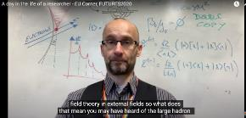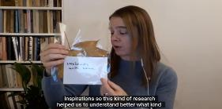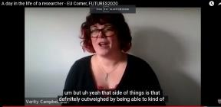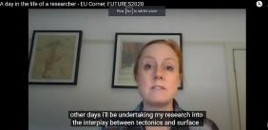
Five researchers were featured in A Day in the Life of a Researcher, which took place on Saturday 28th November at 15:00-16:00 on YouTube and it was also featured on the main Futures EU Corner webpage. The event was an exclusive insight to the work of Marie Curie Fellows and other EU funded researchers at the University of Plymouth and the audience had a glimpse into the daily activities of these researchers and some top tips on pursuing a career in research. The talks were an exciting opportunity for all to learn about high-intensity lasers to explore fundamental physics, explore the benefits people experience when interacting with the natural environment, learn about mathematical sciences and a career within data analysis, the amazing places geologists visit, the highs and the lows of fieldwork and the range of geoscience career pathways that are possible across industry and academia. 153 people viewed this on YouTube.

EU Corner mural
General Public (27-28 November)
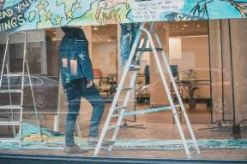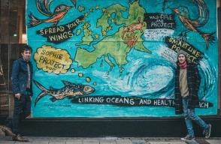
Artist Steve McCracken had conversations with 3 researchers from 3 EU funded projects taking place at the University of Exeter. These conversations informed the very large mural he created to communicate their research and the benefits of EU research funding. The projects cover the topics of wildfires, oceans and human health, and how technology can improve wellbeing. The mural was hung in a large gallery window a few doors away from the city’s main bus station, where it was seen by hundreds of people from all backgrounds across the community. It is still there in early 2021! With so much online, it was beneficial to find a format with such instant impact right in the centre of the city, passed by many cars, buses, and pedestrians. An estimated 2000 people saw the mural over the ERN, and a further 15 engaged with the mural on Twitter. Photographs of the mural were placed on the FUTURES website, too.

Table 1: Overview of activities
 | Activity | Venue/Platform | Attendance
1 | Discover and Discuss | Online connection to school classrooms | 89
2 | Curiosity Carousel | Online (Remo) | 36
3 | Researchers' Tales | Zoom webinar | 55
4 | I’m an EU Scientist, Get Me Out of Here! | Online (I’m A Scientist web chat platform)  I'm A Scientist web platform (https://blue20.imascientist.org.uk/how-to-use-im-a-scientist-video-guides/ ) | 57
5 | Discovery Talks: Sustainable Food: Thinking, Knowing; Doing | Zoom webinar | 58
6 | Discovery Talk: Bubbles, Butterflies, Beetles and the Optics of Fruit. | Zoom webinar | 25
7 | Discovery Talks: History from home | Zoom webinar | 20
8 | Discovery Talks: Music for the Shy? | Zoom webinar | 14
9 | Discovery Talk: Quantum parallel worlds | Zoom webinar | 50
10 | Discovery Talks: A Short History of the Future of Work | Zoom webinar | 20
11 | Discovery Talks: How will STEMM research affect the daily lives of Bristolians in the future? | Zoom webinar | 8
12 | Discovery Talks: A Matter of Life and Breath | Zoom webinar | 30
13 | Discovery Talks: Understanding COVID | Zoom webinar | 34
14 | FUTURES Exhibits: Bristol Botanic Garden – An Unusual Spring and Summer | Online exhibition, Futures website | 84
15 | FUTURES Exhibits: Health and Creativity | Online exhibition, Futures website | 238 exhibition engagements, plus 18 workshop participants.
16 | FUTURES Exhibits: Art of Science | Online exhibition, Futures website | 105
17 | FUTURES Exhibits: Picture This – A Research Without Borders Virtual Showcase | Online exhibition, Futures website | 28
18 | Do Try This At Home | Online, Futures website | 248
19 | FUTURES Snap It Share It Photography competition | Instagram, Twitter | 1
20 | FUTURES on Air | Radio Stations including Phonic FM, St Austell, Bath and Sound Art | 3000
21 | Science Showoff presents: Never Explain | YouTube | 73
22 | Global Science Show | Twitter | 950
23 | I'm A Researcher - Ask Me Anything | Reddit, Reddit website. | 6221
24 | FUTRESXINTSTAGRAM | Instagram | 27813
25 | Writing Futures! Dare to Write? On Tour with FUTURES 2020 | Online connection to school classrooms (via CrowdCast) | 66
26 | How the Ancient Greeks Can Improve Your Health | Zoom | 36
27 | Talking about Mindfulness Therapy for Young People | Zoom | 26
28 | Who do we think you are? Online social identity detection | Zoom | 28
29 | Serious Games: learn by doing | Zoom | 22
30 | Lockdown Blues | Zoom | 34
31 | Why is Climate Change so Hard? | Zoom | 245
32 | Gathering For A Future | Zoom | 9
33 | How to fix a broken planet | Zoom | 20
34 | The Big Family Quiz | Zoom and Kahoot quiz application | 64
35 | Research on your doorstep: online science for schools | Zoom | 80 (6 live on Zoom + 33 + 16 + 25 for the three YouTube videos)
36 | Maritime History and Heritage: Land Ahoy! | Zoom | 182 (77 live on Zoom + 15 + 76 + 11 + 3 for the four YouTube videos)
37 | Discovery Talks: Expedition Earth: An Explorer’s Guide to a Planet in Peril | Zoom | 1,900 (211 live on Zoom + 1,689 on YouTube)
38 | EU Corner: The South West and Europe | Online display (Padlet) Futures website | 6
39 | EU Corner: European Discovery Map | Online interactive map, Futures website | 25
40 | EU Corner: Mural | Make Tank, Exeter | 2015
41 | EU Corner: Twitter take over | Twitter | 373
42 | EU Corner: Day in the Life of a Researcher | YouTube, and FUTURES website | 153

Some events had more than one session, meaning there were 48 activity or event sessions in total.
1% did not provide this information.

