Instructions for accessing the Doctoral Developments webinar, 9 February 2018.

Background

This is a virtual webinar and is only accessible online. It is hosted using the Adobe Connect software. You will need access to a computer (Windows or Mac) with a good internet connection and audio. You may be able to access the webinar via a mobile device but may be required to download 3rd party apps.

Because of changes to Google Chrome, with regard to 3rd party software add-ins, we recommend that you use MS Internet Explorer or Mozilla Firefox to access this webinar. We have had no feedback from Mac users regarding issues of accessing these sessions so assume that this works fine.

We suggest you try accessing the webinar software a few days before the webinar to check for any IT issues. Please contact us if you have problems accessing the system.

Access the webinar
- Go to http://uob.adobeconnect.com/rdu/
- Your system may have to add an Adobe Connect add-in to view this.
- You should see a screen like this
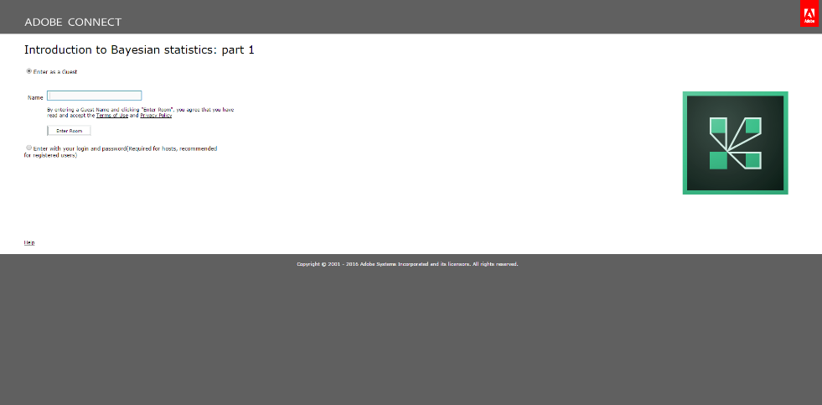
- You will need to enter the webinar as a guest.
- Please type in your full name (first name and surname).
- Click on ‘Enter Room’.
- There may be a small delay whilst the Adobe Connect console is initiated.
- Once this opens you will be presented with a ‘tips’ window.
- Once you have browsed this please close this window and await further instructions from the presenter or moderator.
- If you encounter any problems please email n.j.bannister@bath.ac.uk or doctoralskills@bath.ac.uk
- Please do email your feedback of your experiences of this session to E.Parker@bath.ac.uk.

