
Job Description

Job title | Manager for the Bath Institute for the Augmented Human (IAH Manager)
Department/School | Bath Institute for the Augmented Human
Job family | Research Management
Grade | 8
Reporting to | Director of the Bath Institute for the Augmented Human
Responsible for | Bath Institute for the Augmented Human  support staff
Location | University of Bath campus (Claverton Down or Bath City sites). Applicants may be required to work flexible hours and to travel within the UK and overseas as required.

Background and context



The Bath Institute for the Augmented Human (IAH) is the University’s newest research Institute, established in 2023, as an innovative and agile leader in Human Augmentation R&D in the UK and Internationally.

Our opportunity
Human augmentation – the use of science and technology to enhance physical and cognitive performance – has the potential to transform every aspect of our lives. It can enable humans to transcend our biological limitations, improve our health and wellbeing, and extend our lifespans.

Increasingly, we are using cutting-edge technology to keep us healthy and help us perform better. There are so many areas where intelligent machines can make a difference.

For instance, there are wearable neurotechnology headsets now that measure the brain activity of a person who, due to sickness or injury, can no longer communicate or move, and then translate these signals into responses people can understand. Strategies are also being developed to link brains directly with exoskeletons – a special kind of suit that can be worn by a person recovering from a stroke or by firefighters or construction workers. These suits enhance a person’s ability to walk, climb and carry heavy loads, and can accelerate recovery from injury or improve workplace safety. We’re also working on brain-training neurotechnology that can enhance performance in sport and mental wellbeing, and can be used to treat a range of conditions such as stroke, chronic pain, ADHD, depression and PTSD.

The speed at which advanced innovations in this field are developing is rapid. The opportunities to bring multiple new human-machine interfacing technologies together are immense and it is very important for the UK to lead innovation in human augmentation and capitalise on these opportunities. There is an opportunity to help humans across the whole spectrum of their lives – not just physically and mentally but supporting the way we live and work on a day-to-day basis, and thus human augmentation is expected to lead to many beneficial social and economic impacts.

Our response
The Bath Institute for the Augmented Human aims to be a leading institute nationally and globally, driving responsible, cutting-edge research and trialling and deploying human augmentation technologies that can impact broadly. Our vision is a complete multidisciplinary training and innovation ecosystem that revolutionises the way that humans’ interface, interact, improve, and evolve with technology. The Institute will be a unique body of interdisciplinary research focusing on research excellence and addressing the global need for new tools and technologies for augmenting the human and developing researchers that have the skills to develop, trial, regulate and deploy human augmentation technologies.

No other Institute has the capacity to bring together such a breadth of interdisciplinary research involving the body, the mind, the physical environment, the digital environment, and the social and policy contexts, in a way that Bath has demonstrated.

We’re setting ourselves an ambitious programme involving 50+ academics from an excellent mix of disciplines, from robotics, engineering and computer science to health, neuroscience and psychology. Together, we’re establishing a world-leading research institute.

We will work together – along with industry partners, patient groups and others – to find new and imaginative ways to integrate machines with our bodies and minds. Our end goal is to push the limits of our natural capabilities – improving quality of life and benefiting humanity. We’ll also be taking a leading role in devising rules that ensure no harm is done by the tech developed in this field. We want to guarantee Human Augmentation technology is deployed both safely and ethically. The Bath Institute for the Augmented Human has been founded to accelerate technological developments and help the UK prepare for the growing impact of direct human-to-machine interactions.

Our focus
The Bath Institute for the Augmented Human will establish pathways to impact with minimum barriers, achieving impact across multiple sectors. Responsible research addressing societal, legal, and ethical considerations will be at the core of the institute. The Institute is founded on the following Mission, Vision, and Values:

Mission – To leverage technology for the advancement of human health, wellbeing, and performance.

Vision – To establish a world-leading multidisciplinary training and innovation ecosystem that revolutionises the way that humans interface, interact, improve and evolve with technology.

Values -
- Trusted – The leading voice in the development and deployment of human augmentation.
- Inclusive – Enabling a diverse, interdisciplinary, collaborative, and inclusive community.
- Impactful – Embedding co-creation to deliver impact through innovation.

The figures below provide a high-level overview of the main application domains and underpinning human augmentation technologies we aim to focus on along with an outline of the innovation ecosystem.

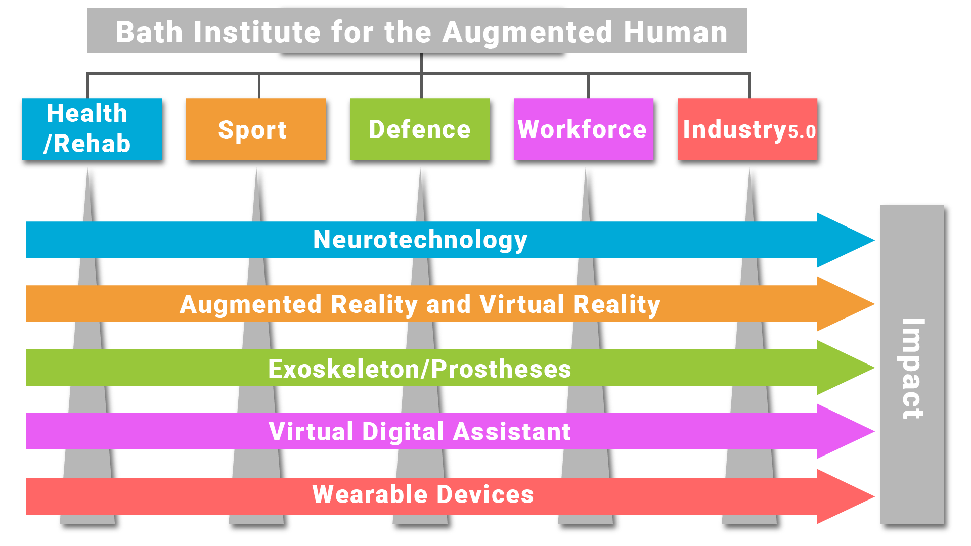
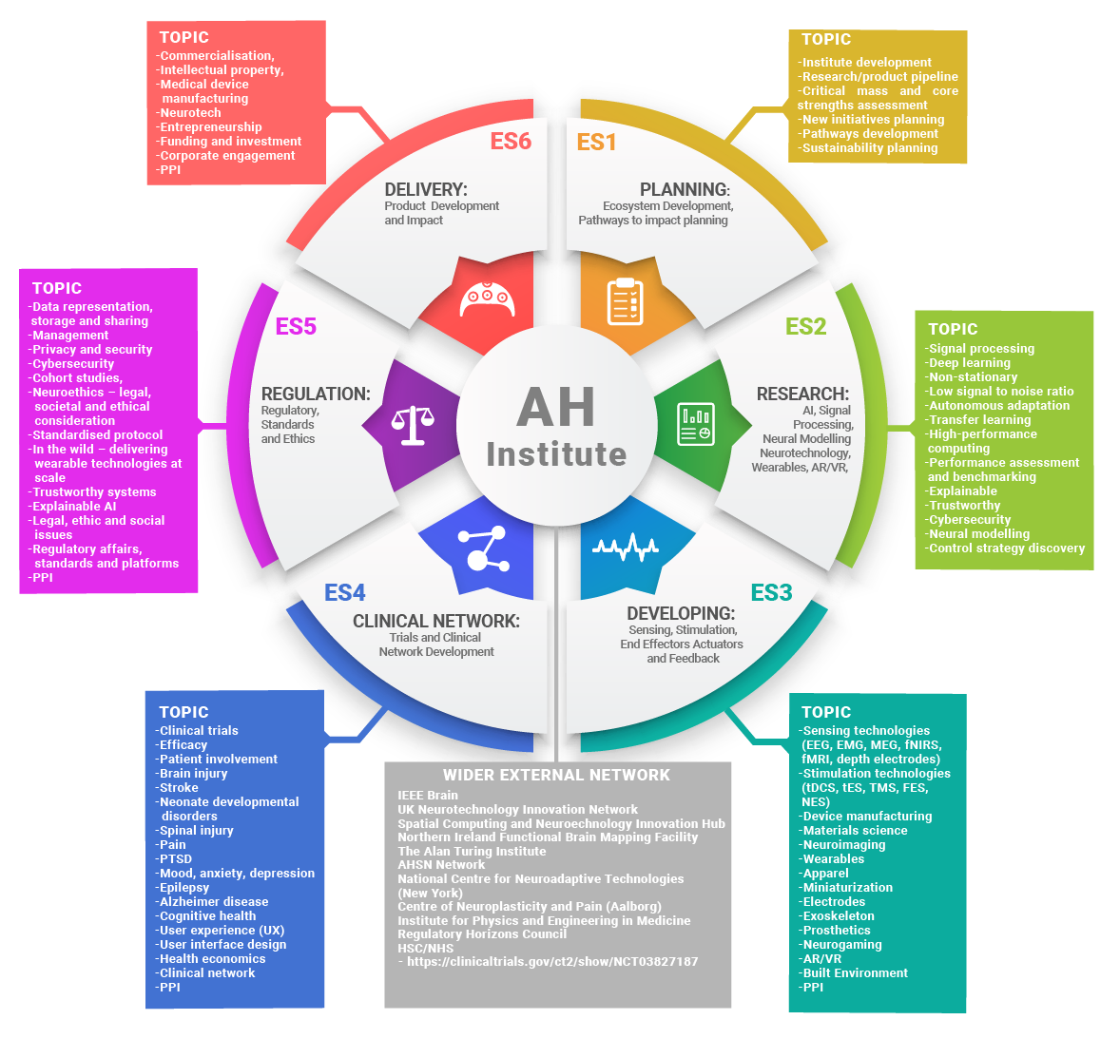

Job purpose
The Bath Institute for the Augmented Human Manager will have significant responsibility for delivering the strategy of the Institute on a day-to-day basis and maintaining alignment to the Institute’s long-term vision.

The Institute Manager will collaborate with the Academic Directors and steering committee, and administrative and technical support staff associated with Institute. The Institute Manager will also act as line manager for other administrative/technical posts within the Institute. The post-holder will be required to work closely with colleagues across the University, in both academic and professional services departments.

The Institute manager will contribute in leadership to achieve a cohesive and performance driven team, ensuring team members are equipped, motivated, and supported to achieve the successful delivery of shared goals across the Institute.

The IAH Manager is line managed by the Director of the Institute. The post-holder will have considerable autonomy and will be expected to show substantial personal initiative.

The IAH Manager line manages several key administrative posts: initially these include, a Coordinator and Public Engagement Officer, Business Development Manager and Impact Coordinator and Clinical Trials manager. The IAH Manager may also have responsibility for line managing a team of Commercial Research Associates and a technical support team (software and electronics engineer and technicians) dedicated to the IAH as well as coordinating interaction of PhD researchers and post-doctoral researchers within the IAH.

Main duties and responsibilities

1 | Strategic Planning and Business Development & Engagement  - To contribute to the development of a grant/business development strategy of the Institute and contribute to ensuring a sustainable Business Plan is in place by the end of its initial phase of University Institute funding.  - To contribute to securing significant sustainable income for the Institute through a variety of methods, including engaging companies in long-term strategic partnerships.  - To contribute to developing an external partnerships network through establishing regular network activities, identifying strategic funding initiatives, and influencing via targeted engagement opportunities  - To manage and develop relationships with a portfolio of individual contacts and organisations, utilising a wide range of methods; developing networks amongst contacts; and involving partners and prospects closely with planning activity within the Institute.  - To generate, manipulate and analyse information to support strategic planning and management, in order to identify new potential clients and new business needs/demands.  - To keep up to date with national and international activities in human augmentation, including the evolving funding landscape.  - To provide regular pipeline forecasts and reports to inform the University leadership team of progress, capacity planning and development priorities.  - To contribute to driving the strategic implementation of the Institute in partnership with the Directors.  - To obtain internal and external feedback, reviews and evaluation data and provide insight and recommendations to the leadership team on opportunities for improvement.
2 | Programme/Project Delivery and Management  - To work in close collaboration with the Director, Deputy Directors, Institute staff, Research and Innovation Services, associated departments (including Computer Science, Electrical and Electronic Engineering, Psychology, and Health) and the wider University administration to develop and promote the Institute and deliver its objectives.  - To lead in developing relationships with industry, explore a wide variety of external opportunities, leverage existing support, and create new funding streams.  - To work with the Director and Deputy Directors to discuss and agree priorities and implement the strategy as laid out in the Institute Strategy document which include a range of operational objectives and processes to be implemented.  - To be proactive in driving the expansion of the Institute’s multidisciplinary engagement and strategic partnerships.  - To monitor and contribute to achieving key delivery targets, particularly in relation to external collaboration, funding identification and creation.  - To work with the wider IAH membership and steering team to ensure projects are integrated within the Institute.  - To contribute to the development of a robust project implementation plan and lead the delivery of this plan to ensure all activities are delivered to cost, quality and time parameters and all project’s key delivery targets are met on a quarterly and yearly basis.  - To bring together institute member and other research groupings within the Institute to collaborate on project delays, finance, new opportunities, and delivery issues.  - To oversee the quality and maintenance of all project management documentation, including financial spend profiles and forecasts; risk registers; background IPR register; project plans etc.  - To lead on the development of formal reporting processes:  - Of the Institute to the University Executive Board  - Submission of annual monitoring reports and financial claims as required under its contract.  - Contribute to other initiatives to deliver policy, industry and academic research and innovation projects.
3 | Project Management and Governance and Operational Development and Delivery  - To project manage the day-to-day work of the team of Commercial Research Associates and technical support.  - To develop and maintain processes for capturing and recording data relating to contacts and partnerships.  - To ensure compliance with University contractual requirements and internal financial processes.  - Develop and lead the professional service performance and delivery of the Institute, including financial, legal, resourcing and benefits delivery.  - Work collaboratively with key stakeholders, develop systems, information and processes for effective management, governance, and assurance to develop and sustain the Institute.  - To contribute to the financial management of the Institute, including the regular formal financial and progress reporting against agreed requirements and metrics to funders.  - To present at high-profile meetings and/or external forums as relevant to support the communications and engagement activities of the Institute  - To lead on engagement and collaboration with professional services teams within the University e.g. Finance, Legal, HR, Research Services and Academic Departments on behalf of the Institute to ensure seamless operational delivery between the Institute and its external partners.  - To deputise for the Director / Deputy Director as appropriate.  - To oversee compliance with University governance and policy and support the Academic Directors in delivering the institutes strategic objectives.
4 | Communications  - To provide written and verbal updates to the Institute’s Director, Deputy Directors, and Steering Group, as required.  - To create influence and impact internal and external to the University, including presenting and disseminating information on Institute activities to a variety of groups and audiences.  - To work closely with the Institute’s Marketing and Communications Officer to ensure effective and appropriate external communications.  - To promote IAH across the UK.
5 | The Institute Manager will from time to time be required to undertake other duties of a similar nature as reasonably required by Institute Director and/or Deputy Director.

Person Specification

Criteria | Essential | Desirable
Qualifications
An undergraduate and/or Masters degree | √
A PhD degree in subject area of direct relevance for the project, or equivalent significant relevant experience and professional qualification |  | √
A project management qualification |  | √
Experience/Knowledge

Familiarity with the technologies associated with human augmentation and their applications |  | √
Project management experience | √
Experience in delivering collaborative projects between academic organisations and/ business | √
An understanding of research funding opportunities |  | √
Experience of line management | √
Experience of coordinating work across internal and external teams | √
Skills
Experience of producing written documents materials to a high standard. A high level of literacy and ability to draft briefing papers for senior colleagues | √
An understanding of mechanisms for corporate engagement with universities, including contract development |  | √
Experience of public speaking and giving presentations to a variety of audiences | √
Experience of working with a diverse range of colleagues within a large and complex organisation |  | √
Ability to organise and prioritise own and others’ workloads | √
Attributes
Versatile, innovative and developing creative solutions | √
Ability to be an effective interdisciplinary team worker | √
Commitment to safe working practices | √
Commitment to working within professional and ethical codes of conduct | √
Commitment to collaborative and interdisciplinary engagement | √

