Accommodation Additional Requirements Form 2026-27

If you have a long-term condition or disability that affects your accommodation requirements, please complete this form. The information you share will help us to:

- Understand your individual needs while you’re living in our accommodation.
- Prioritise allocating rooms in a way that reflects students’ individual needs.
- Put the appropriate support in place to help make your transition into university accommodation as smooth and comfortable as possible.

How we use your personal data
All personal data is held securely by the University and will be stored and used in compliance with the Data Protection Act 2018 and the General Data Protection Regulation (EU) 2016/679. We will not divulge your information to any third parties apart from applicants who are assigned a place with one of our Nomination accommodation providers for purposes of contact and contract details.

We may recommend disclosure of relevant information to the appropriate personnel to ensure your support across the University. These can include:

- Residence Life Team
- Director of Campus Services
- Student Support and Safeguarding
- Security Team
- University Medical Centre
- Students' Union Advice & Support
- Your academic supervisor or personal tutor
- Host or This Is Fresh if you are allocated within one of our nominations accommodations

We will advise you if we feel it is necessary to make any further disclosures to other personnel not listed above. The University cannot guarantee to arrange appropriate support if adequate disclosure of disability or medical history is not made in writing at the time of application.

By submitting this form, you agree to us holding and disclosing personal and statistical information in appropriate ways. You also confirm that the information you have provided is true and correct at the time of submitting your application.

Signature and agreement
By signing the agreement section below, you agree to us holding and disclosing personal and statistical information in appropriate ways. You also confirm that the information you have provided is true and correct at the time of submitting your application.
Name (block capitals): Date:

Personal details

- First name:

- Preferred name (if different to first name):

- Surname:

- Date of Birth (DD/MM/YYYY):

- Gender:

- Is your gender the same as the sex you were assigned at birth? Yes ☐ No ☐

- Preferred pronouns:

- Contact phone number:

- University of Bath email address:
This has been provided to you by the University and is made up of your initials followed by a set of numbers (e.g. Joe Bloggs - jb2026@bath.ac.uk). If you applied for University accommodation through the accommodation portal, this is the username you would have used to log in there.

- Personal email address:

Study details

- Student type: Undergraduate ☐ Postgraduate ☐

Other (please detail):

- University of Bath student number:
This is a 9-digit number. The first 2 digits represent the year you enrolled at the University, unless you deferred your place (e.g. if you enrolled in 2026, the first 2 digits will be 26). If you already have access to your library card, your student number can be found on there.

- What year of study will you be in during the 2026-27 academic year?

Year 1 ☐ Year 2 ☐ Year 3 ☐ Year 4 (Integrated Masters) ☐

Placement Year ☐ Other (please detail):

- Fee paying status: Home ☐ Overseas ☐

Your conditions and circumstances

- Do you consider yourself to have any neurological conditions?
This could include a type of neurological condition or seizures.

Yes ☐ No ☐ Not sure ☐

- Please provide details of any neurological conditions here:

- Do you consider yourself to have any forms of neurodivergence?
This could include Autism, a Specific Learning Difficulty (SpLD) such as ADHD, dyslexia, dyspraxia, etc, or other forms of neurodivergence.

Yes ☐ No ☐ Not sure ☐

- Please provide details of any neurodivergent conditions here:

- Do you consider yourself to have any chronic health conditions?
This could include allergies, an autoimmune disorder, cancer, a cardiovascular condition, fatigue conditions, gastrointestinal conditions, an infectious disease, a respiratory disability, a skin condition, or other forms of chronic health conditions.

Yes ☐ No ☐ Not sure ☐

- Please provide details of any chronic health conditions here:

- Do you consider yourself to have any physical or sensory disabilities?
This could include a physical disability, a hearing impairment, a visual impairment, or other forms of physical or sensory disabilities.

Yes ☐ No ☐ Not sure ☐

- Please provide details of any physical or sensory disabilities here:

- Do you consider yourself to have any mental health or psychological conditions?
This could include a long-term mental health condition, a condition related to trauma, Obsessive Compulsive Disorder (OCD), or other forms of long-term mental health or psychological conditions.

Yes ☐ No ☐ Not sure ☐

- Please provide details of any mental health or psychological conditions here:

- Are your additional requirements for accommodation the result of a medical intervention, procedure or surgery, or associated ongoing treatment?

Yes ☐ No ☐ Not sure ☐

- Please indicate whether the medical intervention has already happened or is planned to happen.

Already happened ☐ Planned to happen ☐ Not sure ☐

- If already happened, when did your medical intervention, procedure or surgery take place?

- If planned to happen, when will your medical intervention, procedure or surgery take place?

- If you have any conditions or circumstances that are relevant to your application that you have not been able to select or indicate above, please provide details in the box below:

- Please describe how your conditions or circumstances affect your accommodation requirements. Please provide as much detail as possible in the box below.

Accommodation requirements

- Due to my long-term condition/disability, I require:

Please only indicate needs, not preferences. | Yes | No
Accommodation on campus | ☐ | ☐
Accommodation in the city (not on campus) | ☐ | ☐
Self-contained studio room (includes own kitchen storage, food preparation area, cooking facilities and bathroom) | ☐ | ☐
Bedroom with an ensuite (includes private bathroom) | ☐ | ☐
Bedroom with private wash hand basin | ☐ | ☐
Accommodation with Eat and Drink credit (only available for undergraduates) | ☐ | ☐
Large room | ☐ | ☐
Ground floor room/room with lift access.  Please specify in Question 31 if you require one of these options specifically. Otherwise, we will assume either is suitable. | ☐ | ☐
Small kitchen group | ☐ | ☐
Small personal fridge in room for medication or special dietary food | ☐ | ☐
Double bed for a physical need | ☐ | ☐
Wheelchair accessible room | ☐ | ☐
Shower chair | ☐ | ☐
Motorised door opening device on external doors to building | ☐ | ☐
Parking permit  Please be aware this will require further assessment of circumstances for approval. | ☐ | ☐
An additional room for a support worker/carer.  Please be aware that whilst we make every effort to provide a suitable room for carer, we cannot guarantee this and is subject to availability at time of receipt of application. This room will not be provided for free. | ☐ | ☐
Accommodation suitable for an assistance/emotional support animal.  Please be aware this will require further assessment for approval. | ☐ | ☐
Fire alarm activation aid (vibrating alerter) | ☐ | ☐
Braille signage within the accommodation | ☐ | ☐

- If there are any other facilities, adaptions, or services you would require within your accommodation, please provide details in the box below:

- If there is any specific equipment you will need to bring with you, please provide details in the box below:

- For undergraduate students only:

Will you be aged 21 or over before the 2026-27 academic year starts?

Yes ☐ No ☐ Does not apply to me – I am a postgraduate student ☐

IMPORTANT: If you are an undergraduate student aged 21 or over before the 2026-27 academic year starts, the next question (question 35) does not apply to you. You will automatically be allocated to a mature flat, which cannot be combined with any lifestyle preferences.

- In your main accommodation application, you can select the following optional lifestyle preferences:

- Undergraduate: Single Sex, Quiet, Alcohol Free, Quiet & Alcohol Free, or LGBTQ+.
- Postgraduate: Quiet or Vegetarian
While these are treated as preferences in the main application, we recognise that for some individuals they may be essential requirements.
If this applies to you, please detail in the box below any lifestyle preferences you selected, and why they are a need for you rather than a preference.

- Are you in receipt of Disabled Students’ Allowance (DSA)?

Yes ☐ No ☐ Currently applying ☐

To find guidance on Disabled Students’ Allowance, please follow the link: https://www.gov.uk/disabled-students-allowance-dsa

Emergency evacuation

As part of our emergency evacuation procedures, we need to ensure that all residents can leave their accommodation safely at all times of the day or night. We can agree for a personal emergency evacuation plan that will provide appropriate assistance based on your needs. This plan will be shared with all relevant departments for use in the event of an emergency.

All students are advised to download the SafeZone app.

Please note that an accommodation PEEP is separate to any other PEEP you may have in place (e.g. for your department of study).
- Please select the statement that applies to you. In the event of an emergency:

☐ | I could evacuate my room without assistance at any time of day or night. I therefore do not require a personal emergency evacuation plan (PEEP).
☐ | I would require assistance to evacuate my room at any time of day or night. I therefore require a personal evacuation plan (PEEP) to be set up prior my arrival.

- If you selected that you would require a PEEP, please complete the following:

 | Yes | No
I use a wheelchair or mobility aid sometimes/all the time.
I find stairs difficult to use.
I can get confused and disorientated which impacts on my functioning when hearing a fire alarm.
I have epilepsy that could be triggered by flashing lights or loud alarms.
I have a visual/hearing impairment that will impact my evacuation (if I remove my hearing aid/cochlea implant).

- If there is any other reason why you would find it difficult to evacuate your room quickly or require immediate assistance in the event of an emergency, please provide details in the box below:

Eligibility for university accommodation beyond first-year

We are only able to offer students university accommodation beyond their first-year where a long-term condition or disability makes living in private housing significantly challenging and there is crucial need for this support.

Due to a limited number of rooms, there is an assessment process in which students must meet specific eligibility criteria. Application forms are issued each November, and completed forms must be submitted by the end of December. All applications are reviewed by a panel made up of representatives from both ResLife and the Disability Team.

- Would you like us to record on our system that you may require university accommodation beyond first-year due to a long-term condition or disability?
You will receive information about applying to return to university accommodation regardless of your answer. This question is used solely to help us estimate how many students may require accommodation beyond their first year.

☐ | Yes – I may require
☐ | No – I will not require
☐ | Unsure

Supporting documentation

- Do you have supporting documentation in relation to your conditions or circumstances?
This could include a formal diagnostic assessment, a letter/report from a professional such as a GP, or other forms of supportive documentation.

Selecting ‘Yes’ indicates that you intend to submit supporting documentation, so we will know to expect it.

Yes ☐ No ☐

Please see the final page of this document for instructions on how to upload your Additional Requirements Form and supporting documentation.

Other information and feedback

Contact us
If you would like to discuss any additional requirements related to your accommodation, please email reslifesupport@bath.ac.uk and we will be able to support you with your queries or concerns.

Alternatively, you can book a virtual appointment with us. Just follow this link and book one under ‘Additional Requirements (Accommodation)’: Speak to the ResLife Support Team
Consent to speak to a nominated person
Due to GDPR data protection regulations, we can only discuss your accommodation application and Additional Requirements Form directly with you as the applicant. If you would like us to communicate with someone else on your behalf, you will need to provide written consent authorising us to speak with your nominated person. Please email this consent to reslifesupport@bath.ac.uk, including the nominated person’s full name, email address, and phone number.

Additional Requirements Financial Support Fund
Please ensure that you are able to cover the cost of the room preferences you have indicated. Means-tested financial support is available for specific groups of students with a long-term condition or disability, subject to eligibility. To learn more about the criteria for this financial support, please visit this link: https://www.bath.ac.uk/guides/additional-requirements-financial-support-fund/

Academic support

The ResLife Support Team and this form are intended to support you with any accommodation related needs. For academic support connected to long-term conditions or disabilities, including adjustments for your studies, please contact the Disability Service.

Feedback

- If you have any feedback on how this application form could be improved, please provide details in the box below. This is so we can consider how to adjust our form to better meet the needs of our students.

How to upload your Additional Requirements Form and supporting documentation
Please upload your Additional Requirements Form and supporting documentation in the Accommodation Portal.
- Login with your University of Bath username

- Select ‘Manage my accommodation account’

- In the top menu bar, click the drop-down titled ‘Additional Requirements upload and Account details’ and select ‘Upload Additional Requirements documents’

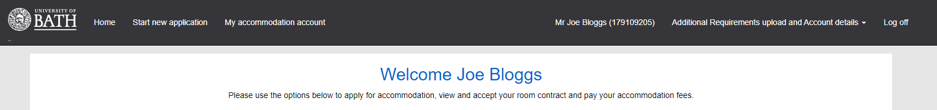

- To upload your Additional Requirements Form, click on the drop-down menu titled ‘Updating which document?’, and select ‘Other Document: Additional Requirements form’.

- You may upload up to two supporting documents from the drop-down menu: one as ‘Other Document: Supporting medical evidence’, and one as ‘Other Document: Additional supporting evidence’.

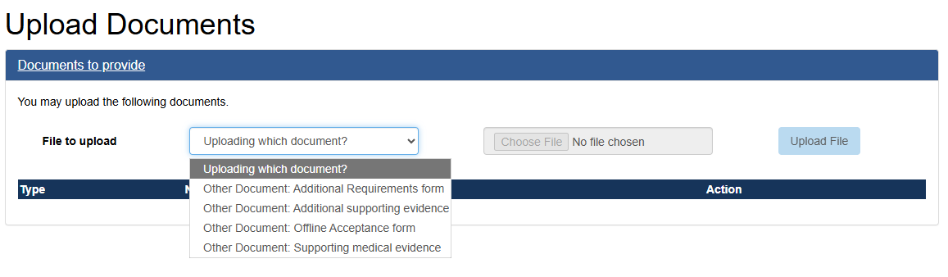

IMPORTANT: Please note that the portal only accepts files in PDF or image format. You will need to save this form as a PDF and ensure that any supporting documents are also in one of these formats.

Alternatively, you can email your Additional Requirements Form and supporting documentation to reslifesupport@bath.ac.uk

