Biology and the Olympics
TRUE OR FALSE ROUND – with a few trick questions snuck in :D

- DNA stands for Deoxyribonucleic adenine

- A virus can only replicate inside the host cells of living organisms.

- Sherlock and Watson discovered the double helix structure of DNA

- Cytosine is paired with Thymine in DNA

- Women who use anabolic steroids often develop masculine features

- Adenine is paired with Thymine in DNA

- A virus can be made of both RNA and DNA

- Micro encephalopathy is the main health problem associated with Zika

- The endocrine system is a collection of glands that produce hormones

- Zika is transmitted by the male Aedes mosquito

- Erythropoietin is a protein hormone, not a steroid

- Ebola is transmitted via close contact with bodily fluids of infected people

- Herd immunity is when most of a population is vaccinated to protect others

- HGH is commonly misused by endurance athletes e.g. marathon runners

MISSING NUMBER

- There are ….... pairs of autosomes in the human body

- How many transmission methods are known for the Malaria disease? …....

- The cells of the immune system that HIV attacks are called CD…... T cells

- ….... % of Malaria deaths occur in Africa

- HIV can be transmitted in …… different ways?

- Lance Armstrong was stripped of …... tour de France titles when found to be doping

- DNA strands are made up of ……. different nucleotides?

- How many species of Plasmodium (malaria) infect humans? …….

- How many times has Pauline Cafferkey been admitted to hospital due to Ebola? …….

BINGO

Athletes Foot | Vaccine | Endocrine Gland | Virus | Antibiotic | Antigen
Pathogen | Uracil | Vector | Verruca | Inherit | Insulin
Exocrine Gland | Guanine | Hormone | Bacteria | Host | Antibody

PICTURE ROUND
Athletes

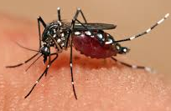

ZIKA

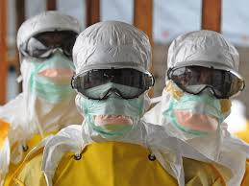
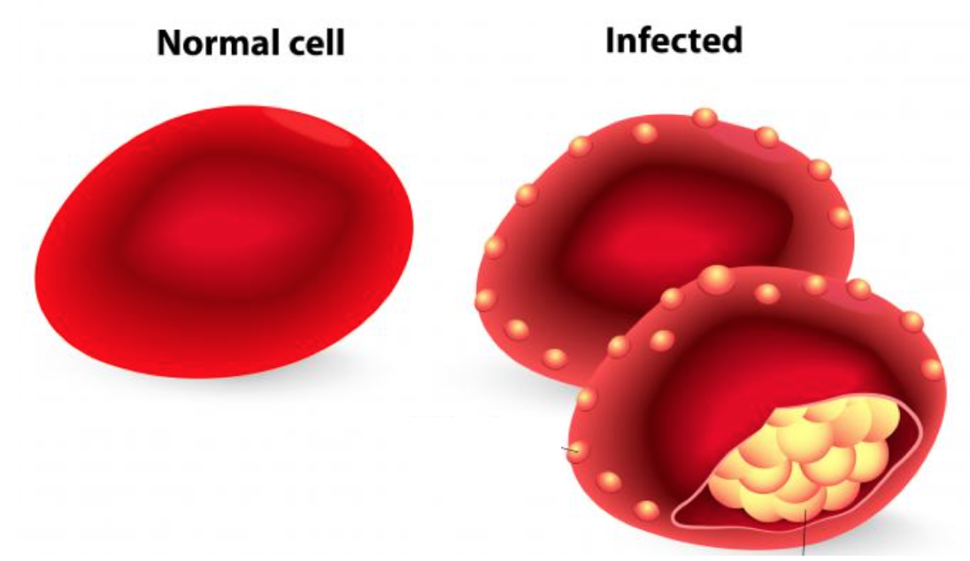
Three Big Killers

