BUILDING RESILIENCE

Exercise 1
Think of someone who is resilient.
What are they thinking? What are they doing? How are they feeling?

Exercise 2
Reflect on these areas and write something to change, something to think about, or something to revisit at a later date
Life basics
Sleep, exercise, diet, leisure, environment
Belonging
Relationships, influence and control
Learning
Organised, life skills, planning
Core self
Talents, improvements, emotional intelligence, likes/dislikes

Exercise 3
What are you fearful of? What worries you?

Plan for later
DO SOMETHING!
Nothing can be done
Does it need action now?
Does it need action?
It’s important
It’s imagined / not important now
Does this thought need attention?
It will still arrive…it just needs managing
CHALLENGE
FEAR
SETBACK
WORRY IS JUST A PROTECTIVE THOUGHT FROM
16

Exercise 4
Short term: Cool down Long term: Perspective
Happy place Learn from failure
Shift your mind-set
Comment on how you can build your own ‘bouncebackability’.
Do you know the best ways to cool down?
Complete the sentence: What would ______________ do? It might help to think back to Exercise 1.

Exercise 5
Are there any thoughts you have where you can shift your mind-set? Look back at Exercise 3, can you think about this in a different way?
When have you failed? What can you learn from it? Use the graphic below to help you.
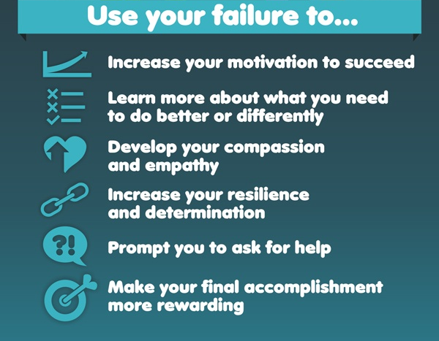

innerdrive.co.uk

