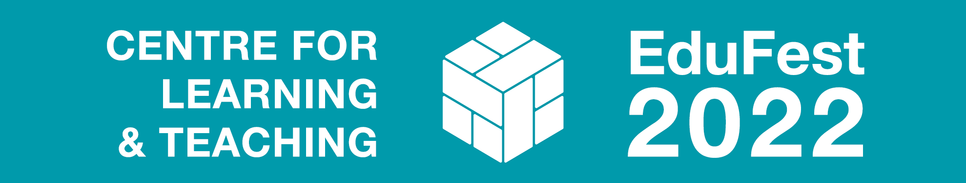

Call for participation
Theme: Assessment & Feedback
High quality assessments and feedback are central to an excellent education. However, they also place a heavy burden on staff and students. Debates around the purpose and design of assessments are not new, but the last two years have provided an opportunity to move away from traditional models of both assessment and feedback. Having transitioned swiftly into different forms of online and blended teaching, learning and assessment, we have an opportunity to reflect on how we can take our best practice forward to benefit everyone in our University community.

Call for participation: To learn from and celebrate the excellent work carried out here at the University of Bath, we are inviting colleagues to submit proposals that reflect on these challenges for Talking Points and Lightning Talks we would be particularly interested in;
- Examples of innovative forms of assessment, moving away from the more traditional essays and closed book exams.
- Examples of successful AFL (assessment for learning)
- Different forms of feedback and feedforward
- Strategies for increasing the impact and efficiency of feedback/ feedforward.
- As well as assessment and feedback we would also welcome presentations around other teaching and learning themes.
As part of EduFest you will get to hear from some of our TDF project holders, NTFs and other current teaching and learning initiatives.
Please complete the form below and send electronically to clt@bath.ac.uk by 5pm on Monday 28 March 2022.
Name(s)
Department
Contact email
(Lead presenter)
Session title
Session type (please tick) | 5-min Lightning Talk  ☐ | 30-min Talking Point: 15-min conference-style paper detailing innovation in practice, ongoing pedagogical research and policy developments + 15 minutes Q & A  ☐
Theme(s) this session is relevant to (tick all that apply) | Innovative forms of assessment |  | ☐
 | Successful assessment for learning |  | ☐
 | Forms of feedback and feedforward |  | ☐
 | Impact and efficiency of feedback/ feedforward. |  | ☐
 | Other Learning & Teaching themes |  | ☐
Session/poster abstract
(max. 200 words)
Session requirements

