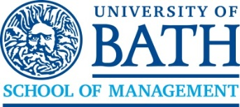
Doctor of Business Administration (DBA)
Higher Education Management

The DBA Scholarship Fund Application Form - Entry November 2025

Each scholarship application will undergo a single review by a scholarship committee, following the submission of your application. The deadline date for consideration of a scholarship will be on, 28 February 2026, 31 May 2026, 31 August 2026

Only scholarship forms submitted and uploaded at the point of application will be considered.

Surname: Application Date:
Forenames: Application Number:

While we deliberately keep the DBA cohort small to ensure a level of individual attention appropriate to a doctoral study, we actively cultivate cohort diversity through our scholarship programme. We aim to bring together candidates from every corner of the globe and higher educational environment. This generates a high-quality learning experience with the cohort drawing on a wide range of cultural backgrounds, insight from different education systems and experiences from outside the HE sector.

With the above in mind, in no more than 500 words, please summarise your case for a scholarship. Each application is reviewed by a panel of faculty members considering the following criteria:

- The contributions you will make to research and practice through the DBA
- Evidence of financial need or other adversity that might otherwise prevent you from participating in the DBA
- Partnership with the University of Bath, the School of Management, and its international activities
- The contribution you will make to the diversity of the programme

Application Statement

