

HEALTH & SAFETY HANDBOOK
High Hazard
Departments
2019/20

Department of

CONTENTS

1. Introduction 3
2. In an Emergency 4
Fire Evacuation 4
Invacuation 5
First Aid 5
Flood/Leak 5
Service Failure 5
3. University Health & Safety Law 6
Health & Safety Policy 6
Activity Specific Policies 6
Law Poster 6
4. Roles & Responsibilities 7
Department 7
University 7
5. Contacts 8
6. Planning and Implementation 9
Risk Assessment 9
Expectant or Nursing Mothers 9
Placements and Fieldwork 10
Fire Risk Assessment 10
Electrical Equipment 10
Out of Hours/Lone Working 10
Display screen equipment 11
Stress Management 11
Asbestos 11
Manual Handling 11
Smoking 11
Health Surveillance 11
7. Monitoring 12
Reporting Accidents and Incidents 12
Inspections 12
Health & Safety Committee 12
8. Review and Audit 12
9. Declaration 13

Introduction

Message from the Head of Department/Director:

In an Emergency

Never put yourself or others in danger. If in doubt - contact Security.

Fire Evacuation
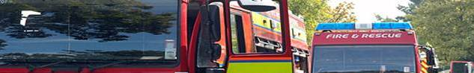
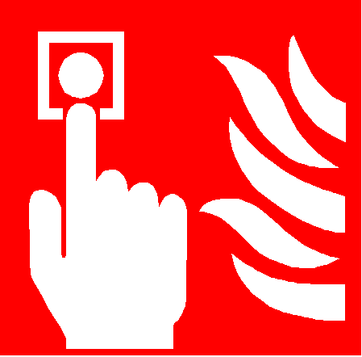 | If you discover a fire (or other emergency situation) raise the alarm by operating the nearest break-glass call point and dial 666 from an internal phone or 01225 383999 from a mobile. Provide details of your location and the exact location of the fire.
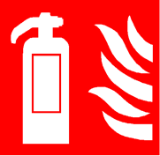 | Do not attempt to fight the fire unless you have been trained and are confident to do so. Otherwise you must evacuate the building immediately and report your actions to the Fire Warden or Evacuation Controller at the assembly point.
 | If you are in the building when the fire alarm is activated you must leave immediately by the nearest exit and go directly to the assembly point. Ensure all visitors are escorted out of the building by their hosts.  Further information on fire safety is available on the University’s website. Fire Safety training is mandatory for all members of staff and recommended for all students.
 | If you have impaired mobility/sight/hearing impairment, then please ask your line manager / supervisor / tutor to help you produce a PEEP (Personal Emergency Evacuation Plan). The plan will identify how you will be evacuated in the event of an emergency for which a number of different measures may be implemented including the assignment of a buddy. Key members of staff where you regularly work should be provided with a copy of your PEEP by your line manager or supervisor, together with Security and the University Health, Safety & Environment Service (UHSE).
 | Fire Escape Routes – must be kept clear of combustible material and stored items to ensure that they remain fully accessible and free from sources of ignition. All fire doors must be maintained self-closing at all times and not wedged open for any reason unless by an approved device.
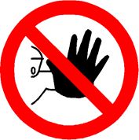 | Do not attempt to use a lift during an evacuation unless you are disabled and it is a designated evacuation lift. Do not stop to collect personal belongings.
 | Good housekeeping - can lower the chances of a fire starting.  - Empty bins regularly  - Avoid the accumulation of combustible material  - Turn equipment off at the wall at the end of the working day  - Keep cables tidy
Please insert a map of your building and assembly point clearly marked

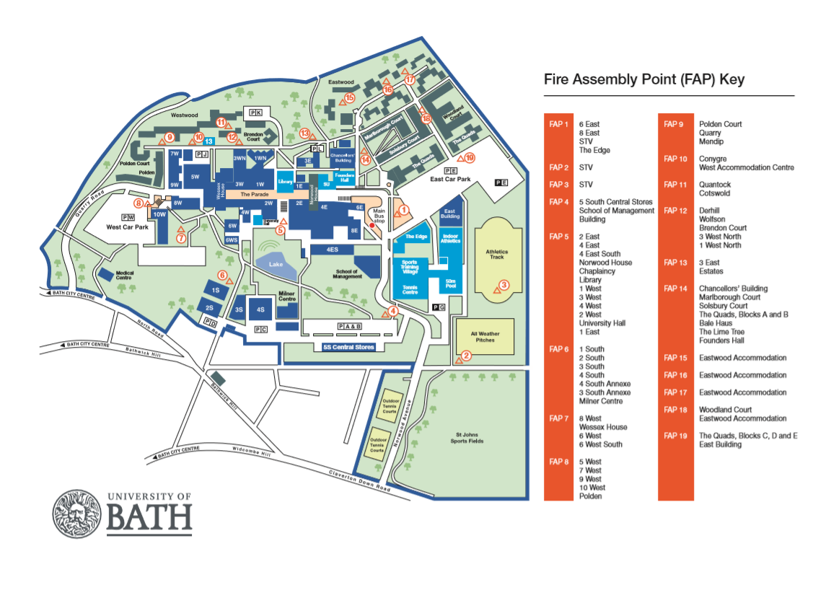
Fire extinguishers - are available for use by trained staff who feel confident to use them. However you should never do anything which puts you or anyone else at risk. If you cannot put out the fire with one extinguisher then evacuate and call Security. If you do decide to fight the fire, ensure you use the correct extinguisher for the material on fire because using the wrong one could make the fire much worse.
IF IN DOUBT - GET OUT!

Fire Wardens –
- Nominated by the Department and fully trained
- Role is to help everyone evacuate the building safely
- Identifiable by their high-visibility vests

Dangerous Substances – Materials which are highly flammable, oxidising or potentially explosive. Specific precautions, including adequate ventilation, are required when handling and storing dangerous substances to minimise the possibility of an incident. These precautions and additional controls must be identified through a DSEAR risk assessment.

Waste – can contribute to the risk of fire and the spread of disease.
- Remove and dispose of regularly.
- Combustible waste must not be allowed to accumulate in high risk areas such as laboratories and workshops
- Correct procedures must be followed for the disposal of specific hazardous waste.
- Do not over-stock

Invacuation
There may be rare occasions when the invacuation alarm is activated. This will require you to enter the nearest safe, (i.e. not on fire) building. Further details.
Invacuation training is available on Moodle.


First Aid
If you or someone around you becomes injured please contact your nearest first aider or ring Security on 666. Further information about first aid and incident reporting is on the University’s website

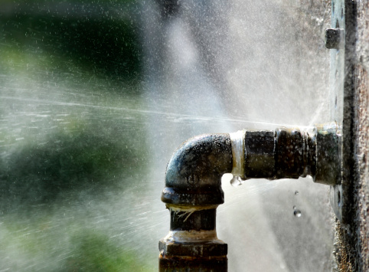
Flood/Leak
If you can stop the leak safely then do so, inform the Technical Manager/security. Warn people in the rooms below to safeguard papers and equipment.

If there is electrical equipment in the vicinity of the water do not attempt to move it or to wade through any water until the mains has been switched off and declared safe by a competent member of Estates or Departmental technical staff (where applicable).

Service Failure
If there is an electricity or equipment failure during working hours, contact the Technical Manager (if applicable)/Security (5349).

University Health & Safety Law

Health & Safety Policy
The University recognises and accepts its legal responsibility as an employer to provide a safe and healthy workplace for its staff, students and visitors. It has produced a number of Health and Safety policies in respect to its activities, all of which include an interpretation of legislation plus roles and responsibilities. These are important documents which must be followed.

It is the responsibility of all employees and students to ensure they don’t do anything which would be detrimental to their own health and safety or that of others. They must also cooperate with the University in respect of health and safety and not interfere or otherwise damage any equipment provided for the purpose.

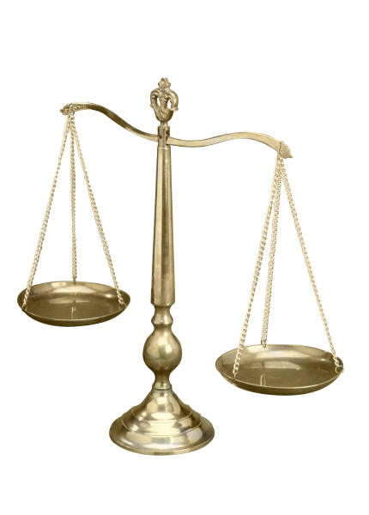

Law Poster
Basic information about health and safety law and what you can expect from the University is available via easy to understand leaflets which are available in large print, easy-read and audio.

Responsibilities

Department
- Develops suitable local arrangements to ensure compliance with legislation and University policy.
- Assesses the risk of its work based activities and records the significant findings.
- Identifies and implements suitable and sufficient measures to control the risk to as low as reasonably practicable.
- Ensures adequate training including induction training, instruction, information and supervision is provided to those engaged in work activities and for whom the Department has responsibility.
- Carries out regular Health & Safety inspections.
- Monitors and reviews local arrangements in place.

Health and Safety Policy – Arrangements and Organisation

Security
- Provides a first response service in respect of any Health & Safety related incident.
- Attends all alarm activated fires, carries out limited fire-fighting and determines when or if the Fire & Rescue Service are called.
- Provides first aid.

University Health Safety & Environment Service
- Provides specialist Health & Safety advice to the University including construction safety, fire safety, radiation safety, occupational health.
- Develops core policies, procedures and process in line with legislation and a recognised health and safety management system.
- Monitors the health and safety performance of the University and all Departments using audits, inspections and fundamental reviews.
- Develops and provides a range of generic health and safety training.
- Monitors health and safety related incidents, near misses and dangerous occurrences, ensuring they are fully investigated and reported.
- Provides a key point of contact with enforcement agencies in respect of fires and associated inspections; serious incident investigations and inspections.
- Cooperates with enforcement and government bodies to ensure compliance in respect chemical, biological and radiological safety, maintaining relevant permits and providing regular reports to them as necessary.
- Authority to take appropriate action as necessary to remedy any situation in which there is a serious and imminent risk to safety and/or health.

Contacts

Department

Head of Department

Deputy HoD

Technical Manager

H&S Coordinator/Officer

Radiation Protection Supervisor

Department Laser Safety Supervisor

First Aiders | Security | 666
Fire Wardens

University Health Safety & Environment Service (UHSE)

All Enquiries: | UHSE@lists.bath.ac.uk
Head of Health, Safety & Environment | Mr Chris Young | WH 3.16 Ext 4839  R.C.Young@bath.ac.uk
Scientific Safety Adviser | Mrs Debbie Robarts | WH 3.12 Ext 6542  D.J.Robarts@bath.ac.uk
Fire Safety Adviser | Mr Mark Burton | WH 3.12 Ext 5171  M.C.Burton@bath.ac.uk
Health & Safety Adviser (Performance & Monitoring) | Mr Paul Maggs | WH 3.12 Ext 6491  C.P.Maggs@bath.ac.uk
Health & Safety Adviser (Health & Wellbeing) | Ms Amanda Chapman | WH 3.12 Ext 4751  A.Chapman2@bath.ac.uk
Hazardous Waste Manager | Mr Russel Barlow | 1S 0.58 Ext 3297  waste@lists.bath.ac.uk
UHSE Admin Support | Mrs Marcia Martin | WH 3.12 Ext 4088  M.A.Martin@bath.ac.uk

Planning and Implementation

Risk Assessment

Hazard – anything which has the potential to cause harm

Risk – likelihood that harm will be caused by the hazard together with the severity of that harm.

Before any activity takes place, an assessment of risk must be made. If those risks are identified as significant they need to be recorded using the University template. The template includes a colour coded risk matrix in which the likelihood and severity of the risk is assessed. Risk assessment guidance and template:

Expectant or Nursing Mothers

Some hazards may have a greater impact on pregnant and breast feeding mothers.

If you become pregnant, you should inform your Supervisor or line manager IN WRITING. A personal Risk Assessment will then be undertaken to identify any additional control measures needed.

Children and Young People

Children under the age of 16 years are more vulnerable to the impact of some hazardous activities due to their physical immaturity, lack of knowledge and experience. They must therefore be supervised at all times and are not permitted into areas of potential high risk such as laboratories and workshops unless as part of an agreed University Open Day during which high risk activities must not take place.

A Young Person is anyone between the age of 16 and 18 years old. Any activity based risk assessment must take account of their potential physical and emotional immaturity, lack of knowledge and experience so that additional controls can be implemented to minimise risk exposure.

Placements, Fieldwork and Working off-site

The Head of Department is responsible for the health and safety issues arising from departmental activities. This includes activities that the department organises away from University premises such as fieldwork or placements and working off site. An assessment of the risks likely to be encountered must be made, and any additional control measures required identified and implemented as far as is reasonably practical, bearing in mind the limitations of the University’s control.

Fire Risk Assessment

The University has a programme of Fire Risk Assessments which ensures that each building is assessed annually if high risk and a minimum of every three years for low risk. The Fire Risk Assessments are carried out by the University’s Fire Safety Adviser following both, legislation and best practice guidance.

Electrical Equipment

Under no circumstances should any electrical apparatus be used if it is damaged or if there are any doubts as to its safety.

All electrical equipment must be tested by a competently trained person to ensure it is safe unless the equipment is of low risk and within a low risk environment in which case regular inspections will suffice. Portable equipment must carry a sticker stating the last date of testing. Never use equipment which has failed testing. All electrical equipment should be the subject of regular visual inspections by users of it, to proactively identify any defects or damage which might impair its safety.

Extension leads should be avoided if at all possible. If there is no other option then please ensure you do not use them for high wattage equipment such as kettles and ovens. Each extension lead must be subject to PAT and treated as an electrical appliance for this purpose. Only use equipment for the purpose intended.

Out of Hours/Lone Working

During normal working hours (8.00 am-6.00 pm) the University is able to provide a safe environment for people to work in. Out of those hours, less assistance is available from specially trained staff, e.g. specially trained First Aiders and Fire Wardens. Consequently, additional precautions must be taken when out of hours working becomes necessary, and there is a significant possibility of the person concerned becoming incapacitated or having a heart attack.

Display screen equipment

Workstations should be set up ergonomically to prevent musculoskeletal ailments and eye strain. Any member of staff who habitually uses a workstation must therefore complete a workstation assessment. Each Department must ensure that they identify and train a Workstation Assessor who can support those carrying out a self-assessment. Workstation Assessment Training is available from the website.

Wellbeing

The University follows the Whole University approach to securing wellbeing. A range of tools have been produced to help people manage their wellbeing.

Managing Contractors
You are responsible for ensuring that any contractors working under your control are managed in accordance with the University's Management of Contractor Policy. In particular, you must:

- Only use competent contractors

- Make sure that all contractors receive an appropriate induction. We have developed a generic contractor induction presentation that you can use for this purpose. You can add further information about local hazards or local rules where applicable.

- Gain advanced approval from Estates before you allow any work to be carried out on building fabric, services or infrastructure. Note - this requirement applies to any work carried out by departmental staff, too.

- monitor your contractors at suitable intervals to make sure that they are working as agreed.

- report any accidents, incidents or near misses on the online incident form

Asbestos
Any building which was built prior to 2000 could contain asbestos.
- Do not drill, screw, unscrew or otherwise penetrate the fabric of the building

If any work to the building is required or if you suspect that asbestos has been disturbed then please contact the Estates Department. Awareness training is available via Moodle.

Manual Handling

Activities involving the manual handling of large, heavy or awkward materials and equipment must be assessed for risk to take into account the task, individual, load and the environment. If the activity involves twisting while holding the load, repetitive lifting, lowering or carrying over a long distance, then the risk of injury increases. Training for manual handling assessors and for staff whose roles involve manual handling activities is available from the Safety, Health and Employee Wellbeing Service.

Smoking

It is illegal to smoke in any building and it is University Policy not to permit smoking in the immediate vicinity of a building or on the Parade.

Health Surveillance

Health surveillance, initially via questionnaire, is carried out on an annual basis by the University Health, Safety & Environment Service for night workers and those who may be have potential allergen exposure or Dermatitis risk. If you feel that you might be at risk then please inform your line manager or supervisor

Laboratories and Workshops

Additional safety precautions are necessary in laboratories and workshops because of the potential risks posed by the hazards likely to be present. Admittance to these areas is not permitted until a suitable induction has been completed.

Biological Safety

Any work involving microbiological and genetically modified organisms, human and animal tissues (including cell cultures), blood and other bodily fluids, human endo-parasites and hazardous plant material, must comply with legislation and University Policy. Detailed guidance is available on the web

Chemical Safety

It is a legal requirement under current CoSHH legislation that an assessment of health risk is made prior to any handling of chemical material.

Some work involving chemical substances pose a higher risk than others. There are further resources available online.

Radiation and Laser Safety

Anyone undertaking work involving the use of ionising radiations MUST register with the Scientific Safety Manager and consult with the Department Radiation Protection Supervisor.

Anyone intending to work with lasers must contact the Department Laser Safety Supervisor prior to carrying out any laser work. Work must be carried out in accordance with the University’s laser safety guidance.

Nanoparticles

The risk of using some nanotechnologies for research purposes is still not fully understood which is why protective measures identified within University guidance must be followed.

Gas Safety

Gas cylinders must be stored, transported and used in ways which reduce the risk of contamination, gas release or impact which could result in serious injury. Training must be completed satisfactorily before any attempt is made to examine, fill, use or move gas cylinders. For further advice contact the Hazardous Waste Manager

Waste Disposal

The disposal of any waste material forms part of the CoSHH assessment which should be completed before any such work is carried out.

Dangerous materials must always be made safe before disposal but if this is not possible, the Hazardous Waste Manager must be informed. Details are available on the website.
Monitoring

Reporting Accidents and Incidents

Incidents or accidents are defined as unplanned events which either did cause, or had potential to cause injury or damage to apparatus, equipment or buildings. All incidents or near misses must be reported.

There are several reasons for reporting incidents but the main one is to enable a full investigation to be carried out so that the cause can be identified and measures implemented to prevent a reoccurrence. The aim is not to apportion blame.

Inspections

Departmental safety inspections should be carried out routinely to ensure that good Health & Safety practice is being followed. The results of these inspections should identify any need for action and thus should be reviewed regularly to ensure that any such action has been undertaken and has been effective. If anyone has a Health & Safety concern about any aspect of the University they should in the first instance, inform the relevant Department although they can if they prefer, contact the University Health, Safety & Environment Service direct.

Health & Safety Committee

Each Department should have its own Committee to which any Health & Safety matter can be referred. The committees of high risk Departments should meet at least three times a year. The key points from all meetings should be recorded and any actions identified from them, should be monitored.

Each professional member of the University’s Health, Safety & Environment Service has been allocated to a specific Department or Faculty which means that they receive a copy of the minutes and attend the Departmental meetings whenever possible.

Any matters which cannot be resolved at Departmental level can be escalated to the University Health & Safety Committee.

Review and Audit

Departmental or activity specific audits will be carried out by the University Health, Safety & Environment Service on a programmed basis to ensure that all buildings on campus are audited within a five year cycle. High risk areas will be subject to more rigorous attention and likely to take place more frequently than every five years.

The Head of Department together with other key departmental personnel may upon request, assist or accompany the lead auditor.

Declaration

I have received, read and understood a copy of the HEALTH & SAFETY HANDBOOK which governs my activities in the University and more specifically within this Department. I agree to work to the standards and guidance it contains.
Last name: ……………………………………………………………………………….…..
First name: …………………………………………………………………………….……..
Staff Student Visitor
If a member of staff please provide job title: …………………………………………...…
Supervisor: ..................................................................................................................
Signature: ....................................................................................................................
Date: ............................................................................................................................
When complete this declaration must be returned to

