

HEALTH & SAFETY HANDBOOK
High Hazard
Departments
2023/24

Department of

CONTENTS

1. Introduction 3
2. In an Emergency 4
Fire Evacuation 4
Invacuation 5
First Aid 5
Flood/Leak 5
Service Failure 5
3. University Health & Safety Law 6
Health & Safety Policy 6
Activity Specific Policies 6
Law Poster 6
4. Roles & Responsibilities 7
Department 7
University 7
5. Contacts 8
6. Planning and Implementation 9
Risk Assessment 9
Expectant or Nursing Mothers 9
Placements and Fieldwork 10
Fire Risk Assessment 10
Electrical Equipment 10
Out of Hours/Lone Working 10
Display screen equipment 11
Stress Management 11
Asbestos 11
Manual Handling 11
Smoking 11
Health Surveillance 11
7. Monitoring 12
Reporting Accidents and Incidents 12
Inspections 12
Health & Safety Committee 12
8. Review and Audit 12
9. Declaration 13

Introduction

Message from the Head of Department/Director:

In an Emergency

Never put yourself or others in danger. If in doubt - contact Security.

Fire Evacuation

 | If you discover a fire (or other emergency situation) raise the alarm by operating the nearest break-glass call point and dial 666 from an internal phone or 01225 383999 from a mobile. Provide details of your location and the exact location of the fire.
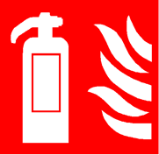 | Do not attempt to fight the fire unless you have been trained and are confident to do so. Otherwise you must evacuate the building immediately and report your actions to the Fire Warden or Evacuation Controller at the assembly point.
 | If you are in the building when the fire alarm is activated you must leave immediately by the nearest exit and go directly to the assembly point. Ensure all visitors are escorted out of the building by their hosts.  Further information on fire safety is available on the University’s website. Fire Safety training is mandatory for all members of staff and recommended for all students.
 | If you have impaired mobility/sight/hearing impairment, then please ask your line manager / supervisor / tutor to help you produce a PEEP (Personal Emergency Evacuation Plan). The plan will identify how you will be evacuated in the event of an emergency for which a number of different measures may be implemented including the assignment of a buddy. Key members of staff where you regularly work should be provided with a copy of your PEEP by your line manager or supervisor, together with Security and the University Health, Safety & Environment Service (UHSE).
 | Fire Escape Routes – must be kept clear of combustible material and stored items to ensure that they remain fully accessible and free from sources of ignition. All fire doors must be maintained self-closing at all times and not wedged open for any reason unless by an approved device.
 | Do not attempt to use a lift during an evacuation unless you are disabled and it is a designated evacuation lift. Do not stop to collect personal belongings.
 | Good housekeeping - can lower the chances of a fire starting.  - Empty bins regularly  - Avoid the accumulation of combustible material  - Turn equipment off at the wall at the end of the working day  - Keep cables tidy
Please insert a map of your building and assembly point clearly marked

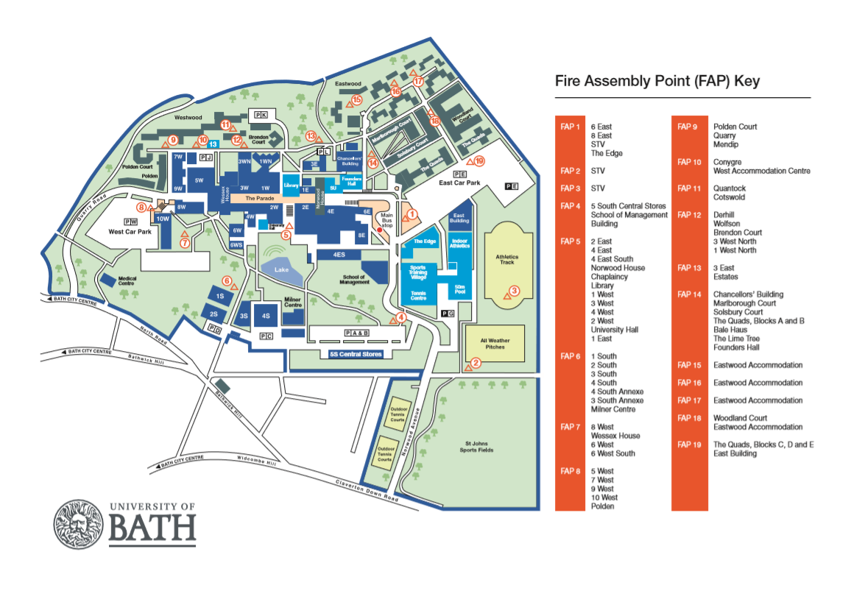
Fire extinguishers - are available for use by trained staff who feel confident to use them. However you should never do anything which puts you or anyone else at risk. If you cannot put out the fire with one extinguisher then evacuate and call Security. If you do decide to fight the fire, ensure you use the correct extinguisher for the material on fire because using the wrong one could make the fire much worse.
IF IN DOUBT - GET OUT!

Fire Wardens –
- Nominated by the Department and fully trained
- Role is to help everyone evacuate the building safely
- Identifiable by their high-visibility vests

Dangerous Substances – Materials which are highly flammable, oxidising or potentially explosive. Specific precautions, including adequate ventilation, are required when handling and storing dangerous substances to minimise the possibility of an incident. These precautions and additional controls must be identified through a DSEAR risk assessment.

Waste – can contribute to the risk of fire and the spread of disease.
- Remove and dispose of regularly.
- Combustible waste must not be allowed to accumulate in high -risk areas such as laboratories and workshops
- Correct procedures must be followed for the disposal of specific hazardous waste.
- Do not over-stock

Invacuation
There may be rare occasions when the invacuation alarm is activated. This will require you to enter the nearest safe building. Alerts are sent out via Safe Zone and through messages direct to networked PCs.


First Aid
If you or someone around you becomes injured please contact your nearest first aider or ring Security on 666. Further information about first aid and incident reporting is on the University’s website

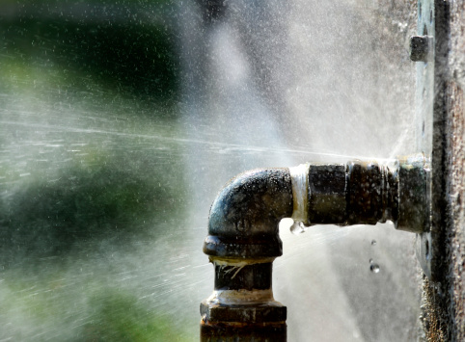
Flood/Leak
If you can stop the leak safely then do so, inform the Technical Manager/security. Warn people in the rooms below to safeguard papers and equipment.

If there is electrical equipment in the vicinity of the water do not attempt to move it or to wade through any water until the mains has been switched off and declared safe by a competent member of Campus Infrastructure or Departmental technical staff (where applicable).

Service Failure
If there is an electricity or equipment failure during working hours, contact the Technical Manager (if applicable)/Security (5349).

University Health & Safety Policy

Health & Safety Policy
The University recognises and accepts its legal responsibility as an employer to provide a safe and healthy workplace for its staff, students and visitors. It has produced a number of Health and Safety policies in respect to its activities, all of which include an interpretation of legislation plus roles and responsibilities. These are important documents which must be followed.

It is the responsibility of all employees and students to ensure they don’t do anything which would be detrimental to their own health and safety or that of others. They must also cooperate with the University in respect of health and safety and not interfere or otherwise damage any equipment provided for the purpose.



Law Poster
Departments are responsible for making sure that their staff members have access to required general health and safety information. Most departments display the Health and Safety Law poster in their buildings. You can also access key information by downloading the Health ad Safety Executive’s free health and safety leaflet. Copies are available in large print and easy to read formats.

Health & Safety Standards, Guidance and Procedures

The University’s Safety, Health and Employee Wellbeing website provides links to a variety of policies, procedures and standards that may apply to your work. You can also find work-related health and safety information on the Health and Safety Executive’s website.

- Roles & Responsibilities

Department
Your department is responsible for:

- Developing suitable local arrangements to ensure compliance with legislation and University policy.
- Assessing the significant risks of its work-based activities.
- Identifying and implementing suitable and sufficient measures to control the risk to a level that is as low as reasonably practicable.
- Recording the significant findings of these risk assessments.
- Ensuring that you have adequate training, including induction training, instruction, information and supervision to carry out your work activities safely.
- Carrying out regular Health & Safety inspections of your workplace.
- Monitoring and reviewing the local arrangements in place to safeguard your health, safety and wellbeing.

You can read more about the University’s health and safety policy here: Health and Safety Policy – Arrangements and Organisation

Heads of Department have specific responsibilities for managing health and safety in their department. These are described in the Manage health and safety in your department web pages.

Security
The University’s Security service:
- Provides a first response service in respect of any Health & Safety related incident.
- Attends all alarm activated fires, carries out limited fire-fighting and determines when or if the Fire & Rescue Service are called.
- Provides first aid.

University Safety, Health & Employee Wellbeing Service (SHEW)
SHEW provides competent advice on health, safety and wellbeing matters. We are responsible for:
- Providing specialist Health & Safety advice to the University including in specialist areas such as construction safety, fire safety, radiation safety, occupational health.
- Developing core policies, standards, procedures and processes, in line with legislation and a recognised health and safety management system.
- Monitoring the health and safety performance of the University and all Departments using audits, inspections and reviews.
- Developing and facilitating a range of generic health and safety training.
- Investigating health and safety related incidents, near misses and dangerous occurrences, ensuring they are fully investigated and reported.
- Providing a key point of contact with enforcement agencies in respect of fires and associated inspections; serious incident investigations and inspections.
- Cooperating with enforcement and government bodies to ensure compliance in respect chemical, biological and radiological safety, maintaining relevant permits and providing regular reports to them as necessary.
In addition to these general duties, SHEW has delegated authority to take appropriate action as necessary to remedy any situation in which there is a serious and imminent risk to safety and/or health.

Contacts

Department

Head of Department

Deputy HoD

Technical Manager

H&S Coordinator/Officer

Radiation Protection Supervisor

Department Laser Safety Supervisor

First Aiders | Security | 666
Fire Wardens

The University’s Safety, Health & Employee Wellbeing Service (SHEW)

All Enquiries: | shew@bath.ac.uk
Deputy Director Safety & Wellbeing Services | Mr Chris Young | WH 3.16 Ext 4839  rcy20@bath.ac.uk
Scientific Safety Adviser | Mrs Debbie Robarts | WH 3.12 Ext 6542  djr54@bath.ac.uk
Fire Safety Adviser | Mr Mark Burton (Mon-Wed) | WH 3.12 Ext 5171  mcb52@bath.ac.uk
Health & Safety Adviser (Performance & Monitoring) | Mr Paul Maggs | WH 3.12 Ext 6491  adscpm@bath.ac.uk
Hazardous Waste Manager | Mr Russel Barlow | 1S 0.58 Ext 3297  waste@lists.bath.ac.uk
Staff Health & Wellbeing Manager | Ms Heather Girling | 2 South 1.09 Ext 4669  hlg43@bath.ac.uk
SHEW Admin Support | Mrs Marcia Martin | WH 3.12 Ext 4088  adsmam@bath.ac.uk

Planning and Implementation

Risk Assessment

Hazard – anything which has the potential to cause harm

Risk – likelihood that harm will be caused by the hazard together with the severity of that harm.

Before any work activity takes place, a risk assessment needs to be carried out. If the risks identified are considered to be significant, then steps must be taken to reduce risks as low as is reasonably practicable. Risk assessments should ideally be recorded on the University risk assessment template. The template includes a colour coded risk matrix in which the likelihood and severity of the risk is assessed. Your line manager is responsible for making sure that you have seen and understood the risk assessments for the work you will be doing.

You are responsible for following risk assessments including implement any control measures that are identified in the assessment. If you are unable to do so, then you should not carry out the task but instead speak to your line manager for guidance.
You can find more information on risk assessments on the Risk assessment guidance webpages.

Expectant or Nursing Mothers

Some hazards may have a greater impact on pregnant people and new mothers.

If you become pregnant, you should inform your Supervisor or line manager IN WRITING. This should also be notified to Human Resources. Your line manager is responsible for carrying out a personal risk assessment with you to identify there are any additional control measures needed to protect you and your unborn child.

Children and Young People

Children under the age of 16 years are more vulnerable to the impact of some hazardous activities due to their physical immaturity, lack of knowledge and experience.

If you are responsible for supervising children or young people in the workplace, then you must ensure that they are supervised at all times and are not permitted into areas of potential high risk such as laboratories and workshops, unless this access has been agreed as part of an University Open Day. High risk activities must not take place whilst such visits are in progress.

A Young Person is anyone between the age of 16 and 18 years old. Any activity-based risk assessment must take account of their potential physical and emotional immaturity, lack of knowledge and experience so that additional controls can be implemented to minimise risk exposure.

Placements, Fieldwork and Working off-site

Departments are responsible for your health and safety issues if you are working away from the main campus. This includes activities that the department organises away from University premises such as fieldwork or placements and working off site. An assessment of the risks likely to be encountered must be made, and any additional control measures required identified and implemented as far as is reasonably practical, bearing in mind the limitations of the University’s control. You are responsible for following the agreed risk assessments and implementing any agreed control measures.

As with all risk assessments, if you have any concerns that risks have not been adequately controlled then you should stop carrying out the task 9where it is practical to do so) and discuss with your line manager.

Fire Risk Assessment

The University has a programme of Fire Risk Assessments which ensures that each building is assessed annually if high risk and a minimum of every three years for low risk. The Fire Risk Assessments are carried out by the University’s Fire Safety Adviser following both legislation and best practice guidance.

Any issues identified during the Fire Risk Assessment will be shared with Campus Infrastructure and/or the Head of Department to enable these to be resolved.

Electrical Equipment

Under no circumstances should any electrical apparatus be used if it is damaged or if there are any doubts as to its safety.

Departments are responsible for making sure that all of their electrical equipment is safe to use. All electrical equipment must be tested by a competent, trained person to ensure it is safe unless the equipment is of low risk and used within a low-risk environment in which case regular user inspections will suffice. Portable equipment must carry a sticker stating the last date of testing. Never use equipment which has failed testing.

Users should carry out regular visual inspections of the equipment they use so that any defects or damage which might pose a significant risk can be easily identified. Suggested periods for checking of equipment are provided in the HSE’s publication Managing Portable Electrical Equipment. If you work from home, then you will be required to periodically carry out check of any electrical equipment provide by the University. SHEW has issued guidance to assist you with this.

The use of extension sockets should be avoided where it is practicable to do so. If there is no other option, then please ensure you do not use them for high wattage equipment such as kettles and ovens. Extension leads must not be daisy chained or sockets overloaded. Each extension socket must be subject to PAT and treated as an electrical appliance for this purpose. Only use equipment for the purpose intended.

Out of Hours/Lone Working

During normal working hours (8.00 am-6.00 pm), the University has arrangements in place to ensure that additional support is widely available to assist Security to manage incidents and emergencies. Outside of those hours, less assistance may be available from additional trained staff, such as First Aiders and Fire Wardens.

Risk assessments for lone working and out of hours working should consider the risks involved in the work being carried out and how these will be reduced to a tolerable level. Line managers are responsible for making sure that assessments are carried out, but they may ask you to assist with this. In addition to the task, risk assessments should consider likelihood of someone requiring emergency assistance or support If you are required to lone work, or to work outside of normal hours, please read the guidance on the additional precautions that must be taken to ensure that such work is safe.

People who lone work or who work outside of normal hours are encouraged to download the free Safe Zone App. This enables people to quickly contact security f they need assistance or if they need to report any concerns that they might have.

In the event of an emergency, Security can be contacted, at any time, by landline on extension 666 or 01225 3863999 from a mobile.

Display screen equipment

Every worker who works habitually (more than an hour per working day) with a computer is generally considered to be a workstation “user”. Users are required to carry out a self-assessment of their workstation to ensure that it has been set up / adjusted correctly. You’ll find guidance on how to set up your workstation correctly on the self-assessment web pages.

Ergonomically set up workstations prevent musculoskeletal ailments and eye strain and also provide a more efficient way of working. It is equally important that you follow guidance around taking regular screen breaks.

Department are expected to identify and train a local Workstation Assessor who can support those carrying out a self-assessment. Workstation Assessment guidance is available from the website. If the self-assessment identifies any issues, then a member of SHEW will contact you to discuss potential solutions.

Wellbeing

The University follows the Whole University approach to securing wellbeing. A range of tools and resources have been produced to help people to manage their wellbeing.

The University has several support measures in place that employees can make use of. These include:
- Access to counselling services through the Royal United Hospital
- Coaching and Mentoring
- Access to the STV
- Rewards and Benefits offered to staff to support wellbeing and work-life balance

There is a network of Wellbeing Champions who are a key part of our efforts to build a wellbeing focussed culture. They have led and developed several wellbeing initiatives and can be contacted by any employee who needs support.

Managing Contractors
You are responsible for ensuring that any contractors working under your control are managed in accordance with the University's Management of Contractor Policy. You must:

- Only use competent contractors

- Make sure that all contractors receive an appropriate induction. We have developed a generic contractor induction presentation that you can use for this purpose. You can add further information about local hazards or local rules where applicable.

- Gain advanced approval from Campus Infrastructure before you allow any work to be carried out on building fabric, services or infrastructure. Note - this requirement applies to any work carried out by departmental staff, too.

- monitor your contractors at suitable intervals to make sure that they are working as agreed.

- report any accidents, incidents or near misses on the online incident form

Asbestos

Any building which was built prior to 2000 could contain asbestos. Departments are not permitted to carry out any work on building fabric or services without first having gained the express approval of Campus Infrastructure.

- You must not drill, screw, unscrew or otherwise penetrate the fabric of the building.

If any work to the building is required or if you suspect that asbestos has been disturbed then please contact the Campus Infrastructure Department. If you believe that asbestos may have been disturbed in your building please contact Security immediately on 666 or 01225 383999.

You can access basic Asbestos awareness training via Moodle.

Further information is available from the Health and Safety Executive .

Manual Handling

Activities involving the manual handling of large, heavy or awkward materials and equipment must be assessed for risk to take into account the task, individual, load and the environment. If the activity involves twisting while holding the load, repetitive lifting, lowering or carrying over a long distance, then the risk of injury increases.

Your department is responsible for ensuring that you have received appropriate training. This includes training if you are required to carry out manual handling assessments as well as specific training for any tasks that you are required to do where there is significant risk of an injury when carrying out manual handling activities.

Advice on training is available from the Safety, Health and Employee Wellbeing Service. The full requirements are described in the University’s Manual Handling Safety Standard. We have also developed a template for assessing manual handling tasks and a generic manual handling assessment for office based work.

Smoking

It is illegal to smoke in any building and it is University Policy not to permit smoking in the immediate vicinity of a building or on the Parade.

Health Surveillance

The university offers all workers Health surveillance, initially via questionnaire, on an annual basis to all night workers and those who may be at risk of allergen exposure or contracting dermatitis in the workplace. If you feel that you might be at risk, then please inform your line manager or supervisor and they will contact SHEW for advice.

Laboratories and Workshops

Additional safety precautions are necessary in laboratories and workshops because of the potential risks posed by the hazards likely to be present. Admittance to these areas is not permitted until a suitable induction has been completed. You should speak to your Technical Services manager to arrange an induction.

Biological Safety

Any work involving microbiological and genetically modified organisms, human and animal tissues (including cell cultures), blood and other bodily fluids, human endo-parasites and hazardous plant material, must comply with legislation and University Policy. Please read the detailed guidance on safe working with these materials if this is part of your job role.

Chemical Safety

It is a legal requirement under current CoSHH legislation that an assessment of health risk is made prior to any handling of chemical material. Line managers are responsible for making sure that CoSHH assessments have been completed. You are responsible for making sure that you follow those risk assessments and any associated procedures.

Some work involving chemical substances pose a higher risk than others. A detailed guide on working with chemicals is available here to help you understand the University’s policies and procedures.

Radiation and Laser Safety

Anyone undertaking work involving the use of ionising radiations MUST register with the Scientific Safety Advisor and consult with the Department Radiation Protection Supervisor.

Anyone intending to work with lasers must contact the Department Laser Safety Supervisor prior to carrying out any laser work. Work must be carried out in accordance with the University’s laser safety guidance.

If you have any concerns about work with these materials, then please contact your department’s Technical Services team in the first instance. You can also contact the University’s Scientific Safety Manager for further advice.

Nanoparticles

The risk of using some nanotechnologies for research purposes is still not fully understood. Anyone undertaking work involving nanomaterials MUST register with the Scientific Safety Advisor before any work is allowed to be carried out.

The University has developed specific guidance that must be followed. When registering your work you will be expected to show how you will comply with this requirement.

Gas Safety

Gas cylinders must be stored, transported and used in ways which reduce the risk of contamination, gas release or impact which could result in serious injury. Training must be completed satisfactorily before any attempt is made to examine, fill, use or move gas cylinders. For further advice contact your department’s Technical Services manager or the University’s the Scientific Safety Advisor.

Waste Disposal

The disposal of any waste material forms part of the CoSHH assessment which should be completed before any such work is carried out.

Dangerous materials must always be made safe before disposal but if this is not possible, the Hazardous Waste Manager must be contacted for advice.

- Monitoring

Reporting Accidents and Incidents

Incidents or accidents are defined as unplanned events which either did cause, or had the potential to cause, injury or damage to people, apparatus, equipment or buildings. All incidents or near misses must be reported.

There are several reasons for reporting incidents but the main one is to enable a full investigation to be carried out so that the cause can be identified, and measures implemented to prevent a reoccurrence. The aim is to learn lessons from such occurrences and not to apportion blame.

Inspections

Your departmental is required to carry out routine safety inspections to ensure that good Health & Safety practice is being followed. High-risk departments should inspect all department managed areas and facilities at least three times a year. Larger departments may wish to carry out more frequent inspections covering smaller areas rather than inspecting everywhere each time. This could be carried out over a number of inspections.

The results of these inspections should identify any need for action and thus should be reviewed regularly to ensure that any such action has been undertaken and has been effective. Please make sure you cooperate with people carrying out inspections. You can use these as opportunities to raise any concerns about health and safety.

If you have a Health & Safety concern about any aspect of the University, at any time, then you should speak to your line manager in the first instance. If that is difficult to do, then you can contact the University’s Safety, Health, & Employee Wellbeing Service direct for advice.

Health & Safety Committee

Each Department should have its own Committee to which any Health & Safety matter can be referred. The committees of high-risk Departments should meet at least three times a year. The key points from all meetings should be recorded and any actions identified from them, should be monitored. This should include discussion of the significant finding s of inspections and actions taken (or required) to address any areas of concern.

Each professional member of the University’s Safety, Health & Employee Wellbeing Service has been allocated to a specific Department or Faculty which means that they receive a copy of the minutes and attend the Departmental meetings whenever possible.

Any matters which cannot be resolved at Departmental level can be escalated to the University Health & Safety Committee.

Review and Audit

Departmental or activity specific audits will be carried out by the University Health, Safety & Environment Service on a programmed basis to ensure that all buildings on campus are audited within a five-year cycle. High risk areas will be subject to more rigorous attention and likely to take place more frequently than every five years.

The Head of Department together with other key departmental personnel may upon request, assist or accompany the lead auditor. You should be advised of any significant findings from these checks that might impact your work.

Declaration

I have received, read and understood a copy of the HEALTH & SAFETY HANDBOOK which governs my activities in the University and more specifically within this Department. I agree to work to the standards and guidance it contains.
Last name: ……………………………………………………………………………….…..
First name: …………………………………………………………………………….……..
Staff Student Visitor
If a member of staff please provide job title: …………………………………………...…
Supervisor: ..................................................................................................................
Signature: ....................................................................................................................
Date: ............................................................................................................................
When complete this declaration must be returned to

SHEW recommend that the declarations be kept for the year that the handbook applies to.

