 | Regulatory Reform (Fire Safety) Order 2005: Fire Risk Assessment PAS 79 Format
Building | Esther Parkin
Version | 2022/34/5
 | 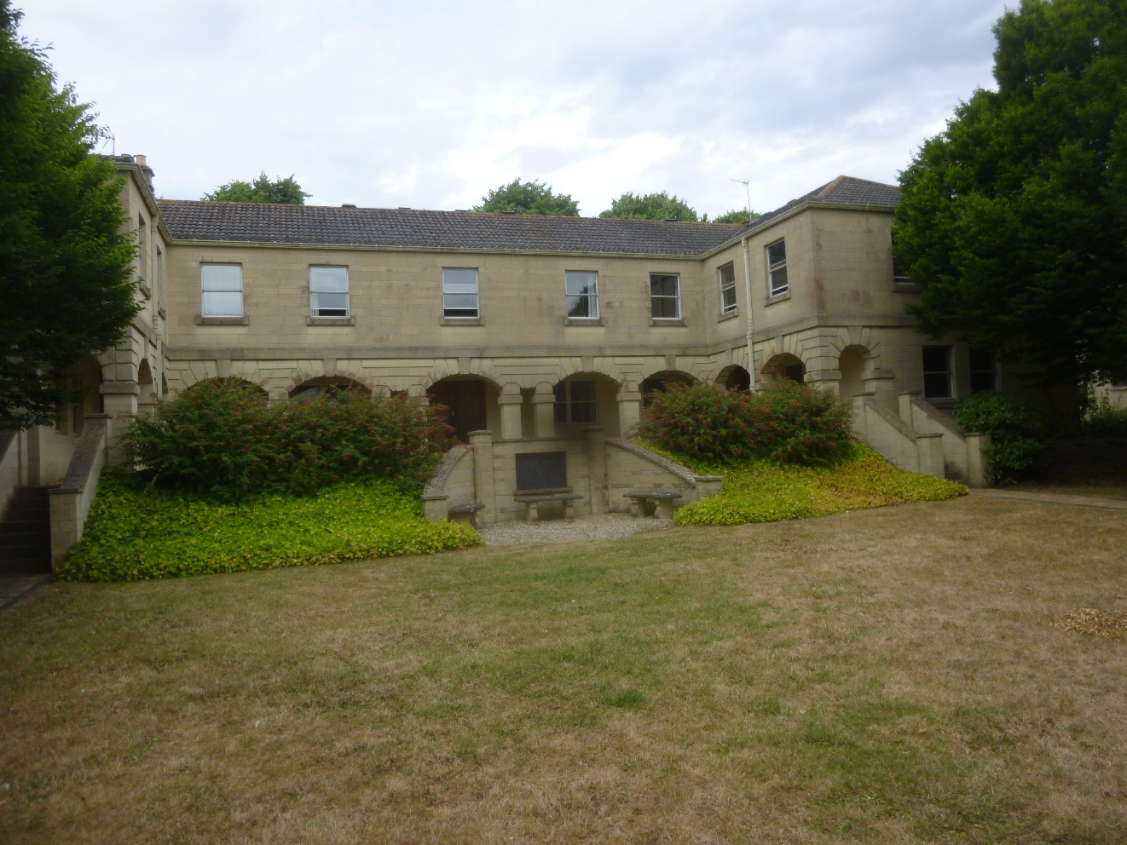
Printed | 15TH August 2022
File | 12_01_25 assessment pro forma pas79 origin.docx

Table of Contents
FILE DETAILS 3
ASSESSMENT DETAILS 3
GENERAL INFORMATION 3
The Premises 3
The Occupants 4
Occupants Especially At Risk From Fire 4
Fire Loss Experience 4
Other Relevant Information 4
Relevant Fire Safety Legislation 5
FIRE HAZARDS AND THEIR ELIMINATION OR CONTROL 6
Electrical Sources Of Ignition 6
Smoking 6
Arson 7
Portable Heaters And Heating Installations 7
Cooking 7
Lightning 8
Housekeeping 8
Hazards Introduced By Outside Contractors And Building Works 9
Dangerous Substances 9
Other Significant Fire Hazards That Warrant Consideration Including Process Hazards That Impact On General Fire Precautions 10
FIRE PROTECTION MEASURES 10
Means Of Escape From Fire 10
Measures To Limit Fire Spread And Development 12
Emergency Escape Lighting 13
Fire Safety Signs And Notices 13
Means Of Giving Warning In Case Of Fire 14
Manual Fire Extinguishing Appliances 14
Relevant Automatic Fire Extinguishing Systems 15
Other Relevant Fixed Systems And Equipment 15
MANAGEMENT OF FIRE SAFETY 15
Procedures And Arrangements 15
Training And Drills 17
Testing And Maintenance 19
Records 20
FIRE RISK ASSESSMENT CONCLUSIONS 21
LIKELIHOOD OF A FIRE 21
CONSEQUENCE OF A FIRE 21
OVERALL LIFE RISK 21
ACTION PLAN 24
PHOTOGRAPHIC RECORD 25

 | FILE DETAILS
 | Saved date | 15th August 2022
 | Printed date | 15th August 2022
 | File name | 12_01_25 assessment pro forma pas79 origin.docx
 | File pathway | U:\safety\FIRE SAFETY\Fire Risk Assessments\Assessment proforma development\12_01_25 assessment pro forma pas79 origin.docx
 | ASSESSMENT DETAILS
 | Responsible person (e.g. employer) or person having control of the premises: | University of Bath
 | Address of premises: | University of Bath, Claverton Down, Bath BA2 7AY
 | Person(s) consulted: | Sharon Feltham - Deputy Accommodation Operations Team Leader
 | Assessor: | Mark Burton – Fire Safety Advisor
 | Reviewed by: | Gavin Ison – Fire Safety Advisor
 | Date of fire risk assessment: | 15th August 2022
 | Date of previous fire risk assessment: | 05/10/2021
 | Suggested date for review: | August 2023
 | The purpose of this report is to provide an assessment of the risk to life from fire in these premises, and, where appropriate, to make recommendations to ensure compliance with fire safety legislation. The report does not address the risk to property or business continuity from fire.
 | GENERAL INFORMATION
1.0 | The Premises
1.1 | Number of floors: | 2
1.2 | Approximate floor area: | Level 1 – 256 m2  Level 0 – 268 m2  Total – 524 m2
1.3 | Brief details of construction: | Block construction, suspended timber floors and a pitched tiled roof. There is a double garage and covered car parking area at the side of the property.
1.4 | Use of premises: | The Esther Parkin building is managed by the Esther Parkin Trust, its purpose is to provide temporary accommodation for visiting academics.
1.5 | Significant features | Self-contained accommodation blocks for visiting academics and staff rather than students.
1.6 | Fire risks | Kitchens within each flat. 6 in total.
2.0 | The Occupants
2.1 | Approximate maximum number: | 80
2.2 | Approximate number of employees at any one time: | 60 – Occupying the meeting room and training room downstairs.  Total - 80
2.3 | Maximum number of members of public at any one time: | 20 – Visiting academics plus families
2.4 | Maximum number of students at any one time: | 0
3.0 | Occupants Especially At Risk From Fire
3.1 | Sleeping occupants: | 16
3.2 | Disabled occupants: | Personal emergency evacuation plans (PEEPs) are written as necessary as they are identified.
3.3 | Occupants in remote areas and lone workers: | On occasions there will be building occupants alone within rooms.
3.4 | Young persons: | On occasions there will be family members of visiting academics under the age of 18. Supervised by parents.
3.5 | Others: | None.
4.0 | Fire Loss Experience
4.1 | History of fire loss experience: | None.
5.0 | Other Relevant Information
5.1 | Other information relevant to fire risk assessment: | Although the primary concern of this Fire Risk Assessment is for life safety the University of Bath is also concerned with building preservation and business continuity. All of the points detailed in this fire risk assessment have some implication on building preservation and business continuity. In particular the University of Bath has adopted the following principles :-  • To ensure as a minimum requirement all buildings will be upgraded to have a fire alarm system conforming to British Standard 5839 Part L1 standard. In addition all fire alarm systems are remotely monitored by security that act as first responders to an incident and can call the Fire Service if there is a confirmed fire.  • To ensure all fire protection systems are regularly maintained so that they are able to perform their intended function throughout the life of the building.  • To ensure that there is an adequate standard of fire safety management throughout the life of the building.  • To take a pro-active role in the maintenance fire doors and the upgrading of cavity barriers and compartmentation where necessary in accordance with the University Plan.
6.0 | Relevant Fire Safety Legislation
6.1 | The following fire safety legislation applies to these premises: | Regulatory Reform (Fire Safety) Order 2005
6.2 | The above legislation is enforced by: | Avon Fire and Rescue Service (the Local Fire Authority)
6.3 | Other legislation that makes significant requirements for fire precautions in these premises (other than the Building Regulations 2000): | None.
6.4 | The legislation to which 6.3 makes reference is enforced by: | N/A
6.5 | Comments:
 | FIRE HAZARDS AND THEIR ELIMINATION OR CONTROL
7.0 | Electrical Sources Of Ignition
7.1 | Reasonable measures taken to prevent fires of electrical origin? | Yes
7.2 | More specifically:
 | - Fixed installation periodically inspected and tested? | Yes
 | - Portable appliance testing carried out? | Yes
 | - Suitable policy regarding the use of personal electrical appliances? | Yes
 | - Suitable limitation of trailing leads and adapters? | Yes
7.3 | Comments and hazards observed: | The fixed electrical installation is tested every 5 years by the Estates department. Portable appliance testing is covered by the PAT testing policy. Staff are aware that they must have their own electrical equipment PAT tested if they wish to use it in the building.
8.0 | Smoking
8.1 | Reasonable measures taken to prevent fires as a result of smoking? | Yes
8.2 | More specifically:
 | - Smoking prohibited in the building? | Yes
 | - Smoking prohibited in appropriate areas? | Yes
 | - Suitable arrangements for those who wish to smoke? | Yes
 | - This policy appeared to be observed at time of inspection? | Yes
8.3 | Comments and hazards observed: | Smoking is not permitted in the building and there are signs prominent within the building to remind occupants. There was no evidence of smoking in the building.  The University smoking policy appeared to be followed. There is a designated smoking area outside the main entrance by the road.
9.0 | Arson
9.1 | Does basic security against arson by outsiders appear reasonable? | Yes
9.2 | Is there an absence of unnecessary fire load in close proximity to the premises or available for ignition by outsiders? | Yes
9.3 | Comments and hazards observed: | The University campus is an open site where access is largely unrestricted, University Security are present 24 hours a day and those acting suspiciously are challenged. Flood lights are provided at strategic points around the campus to provide lighting without being excessive.  The campus is monitored CCTV cameras and patrolled by 24/7 security staff. All entrance doorways are monitored by CCTV cameras.
10.0 | Portable Heaters And Heating Installations
10.1 | Is the use of portable heaters avoided as far as practicable? | Yes
10.2 | If portable heaters are used:
 | - Is the use of the more hazardous type (e.g. radiant bar fires or LPG appliances) avoided? | Yes
 | - Are suitable measures taken to minimize the hazard of ignition of combustible materials? | Yes
10.3 | Are fixed heating installations subject to regular maintenance? | Yes
10.4 | Comments and hazards observed: | The fixed heating installation is maintained and tested regularly by the Estates Department. There was no evidence of electric convector heaters being used.
11.0 | Cooking
11.1 | Are reasonable measures taken to prevent fires as a result of cooking? | Yes
11.2 | More specifically:
 | - Filters changed and ductwork cleaned regularly? | N/A
 | - Suitable extinguishing appliances available? | Yes
11.3 | Comments and hazards observed: | Each of the accommodation blocks has a CO2 extinguisher and fire blanket supplied with each kitchen.
 |  | The building is occupied by visiting academics rather than students the risk of fire from cooking is therefore lower than other University student accommodation.
 |  | A 9-litre water extinguisher is sited on the ground floor to provide a class A response for first aid firefighting for tenants and Security should there be a need.
12.0 | Lightning
12.1 | Does the building have a lightning protection system? | Yes
12.2 | Comments and deficiencies observed: | The lightning protection system is maintained by the Estates Department.
13.0 | Housekeeping
13.1 | Is the standard of housekeeping adequate? | Yes
13.2 | More specifically:
 | - Combustible materials appear to be separated from ignition sources? | Yes
 | - Avoidance of unnecessary accumulation of combustible materials or waste? | Yes
 | - Appropriate storage of hazardous materials? | Yes
 | - Avoidance of inappropriate storage of combustible materials? | Yes
13.3 | Comments and hazards observed: | Housekeeping is good within the common parts of the building, exit routes are clear of combustible material and storage.
 |  | The rear of the Training Room is used as a storage area. This is considered to be reasonable as this is not on an escape route.
 |  | At the rear of the garage there is a cleaner’s cupboard used for the storage of cleaning chemicals. Kept locked and secure. Not on escape route.
 | Hazards Introduced By Outside Contractors And Building Works
14.1 | Are fire safety conditions imposed on outside contractors? | Yes
14.2 | Is there satisfactory control over works carried out in the building by outside contractors (including “hot work” permits)? | Yes
14.3 | If there are in-house maintenance personnel, are suitable precautions taken during “hot work”, including use of hot work permits? | Yes
14.4 | Comments: | External contractors have to undertake an induction at Estates prior to working that covers Health and Safety and Fire Safety at the University. Permit to work and hot work permits are covered in this induction. Estates personnel are similarly trained. All contractors are monitored by in-house competent persons.  All contractors and Estates Personnel will contact Accommodation and Hospitality to arrange an appropriate time for their visit.
15.0 | Dangerous Substances
15.1 | If dangerous substances are, or could be, used, has a risk assessment been carried out, as required by the Dangerous Substances and Explosive Atmospheres Regulations 2002? | Yes
15.2 | Comments: | There are no substances that fall under Dangerous Substances and Explosive Atmospheres Regulations 2002.
16.0 | Other Significant Fire Hazards That Warrant Consideration Including Process Hazards That Impact On General Fire Precautions
16.1 | Hazards: | None.
16.2 | Comments and deficiencies observed:
 | FIRE PROTECTION MEASURES
17.0 | Means Of Escape From Fire
17.1 | It is considered that the building is provided with reasonable means of escape in case of fire. | Yes
17.2 | More specifically:
 | - Adequate design of escape routes? | Yes
 | - Adequate provision of exits? | Yes
 | - Exits easily and immediately operable where necessary? | Yes
 | - Fire exits open in direction of escape where necessary? | Yes
 | - Avoidance of sliding or revolving doors as fire exits where necessary? | Yes
 | - Satisfactory means for securing exits? | Yes
 | - Reasonable distances of travel:
 | - Where there is a single direction of travel? | Yes
 | - Where there are alternative means of escape? | Yes
 | - Suitable protection of escape routes? | Yes
 | - Suitable fire precautions for all inner rooms? | Yes
 | - Escape routes unobstructed? | Yes
17.3 | It is considered that the building is provided with reasonable arrangements for means of escape for disabled people. | Yes
17.4 | Comments and deficiencies observed: | On either wing of Esther Parkin building there are 2 cottages (flats 1 and 2) that are mirror images of each other.  They are 2 storey and have a kitchen, toilet and living room downstairs and 4 bedrooms upstairs. All are accessed from the entrance hall/first floor landing. All rooms have standard doors onto the entrance hall. Automatic fire detection is provided in all rooms to provide early warning of fire.
 |  | A central staircase provides access to flats 3 and 4 on the first floor, these have an identical layout. A flat lobby gives access to a bathroom, kitchen, living room and two bedrooms.
The travel distance within these flats is approximately 9m, a protected route formed by the flat lobby is therefore not required. Automatic fire detection is provided in all rooms to provide early warning of fire.
Window escape is available from all rooms in both flats. The primary means of escape is out through the flat entrance door into a protected stairway.
 |  | Level 0 or the ground floor of this building is primarily training and meeting rooms for Accommodation and Hospitality Services. Both of these rooms have separate entrances the Training room has a maximum occupancy of 40 and the Meeting room 20. Additionally, there is a kitchen to provide food and beverages and toilets accessed from a small lobby.
 |  | Flat 5 entrance is at the rear of Esther Parkin, level 0, it provides access to a bedroom from which there is access to a small bathroom/toilet and kitchen. Travel distances are very short to the final exit door.
 |  | A covered walkway leads to a double open sided car port. At the rear of the port there is a large cupboard that contains general University storage. Typically boxes of toilet rolls and cleaning chemicals.
 |  | All fire doors in this building are subject to the University of Bath fire door inspection program
The means of escape for mobility impaired persons is considered to be reasonable. There is no lift within the building and there are therefore no arrangements for evacuation from the first floor.
Mobility impaired persons would not be allocated to this accommodation.
18.0 | Measures To Limit Fire Spread And Development
18.1 | It is considered that there is:
 | - Compartmentation of a reasonable standard. | Yes
 | - Reasonable limitation of linings that might promote fire spread. | Yes
18.2 | As far as can reasonably be ascertained, fire dampers are provided as necessary to protect critical means of escape against passage of fire, smoke and combustion products in the early stages of a fire? | Yes
18.3 | Comments and deficiencies observed | Estates department have a policy of making good any fire breaks during a refurbishment that have been damaged as a result of previous works and upgrading to current standards where new works are concerned.
 |  | During refurbishment works after an asbestos strip out cavity barriers are re-instated above suspended ceilings to typically separate corridors from risk rooms. The exact positions of cavity barriers are agreed with the Fire Safety Advisor for the University.
 |  | The fire compartmentation appeared to be compliant and to a reasonable standard. The above comments are based upon a visual inspection only.
19.0 | Emergency Escape Lighting
19.1 | Reasonable standard of emergency escape lighting system provided? | Yes
19.2 | Comments and deficiencies observed | The emergency lighting system meets the requirements of British Standard 5266. A Dali emergency lighting system has been installed following an action from a previous FRA.
20.0 | Fire Safety Signs And Notices
20.1 | Reasonable standard of fire safety signs and notices? | Yes
20.2 | Comments and deficiencies observed | University specific Fire Action Notices and fire assembly point plans have been provided and sited next to break glass call points on exit routes.
 |  | An example of a Fire action notice is shown in appendix 3.
 |  | Exit signage conformed to the Health and Safety (Safety, Signs and Signals) Regulations.
21.0 | Means Of Giving Warning In Case Of Fire
21.1 | Reasonable manually operated electrical fire alarm system provided? | Yes
21.2 | Automatic fire detection provided?  (throughout building)  (part of building only) | Yes – throughout the building
21.3 | Extent of automatic fire detection generally appropriate for the occupancy and fire risk? | Yes
21.4 | Remote transmission of alarm signals? | Yes
21.5 | Comments and deficiencies observed: | Each fire alarm panel is networked connected onto the campus wide fire alarm system to enable remote monitoring from the 24-hour manned Security control room.
The building has a British Standard 5839 Part 1 L1 coverage fire alarm system. Automatic detection is provided in all risk rooms.
This system is a common fire alarm system, a fire alarm activation will result in a simultaneous evacuation of the whole of Esther Parkin.
Security will attend all fire alarm activations.
 |  | The building is provided with a simultaneous evacuation strategy (i.e. on activation of the fire alarm system all building occupants will leave the building and assemble at the Fire Assembly Point for the building).
 |  | Security have Standard Operating Procedures detailing their response to University buildings following a fire alarm activation. In some buildings at certain times there is a two-stage response that allows for a 5 minute investigation time. I refer to this document for a full explanation.
 |  | A program of cause and effect testing for fire alarm activations is in place at the University to check all causes on an annual basis. Carried out by the University fire alarm contractors.
 |  | The Fire Assembly Point for this building is FAP number 14, located on the north access road. It is suitably signed.
 |  | Domestic battery-operated smoke detectors sited within the cottages and throughout are not required and may be removed.
22.0 | Manual Fire Extinguishing Appliances
22.1 | Reasonable provision of portable fire extinguishers? | Yes
22.2 | Hose reels provided? | No
22.3 | Are all fire extinguishing appliances readily accessible? | Yes
22.4 | Comments and deficiencies observed: | Firefighting equipment is provided and sited in accordance with British Standard 5306.
 |  | A University firefighting point consists of a 9 Litre water extinguisher and a 2kg CO2 extinguisher. When appropriate additional hazards are risk assessed and additional firefighting equipment provided.
 |  | Kitchens are supplied with a CO2 extinguisher and fire blanket.
 |  | A 9-litre water extinguisher is sited on the ground floor and first floor main staircase to provide a class A response to first aid firefighting for tenants and Security should there be a need.
23.0 | Relevant Automatic Fire Extinguishing Systems
23.1 | Type of system: | None.
23.2 | Comments: | N/A
24.0 | Other Relevant Fixed Systems And Equipment
24.1 | Type of fixed system: | None.
24.2 | Comments: | N/A
24.3 | Suitable provision of fire-fighters switch(es) for high voltage luminous tube signs, etc. | N/A
24.4 | Comments: | N/A
25.0 | Access for Fire Appliances
25.1 | Comments: | Esther Parkin can be accessed via Norwood Avenue through the East carpark and then via the North access road.
 |  | The Fire Service will be met by Security Officers on their arrival on site and shown where to go.
26.0 | Water Supplies
26.1 | Comments: | Fire hydrants are located on the North access road and are suitably signed. Security have a hydrant plan that will be passed to the Fire Service should they need to locate a hydrant quickly.
 |  | There have been hydrant flow tests on various hydrants on site following the completion of new buildings to check pressure and flow. The general consensus is that the minimum flow rate of 2100 L/min as recommended in National guidance document on the provision of water for firefighting is not met. Recent tests for the School of Management building have shown flow rates of 1100 L/min. The reason for this is that the University of Bath site is on top of a hill in Bath. Estates are currently investigating possible solutions.
 | MANAGEMENT OF FIRE SAFETY
25.0 | Procedures And Arrangements
25.1 | Fire safety is managed by: | Andrew Nash – ISO and Compliance Manager
25.2 | Competent person(s) appointed to assist in undertaking the preventive and protective measures (i.e. relevant general fire precautions)? | Yes
 | Comments: | Kevin Houston – Deputy Accommodation Operations Team Leader  Safety Health Environment and Welfare services  Maintenance issues are managed by the Estates Department.  Security Officers  Fire Wardens
 |  | There are sufficient competent persons at the University to assist the Responsible Person to undertake preventative and protective measures.
25.3 | Is there a suitable record of the fire safety arrangements? | Yes
 | Comments: | Estates have in place a program to identify the position of utility isolation valves for all University buildings. Plans will be produced and held on file for use by Estates and for Security to pass to the emergency services as required. Should the need arise to isolate gas and electricity should there be an incident in a building.
25.4 | Appropriate fire procedures in place? | Yes
 | More specifically:
 | - Are procedures in the event of fire appropriate and properly documented? | Yes
 | - Are there suitable arrangements for summoning the fire and rescue service? | Yes - University Security Officers
 | - Are there suitable arrangements to meet the fire and rescue service on arrival and provide relevant information, including that relating to hazards to fire-fighters? | Yes - The Fire Service will be met when entering the campus by Security and directed to the appropriate building.
 | - Are there suitable arrangements for ensuring that the premises have been evacuated? | Yes - Security Officers will sweep a building to ensure it has been evacuated.
 | - Is there a suitable fire assembly point(s)? | Yes - See Appendix 2, University Fire Assembly Point Plan. Each building will have a designated fire assembly point.
 | - Are there adequate procedures for evacuation of any disabled people who are likely to be present? | Yes - Security staff have procedures in place where they can assist with the evacuation of mobility impaired persons by the use evacuation chairs.
 | Comments: | Security have well versed procedures in attending a fire alarm activation initially and deciding whether to call the Fire Service.  Occupiers are instructed on fire evacuation procedures prior to occupation.
It is acknowledged that since the pandemic there are less Fire Wardens in buildings due to hybrid working. i.e. more staff are working from home and a proportion of these are Fire Wardens. This scenario is different to the expected norm at the University. However, during evacuation drills, as witnessed by University Fire Safety Advisors, evacuation times have not increased. Fire evacuation drills have been orderly, timely and well managed.
Security Officers continue to provide a First Response service to all fire alarm activations in all University buildings. This provides an almost instant back up for Fire Wardens in performing a sweep.
The Safety Health Environment and Welfare Service (which includes University Fire Safety Advisors) continue to monitor the situation and may instigate more changes in the future.
 |  | A University specific Fire Action Notice is in Appendix 3 at the rear of this document.
25.5 | Persons nominated and trained to use fire extinguishing appliances? | Yes
 | Comments: | Security Officers and Fire Wardens
25.6 | Persons nominated and trained to assist with evacuation, including evacuation of disabled people? | Yes
 | Comments: | Security Staff and other persons as nominated in a PEEP.
25.7 | Appropriate liaison with fire and rescue service (e.g. by fire and rescue service crews visiting for familiarization visits)? | Yes
 | Comments: | The Fire Safety Advisor liaises with Avon Fire and Rescue Service. The Fire Service on occasions visit the University for the purpose of gathering and checking information held on their data base. (A 7.2.d inspection)
25.8 | Routine in-house inspections of fire precautions (e.g. in the course of health and safety inspections)? | Yes
 | Comments: | During routine Health and Safety inspections and audits.
 |  | All University plant rooms undergo an annual health and safety inspection that incorporate fire safety checks. These inspections are managed by Warren Cole – Compliance, Safety and Information Manager. Actions are allocated and reviewed at regular intervals.
26.0 | Training And Drills
26.1 | Are all staff given adequate fire safety instruction and training on induction? | Yes
 | Comments: | A Health and Safety Induction Checklist is completed by all staff. All staff also have to complete a basic fire safety awareness that is based on Moodle.
26.2 | Are all staff given adequate periodic “refresher training” at suitable intervals? | Yes
 | Comments: | A Health and Safety Induction Checklist is completed by all staff. All staff also have to complete a basic fire safety awareness that is based on Moodle.
26.3 | Does all staff training provide information, instruction or training on the following:
 | - Fire risks in the premises? | Yes
 | - The fire safety measures in the building? | Yes
 | - Action in the event of fire? | Yes
 | - Action on hearing the fire alarm signal? | Yes
 | - Method of operation of manual call points? | Yes
 | - Location and use of fire extinguishers? | Yes
 | - Means for summoning the fire and rescue service? | Yes
 | - Identity of persons nominated to assist with evacuation? | Yes
 | - Identity of persons nominated to use fire extinguishing appliances? | Yes
 | Comments: | All staff also have to complete a basic fire safety awareness that is based on Moodle.
26.4 | Are staff with special responsibilities (e.g. fire wardens) given additional training? | Yes
 | Comments: | Where necessary Fire Wardens are trained by the Fire Safety Advisor
26.5 | Are fire drills carried out at appropriate intervals? | Yes
 | Comments: | Fire drills are co-ordinated by UHSE (University Health Safety Environment Service)
26.6 | When the employees of another employer work in the premises:
 | - Is their employer given appropriate information (e.g. on fire risks and general fire precautions)? | Yes
 | - Is it ensured that the employees are provided with adequate instructions and information? | Yes
 | Comments: | Contractors have to watch the Induction video prior to working at the University of Bath. Additional advice and permit to work information can be found in “Code of Safe Working Practice for Building Maintenance Contractors” as issued by the Estates Department.
27.0 | Testing And Maintenance
27.1 | Adequate maintenance of premises? | Yes
 | Comments and deficiencies observed: | Managed by the Estates Department
27.2 | Weekly testing and periodic servicing of fire detection and alarm system? | Yes
 | Comments and deficiencies observed: | Managed by the Estates Department and Wessex Fire and Security in accordance with British Standard 5839.
 |  | Weekly fire alarm testing in student accommodation is carried out by Accommodation and Hospitality staff. All these staff have had suitable training from Wessex Fire and Security.
27.3 | Monthly and annual testing routines for emergency escape lighting? | Yes
 | Comments and deficiencies observed: | Managed by the Estates Department for all buildings. The Estates department have a team of 7 electricians who are in University buildings on a daily basis doing lighting repairs, this instantly highlights areas where the emergency lights are not working. These lights are then repaired straight away. So although there is not a strict monthly function test, Estates electricians are continuously checking and maintaining the normal and emergency lighting.
 |  | In addition to this many of the buildings have either full or an element of DALI self-test emergency lighting systems installed. There is a general program of works to change all emergency lighting over to the self-test type.
27.4 | Annual maintenance of fire extinguishing appliances? | Yes
 | Comments and deficiencies observed: | Managed by the Estates Department
27.5 | Periodic inspection of external escape staircases and gangways? | N/A
 | Comments and deficiencies observed:
27.6 | Six-monthly inspection and annual testing of rising mains? | N/A
 | Comments and deficiencies observed:
27.7 | Weekly and monthly testing, six monthly inspection and annual testing of fire-fighting lifts? | N/A
 | Comments and deficiencies observed:
27.8 | Weekly testing and periodic inspection of sprinkler installations? | N/A
 | Comments:
27.9 | Routine checks of final exit doors and/or security fastenings? | Yes
 | Comments: | During routine Health and Safety inspections and audits.
27.10 | Annual inspection and test of lightning protection system? | Yes
 | Comments: | Managed by the Estates Department
27.11 | Other relevant inspections or tests: | None.
 | Comments:
28.0 | Records
28.1 | Appropriate records of:
 | - Fire drills? | Yes
 | - Fire training? | Yes
 | - Fire alarm tests? | Yes
 | - Emergency escape lighting tests? | Yes
 | - Maintenance and testing of other fire protection systems? | Yes
28.2 | Comments: | The Fire Alarm, Emergency Lighting, Fire Fighting equipment and Lightning protection systems records are kept with the Estates Department.  Fire drills and training records are kept by UHSE.
 | FIRE RISK ASSESSMENT CONCLUSIONS
 | LIKELIHOOD OF A FIRE  Taking into account the fire prevention measures observed at the time of this risk assessment, it is considered that the hazard from fire (likelihood of fire) at these premises is: | Medium
 | CONSEQUENCE OF A FIRE  Taking into account the nature of the building and the occupants, as well as the fire protection and procedural arrangements observed at the time of this fire risk assessment, it is considered that the consequences for life safety in the event of fire would be: | Slight harm
 | OVERALL LIFE RISK  Accordingly, it is considered that the risk to life from fire at these premises is: | Tolerable
 | Comments: | This is a slightly different University accommodation block as it is let to visiting Lecturers/Academics and their families rather than students. The risk of fire from unattended cooking is therefore less as the building is not occupied by students.  This building is low rise (two floors only) and has adequate fire precautions, that are well maintained.
 | Risk level Action and timescale | A suitable risk-based control plan should involve effort and urgency that is proportional to risk. The following risk-based control plan is based on one advocated by BS 8800 for general health and safety risks:
 | Trivial | No action is required and no detailed records need be kept.
 | Tolerable | No major additional controls required. However, there might be a need for improvements that involve minor or limited cost.
 | Moderate | It is essential that efforts are made to reduce the risk. Risk reduction measures should be implemented within a defined time period.  Where moderate risk is associated with consequences that constitute extreme harm, further assessment might be required to establish more precisely the likelihood of harm as a basis for determining the priority for improved control measures.
 | Substantial | Considerable resources might have to be allocated to reduce the risk. If the building is unoccupied, it should not be occupied until the risk has been reduced. If the building is occupied, urgent action should be taken.
 | Intolerable | Building (or relevant area) should not be occupied until the risk is reduced.
 |  | (Note that, although the purpose of this section is to place the fire risk in context, the above approach to fire risk assessment is subjective and for guidance only. All hazards and deficiencies identified in this report should be addressed by implementing all recommendations contained in the following action plan. The fire risk assessment should be reviewed regularly.)

 | ACTION PLAN
 | It is considered that the following recommendations should be implemented in order to reduce fire risk to, or maintain it at, the following level: | Tolerable
 | Definition of priorities (where applicable):

# | Action required | Priority | Action by whom | Target completion | Date action Taken/Comments
1 | Domestic battery-operated smoke detectors sited within the cottages and throughout are not required and may be removed. | Low | Estates | 1 Month
2 | The service cupboard (sited with the main staircase) should be kept locked when not in use. | Low | Estates | 1 Month

 | PHOTOGRAPHIC RECORD
 | The fire alarm panel sited at ground floor level within the main staircase. | 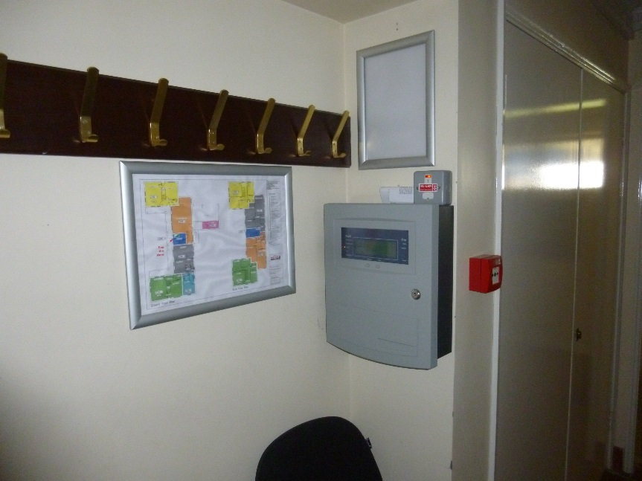
 | Adequate window escape from accommodation areas. | 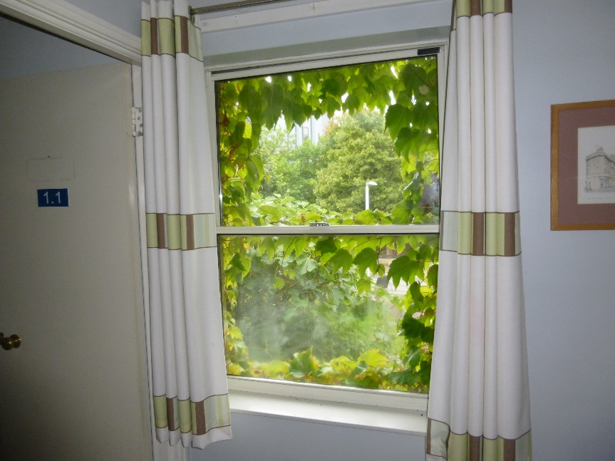
 | Rear of Esther Parkin. | 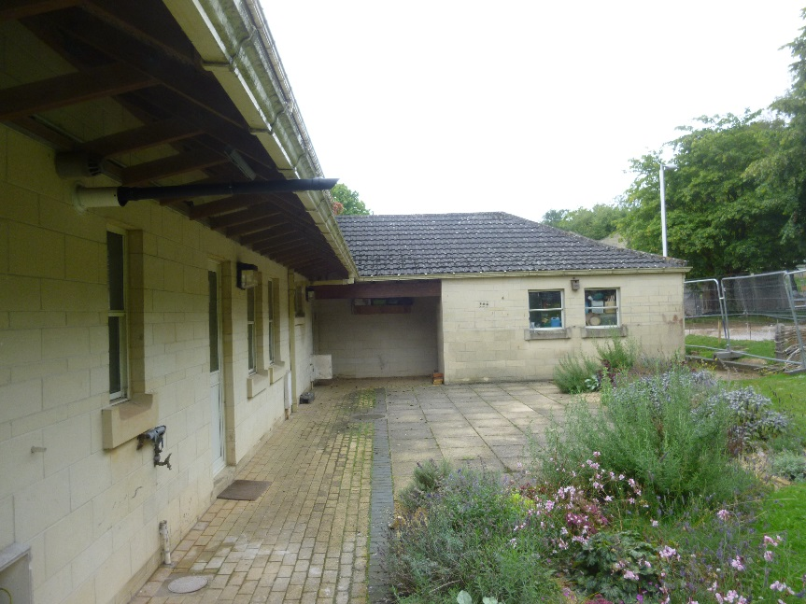
 | There is a double garage and covered car parking area at the side of the property. | 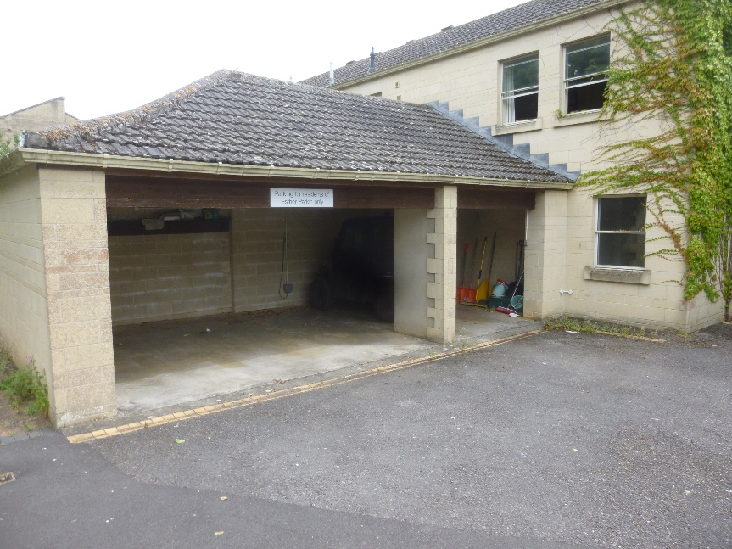
 | The ground floor training room. | 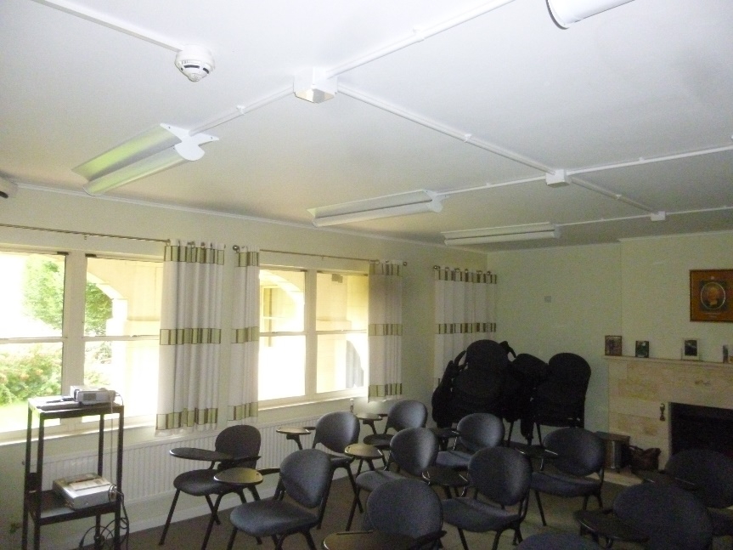
 | Ground floor entrance hall. | 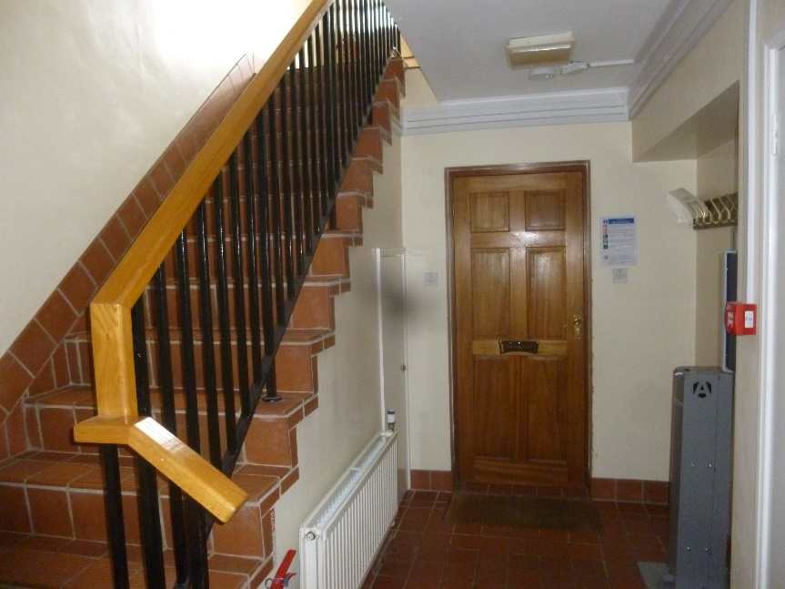
 | All domestic smoke detectors are redundant. They have been replaced by a British Standard 5839 Part 1 fire alarm system. They should all be removed to avoid confusion. | 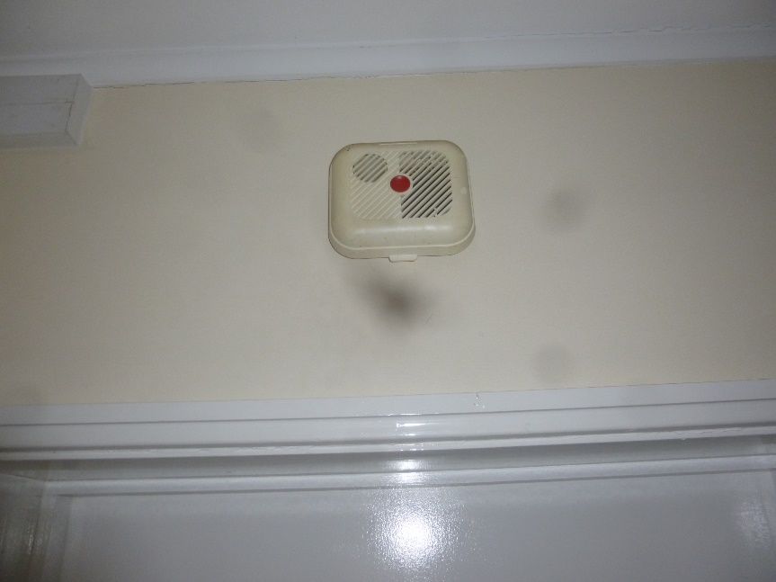
 | The service cupboard (sited with the main staircase) should be kept locked when not in use. | 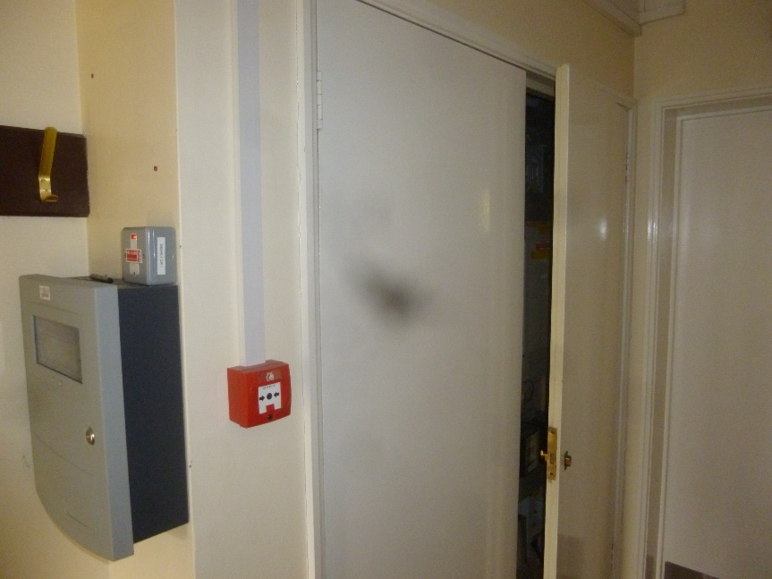

Appendix 1 - Plans
Appendix 2 – Site Plan
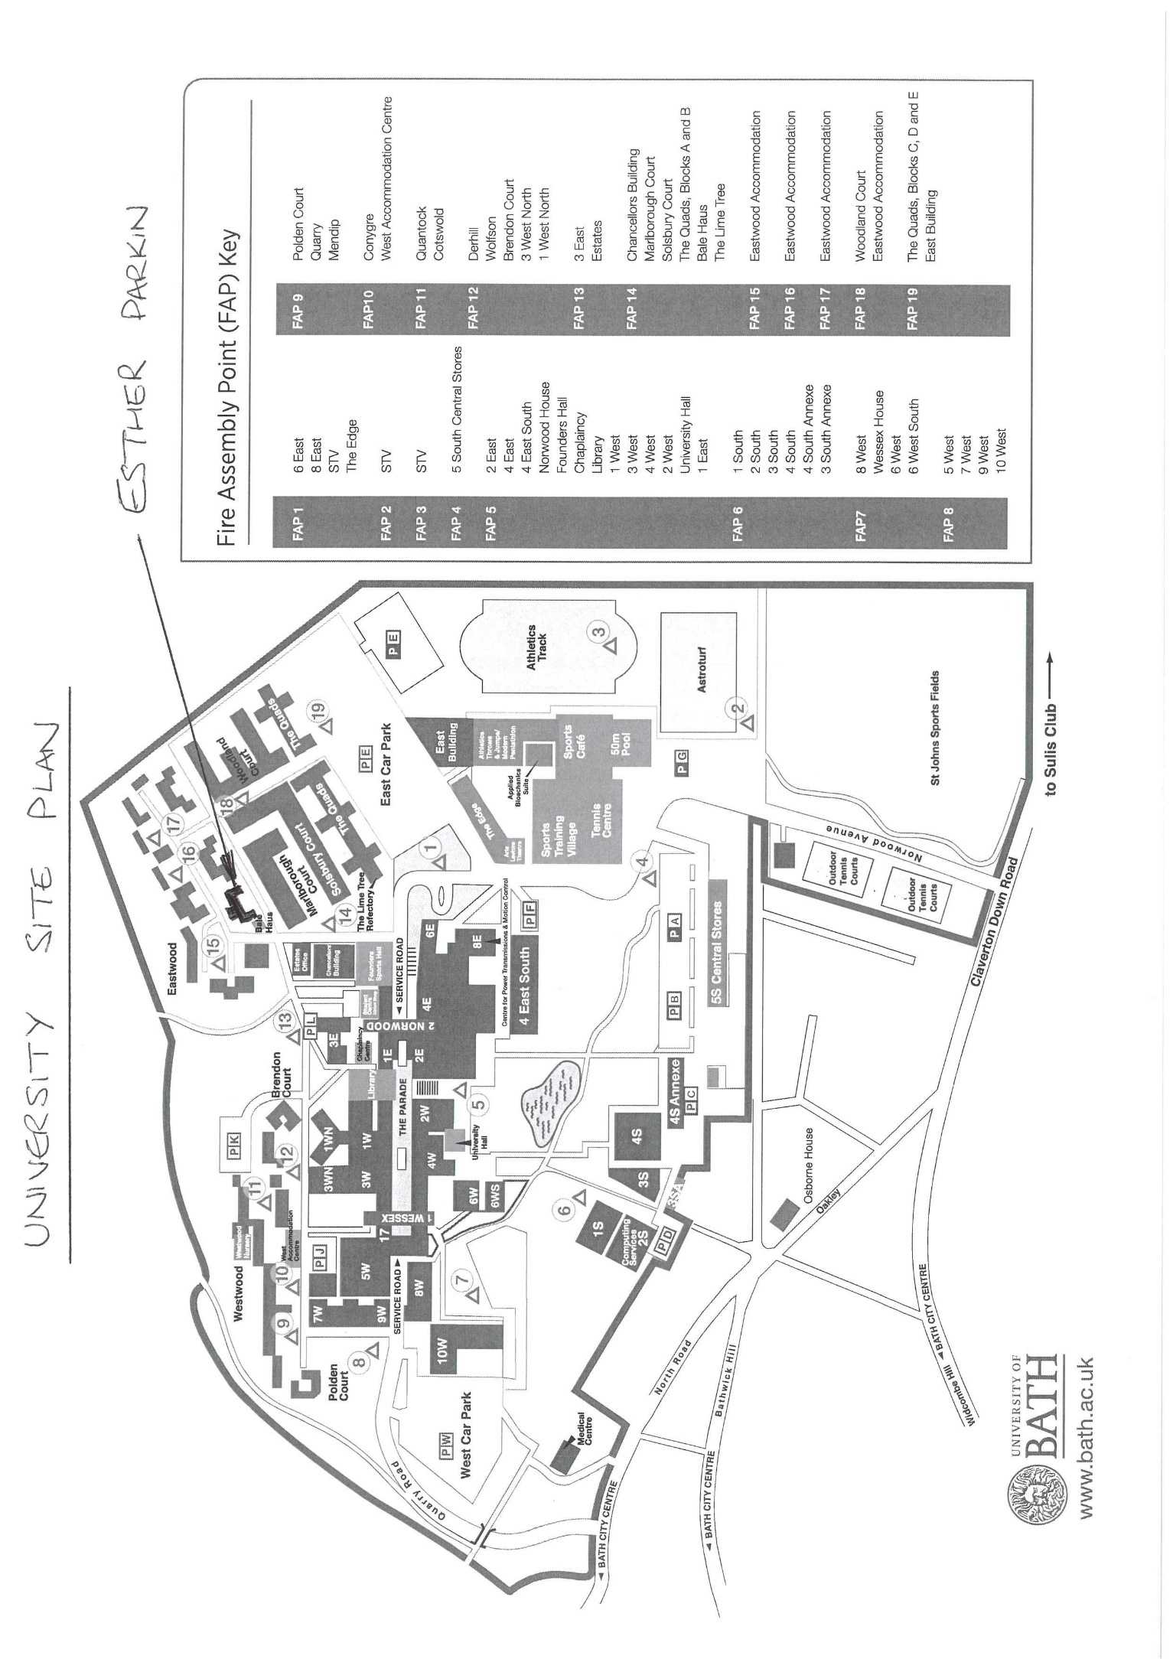
Appendix 3 – University Fire Action Notice
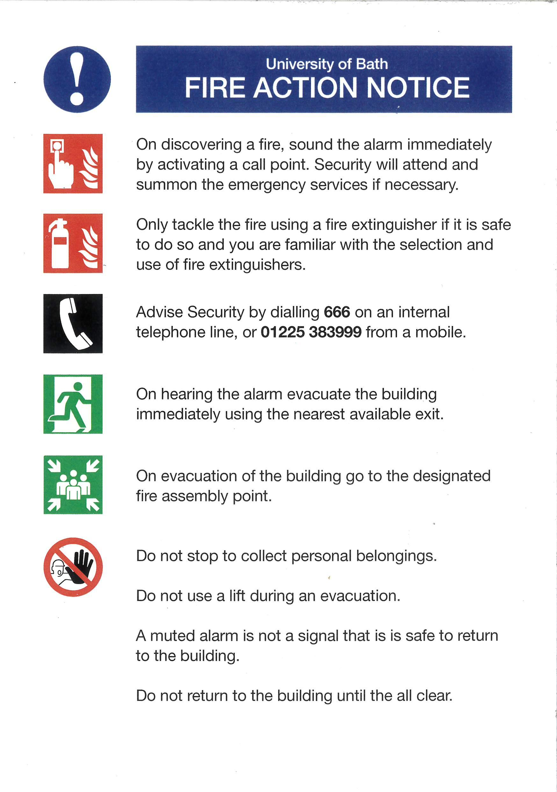

This fire risk assessment should be reviewed by a competent person by the date indicated above or at such earlier time as there is reason to suspect that it is no longer valid, or if there has been a significant change in the matters to which it relates, or if a fire occurs.
Reasonable only in the context of this fire risk assessment. If specific advice on security (including security against arson) is required, the advice of a security specialist should be obtained.
Based on visual inspection of readily accessible areas, with a degree of sampling where appropriate
Based on visual inspection of readily accessible areas, with a degree of sampling where appropriate.
A full investigation of the design of HVAC systems is outside the scope of this fire risk assessment.
Based on visual inspection, but no test of illuminance levels or verification of full compliance with relevant British Standards carried out.
Based on visual inspection, but no audibility tests or verification of full compliance with relevant British Standard carried out.
Relevant to life safety and this risk assessment (as opposed purely to property protection).
Relevant to life safety and this risk assessment (as opposed purely to property protection).
This is not intended to represent a legal interpretation of responsibility, but merely reflects the managerial arrangement in place at the time of this risk assessment.
The following simple risk level estimator is based on a more general health and safety risk level estimator of the type contained in BS 8800: Potential consequences of fire Likelihood of fire Slight harm Moderate harm Extreme harm Low Trivial risk Tolerable risk Moderate risk Medium Tolerable risk Moderate risk Substantial risk High Moderate risk Substantial risk Intolerable risk
In this context, a definition of the above terms is as follows: Low: Unusually low likelihood of fire as a result of negligible potential sources of ignition. Medium: Normal fire hazards (e.g. potential ignition sources) for this type of occupancy, with fire hazards generally subject to appropriate controls (other than minor shortcomings). High: Lack of adequate controls applied to one or more significant fire hazards, such as to result in significant increase in likelihood of fire.
In this context, a definition of the above terms is as follows: Slight harm: Outbreak of fire unlikely to result in serious injury or death of any occupant (other than an occupant sleeping in a room in which a fire occurs). Moderate harm: Outbreak of fire could foreseeably result in injury (including serious injury) of one or more occupants, but it is unlikely to involve multiple fatalities. Extreme harm: Significant potential for serious injury or death of one or more occupants.

