
AAPS potential project descriptions

Designing artificial leaves
Supervisor: Antonio Exposito (Chemical Engineering)
The UK is moving towards zero carbon emissions by 2050. To reach this objective, it is necessary to develop technologies to capture and transform CO₂. Artificial photosynthesis, a carbon-negative process that mimics the reaction in plants, is capable of transforming CO₂, using energy from the Sun, into different molecules such as methanol which can then be used as liquid fuel. However, poor conversion and selectivity of current artificial photosynthesis mechanisms are the main barriers to the commercialisation of the technology.

Solution: We will investigate the role of continuous microreactors, devices with channel dimensions below 1 mm, which can act as artificial leaves and provide a step-change needed in the technology because of their exceptional mass transfer, offering better conversion and control in the selectivity of the process.

Most of the work to boost the process has focused on the reaction chemistry (e.g. improving the catalyst), but reactor engineering and process intensification can be parallel research lines to improve the technology. Only a few groups have reported the use of microreactors for continuous CO₂ reduction and they stated that the better mass transfer in these devices enhanced the selectivity towards liquid hydrocarbons. Mass transfer is essential for reagents to move across the boundary layer adjacent to the surface of the catalyst. It is especially crucial in multi-phase reactions, such as in the case of artificial photosynthesis. Despite the promising results using continuous microreactors, the reactor role in the process has not been deeply understood and further investigation and optimisation of the channel designs, as proposed in this project, could lead to a superior control in the process.

Advanced Verification and Validation of Automotive Software using Driver-in-the-Loop simulators
Supervisor: Chris Vagg (Mechanical Engineering)
The objective of the research project is to adapt an existing Driver-in-the-Loop (DiL) simulator and link this with falsification functions already developed, to demonstrate automatic generation of software test cases which can be executed by a human or robot driver, and automatically evaluated.
This has direct application in mainstream automotive software development, and especially interesting applications in ADAS and Autonomous Driving software development where the interaction with a human driver can be evaluated, for example to assess the handover of control back to the human driver if the ADAS/AD system cannot cope with the situation. By linking the falsification functions with a DiL simulator the project will demonstrate the potential to introduce a degree of automation into the validation process whilst also incorporating the real behaviour and responses of a human driver.

Investigating the effect of uneven temperature distribution on battery performance
Supervisor: Chris Vagg (Mechanical Engineering)
Battery temperature is extremely important in optimising performance, managing safety, and limiting long-term degradation of batteries. However, the effect of temperature distributions within a pack or across individual battery cells is poorly understood. The project will investigate the influence of this, and consider ways to mitigate temperature variations through the design of the battery pack and its thermal management system. The project will involve some 3D simulation, design of a test rig to cool and/or heat battery cells, and an experimental phase to evaluate the effect of the temperature distribution on the battery performance. The proportion of these activities can be adapted to the students’ interests, and will compliment existing work on a European research project, as well as ongoing Masters’ and PhD project work.

Investigating cooling strategies for electric motors
Supervisor: Chris Vagg (Mechanical Engineering)
Effective cooling of electric motors is a very topical problem, for example in electric vehicles. More effective cooling means that a motor can be run at higher powers – the power density is increased. This project will involve setting up a small in-hub motor on a dynamometer test rig to evaluate the effectiveness of different cooling approaches such as air, water and oil cooling. This experimental work will directly support a PhD student who is using Machine Learning to predict the motor’s internal temperatures. You will need to do some 3D design and test rig commissioning, oversee experimental work, and possibly get involved in the machine learning aspects, all supported by the PhD student. The hub motor being evaluated is 25kW and has an impressive power density, making it a strong candidate for future TBRe powertrains.

Seeing Green - Evaluating the theory and impacts of introducing ‘green number plates’ to accelerate adoption of electric vehicles in the UK.
Supervisor: Lorraine Whitmarsh (Psychology)

Since 2020, the UK Department for Transport introduced a policy that all electric vehicles (EVs) would, by default, be fitted a green rectangle on their number plate. The stated objective was to increase the observability of EVs, enable preferential policies and accelerate the adoption of the technology. Norway, Hungary, China and Canada have similar green plate initiatives. However, the relative impact is unclear and the UK remains a gap for a published evaluation of the theory underpinning the policy and a qualitative or quantitative estimate of the impacts four years on from its introduction.
The placement would begin with desk research and secondary data analysis to (a) identity possible impacts of green number plates and processes to explain these; and (b) to compare diffusion rates of EVs across countries with vs without green number plates. Subject to additional funding, there may be an opportunity to conduct additional empirical research to explore their effects on current and prospective EV users.

Characterisation of a Novel Multifunctional Structural Battery Composite Material using Microdroplet Testing
Supervisor: Andy Rhead (Mechanical Engineering)
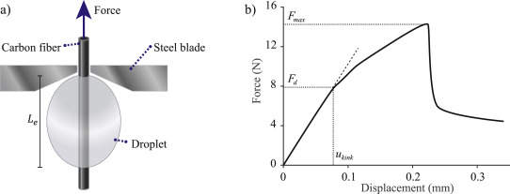
Structural batteries are a promising new technology, exploiting the exceptional mechanical and electrochemical properties of carbon fibres to simultaneously store electrochemical energy and maintain mechanical load. This offers significant opportunities for weight-saving in aerospace and automotive applications. Characterisation of the interface between carbon fibres and electrode/separator coatings is important to understand the performance of structural batteries as a whole system. One such method is called microdroplet testing, consisting of debonding a single drop of the relevant coating from a single fibre as shown in figure 1 [1]. The resulting project will therefore allow the student to design and manufacture samples for testing, and carry out experimental analysis, both key skills which are sought after in both industry and academia.
Figure 1: Overview of microdroplet testing. a) Schematic showing microdroplet testing. b) An example of a common force-displacement curve for microdroplet tests. [1]

[1] J. Xu et al., “Characterization of the adhesive properties between structural battery electrolytes and carbon fibers,” Composites Science and Technology, vol. 188, p. 107962, Mar. 2020, doi: 10.1016/j.compscitech.2019.107962.

Characterisation of a Novel Multifunctional Structural Battery Composite Material using Nanoindentation Push-out Testing
Supervisor: Andy Rhead (Mechanical Engineering)
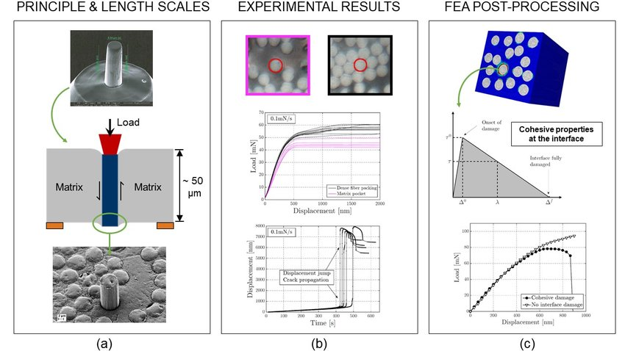
Structural batteries are a promising new technology, exploiting the exceptional mechanical and electrochemical properties of carbon fibres to simultaneously store electrochemical energy and maintain mechanical load. This offers significant opportunities for weight-saving in aerospace and automotive applications. Characterisation of the interface between carbon fibres and electrode / separator coatings, and crucially, the surrounding biphasic electrolyte resin system is important to understand the performance of structural batteries as a whole system. Nanoindentation push-out testing is a technique consisting of using a flat punch indenter tip to push individual fibres out of their surrounding materials as shown in figure 2 [2]. The resulting project will therefore allow the student to use a novel material characterisation method, and carry out experimental analysis, key skills which are sought after in both industry and academia.
Figure 2: Overview of push-out test. a) Schematic of a single fibre push-out test. b) micrograph of a de-bonded fibre at the end of a test. [2]
[2] T. Pardoen et al., “Nanomechanics serving polymer-based composite research,” Comptes Rendus. Physique, vol. 22, pp. 1–22, Mar. 2021, doi: 10.5802/crphys.56.

Set-Up Of An Interferometric Scattering (Iscat) Microscope For Optical Tracking Of Single-Particle Ion Dynamics In Structural Batteries
Supervisor: Andy Rhead (Mechanical Engineering)
Structural batteries are a promising new technology, exploiting the exceptional mechanical and electrochemical properties of carbon fibres to simultaneously store electrochemical energy and maintain mechanical load. This offers significant opportunities for weight-saving in aerospace and automotive applications. One of the crucial requirements to understand how these batteries charge and discharge, is to assess lithium ion flow. This project will consist of assisting the university structural batteries research group in setting up an imaging platform to assess lithium ion particle dynamics in real time [3]. The general microscope set up is shown in figure 3. The resulting project will therefore allow the student to assist in experimental set-up, and time-allowing, manufacture samples for testing, and carry out experimental analysis. All of these are key skills which are sought after in both industry and academia.
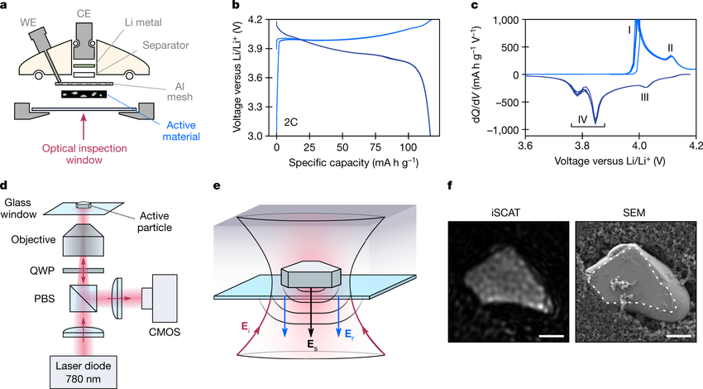
Figure 3: a) Overall geometry of the optical microscopy half-cell (WE, working electrode; CE, counter electrode). b) Optical setup of the interferometric scattering (iSCAT) microscope. PBS, polarizing beam splitter; QWP, quarter-wave plate; CMOS, complementary metal oxide semiconductor camera [3]

[3] A. J. Merryweather, C. Schnedermann, Q. Jacquet, C. P. Grey, and A. Rao, “Operando optical tracking of single-particle ion dynamics in batteries,” Nature, vol. 594, no. 7864, pp. 522–528, Jun. 2021, doi: 10.1038/s41586-021-03584-2.


ART-AI potential project descriptions

Interactive Electronics Fabrication by Applying Machine Learning to Robotic Spraying
Supervisor: Ollie Hanton (Computer Science)

Additive manufacturing of electronics has opened ways for makers to prototype and produce custom devices through 3D printing and spraying. Interactive fabrication allows makers to input design into computer controlled systems in real time making the most of the accuracy, replicability and speed of CNC set-ups combined with traditional crafting workflows. However, applying interactive fabrication to the spraying of electronics is non-trivial. We propose 1) hardware development to optimise our current robot arm/spraying set-up 2) applying machine learning methods to support the development of complex repetition and response algorithms between the system and the maker involved in the arm movements of makers when spraying conductive materials and 3) generating a toolkit of interactions, extending the bounds of interactive fabrication for electronics design.

In this project, we build on our previous work that looks at developing independent hand-held interactive fabrication tools, by utilising a universal robot arm to track a maker’s movements in spraying complex electronic systems. Spraying offers a means to create free-form circuitry extending the ways in which devices can be designed, prototypes and produced, dovetailing with the potential for interactive fabrication and iterative design. Spraying (e.g. car bodyworks) has traditionally been at the forefront of automation, the use of spraying and atomised material in configurable 3D printing set-ups is inaccessible to non-specialists. In this project we aspire to explore the potential for developing a fabrication set-ups that can produce custom electronics on demand.

AI powered tool for identifying user traits in VR
Supervisor: Crescent Jicol (Computer Science)

The way we interact with the real world is heavily dependent on our individual characteristics, such as how extraverted, open or agreeable we are as individuals. Whereas conventional media such as movies will be inevitably regarded differently by users depending on their traits, VR offers a unique opportunity to customise content to appeal to each individual in particular. Imagine sharing a virtual space with a friend, but you each see a version of that space that is custom created to cater to your individual traits! Doing this in games offers a unique opportunity to seamlessly adjust the gameplay to best engage with diverse users. However, to reduce required effort on the users’ side, new methods to measure user traits will be designed and tested. Questionnaires which are traditionally used for measuring traits are not practical in the context of consumer VR content, being uninteresting and time consuming.

The plan is to create a new tool that transparently and seamlessly measures user traits while they are in VR, based on their behaviour. This tool would then indicate the degree to which a user shows certain traits, and the application can dynamically adjust itself according to these traits to benefit the user experience.

This project, if successful, will substantially advance our understanding of how personality traits interact with content and shape what users feel within VR experiences. The resulting theoretical models will offer a framework for the creation of adaptive VR content that will ultimately open this technology to ever wider segments of the population and to more diverse samples of users. The proposed work will enable a new generation of trait-informed adaptive VR content which will have two main benefits: (i) improve the effectiveness of VR applications and (ii) bring these benefits to wider and more diverse user populations.

Forget touchscreens; ditch the knobs
Your next car won't be controlled by these boring commands alone
Supervisor: Adwait Sharma (https://adwaitsharma.com) (Computer Science)


Are you tired of the same old touchscreen and knob controls in your car? Are you passionate about designing and/or implementing next-generation input techniques for future cars? If so, be part of an exciting project including Unibz and BMW.

This project transforms the surface of your car into a functional unit using our smart textile sensors. These sensors pick up your touch, infer your pose, and even tune into your heartbeat. Picture yourself a simple gesture on your steering wheel projects a dynamic map directly onto your windshield, expanding your view with a glance - anticipating your need, and having the music automatically adjusted to match your mood. This project isn't only about engineering; it's also about designing novel interactions that will elevate every journey. If you're passionate about creating practical, responsive, and intuitive experiences, we want you.

Requirements: Python programming and/or a background in UI/UX design for next-gen car interaction systems.

If you’re interested to be a part of this exciting journey, send your CV to Adwait [as5339@bath.ac.uk] with the subject line "Car Interaction Project".

Discovery of skill hierarchies in reinforcement learning
Supervisor: Özgür Şimşek (Computer Science)

A fundamental research question in AI is how to enable autonomous discovery of action hierarchies, in other words, how to endow artificial agents with the ability to autonomously form useful high-level behaviours (for example, grasping) from existing behavioural units (for example, primitive sensory and motor actions available to a robot). This ability allows a developmental process during which an agent can learn to display behaviours of increasing complexity through continuously building on its existing set of skills to acquire new ones. For example, grasping may be followed by manipulating objects in different ways, which may be followed by using a key to unlock the door to an adjacent room, and so on, forming a continuously growing hierarchy of behaviours. This process not only produces more capable artificial agent but also allows their behaviour to be more transparent and explainable. This project will explore various approaches to this problem in the context of reinforcement learning, including those that are rooted in graph theory and information theory.

SAMBa potential project descriptions

Leveraging historical data for enhanced statistical inference in clinical trials
Supervisor: Haiyan Zheng (Mathematical Sciences)

One principal objective of early phase clinical trials is to evaluate the early efficacy of a new treatment as compared to a standard of care. In oncology settings, a binary outcome (responder versus no responder) would typically be used to characterise such early efficacy. In some circumstances, external-trial information may be available from historical studies that have been conducted in a related patient population involving the same standard of care. It would generally be expected that incorporating such external-trial information can lead to more precise estimation. This project will review several approaches to evidence synthesis for the context. Motivated by a real clinical trial dataset, a simulation study will be designed and performed for a thorough comparison of those methods.

Branching Brownian motion and branching random walks
Supervisor: Matt Roberts (Mathematical Sciences)

Branching Brownian motion and branching random walks are key models in probability theory, with surprising applications ranging from evolution of DNA to nuclear reactors. They involve particles moving around independently in space and giving birth to new particles, which in turn move around and give birth themselves, and so on. Classical homogeneous versions of these processes, in which every particle branches at the same rate, have been studied for many years and are largely well-understood. However, if the branching rate depends on the position of the particle, then the picture is far from complete. Some open questions include:

- If particles at position x branch at rate |x|^p for p>0, where are most of the particles, and where is the maximal particle? This has been done for branching Brownian motion (at least for p<2) - see [1] - but not for branching random walks, in which case the answer may be significantly different.
- If the branching rates are given by a collection of independent and identically distributed random variables with heavy tails, then the position of the maximal particle is implicitly known to first order [2], but is the second order term of size log(t) like in the homogeneous case?
- If the branching rates themselves are given by a random walk or Brownian motion (reflected at the origin) then nothing is known. Some simulations could be carried out to make predictions, as well as trying to prove theoretical bounds.
[1] Growth rates of the population in a branching Brownian motion with an inhomogeneous breeding potential, Berestycki et al. Stochastic Processes and their Applications 125:5, pp 2096-2145 (2015)
[2] Intermittency for branching random walk in Pareto environment, Ortgiese and Roberts. Annals of Probability 44:3, pp 2198-2263 (2016)
Noise sensitivity of random graphs
Supervisor: Matt Roberts (Mathematical Sciences)
Noise sensitivity is a topic in probability theory that aims to quantify whether functions of a large number of inputs are sensitive to changes in a small fraction of those inputs. For example, if a small percentage of votes in a general election are miscounted, is that likely to change the result of the election? (This can be thought of as a more down-to-earth mathematical version of the classical chaos theory question, if a butterfly flaps its wings on the other side of the world, can it affect the weather here?)
In this project, we will:
- Review the existing literature on noise sensitivity, concentrating on recent progress (e.g. “Noise sensitivity of percolation via differential inequalities” by Tassion and Vanneuville).
- Write some computer simulations of simple examples.
- Look into whether we can apply the theory to new problems, for example the size of the largest component in random graphs.

How do people connect with each other in social networks?
Supervisor: Matt Nunes (Mathematical Sciences)

The ubiquity of social media data has resulted in a surge of activity in research in the area of statistical network analysis. In particular, there is evidence that many real datasets fit so-called scale-free network models, where the number of connections between individuals have certain decay properties (most people have some connections, but certain individuals have several times as many connections). This project will look at what connections properties different network datasets have, how to estimate these properties, or alternatively investigate whether we can determine whether two networks are statistically similar or not.

Starting references:
1. Barabasi, A. L. Network Science. http://networksciencebook.com.
2. Newman, M. E. J. (2010) Networks: an introduction. Oxford University Press.
3. Barabasi, A. L. and Albert, R. (1999) Emergence of scaling in random networks. Science 289 (5439): 509–512.

Statistical modelling of river flow data
Supervisor: Matt Nunes (Mathematical Sciences)

Careful statistical analysis of environmental datasets is vital in many scientific areas, for example informing models of climate change, predicting risk of flooding or management of infrastructure. In this project we will investigate statistical models for data on networks of rivers, with the aim of being able to identify trends, seasonalities and perform prediction.

It is desirable that a student has completed a module on statistical modelling. A module on time series would be beneficial.

Starting references:
1. Prosdocimi, I. et al. (2019) Areal Models for Spatially Coherent Trend Detection: The Case of British Peak River Flows. Geophysical Research Letters 46 (22).
2. Knight, M. I et al. (2020) Generalised Network AutoRegressive Processes and the GNAR package. Journal of Statistical Software 96 (5), 1-36.
3. Wu and Qu (2012) Modelling and analysis of river networks based on complex network theory. Proceedings of 2nd International Conference on Computer and Information Application.

Use of ensembles in statistical learning problems
Supervisor: Matt Nunes (Mathematical Sciences)

Ensembles in machine or statistical learning refers to collections of models which are then combined in some way to improve predictions or inference, for example in regression or classification problems. There are several different ways to generate these ensembles, including so-called bagging, boosting, or parameter perturbation. In this project, we will investigate how effective these methods are in different contexts, applying them to datasets from biological images to surveys to disease treatments.

Starting references:
- Moreira, J. M. et al. (2012) Ensemble Approaches for Regression: A survey. ACM Computing Surveys 45 (1). 10:1-10:40.

Which physical features are most important in classifying intensity of solar events?
Supervisor: Matt Nunes (Mathematical Sciences)

Solar flares and coronal mass ejections (CMEs) are physical releases of energy which result in electromagnetic waves originating from the sun which travel towards Earth; some of these are frequent, smaller emissions, whereas others can be larger. Such events can be detrimental in many ways, for example producing adverse weather conditions and destabilising electricity production and supply. It is therefore of interest to be able to accurately classify harmful CMEs against those which are benign. Methods to classify solar flares are based on local geophysical and atmospheric features of the Sun in the time preceding a flare. However, it is still an open question as to which of these features are most important; knowing this information will allow more computationally efficient and faster prediction of the occurrence of a solar event, and will ultimately be able to provide an early warning of harmful ejections. This project will investigate some aspects of feature selection for this problem, with the focus being traditional statistical techniques or machine learning dependent on the student.

Starting references:
1. Riley, P. et al (2023) Which Upstream Solar Wind Conditions Matter Most in Predicting Bz Within Coronal Mass Ejections. Space Weather. e2022SW003327
2. M. A. Reiss et al. (2021) Machine Learning for Predicting the Bz Magnetic Field Component From
Upstream in Situ Observations of Solar Coronal Mass Ejections. Space Weather. e2021SW002859.

Gaussian processes on non-Euclidean spaces
Supervisor: Vangelis Evangelou (Mathematical Sciences)

Gaussian processes (GP) are a versatile machine learning model with applications in spatial statistics, functional data analysis, computer experiments, among others. In practice, GP provide a flexible class of models that is able to capture dependencies in the data. For example, in spatial statistics, GP are used to model spatial dependencies, where the dependence is a function of the Euclidean distance between sampled locations. In modern applications of GP, for example when used to optimise computer models, or when modelling chemical data, the Euclidean distance is not appropriate. Direct application of the theory of GP for Euclidean spaces is not valid, and new theory, inspired by the recent applications of GP, is needed. This project will investigate the literature of GP in non-Euclidean spaces and propose modelling and computational techniques suitable for these cases.

Polynomial Factorisation
Supervisor: James Davenport (Computer Science)

Please follow this link to access a pdf of the project description: James Davenport_FactorProject.pdf

