Faculty of Science – Wellbeing Survey results
Context setting:
As part of the University’s mental health and wellbeing strategy, Faculties and Departments are being asked to develop a Wellbeing Action Plan (WAPs) to support managing health and wellbeing in a positive and pro-active way.
We recognise that each area is likely to have varying requirements when considering the health and wellbeing of their staff/teams and the roles they undertake. Therefore, The Faculty of Science agreed to develop a Faculty wide WAP which will be developed by the Wellbeing Champions to implement locally
As a starting point for developing the WAP Heather Girling – Staff Wellbeing Manager launched a wellbeing survey to all faculty staff on 21st September and closed on 9th October. The idea of the survey was to capture baseline data to identify what is working well and key areas where we can develop initiatives to effectively manage health and wellbeing.
Survey:
The survey was open from 21st September 2020 to 9th October 2020.
Issued to 694 staff via email.
Completion rate: 41% (288 responses) – under half responded.
- Slightly more female than males completed the survey
- Highest response rate was 58.6% Academic job family
The survey used incorporates three elements:
1. Health and Safety Executive (HSE) 35-item questionnaire. The HSE Management Standards consider seven key areas of work that, if properly managed, can help to manage wellbeing effectively and reduce work-related stress:
- Demands – Includes issues like workload, work patterns and the work environment.
- Control – How much say the person has in the way they do their work.
- Support – (managerial) Includes the encouragement, sponsorship and resources provided by the organisation, line management and colleagues.
- Support – (peers) Includes the encouragement and resources provided by colleagues.
- Relationships – Includes promoting positive working to avoid conflict and dealing with unacceptable behaviour.
- Role – Whether people understand their role within the organisation and whether the organisation ensures that they do not have conflicting roles.
- Change – How organisational change (large or small) is managed and communicated in the organisation.
Each standard provides simple statements about good management practice in each of the six areas.
- Office for National Statistics (ONS) Annual Population Survey (APS), these personal wellbeing questions consider happiness, meaning, satisfaction and anxiety.

- University of Bath (UoB) questions to measure support and disclosure

Explanation of how to read results:
The scores provided by the HSE survey are based on responses to the questionnaire. They indicate how FoS are performing against each of the Management Standards. The scores range from 1 to 5. A lower score indicates poor performance, or a potential problem area. (Shown in graph below)
The colour coding assess how the FoS is currently performing when compared with the top 20%, average and bottom 20% of the scores of employees responding to the same questions as part of a nationwide survey of psychosocial working conditions. The range is shown from ‘doing well’ to ‘urgent action’ required. (Shown in graph below)
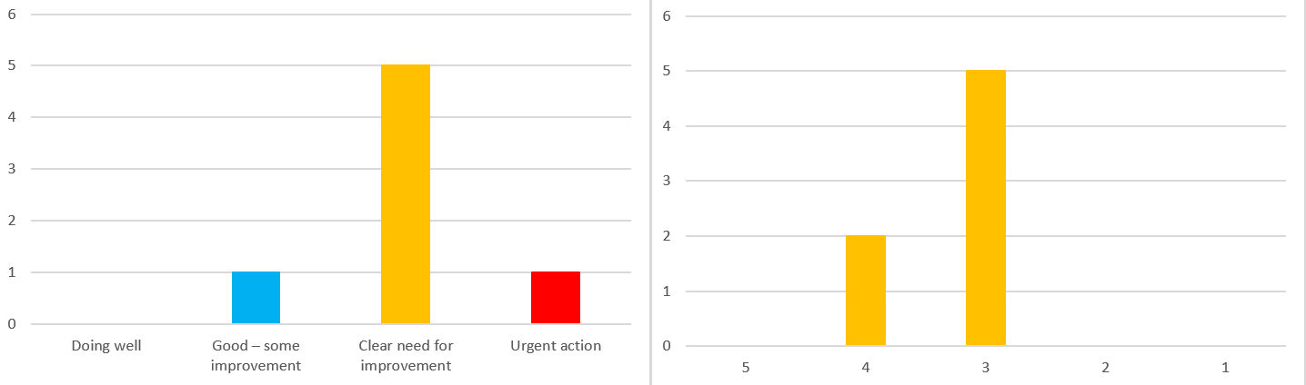
The opinion of the Wellbeing Champions reviewing the output from the Survey was felt that the overall survey results were very positive.
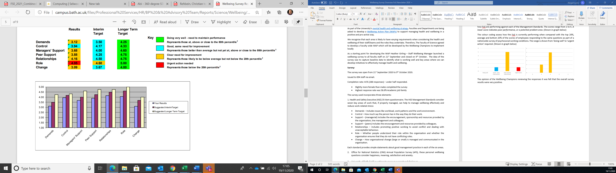
Our Faculty WAP will be focused around improving our already positive response rates. From the results particular attention will focus around:
- I am subject to bullying at work
- I am clear about the goals and objectives for my department
- I understand how my work fits into the overall aim of the organisation
- I get help and support I need from colleagues
- I receive the respect at work I deserve from my colleagues
- My colleagues are willing to listen to my work-related problems
The WAP will be widely shared and communicated once developed and approved by Faculty Executive. If you wish to be involved in creating the WAP please contact your Wellbeing Champions or Amanda Harper or Abi Lyons.

