FUTURES: European Researchers’ Night 2020
Work Package 3: Impact Assessment report
Authors: Hugh Hope-Stone, FUTURES Evaluation Consultant, Independent
Alison Rivett, Evaluation Officer, University of Bristol (UoB)
Tomos Evans, FUTURES Evaluation Assistant, University of Bath (UoBA)
Dean Veall, WP3 Leader, University of Bath (UoBA)

Executive summary
FUTURES2020 allowed the public to learn first-hand about cutting-edge research taking place across South West England, how it is funded and its impact on society.
In 2020 FUTURES took place primarily remotely due to the COVID-19 pandemic, with many modifications from the original plan and no in-person events.
The impact assessment raises several useful recommendations to take forward into any future events, particularly those with a high level of digital content. This is something that is increasingly likely for the foreseeable future and indeed, can provide new opportunities for public engagement rather than merely being a substitute for face-to-face activities during a global pandemic.
However, despite the changed programme the evaluation of FUTURES2020 shows that the activities were still successful in achieving the aims set out in the proposal, with events enjoyed by participants and researchers alike.
Over 44,500 people interacted directly with a FUTURES2020 activity and awareness-raising activities reached nearly 1.9 million people.

Thank you so much for all your time, you have been inspirational. Teacher
I thought it was incredibly interesting and one of the most insightful talks I have ever listened to. Audience Member

Contents
Executive summary 1
Management of Impact Assessment 4
Impact Assessment Methodology 4
Impact Assessment Findings 4
1. Reach: How many people interacted with FUTURES2020? 4
Participation 4
Engagements 5
Awareness-Raising 5
How did people find out about FUTURES2020? 6
2. Audiences: Who is taking part? 7
Gender 8
Age 8
Geographical spread 8
Socio-economic status 9
Ethnicity 9
Reaching New Audiences 10
Schools 10
3. Number of researchers involved 11
4. Evolution of FUTURES 11
Achievement of Impact Objectives 12
1. Participants report a positive experience of FUTURES2020 12
Did people enjoy their experience at FUTURES? 12
Participant opinions, learning and sharing 14
Would participants attend a similar event in future? 15
The ‘remote’ festival experience 15
2. Increased awareness among the general public of the importance of research and innovation and more favourable general attitude towards its funding 17
Has FUTURES raised awareness of the importance of research and innovation? 18
Do participants feel that the research presented was relevant to their lives? 18
Do participants feel more positive about public funding of research? 18
3. Better understanding of the key benefits that research brings to society 18
Do participants report a better understanding of or an increased interest in a research topic? 18
4. Reduction of the stereotypes about researchers and their profession 19
Do participants feel that researchers are ‘people like me’? 19
Better understanding of the European Union among the general public 19
Raising awareness of EU research and researchers 20
How residents feel about EU research and researchers 20
5. Increase, in the long term, of people taking up research careers 21
Awareness of research careers 21
Taking up a career in research 21
6. What was the experience of researchers participating in FUTURES2020? 22
Working online 23
Impact on researchers 25
Impact on research 27
7. Impact on collaborators 27
8. What do we need to change for future FUTURES or similar events? 27
Audience experience 27
Researcher experience 28
Organisation, logistics & activities 28
Overall success of FUTURES2020 29
How successful in meeting the impact objectives were the activities? 29
APPENDIX 1: Gender-breakdown for event delivery 30
APPENDIX 2: Evaluation Response Data 30
APPENDIX 3: Research Questions 31
APPENDIX 4: Evaluation Tools 34
A4.1 Event Observation & Snapshot Interview Proforma 34
A4.2 Post-Event Public Survey 37
A4.3 Post-Event Researchers Survey 44
A4.4 Pop-up Poll Questionnaire 53
A4.5 Teacher Questionnaire 54
A4.6 Pre-event Registration Form (Eventbrite) 55

Management of Impact Assessment
The Impact Assessment was coordinated by the Deputy Head of Public Engagement at the University of Bath and the Evaluation Officer in the University of Bristol’s Public Engagement team with assistance from an external evaluation consultant.

Impact Assessment Methodology
In FUTURES2020 the approach to impact assessment followed that used successfully in 2019 and 2018. Although the same physical methods could not be deployed, due to the remote nature of events, the principles remained the same: to ensure that as much as possible tools do not detract from participants’ enjoyment of the experience but allow all those involved to give their feedback. The following evaluation tools were deployed:
- Reach measurement via registration and attendance records, radio audiences, social media, and website use statistics
- Observation of events to assess the quality of interactions and topics of discussions
- Snapshot interviews to gain insight into participant experiences and key learning outcomes
- Pop-up polls (short participant survey) at the end of online events
- Post-event online surveys to gather feedback from participants and researchers
- Post-event teacher questionnaire to gather feedback about school events
- Post-event debrief researcher interviews to gather their immediate thoughts
- Feedback from organisers and partner organisations
- Social media and website analysis to assess reach of marketing information
Evaluation tool templates and survey questions are included in Appendix 4 with the numbers of responses for each of the evaluation methods listed in Appendix 2. The overall response rate from the combined methods was 47%, which is extremely high for this type of engagement.

Impact Assessment Findings
The impact assessment focused on key research questions to evaluate the outcomes and success of FUTURES2020 activities and how well they met European Researchers’ Night objectives (see Appendix 1 for more details). Each question is addressed below.

Reach: How many people interacted with FUTURES2020?
Event, activity and social media counts showed that there were over 44,500 interactions, and nearly 1.9 million people were aware of FUTURES2020. There were 42 different activities in the programme, with 48 individual sessions or events taking place across the FUTURES2020 period. Of these 48 sessions, 31 were live events, 14 were remote activities and 3 combined both live and remote elements.

Participation
Based on those who logged in to attend, 1,545 people participated in a FUTURES live online event that involved audio-visual contact between audience and presenter. The largest such event was Why Is Climate Change So Hard? with 245 live participants, followed by Discovery Talk: Expedition Earth, where 211 live participants were recorded. Additionally, based on pop-up polls from the events where participants were asked if others were participating with them using the same device, a further 485 appear to have also taken part, bringing the total ‘live’ attendance to 2,030. 28 live events were available to book via the Eventbrite ticketing platform and 2,123 people registered in advance. The ‘drop-out’ rate (from booking to attending) for live sessions was approximately 27%, around what would be expected for online events of this type.

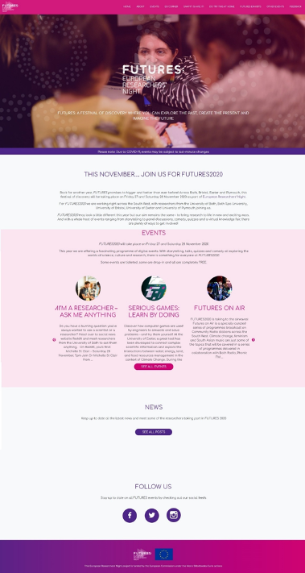
Engagements
Figure 1. FUTURES Website home page
Large numbers of people interacted with remote activities on other platforms including via the FUTURES website and community radio (see below), while 445 people viewed the FUTURES Exhibitions online. The biggest number recorded was for the Natural History Consortium Instagram event (FUTURESxInstagram), with 27,813 engagements (likes, comments and video & story views) recorded. The Global Science Show on Twitter involved 950 people. As in 2019, Reddit was used to create an engaging platform to connect with researchers, with 2020 seeing three Ask Me Anything (AMA) sessions drawing in a combined audience of 5,700.
New to FUTURES2020 was a series of community radio shows aired over the course of the weekend, FUTURES On Air. Seven research stories were broadcast by five community radio stations covering the counties/cities involved in FUTURES. Each item had a 60-minute slot on air. Subsequently, these programmes have been made available via podcasts. The estimated radio audience was 3,000 listening live.

Awareness-Raising
The FUTURES website achieved 16,992 page views and 7,092 unique visitors.
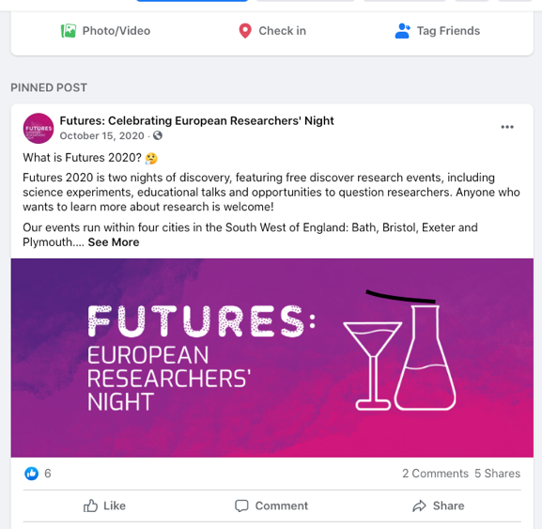
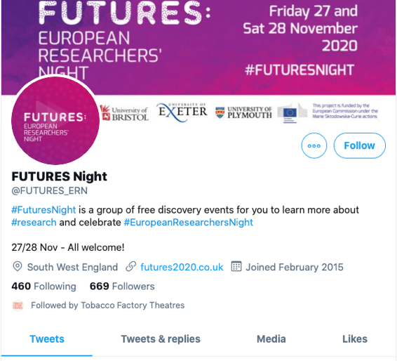
The FUTURES Facebook page was used to deliver a mixed methods awareness raising campaign, posting FUTURES2020 related content and running a series of paid-for adverts directed at regional and local community interest groups and pages. During the campaign the FUTURES page gained 80 likes and the 82 posts reached 100,734 Facebook users and gained 3,304 engagements including Likes, Shares, Comments, media views and link clicks.
Figure 3. FUTURES Facebook page
Figure 3. FUTURES Twitter account
During the campaign the Twitter account (@FUTURES_ERN) posted 194 tweets reaching 101,996 users. The account gained 104 new followers and the posts received 1,548 engagements including likes, retweets and link clicks. Demographic data from Twitter also reveals that 57% who engaged with content were female and 73% were aged 18-34. The two hashtags #FuturesNight and #Futures2020 were used 896 times during the campaign with an estimated reach of 302,589 users and generated 971 engagements.
FUTURES2020 also used Instagram as a communications tool. A six-week campaign was launched through the FUTURES Instagram account reaching 2,881 Instagram users, with the account acquiring 116 followers and the 60 posts gained 147 Engagements including likes, comments and saves. Demographics from Instagram show 74% who engaged were female, 61% were aged 18-34, 29% 35-44, 7% 45-54 and 3% 55-64.
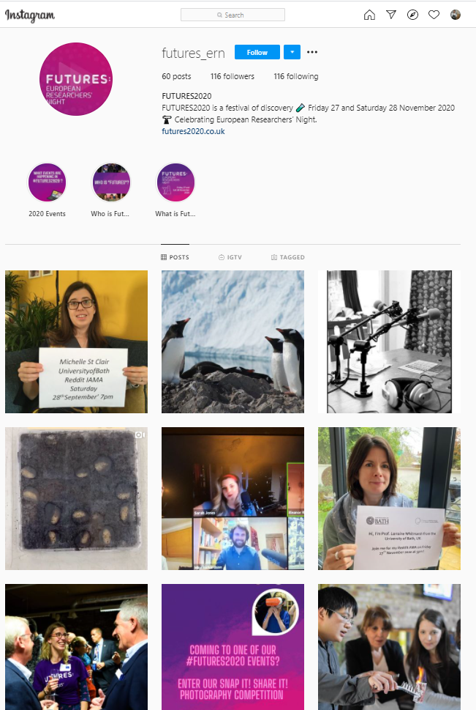
The FUTURES: European Researchers' Night film was commissioned at the end of the 2019 project. This film was used in the awareness campaign before and during the events, and was shared on Facebook, Twitter, and Instagram. The video was viewed 1,275 times on Vimeo.
Figure 4. FUTURES Instagram
Overall, the awareness raising campaign, including paid for advertising, advertorials, online listings and community and interest emails is estimated to have reached 1,888,863 people.

How did people find out about FUTURES2020?
Participants found out about the events and activities via a variety of channels with social media publicity or sharing playing the leading role for those booking via Eventbrite. Email newsletters also proved effective, being cited by 20% of registrants, alongside word of mouth (which in itself could be social media driven). 75% of social media mentions were via Facebook, 22% via Twitter and 2% via Instagram.
Figure 5. How participants found out about the events – Eventbrite Registration data
When asked why they decided to attend those booking via Eventbrite were most likely to say it was because they were interested in the subject (46%), that they wanted to learn something new (18%) or that it sounded fun (13%). This year in particular there was a specific motivation for some:
I want to be better informed so I understand and can manage the risks of Covid better as there is a lot of misinformation out there. Event attendee, Discovery Talk
Figure 6. Why participants attended the events – Eventbrite Booking Data

Audiences: Who is taking part?
The impact assessment also explored the diversity of the audiences. The events were designed to be accessible and attract a wide variety of people, with events targeted at different audiences.
While some were ‘drop-in’ style events or social media activities that required no booking, Eventbrite was used for the majority to help track numbers and ensure events were not over-subscribed. Data was collected from 1,947 Eventbrite bookings, including demographic data, though not everyone registering filled out all the information requested and not all those registering participated. However, we believe the demographic data gives a reasonable indicator of the types of people participating in FUTURES overall.

Gender
Based on booking data the majority (63%) of registrations were by women, compared with 30% by men (the remainder did not state or identified as other). This may be a reflection of who books such events; it is possible that women are more likely than men to book events for their families. However, data from individual events suggests more women than men taking part too, demonstrating the appetite among women to engage with research and STEM for themselves or their families.

Age
From the registration data (bookers were asked to state the ages of those who would be attending), events attracted an audience which was fairly evenly split across age groups. 79% were over 25 and 13% were under 16, but the largest single group were those aged 26-35, in part because many may have booked on behalf of their families. At a significant number of events, adults were accompanied by their children, for example at the Curiosity Carousel where researchers were pleased to have conversations with the whole family.
The event was more accessible for families with young children (they could turn up in their pyjamas!) Organiser
Figure 7. Pie chart showing age distribution amongst attendees booking through Eventbrite

Geographical spread
Access to all events was free and for those taking place online, they were available to anyone anywhere in the world. Consequently, registrations to attend via Eventbrite were recorded from across the UK and internationally. Due to locally driven publicity, the overwhelming majority of registrations were from people giving postcodes in or adjacent to the four cities taking part: Bath, Bristol, Plymouth and Exeter. Out of a total of 1,947 registrations, 1,162 were from local postcodes, making up 60% of registrations. Of the remaining UK registrations most were from large cities such as London, Birmingham, Edinburgh, Glasgow and Nottingham. There were also 269 registrations from 45 countries outside the UK, around 14% of the total. These appeared to be from the USA (48), Italy (43), Ireland (21), India (19) and Singapore (19). Comments in the public survey confirmed that some attendees were joining from the United States and other international locations.

Socio-economic status
The data revealed that there was a spread of attendees across a mix of socio-economic areas (according to the English indices of deprivation 2019). The participants’ postcodes represent a very broad range of deprivation status, from the 10% least deprived to the 10% most deprived. Further analysis reveals that on average, six postcode areas where participants live fell within the 10% most deprived areas in England, making up 14% of bookings, with a further six postcodes within the 30% most deprived most deprived areas, making up 17% of bookings. With the exception of postcode EX1 all were in Bristol or Plymouth. What we are unable to know is the individual’s deprivation status because for example, students who might attend FUTURES events often reside in poorer neighbourhoods. Consequently, these figures may overestimate the audience level of deprivation.
Postcode | % of Eventbrite bookings | UK rank out of 32,844 LSOAs | Postcode | % of Eventbrite bookings | UK rank out of 32,844 LSOAs ⁵
BS6 | 9.4 | 30,377 | PL9 | 2.3 | 28,017
BA2 | 6.0 | 32,180 | BS5 | 2.2 | 11,208
PL4 | 5.0 | 2,315 | BS2 | 1.9 | 1657
BS8 | 4.5 | 18,589 | PL6 | 1.8 | 13,508
EX4 | 4.5 | 19,145 | EX1 | 1.7 | 5,374
BS3 | 4.4 | 3,472 | PL19 | 1.6 | 15,326
BS7 | 3.6 | 23,494 | BS23 | 1.4 | 1,069
PL1 | 3.5 | 1,229 | EX2 | 1.4 | 26,932
PL3 | 3.5 | 28,553 | PL5 | 1.4 | 2,943
BS1 | 3.4 | 1,501 | EX10 | 1.2 | 28,956
BS9 | 3.1 | 26,487 | EX5 | 1.2 | 24,254
PL2 | 2.9 | 1,590 | PL7 | 1.2 | 21,317
BA1 | 2.7 | 16,329 | BS4 | 1.1 | 2,467
BS16 | 2.7 | 9,254 | PL8 | 1.1 | 28,219
Figure 8. Table of Eventbrite bookings distribution by postcode.

Ethnicity
The overall profile of those booking via Eventbrite has a lower proportion of self-identified BAME participants than the UK population as a whole. However, differences between ethnicity are noticeable. Registrations of those identifying as Asian/British Asian (7%) roughly match that of England and Wales (7.5%), but there were just 1% from those identifying as Black/Black British compared with 3.4% of the population as a whole. However, across the South West those from an Asian background make up just 2% of the population, indicating a higher proportion registering from this group, while those identifying as Black/Black British comprise 0.9% of the population, around the same percentage as those registering. Given the very rural nature of the South West, and the urban location of the participating universities we can conclude that FUTURES2020 is reaching at least a proportionate non-white audience, if not a disproportionately higher one overall, and is certainly popular among the Asian/Asian British population.
Figure 9. Pie chart showing ethnicity distribution amongst attendees booking through Eventbrite

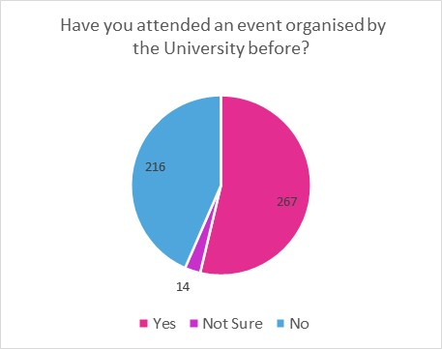
Reaching New Audiences
Figure 10. Pop-up poll results
Results of the quick ‘pop-up’ polls run at 22 of the ‘live’ events indicated that just under half of respondents (43%) had not taken part in an event organised by that University before, whilst 54% said they had previously attended a University event.
This shows that the awareness campaign reached beyond the academic partners’ existing public audiences, and that topics were appealing to a broad section of society.

Schools
Reaching schools in 2020 posed a significant challenge as compared with previous years where the majority of engagement was face to face, either via schools attending FUTURES events or through outreach by researchers going to the schools. The key barriers to attendance and participation were:
- Teachers had little time for activity outside the core curriculum due to lost time through school closures because of Covid-19 restrictions
- Being able to get a whole class online to participate was not possible in many schools due to constraints on accessing IT equipment
In some cases, a teacher led the Q&A with researchers rather than there being direct contact between pupils and researchers.
(There) has been a lower take-up by schools for I’m A Scientist than typical this term. But the schools who have taken part have got on well and the students have really enjoyed it. It is chaos in schools at the moment and everyone’s under massive pressure. It’s very difficult to get access to IT equipment, for example students may not be allowed to move classrooms, therefore can’t go to the IT Suite, or if they can, it has to be carefully scheduled to allow for cleaning, so capacity is reduced. Year Groups may get sent home at extremely short notice. So, there have been more ‘no-shows’, but that’s understandable…For teachers this kind of activity is ‘nice to do’ but it’s not a core part of the curriculum, therefore at the moment it’s just not a priority for them. Partner, I’m An EU Scientist
Two schools (comprising 89 pupils) took part in the University of Bristol run Discover & Discuss events. Both have catchment areas in some of the more deprived areas of Bristol, being based in or adjacent to the top 30% most deprived decile (according to the English indices of deprivation 2019).
(My pupils) gained a greater understanding about the role of scientists and the importance of science in today’s society… How science can solve some of today’s problems. To see that a real scientist looks like a ‘normal’ person. Enabled them to think ‘I could be a scientist’. Teacher, Discover & Discuss
54 students from three schools in Bristol and Swindon (two of which are located in highly deprived areas) took part in a special I’m An EU Scientist FUTURES Zone that ran during November and December.
Thank you so much for all your time, you have been inspirational. Teacher, I’m An EU Scientist
A further 66 pupils took part in Writing FUTURES run by Bath Spa University. As the quotes below attest, for schools even online participation in FUTURES was considered of great benefit to pupils by their teacher and the event facilitator.
The session was great. I think the children are increasingly enjoying words and having fun with them, and I am sure your morning has had a good deal to do with that. Teacher, Writing FUTURES
The FUTURES writing workshop went very well and I believe the students gained a better sense of the breath of storytelling and poetry. They seemed engaged and stimulated by a new perspective, the possibilities of storytelling and of collaboration with their peers… The format of the workshop using Crowdcast went smoothly. Although the personal level of engagement was less , the teachers were excellent at passing the students contributions back to us and the time saved allowed us to give the students more information and inspiration for each activity. Researcher, Writing FUTURES

Number of researchers involved
FUTURES2020 offered the public an opportunity to interact with 260 researchers from five universities (Bristol, Bath, Bath Spa, Plymouth & Exeter) across nearly 50 individual sessions. 13 MSCA Fellows and 23 other researchers in receipt of European funding took part in one or more of these activities. See Appendix 1 for breakdown by university and WP2 Report for more details.

Evolution of FUTURES
2020 is the third year of FUTURES, and it has grown from just two partners to the current five academic institutions. FUTURES2020 faced unprecedented challenges as compared with previous years, with planned face to face events having to switch online due to Covid-19 restrictions. Whilst the pandemic created opportunities for wider participation, it also makes comparing like for like attendance difficult.
In 2020 there were just under 50 possible sessions that the public could enjoy, of which, around 30 were participatory events involving video or audio contact with researchers. Overall, in 2019 there were 23 events or activities of which 22 were face to face. The overall numbers recorded participating live at events were lower in 2020 (1,545) than 2019 (3,334) but this is due to the lack of large in-person events that took place in 2019 such as the Up Late events at We The Curious, attended by 531 visitors, and SS Great Britain, where 450 visitors were recorded.
Along with a switch to online and digital activity, FUTURES2020 also worked through the more traditional media of radio, which is ideally set up to reach people over a wide area and in a socially distanced manner. The programmes were facilitated by South-West-based community radio practitioners Stellaria Media. A series of radio programmes (FUTURES On Air) were co-created by members of five community radio stations, along with researchers from the Universities of Exeter, Bath and Plymouth. Topics included the development of ideas, culture, global affairs, and the natural and scientific world. If online has the potential to reach far wider audiences than in the past, community radio provides an opportunity for deeper engagement with local audiences in the South West and overcomes issues of digital exclusion.
The collaborative approach that was taken to make content, it was very much together with community radio makers, producers and with the researchers. Partner, FUTURES On Air

Achievement of Impact Objectives
The collated quantitative and qualitative data show to what extent the impact objectives of FUTURES have been achieved in the third year.

Participants report a positive experience of FUTURES2020

Did people enjoy their experience at FUTURES?
The direct feedback, social media analysis, pop-up poll results and event observations showed that overwhelmingly participants enjoyed their FUTURES2020 interaction. 93% of respondents in the audience survey said they found the events enjoyable and 70% described them as ‘Very Enjoyable’ through finding out about new research and engaging directly with researchers.
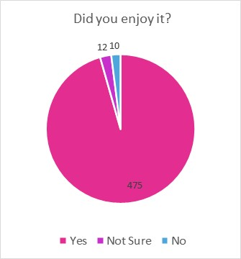
We would like to say a massive thank you and well done to everyone involved. We LOVED it! Event attendee, Land Ahoy!
Figure 11. Pop-up Poll results
The Researchers event was brilliant, I thoroughly enjoyed hearing from different researchers about their fantastic work. Thank you very much to everyone who took part in this event. Event attendee, Researcher’s Tales
The quiz was really exciting and fast-paced. The app was easy to get the hang of and the presenter very engaging. Lockdown Blues was inspiring and relaxing, you could be as involved as you wanted to. The people leading the event were great. Participant, Big Family Quiz & Lockdown Blues Workshop
Quantum parallel worlds - it was a topic I knew little about but find very interesting and it was well explained and engaging. Event attendee, mulitple Discovery Talks
Professor Iain Stewart is a great educator. Inspirational! Event attendee, Expedition Earth
The Letter to My Kidneys exhibition is wonderful. I think it gives great insight and is very moving. Viewer, Letter To My Kidneys Exhibition
Audience feedback at the end of most live events was gathered via a pop-up poll and responses were almost always positive, with 96% of the almost 500 respondents saying they had enjoyed the event. 90% said they learnt something new from participating and felt it was relevant to them.
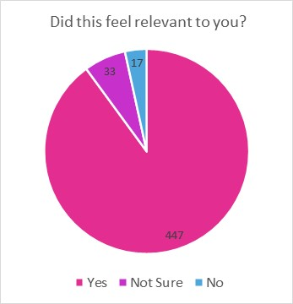
Audiences particularly connected with research topics that had relevance to their own lives or where they live. This is particularly pertinent in rural areas (which make up the majority of the South West of England) where connections to academic research and institutions are generally not very strong, due to the large geographical distances in the region.
Figure 12. Pop-up Poll results
I'm interested in growing produce and belong to a Grow Your Own Food Group in Thornbury. Event attendee, Sustainable Food Discovery Talk
I have Breast cancer and know the importance focusing on the breath through the treatment process. Event attendee, Curiosity Carousel
Climate change. I'm involved with Extinction Rebellion activism. Event attendee, Why Is Climate Change So Hard?
My mum died of COPD last year. Event attendee, Life of Breath Discovery Talk
I used to lead visits to Slapton Sands so it will be great to learn more about what really happened and why that day in 1944. Event attendee, Land Ahoy!
I particularly enjoyed that the scope of the talk, went from universal to a very local (Cornish) relevance. Event attendee, Expedition Earth
The number of people describing FUTURES events as ‘Very Enjoyable’ was somewhat lower than the 82% who described them as such in 2019. This may be as a result of all events taking place online. While being able to access events may have been easier (see discussion below), levels of enjoyment might be higher for some at face-to-face events.
I didn't have to travel to the venue, (I use public transport) so could watch in comfort of my own home. On the other hand, I missed the social aspect of being able to mix with other members of the audience before and after the talk. The quality of the talk was as good as those I've attended in person in pre-Covid times. Event attendee, Expedition Earth
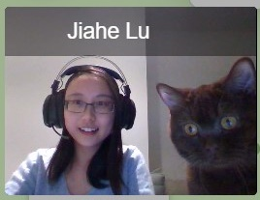
Online is convenient, in-person is more convivial and has networking opportunities. Event attendee, Expedition Earth
Figure 13. Researcher with unexpected visitor
There was some convenience in being able to attend from home. I missed the ability to discuss with others and for interactions in person with the speakers. Event attendee, Discovery Talk
It was easy to get distracted whilst watching on YouTube. I wasn’t as engaged as I would normally have been. Event attendee, Science Show-Off
I think the online experience is very convenient and accessible compared to face to face events but maybe it feels like less of an 'event'. Participant, Lockdown Blues
One participant, when interviewed afterwards noted that it was a learning experience for her in a technological sense as well as discovering more about the research topic.
I was hesitant about attending this event, partly due to unfamiliarity with the technology, but also because I struggle with anxiety, depression and motivation. So actually doing something like this was really positive for me and I felt a real sense of achievement being able to engage. Participant, Who Do We Think You Are?

Participant opinions, learning and sharing
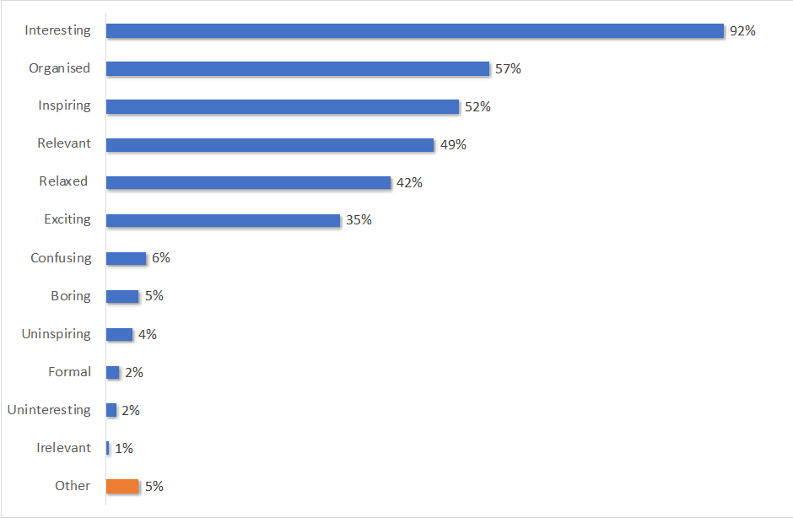
Figure 14. Chart of words describing FUTURES events in audience survey
When given a choice of words to describe the events, the overwhelming majority of responses were positive, with the most common responses being ‘Interesting’ mentioned by nearly everyone in the survey (92%), ‘Organised’ ‘Inspiring’ or and ‘Relevant’ (all cited by half or more of respondents). Only a handful chose negative words (34 responses from a total of 697); the most common such word selected being ‘confusing’, while a few others said it was ‘uninspiring’ or ‘boring’.
I found all the topics interesting in different ways. Perhaps because I learnt about a new topic or because of the way the researcher told their story, as well as the diverse range of researcher experiences. Event attendee, Researcher’s Tales
All (interesting) because they were very relevant and are all important subjects for the future. Event attendee, Expedition Earth
It was inspiring, quite fast paced for me, but I thoroughly enjoyed it. Event attendee, Expedition Earth
Survey respondents also found the research topics interesting, with 59% reporting all topics being of interest and 35% reporting that some were interesting, showing events were stimulating and attendees had a positive experience.
I thought it was incredibly interesting and one of the most insightful talks I have ever listened to. Event attendee, Expedition Earth
Only attended one FUTURES event, I enjoyed it - topic was interesting and presentation very good. Event attendee, Expedition Earth
Thought the quiz was brilliant - great balance of topics and questions the whole family could answer. Event attendee, Big Family Quiz
78% of attendees in the survey said they went on to discuss the ideas they had experienced with others who didn’t attend. A third (31%) said they had found out more about a topic covered at the event they attended, and some intended to share the knowledge gained with others.
I'm a Biology teacher, I hope to share some of these lectures with my classes. Event attendee, Research On Your Doorstep
Figure 15. What participants did after attending the events
Some people even indicated they would change their behaviour having been inspired by what they saw or heard, like this Instagram user commenting on a post relating to plastic pollution in the oceans (one of a number of similar comments in that particular thread)…
I will definitely be joining you with the @onelessbtl #oneless pledge! Instagram user, FUTURESxInstagram

Would participants attend a similar event in future?
Audience observations and feedback indicated that the majority of people would be interested in taking part in more activities like this in the future, whether these were FUTURES-branded, or similar ad-hoc events about research topics organised by the Universities.
Although the post event audience survey did not specifically ask participants whether they would attend a similar event in the future, around 10% of respondents specifically commented in open-response questions that they would like to see more of the same and hoped that it would be repeated next year.
Please Zoom FUTURES events next year, whatever the future brings. Event attendee, multiple Discovery Talks
I look forward to more similar events. Event attendee, Land Ahoy!
More like this please :) Participant, Lockdown Blues Workshop
Another proxy measure for future engagement is the number of people who subscribe to further information updates. Of the approximately 2,100 people who registered for an event beforehand via Eventbrite, 16% actively chose to receive future communications form the event organiser.

The ‘remote’ festival experience
FUTURES2020 was free and primarily delivered online, so for those with digital connectivity, access was not an issue in principle. Indeed, many participants said they only took part because it was online and therefore easier and cheaper to access than a placed based event requiring the effort and cost of travelling.
We are both at a higher risk from COVID-19 and welcome not having to travel in from Cornwall on cold dark evenings. It also allows a more settled domestic routine. Event attendee, Land Ahoy!
Due to my location, I would not be able to attend these talks unless online. Event attendee, Land Ahoy!
The event was more accessible for attendees not local to Plymouth. The interactivity made it engaging and accessible at a comparable level to an in-person event. Event attendee, Expedition Earth
I would never have participated as much in the normal world but now I have I see this as a real asset to learning and entertainment. Event attendee, Expedition Earth
We’ve done a lot of quizzes and this was one of the best. We were really impressed with the software - as well as the people. Participant, Big Family Quiz
Pop-up poll feedback for live events also suggested that a high percentage participated with others in their household. For example, nearly a third (32%) of those who watched the Expedition Earth Discovery Talk did so with other people. As noted previously, in addition to those recorded by the online platform as attending, participants indicated around a further 485 were attending with them using the same device.
Anticipating how many participants would turn up was difficult and the dropout rate between registering on Eventbrite to actually attending was high in some cases while other events were oversubscribed (overall it was approx. 27%). Additionally, unlike face-to-face events, where participants are likely to stay out of inertia (they have made the effort to come anyway) or politeness, no such barriers exist online. Despite this, in many observed events most participants tended to stay for the duration, even though they might drop in and out to attend something else in their home. For example, during Curiosity Carousel, while some attendees stayed for over 2 hours, others stayed for less than 20 minutes (the average time was 54 minutes).
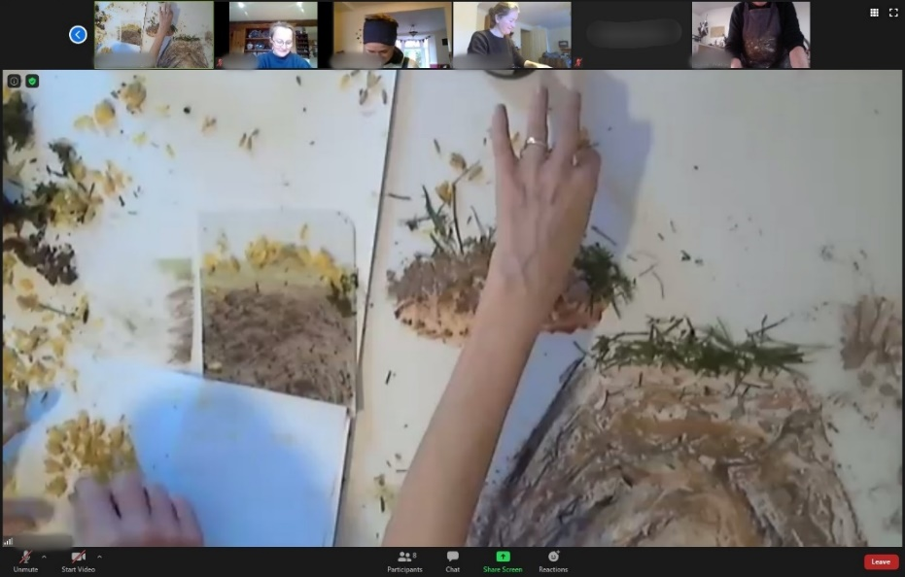
Online events in general also worked well when there was something hands-on for participants to do rather than only reading, listening or talking. For example, the three-hour Gathering for a Future event required participants to paint or sculpt four pieces of art, during which time speech was minimal. Such a process was considered to reduce ‘Zoom stress’ and allow for a more thoughtful interaction. This was enhanced by using artists materials from nature which brought smells and textures into the event, making it feel real rather than virtual.
Figure 16. Hands-on Art activity during Gathering for a Future
Usual Zoom meetings are exhausting but this is more hands on…cuts the thinking out. Participant, Gathering for a Future
It was lovely to have the 5min silence of doing a task and knowing that others were doing the same. It created a powerful connection between us. Participant, Lockdown Blues workshop
Great to spend the afternoon with new people and be creative, felt enriched. Participant, Gathering for a Future
Creating the right ‘atmosphere’ really helps with engagement. Where participants feel relaxed, they start sharing both via audio and chat, and this process helps facilitate a conversation rather than it feeling like a one-way webinar.
Being online did throw up some technical issues such as connecting to and navigating within the event platforms. Almost a fifth of respondents in the public survey reported that the online platform they had used was new to them, so this is perhaps not surprising.
I'm not a frequent user of Zoom [and couldn’t find the right button to click, so] was missing what was being said while I tried! Event attendee, Who Do We Think You Are?
I thought some of the slides were difficult to see but that may have been a problem with my IT or competence. Event attendee, Researcher’s Tales
One participant found it hard to type quickly and thus struggled to keep up with responding. Observation, Who Do We Think You Are?
More generally, online events need to take into account the different set of audience skills and abilities to those usually needed in a face-to-face event.
Whilst it is harder to assess participants’ opinions of the remote activities taking place on social media, community radio etc., feedback from a number of quick polls and from analysis of posted public comments was overall very positive.
Hi Prof! Thanks for taking the time to answer questions! Participant, Reddit AMA
Great family quiz night tonight @FUTURES_ERN. Accompanied by the perfect cup of tea we’re smashing the Northern Lights questions. Twitter user, Big Family Quiz
This is brilliant! Penguins are amazing, I had no idea. Instagram user, FUTURESxInstagram

Increased awareness among the general public of the importance of research and innovation and more favourable general attitude towards its funding
Participants reported three key benefits of attending a FUTURES event: a better understanding of a research topic (71%), an increase in interest in a research topic (52%) and a better understanding of the value of research and researchers to everyday life (32%). Additionally, 22% felt they gained a better understanding of how researchers work with local communities.
Figure 17. What benefits participants gained from attending the events – Public Survey

Has FUTURES raised awareness of the importance of research and innovation?
More than ever before, because of their predominantly online nature, the activities successfully exposed audiences across the South West, other parts of the UK and internationally, to ERN messages, i.e., the importance of research and innovation for their everyday life, the benefits that research brings to society, and better understanding of the European Union among the public.
Thanks for doing it. The more understanding of leading thought we can all gain the better. There is great suspicion of "experts" which is damaging. Event attendee, Discovery Talk
Despite the challenges faced due to Covid-19 restrictions, FUTURES2020 was able to attract an actively engaged audience that was split 40/60 between those who had attended previous similar events run by the contributing universities and those who had not. This suggests that a combination of having more universities involved, along with the easier access online events provided, ensured that FUTURES2020 was successful in broadening reach among those who might not have otherwise engaged with university research and thereby increasing awareness.

Do participants feel that the research presented was relevant to their lives?

Do participants feel more positive about public funding of research?
Three quarters (74%) of audience survey participants said their participation had made them more curious about research that takes place in universities. This was noticeably lower than the 96% recorded in 2019. There is no obvious explanation for this difference; perhaps the online nature of the events makes deeper engagement and consequently, curiosity, harder to develop.
I enjoyed the event. It made the deep knowledge of the researchers accessible to me and I learned about issues and topics that were new to me. Event attendee, Discovery Talk
Attendance at a FUTURES2020 event boosted confidence in talking about science and other university research with friends and family; nearly a quarter (23%) of the survey sample strongly agreed this occurred, with a further 32% slightly agreeing.
Additionally, 72% agreed that attendance made them think that university research is relevant to their life, 44% agreeing strongly.
What I liked about the project was that the community found the subject, and it was about making the connexions with the research. Partner, Futures On Air
I think it is a really good initiative to share research and help people understand the relevance of it to their lives. Event attendee, Discovery Talks

Better understanding of the key benefits that research brings to society

Do participants report a better understanding of or an increased interest in a research topic?
Audiences found the research topics presented interesting; 61% said all those they attended were interesting, with an additional 32% saying some they attended were interesting.
By participating in FUTURES2020, three quarters (74%) of participants in the audience survey agreed it had made them more curious about the research that takes place in universities.
At the same time, researchers believe there is considerable public interest in university research with 81% of researchers believing this to be the case.
Women on naval ships - who knew? [I gained] New perspectives on the US D-Day practice disaster. Event attendee, Land Ahoy!
I got to see that … the pandemic is not only about the disease itself, but also (and very important) about progress in a lot of different directions. Event attendee, Discovery Talk
I was amazed at the amount of research that is going on. We need more of these events to inform people about science and the importance of research. Just brilliant. Thank you for all you do. Event attendee, Discovery Talk
Interactions between researchers and the public appear particularly strong on some social media and online platforms, where dialogue took place over a longer period and where users are in a ‘space’ they feel comfortable and familiar with. The interactions at events and online forums such as Reddit clearly demonstrate that through conversations with researchers, participants gain a more insightful understanding of the challenges and processes that researchers are presented with, such as ethical and methodological questions that the public might not have immediately associated with academic research.
Sometimes this existential thread on the horizon makes me lose all hope, and seeing how people have dealt with Covid just doubles down on that, so having something positive said from an expert actually gives me a glimmer of hope. Participant, Reddit AMA

Reduction of the stereotypes about researchers and their profession

Do participants feel that researchers are ‘people like me’?
Feedback underscored the benefit of dialogue between the researcher and the public to create genuine human connections and reduce stereotypes about researchers. The online nature of the events may have helped in this regard, giving the audience a glimpse inside researchers’ homes.
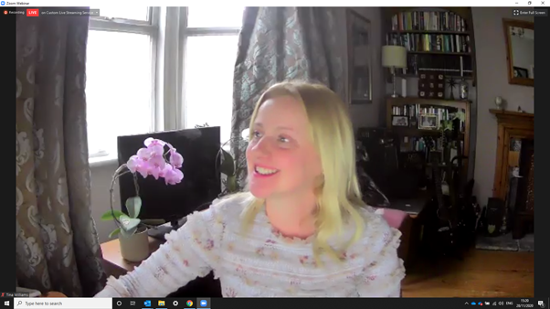
These sessions help to show they [researchers] are human as well as well informed (the video format probably helps in this regard, as it feels more personal and less staged than a presentation in an auditorium, especially when it goes wrong - which is therefore a good thing). Event attendee, Discovery Talks
Figure 18. Relaxed researcher presenting from home
My children love science. Very good opportunity for them to access professionals/scientists and enable them to open their vision. Event attendee, Researcher’s Tales
I loved the enthusiasm and love of their roles by the speakers. Event attendee, Research On Your Doorstep
It is interesting to note that questions often moved away from talking about the research topic and on to more general questions, indicating an appetite for and interest in the working lives of researchers.

Better understanding of the European Union among the general public
Information about the contribution of European funding and academics to local areas was available online (and physically in Exeter), including in dedicated virtual EU Corners. The European Commission branding was shown during or before online events in addition to being featured on the FUTURES2020 website. Social media and online promotion links were made with other ERN-related accounts both before and during the Night. The online EU Corner was also branded clearly with ERN and European Commission logos.
9% of audience survey respondents said they had visited the EU Corner on the FUTURES2020 website, although many more (38%) said they would have done so had they known about it. Of those who had visited, 12% said they had contributed a pin to the European Discovery Map (part of the EU Corner micro-site). Attendance at specific EU Corner “events” totalled 199, with the biggest event being Plymouth University’s Day in the Life of a Researcher with an audience of 153.
The audience survey showed that 10% of participants felt a benefit of taking part was a better understanding of European aspects of research, such as funding.
And keep the links and collaboration with the EU so we don't regress too much in the coming years of isolation. Event attendee, Discovery Talks

Raising awareness of EU research and researchers
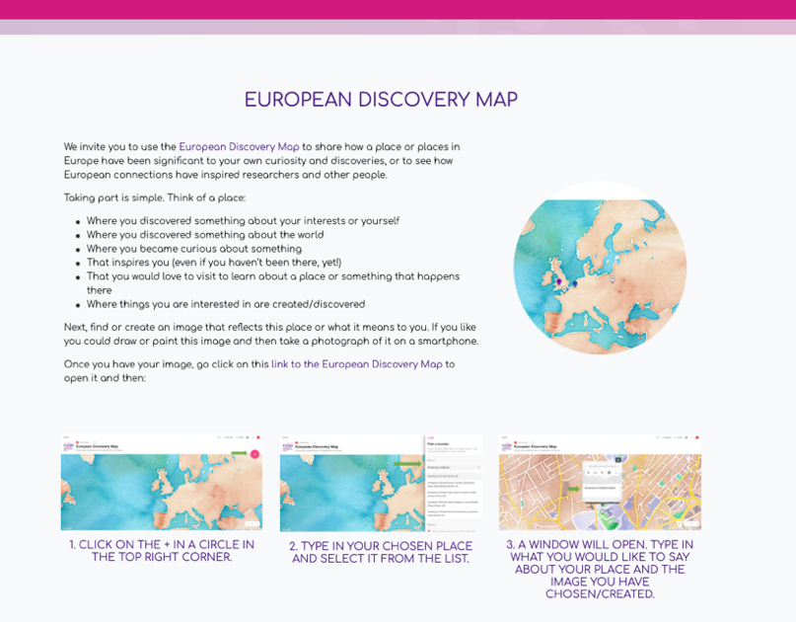
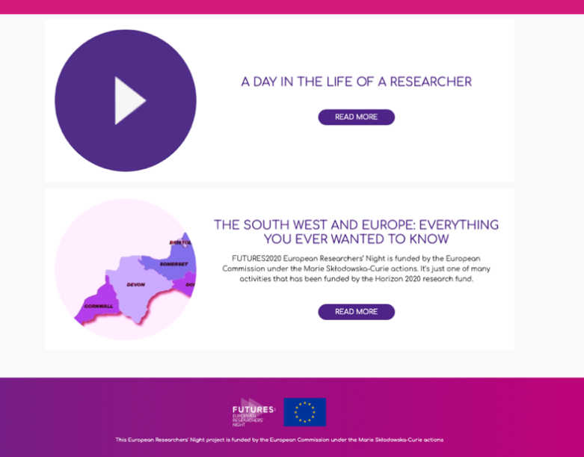
All events were branded as “European Researchers’ Night” to ensure attendees were aware that activities and most research featured were European Commission funded. However, because events were online, the visibility of the branding during events (for example, on Zoom) was not always permanently present, which may have reduced awareness of the EU element of FUTURES.
Figure 19. Pages from the FUTURES website EU Corner
13 of 260 researchers who participated in the Night’s activities are MSCA grant-holders, and 25 hold other types of European Commission grant. Together they comprise 15% of those who took part (20% in 2019) and demonstrated the diversity of European Commission funded research taking place locally. Their feedback also suggests that awareness of EU research was raised, with three fifths (61%) saying they thought the events brought a great deal or some credit to the EU, achieved through the branding of FUTURES as an EU funded event.

How residents feel about EU research and researchers
Nearly all (93%) survey respondents agreed that European research and researchers are important to the South West region (similar to that recorded in 2019). Indeed, 5% of participants specifically joined an event because they wanted to hear more about European research.
10% said they gained a greater understanding of European aspects of research as a result of attending a FUTURES2020 event. This was lower than the 18% recorded in 2019, perhaps suggesting that online rather than a physical event can make understanding more difficult. Given that 93% considered European research to be important, the 10% figure may also indicate that many participants already felt they understood the value of European aspects of research.
The events were timely and relevant for this year. Bringing together of people in a community of learning is an excellent way to share experiences, whatever they are. Thank you. Participant, Lockdown Blues & Talking About Mindfulness Therapy workshops
Feedback from audiences shows they appreciated the focus on research taking place at their local university. While FUTURES2020 attracted new audiences from across the UK and internationally, the vast majority were still resident in the South West. This suggests a good appetite for discovering research taking place at their ‘local’ university and how this links to their own lives and neighbourhoods.
(Participants) enjoyed seeing a video about a local place that they knew and visited regularly and find out about the aquatic life research happening there. They shared their own experience of the ponds and how it matched with the research findings. Observation, Curiosity Carousel
This finding appears to be supported by researcher feedback; with 76% of researchers believing FUTURES brought credit to their university compared with 61% for the EU.
It [FUTURES] promotes the EU as a place of learning and recognising research as important. Researcher, Discovery Talk

Increase, in the long term, of people taking up research careers

Awareness of research careers
Attending FUTURES2020 has led to many participants (32%) to believe they gained a better understanding of the value of researchers to everyday life, how they work in local communities (22%) and about research careers (13%).
Many parents who attended events with their children noted how important it is for children to be able to meet researchers and see that an interest in a particular subject can be the route to a fascinating career.
My 10-year old daughter saw her first history academic - she loves history. Participant, Big Family Quiz
Pupil feedback from the schools Discover & Discuss events demonstrated how through talking to ‘real scientists’ they can both engage with and be inspired by research and researchers.
It was fascinating to learn about how they are trying to stop climate change. Pupil, Discover & Discuss
Really interesting because we learnt a lot from it about the wider world. Pupil, Discover & Discuss
It was exciting to see someone who was doing this for their job. Pupil, Discover & Discuss
One teacher commented that it had raised their students’ awareness of careers in research a lot…
A lot, before they didn’t know what research meant and what it would involve. Teacher, Discover & Discuss
The online nature of the activities was an important factor in enabling all students, whatever their initial level of interest, to learn more about research without feeling any peer-pressure.
Because it’s anonymous, everyone can ask a question and get involved equally. It doesn’t favour confident students who don’t mind putting their hand up and asking a question in front of the class. Teachers say their quiet students often participate more. Partner, I’m An EU Scientist
And a researcher noted that students were inspired to find out more and take their learning further after the session, which is of key importance for future engagement with research.
It is a good sign of engagement if the students are intrigued and want to know more at the end of the session. Researcher, Writing FUTURES
From observation of events, it was noted that pupils were most interested in asking questions about the activity they had done first, and then became more interested in asking about the scientist’s research and career as the session progressed.

Taking up a career in research
23% of audience survey participants said they would consider a career in research. This is possibly a reflection that many respondents are not young students but does show that the FUTURES events are inspiring. Nearly three times as many (63%) said they would recommend a career in research to a family member or friend. Some event attendees wanted to explore more, the possibility of working as a researcher and others felt taking part had inspired them to develop their own research.
Enjoyed being inspired to continue my own research. Event attendee, Discovery Talk
The event inspired me to develop new ideas in my own research that I will soon be starting. Event attendee, Researcher’s Tales
[I would like] to contact a tutor to discuss further education. Event attendee, Land Ahoy!
I'm a grad student in theoretical physics wanting to have an actual impact on the world. Does a math-background guy like me have any hope on contributing to a project like this? Participant, Reddit AMA
Feedback from schools’ events also supports the positive long-term benefits of participating…
Our own evaluation has shown that taking part does boost students’ Science Capital⁵. Partner, I’m An EU Scientist
⁵ Science capital refers to science-related qualifications, understanding, knowledge about science and ‘how it works’, interest and social / family contacts with science jobs. Pupils with higher levels of science capital are more likely to aspire towards a science-related career than pupils with lower levels. ASPIRES project findings, 2013 https://nustem.uk/resource/what-is-science-capital/

What was the experience of researchers participating in FUTURES2020?
Feedback from the researchers involved was gathered by means of an online survey after the events. 61 researcher responses were received, 23% of participating researchers and almost identical to the 2019 response rate.
Most of those responding (80%) had not taken part in previous FUTURES, in part reflecting the extension of the event to include the Universities of Exeter and Plymouth in 2020. Nearly all, however, had had some previous experience conducting public engagement.
All researchers enjoyed taking part: 72% said they enjoyed it a great deal, the remainder enjoyed it to some degree. The percentage of those enjoying it a great deal was somewhat lower than the 89% recorded in 2019, possibly due to some of the stresses of delivering online.
- Aspects they enjoyed most focused around talking to new and wider audiences, and particularly engaging with young people.
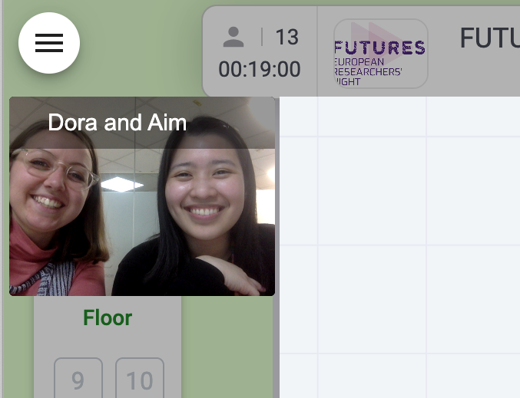
I liked that the audience was much bigger that if I had done some physical engagement. Researcher, Global Science Show
Figure 20. Researchers at Curiosity Carousel
I found the enthusiasm of the kids really great and enjoyed answering their questions, many of which were really excellent. Researcher, I’m An EU Scientist
Reaching a wide audience and online delivery. Researcher, Global Science Show
Being able to talk to people of all ages and walks of life and just share knowledge and information in a way that feels like a happy, fun moment instead of a formal class. Researcher, Curiosity Carousel
It was great to connect with audiences that we may not ordinarily have the opportunity to meet aided by the promotion available through a bigger, recognised project. Researcher, How to Fix a Broken Planet
- Publicity for their research and/or research group: Survey findings showed that two thirds (66%) of researchers believed taking part had brought at least some credit to their research or their research group, with 12% believing it had delivered a great deal of credit.
Raising profile and highlighting interesting and useful research. Researcher, Global Science Show
- Skills development and support and training from the FUTURES Team: Just over half (54%) of researchers who responded said they had attended a training session beforehand, primarily for help with using Zoom and other online tools. All those attending found it useful, with 64% finding it very useful. Most (77%) said they had received briefing materials prior to FUTURES and again all, bar two, said they found such materials useful.
The training sessions with Clare Murphy, it brought us together as a group so we could support each other on the night. Researcher, Researcher’s Tales
I thought we had a lot of pre-event support and advice from the team at Bristol. I found the training really helpful with a lot of people who I can ask for questions and help. Researcher, Curiosity Carousel
It was a good excuse to build upon my existing video production and editing skills. Was great to showcase my research to a wider audience. The pre-event training was very good. Researcher, Global Science Show
- Developing new ways of communicating their research. While much of this re-imagining involved digital or online engagement, co-creating community radio content was also a new experience for those involved. This process proved to be a very satisfying one, and demonstrated to them both the value that broadcast public engagement can deliver to community radio partners as well as the benefits of such a collaboration to listeners.
I've become more aware of the importance of what community radio is and what it stands for. It's such a needed medium, and it really does allow for proper conversations and a lot more. Researcher, Futures On Air
It was certainly a novel spin on the format for COVID-19. It was great to meet some families and it was fun to have to improvise and think on our feet a little. Researcher, Curiosity Carousel

Working online
Researchers taking part in online activities had to adapt and re-think the way they engaged with audiences, and they faced a range of technical and engagement challenges. As identified by audiences, being online meant easy access, no travel and the comfort of their own home. For researchers it meant they could reach those who might not ordinarily attend, but also that it was harder to develop interaction, despite participants generally making an extra effort to do so.
It is always a little strange to talk over Zoom. Engaging with little boxes on a screen doesn't have the same feel. But people DID engage which was great, and we had good conversations. Plus, the real benefit is that nobody has to travel (good for the environment) and you can get people from different parts of the country in one session!! Researcher, How to Fix a Broken Planet
It was different. In a way, it does pose a little bit of a barrier without body language and the ability to have multiple people doing different activities at the same 'stall' but Remo worked perfectly and the process felt quite comfortable and intuitive. I also feel like I ended up talking to people who might otherwise not have attended FUTURES in person (e.g., older people). Researcher, Curiosity Carousel
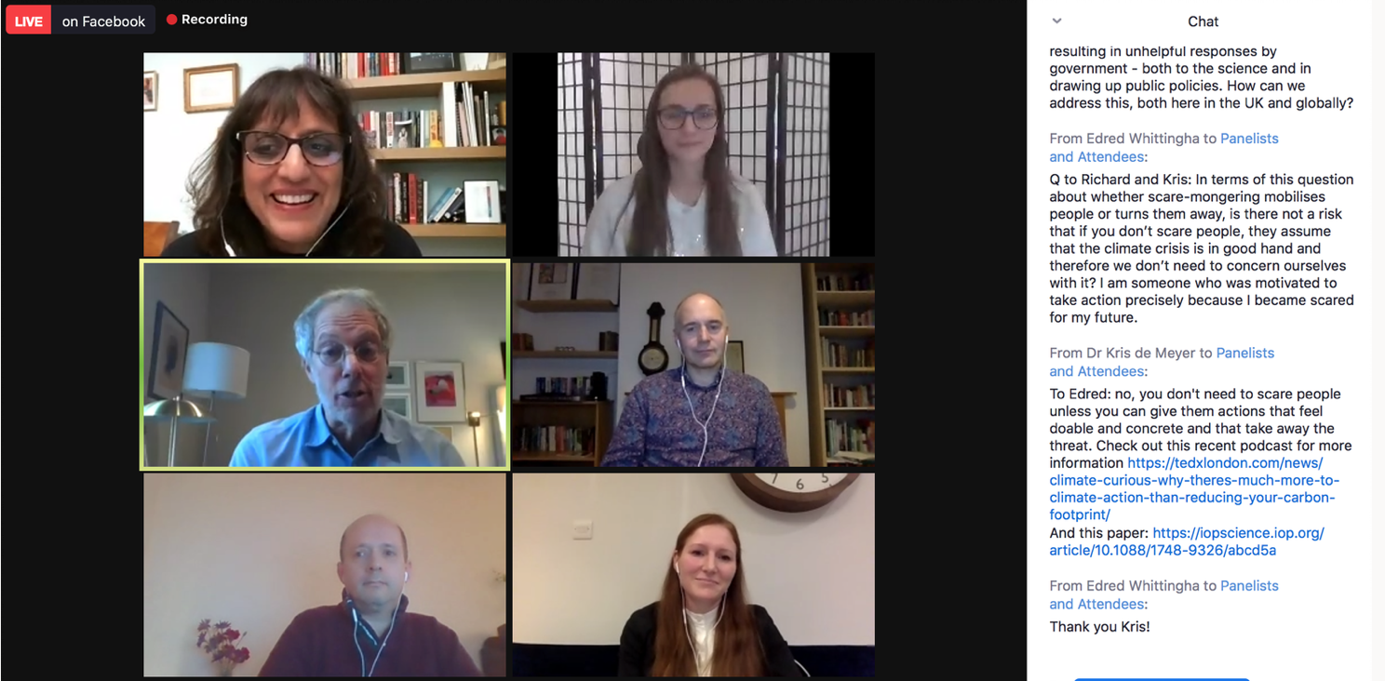
Figure 21. Facebook hosted event
In some cases, researchers reported that digital interactions were possibly better than face to face, as confidence in communicating online has grown hugely over the past 12 months. Researchers noted that it may better suit older and younger audiences too, both in terms of ease of access but also in the ability to communicate and participate (for example those less confident at speaking up in group face to face gatherings).
Students seemed to ask more questions than they normally would - maybe more confident to ask online rather than face to face. Researcher, I’m An EU Scientist
You reach bigger and different audience: it takes less effort for a young pupil to log-in and maybe get drawn in than having to go to a f2f-event. Researcher, Discovery Talk
I really enjoy face-to-face outreach, so in many ways the experience was "neither better nor worse", but doing it online came with the added benefit of reaching more people and reaching people who weren't necessarily actively seeking out science outreach so it felt more inclusive. Researcher, FUTURESxInstagram
For some activities, online might actually work better than face to face, for example if they provide time and space for reflection on the part of both audience and researcher…
It really depends on the type of activity. I believe some activities are best done in person. However, in my case a Reddit AMA worked well because it gave to time to think more before responding to a question. This is good! Researcher, Reddit AMA
Or because the format allows something that would not be possible, practical or as seamless in real life, such as real-time snap polls during events…
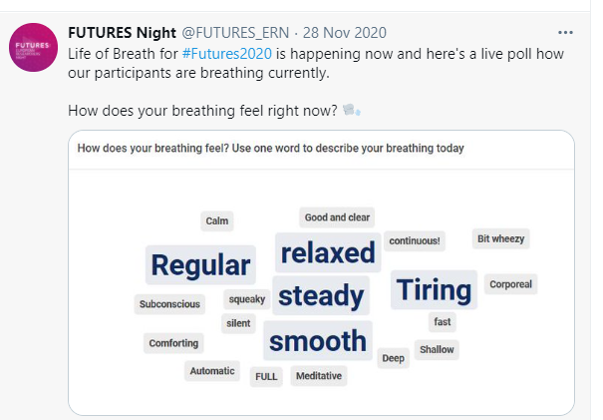
Figure 22. Live poll results from Life of Breath Discovery Talk
This observation report suggests that having a combination of video and text chat can enable more rather than less interaction, compared to a face-to-face setting.
This event had the chat function open, and it was interesting to see how it actually allowed a little more audience interaction than normal, as whilst one panellist was answering a question in speech, rather than sitting silently the other panellists could respond to questions in the chat simultaneously, and actually allowed for more questions to be answered within the time. Observation
Working online threw up a raft of challenges not previously faced by researchers used to face-to-face public engagement activity: it was difficult for them to gauge who was participating in events when video cameras were turned off; not having direct control over the virtual space; freezing and muting issues; and a lack of live chats.
Perhaps, especially with the online version, it would be good to have some pre- and post-event online meetings where different presenters can get together to understand more what each other is doing and learn from each other's experiences and feel more connected with the event as a whole. Researcher, How to Fix a Broken Planet
Some researchers were disappointed at the attendance numbers for their particular events and felt the promotion of them had not been sufficient, particularly by central University social media teams.
Work to have stronger communications about the event. A 'good' audience size for a session about would be ideally well over 100 attendees. Researcher, Discovery Talk
As a consequence of Covid-19 related redesign to FUTURES2020, compressing planning into six weeks, some researchers joined very late, making preparation and marketing more difficult. Central University media teams were also understandably focused on pandemic-related messaging (such as the student experience or Covid-related research), thus having much less capacity to co-promote FUTURES2020.
However, despite some constructive criticisms, most researchers were very appreciative of the level of communications, training and support they received.
The event I took part in was very well organised. I got all the necessary information before, I didn't have to worry about anything. Researcher, Researcher’s Tales
Excellent support for video production, editing and publishing. Researcher, Global Science Show
Working with Joel was fantastic, and everything was made so easy to do (thank you!). Very happy with the final exhibition and grateful to be able to take part! Researcher. FUTURES Exhibition

Impact on researchers
93% of researchers said they had benefited from taking part. Importantly, 70% agreed that public engagement can improve the quality of their research, with 40% strongly agreeing.
67% said they felt at least a bit more confident engaging with the public with 21% saying they felt a lot more confident as a result of taking part. Consequently, nearly half (46%) of researchers said they felt much more likely to participate in public engagement activity in the future and a further 28% saying they were a bit more likely. No researchers said they were less likely to do engagement after their FUTURES experience.
Figure 23. Chart showing perceived benefits from taking part – Researcher’s Survey
The biggest perceived benefit from taking part was enjoyment of sharing their interest and enthusiasm for research (75%) alongside trying out new ways of engaging with the public (72%) and improving communication skills (61%).
I was humbled to see comments in the Reddit AMA that some participants were inspired by my work! Researcher, Reddit AMA
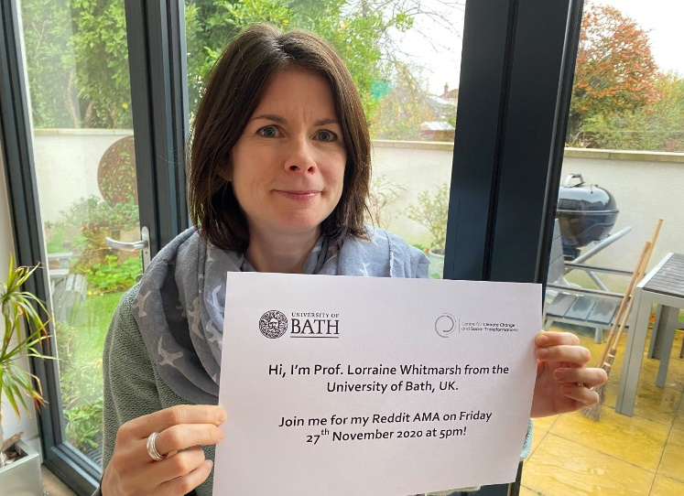
I loved the opportunity to be part of this event, to meet other researchers and to talk about our research with children - especially as it was them asking the questions! Researcher, Futures On Air
Figure 24. Researcher advertising her Reddit AMA session on social media
The workshop was a great experience. I used a new online platform and tried out new angles to my writing activities. The process leading up to the workshop was excellently organised. Thank you! Researcher, Writing FUTURES
I had feedback that this was the first time a lot of people had heard about my study species and found their behaviour really interesting. Researcher, FUTURESxInstagram
I think we all learnt from each other and the children interviewing us were brilliant and really enjoyed it. Researcher, Discover & Discuss
The following feedback indicates just how much of a positive impact taking part can have on a researcher.

📨 A message from your winner, Eliza 🥇
Thank you so much to the students who chose me!
I really enjoyed taking part in I’m an EU Scientist, especially the live Chats. Trying to quickly type out on-the-spot answers to all the great questions (on such a wide range of topics) was both a lot of fun and challenging! I feel very lucky to be involved in science engagement alongside my PhD and have learnt so much from doing this. I would recommend outreach to anyone who wants to improve their communication and presentation skills, to learn more about the science behind their research and how to explain this to a variety of different audiences.
This year has been a difficult one for everyone, and with the cancellation of lots of public engagement events, there have been a lot fewer opportunities for both students and researchers to benefit from outreach. I’m a Scientist is such a brilliant and accessible way for science engagement to take place online, and I’m so happy that I chose to take part. Thanks to everyone that has worked hard to make I’m a Scientist a success, and to the organisers of Futures2020, and once again thanks to all the students for getting involved and for voting for me! – Eliza, winner of the FUTURES Zone
Figure 25. Message to students from I’m An EU Scientist winner
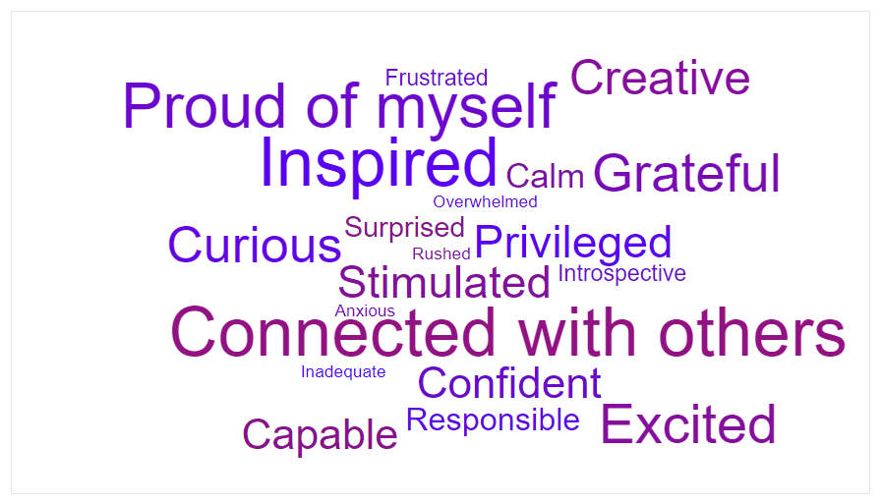
Researchers were asked to select from a list of emotions to describe how they were feeling after being involved in FUTURES, to which the response was extremely positive. As shown in the word cloud (word size is proportional to number of times this was selected), the most selected emotions were ‘Inspired’ and ‘Connected with others’, followed by ‘Proud of myself’.
Figure 26. Image of word cloud indicating the experience of researchers – Researcher’s Survey

Impact on research
Three quarters (76%) of participating researchers believed FUTURES brought credit to their university (31% said a great deal), while over half (66%) believed it brought credit to their research group. When asked about the impact of delivering public engagement online on their research, the response was that it often made them think more about how best to present their work, and to simplify the story to ensure that these new, potentially less academically-focused audiences could fully engage with the research.
It has made me see more possibilities in the way I can present my research to a general audience. Previously I have created short-form documentaries but before this event I wouldn't have considered doing very short casual clips/"reels". Researcher, FUTURESxInstagram
It has required me to think about more engaging ways to communicate and help people to feel involved despite the physical distance and digital barriers. Researcher, How to Fix a Broken Planet
It has really strengthened my enthusiasm to present my research as a coherent story. Researcher, Researcher’s Tales
It made me think of how to explain my research in really simple terms. Researcher, I’m An EU Scientist
As mentioned previously, some of the interactions based on social media and online platforms appear to have created genuine dialogue between the public and researchers. Whilst it is often thought that such online interactions are perhaps shallow or fleeting, in fact they appear to have had a much deeper impact than expected.
The question and answer process that's the Reddit AMA made me reflect on my entire academic career. That was both stimulating and humbling. It's also important to researchers to be made to think about the wider societal implications of their work and consider their responsibilities. The FUTURES event(s) highlighted that. Researcher, Reddit AMA

Impact on collaborators
Although not originally an evaluation question it became clear during the data analysis that there had been a considerable impact on the approximately 20 creative and professional collaborators that worked with researchers on a number of the activities (particularly the Instagram and Community Radio activities as well as in the Workshops producing the Exhibition content). In particular they commented on their own learning and increased engagement with research.
I enjoyed learning about different fields of research - it's made me want to start looking for more scientists to follow on insta! Instagrammer
I've thought about how to make my posts more scientific and inclusive to all audiences. Instagrammer
It’s such a joy to work with people so closely in this way, it was really touching to be facilitating. Artistic Practitioner, Letter To My Kidney Workshop & Exhibition
This is particularly significant given the large numbers of people such ‘influencers’ can reach on social media platforms like Instagram. Two creative practitioners involved in the Exhibition Workshops intend to develop the activities further and one has already applied for funding to do so.

What do we need to change for future FUTURES or similar events?
Given the changes necessary due to Covid-19, many suggestions were around digital interaction, both in audience ability to access and engage, and the researcher’s skill and experience in delivering events online.

Audience experience
From the audience survey, observation and snapshot interviews a number of areas for consideration were identified for forthcoming FUTURES or similar events.
- Technical improvements including: improvements in subtitling, lighting and sound quality; more preparation and rehearsal by presenters to ensure familiarity with platforms; availability of event recordings after the event for those unable to attend live
- Clearer descriptions of events in marketing: to ensure it is clear which audience an event is aimed at; the style of presentation; level of interaction and technology required to join.
- More interaction with audiences: using moderated chat and/or Q&A functions in more events to boost two-way conversations; more feedback to presenters to enable them to adjust their presentation style or speed appropriately.

Researcher experience
To overcome the issues identified by researchers above, the following changes could be considered:
- More training and/or rehearsals for researchers
- More audience interactivity on the digital platforms
- Boosting promotion of events by central university media teams with large reach, by clearly demonstrating how FUTURES events promote their PR aims too

Organisation, logistics & activities
In retrospect, some organisers felt there may have been too many events over a short period of time, given that the novel online events were more time consuming to organise than physical ones.
- Pre-recording events or pre-preparing them for release to social media feeds could reduce some of this last-minute stress, particularly if they are run independently by collaborators rather than by the FUTURES consortium.
The role of the website was greater than expected due to the pivotal role it ended up playing, but was under resourced for what was eventually required. Additionally, some event listings were not as clear as they could have been, often due to last-minute changes to planned events.
- Increase resource for website, particularly to ensure event-listings are easily searchable and to provide a more creative and attractive format
- Identify broad topics for events beforehand to enable better tagging in listings and clearer promotion
- Tag events thoroughly e.g. by topic, audience, location, format, length, timing etc.
- Create a more individualised search function e.g. “what topics interest you?”
In terms of attracting a variety of audiences in the digital space and enabling genuine two-way dialogue the following points are key:
- It is crucial to have a mix of event styles, big webinars as well as more intimate / interactive ones, and for them to be clearly marketed as such
- Timings and lengths of events are also a critical factor, shorter events worked better in daytime
- Careful consideration needs to be given to the digital platforms used, and which best suit certain audiences
For example, Remo was a good, but expensive platform for the virtual research fair as it enabled conversations and interactive activities. The quiz and hosted event formats also worked well, being more engaging for audience and presenters alike. It was also noted that participants connected better online if they already had met face-to-face. Therefore, suggestions for ensuring quality experiences include:
- Ensuring events have a confident host who can give introductions and ask questions etc. helps to engage the audience
- Use separate moderators and technical assistants to ensure events run smoothly for both audience and presenters
- If possible have mixed events – part digital and part in-person (pandemic restrictions permitting) – to increase audience engagement and feelings of connection
There were some high drop-out rates between booking and attending, particularly for longer events and those taking place in the daytime, when there are often more calls on peoples’ time.
- Setting realistic expectations of attendance and making presenters aware in advance that drop-outs are likely to happen is helpful.
Some of the issues noted can really only be overcome by practice and greater familiarity with online platforms and audiences. The learning that the consortium, partners and researchers have gained as a consequence of the swift switch to remote festival delivery will inform future events and certainly improve them second time around.

Overall success of FUTURES2020

How successful in meeting the impact objectives were the activities?
FUTURES2020 has once again successfully met the impact objectives for European Researchers’ Night, despite many pandemic-related challenges. Even in a country-wide lockdown situation, the 260 researchers managed to bring interest, insight and interaction to almost 45,000 people from across the South West of England and beyond.
The fully remote nature of the programme, far from being a negative, has actually diversified the audiences taking part and opened up events to people who otherwise would not be able to attend in person. Using social media platforms for activities has brought research to familiar online spaces, making it ‘everyday’ rather than inaccessible, and normalising conversations about it.
More people than ever before have become aware through FUTURES2020 of the importance of EU research and researchers, and the benefits it brings to society. Participants continue to show a favourable attitude towards the European public funding of research, and increased understanding of the EU’s contribution, perhaps even more so as the ramifications of Brexit become clearer.
The conversations and connections between audiences and researchers have facilitated a better understanding of an incredibly wide variety of research topics; of researchers as people, thus reducing stereotypical impressions; and of the benefits and opportunities that a career in research affords. The large number of children and young people participating with their families means they have all been exposed to the same positive messages and are encouraged to stay curious and keep on discovering together, into the future.
“I was amazed at the amount of research that is going on. We need more of these events to inform people about science and the importance of research. Just brilliant.” Event Participant
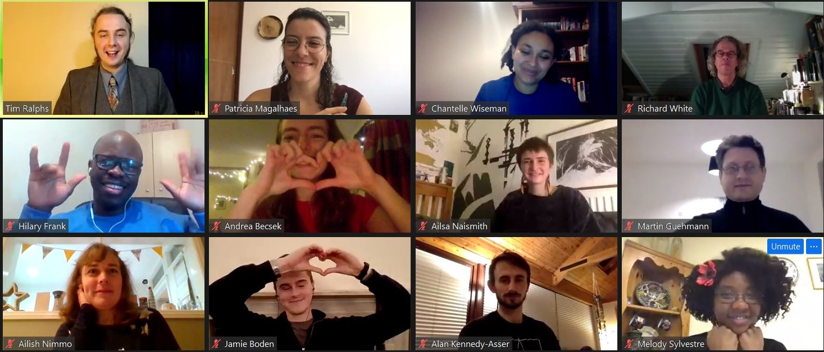
Figure 27. Sharing the research love - screenshot from Researchers' Tales event

APPENDIX 1: Gender-breakdown for event delivery

Participant | Female researchers | Male researchers | Female workers in overall Workforce | Male workers in overall Workforce | Total female involved | Total male involved
UOB | 89 | 65 | 14 | 3 | 103 | 68
UOBA | 18 | 9 | 4 | 5 | 22 | 14
UOE | 18 | 8 | 4 | 1 | 22 | 9
UOP | 15 | 16 | 8 | 0 | 23 | 16
BSU | 5 | 5 | 1 | 0 | 6 | 5
Other Institutions | 6 | 6 | 0 | 0 | 6 | 6
TOTAL | 151 | 109 | 31 | 9 | 182 | 118

APPENDIX 2: Evaluation Response Data
Evaluation Tool | Number of Responses
Eventbrite registrations ^{i} | 1,947
Researcher Survey ^{ii} | 61
Research debriefs ^{ii} | 10
Partner and organiser feedback ^{ii} | 5
Observations and Snapshot Interviews | 31
Public Survey via Eventbrite | 199
Teacher Feedback | 2
Zoom polls | 496
Total Number of Audience Feedback Responses | 728 ^{iii}
Number of Participants at Events ^{iv} | 1,545
Response Rate ^{v} | 47%
i. Used for Demographic Analysis only
ii. Not included in audience feedback response total below
iii. There may be some duplication between these sets of responses
iv. Not including radio or social media activities
v. Number of event participants ÷ Number of audience feedback responses x 100

APPENDIX 3: Research Questions
The table below sets out the research questions used for the impact evaluation, the data analysed and the tools used to collect the data.
QUANTITATIVE IMPACT DATA
Impact Objective | Data | Tool for collection
Number of attendees | Participant count – overall and at each event | Event registration  Entry counts (e.g., stickers)
Type of participants | Participant demographics (including age, gender, ethnicity, socio-economic background etc.) | Event registration  Event observation  Postcard survey  Post-event online survey
Number of researchers involved (especially those funded under FP7/H2020) | Researcher count and funding source / research project | Researcher sign-in sheets and pre-event information forms
Reach of awareness campaign (website, social media, print media) | Media circulation  Social media interactions | Media contacts  Universities Press Office cuttings service  Google Analytics and similar online tools
Evolution over time | Numbers of attendees, researchers, events and venues involved | Comparison with previous reports (FUTURES 2018/19 and Bristol Bright Night 2014/15)
Numbers of participants reporting a positive experience at a FUTURES event | Participant opinions | Event observations  Snapshot interviews  Teacher questionnaire  Postcard survey  Opinion trees  Post-event online survey

QUALITATIVE IMPACT DATA
Impact Objective | Subsidiary Research questions | Data | Tool for collection
Increased awareness among the general public of the importance of research and innovation and a more favourable general attitude towards its public funding | Has FUTURES raised awareness of the importance of research and innovation?  Do participants feel that the research presented was relevant to their lives?  Do participants feel more positive about public funding of research? | Participant opinions  Researcher reflections | Event observations  Snapshot interviews  Postcard survey  Opinion trees  Sticker votes  Teacher questionnaire  Post-event online survey  Researcher survey
Better understanding of the key benefits that research brings to society | Do participants report a better understanding of or an increased interest in a research topic? | Participant opinions  Researcher reflections | Event observations  Snapshot interviews  Postcard survey  Opinion trees  Sticker votes  Post-event online survey  Researcher survey
Reduction of the stereotypes about researchers and their profession | Do participants feel that researchers are ‘people like me’? | Participant opinions  Researcher reflections | Event observations  Snapshot interviews  Postcard survey  Opinion trees  Teacher questionnaire  Post-event online survey  Researcher survey
Better understanding of the European Union among the general public | Has FUTURES raised awareness of EU research and researchers?  How do South West residents feel about EU research and researchers having taken part in FUTURES? | Participant opinions  Researcher reflections | Event observations  Snapshot interviews  Postcard survey  Opinion trees  Post-event online survey  Researcher survey
Increase, in the long term, of people taking up research careers; | Has FUTURES increased (or reinforced) awareness of research careers?  Would participants be interested in taking up a research career or would they recommend it to someone else? | Participant opinions  Researcher reflections | Snapshot interviews  Opinion trees  Sticker votes  Teacher questionnaire  Post-event online survey  Researcher survey
Appreciation of events and intention to participate in future | Did participants enjoy their experience at FUTURES?  Would participants attend a similar event in future? | Participant opinions | Event observations  Snapshot interviews  Opinion trees  Teacher questionnaire  Postcard survey  Post-event online survey
What was the experience of researchers participating in Researchers’ Night | What were the benefits for researchers?  What was the impact on their research and institution? | Researcher opinions  Partner opinions | Debrief interviews  Researcher survey
What could be improved? | Organisation  Venues  Activities  Participant experience  Researcher experience  Achievement of impact goals | Participant opinions  Researcher opinions  Partner opinions | All tools
Success of activities | How successful in meeting the impact aims were the events? | Participant opinions  Researcher opinions  Partner opinions | All tools

APPENDIX 4: Evaluation Tools
- Event Observation & Snapshot Interview Proforma
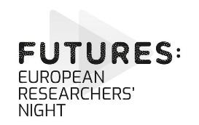
FUTURES: European Researchers Night 2020
EVENT Observation & Snapshot Interview Guide
Please use this guide to record as much as possible about your observations and any ‘snapshot interviews’ you get a chance to carry out with participants.
These will help evaluate the effectiveness of the event as a whole and will not be used to judge individual performances.
Collated results will be used to improve the events next year and in our formal report to the EU.
We are particularly interested in the following aspects:
- Has Researchers’ Night raised awareness of EU research and researchers?
- How do Bristol and Bath residents feel about EU research and researchers having taken part in Researchers’ Night?
- Has Researchers’ Night increased (or reinforced) awareness of research careers?
- Did the Researchers’ Night activities meet the needs of Bath and Bristol residents?
- What was the online experience like, compared to face-to-face events?

What to do
OBSERVATIONS
→ Observe interactions between researchers and participants for 5-10 minutes at a time
→ Focus on the participants’ reactions, comments and experience
→ Note any interesting quotes from participants or researchers
→ Comment on what approaches worked well and note anything that didn’t work so well
→ Circulate around the event if appropriate (e.g., visit different breakout rooms) and observe different interactions if possible
SNAPSHOT INTERVIEWS / MINI FOCUS GROUPS
→ Ask participants (individually or in small groups) a couple of questions from the list below at an appropriate time, e.g. at the end of the event
- Did you enjoy the event / activity?
- What did you talk to the researchers about?
- Have you discovered anything interesting today?
- Have you found out anything that’s surprised you?
- What was the online experience like for you, compared to face-to-face events?
- Is there anything we could improve about this event / activity?
→ Record their responses (audio/video record if possible) and note any interesting quotes
OBSERVATION NOTES (complete one sheet per observation)
Observation Start Time: |  |  | End Time:
Brief Description of Activity observed: (presentation, hands-on activity, group discussion etc.)
Enjoyment: (are participants enjoying the activity and/or talking to the researchers?)
Enjoyment of Activity  - High  - Medium  - Low |  |  |  | Enjoyment of Talking to Researchers  - High  - Medium  - Low
Comments:
Engagement & Interactions: (how are participants engaging with the activity and the researchers?)
- High Engagement  - Medium Engagement  - Low Engagement | - Easy to engage  - Neither hard nor easy  - Hard to engage |  |  |  | - Mostly one-way communications  ○ Participants ○ Researchers  - Mostly two-way interactions
Comments:
Topics of Conversation: (what are participants & researchers talking about?)
→ Tick all that apply & indicate with a double tick which topic, if any, comes up most
- Research Topic  - the Researcher’s working life  - the Researcher as a person |  | - Research Careers  - Participants’ opinions about research topic  - Participants’ experience of research |  |  |  | - European aspects of research  - Other (please specify)
Comments:

Have Participants…? (tick all that apply and note their responses briefly)
- Discovered something new
- Changed their mind about something
- Been surprised by something
- Been inspired to find out more about a topic
- Made a suggestion about the event / activity
Comments:

SNAPSHOT INTERVIEW / MINI FOCUS GROP NOTES
(complete one sheet per interview/focus group)
Time of Interview:
Brief Description of Activity observed: (presentation, hands-on activity, group discussion etc.)
Enjoyment: (Did participants enjoy the activity and/or talking to the researchers?)
Enjoyment of Activity  - High  - Medium  - Low |  |  | Enjoyment of Talking to Researchers  - High  - Medium  - Low
Comments:
Topics of Conversation: (What did participants & researchers talk about?)
→ Tick all that apply & indicate with a double tick which topic, if any, comes up most
- Research Topic  - the Researcher’s working life  - the Researcher as a person |  | - Research Careers  - Participants’ opinions about research topic  - Participants’ experience of research |  |  | - European aspects of research  - Other (please specify)
Comments:

Have Participants…? (tick all that apply and note their responses briefly)
- Discovered something new  - Changed their mind about something |  |  |  | - Been surprised by something  - Been inspired to find out more about a topic
Comments:

What was the online experience like for participants? (tick most applicable response & note comments)
- Better | - Neither better nor worse |  |  | - Worse |  | - Not Sure
Comments:

Any suggestions for things we could improve about this event / activity?

- Post-Event Public Survey
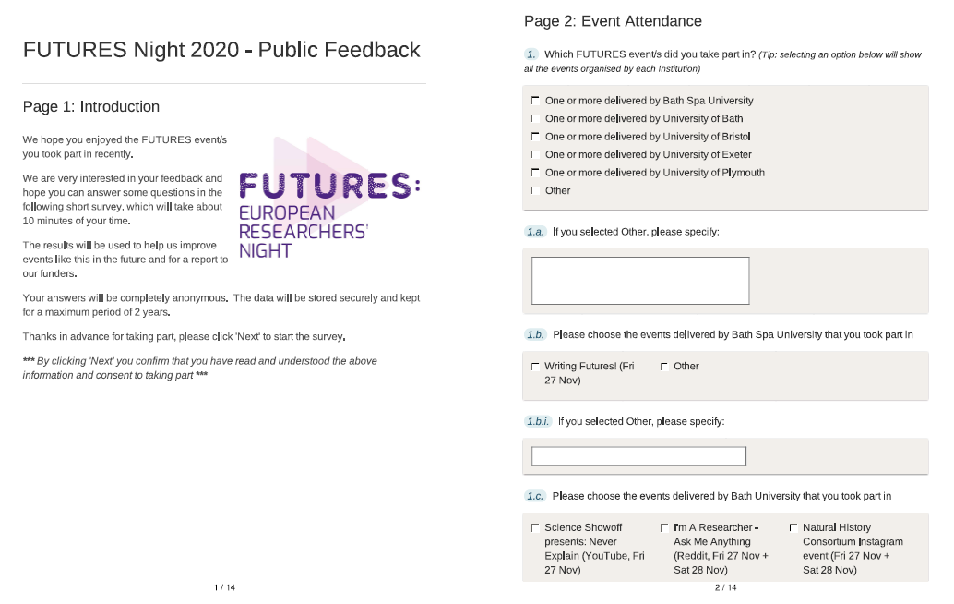
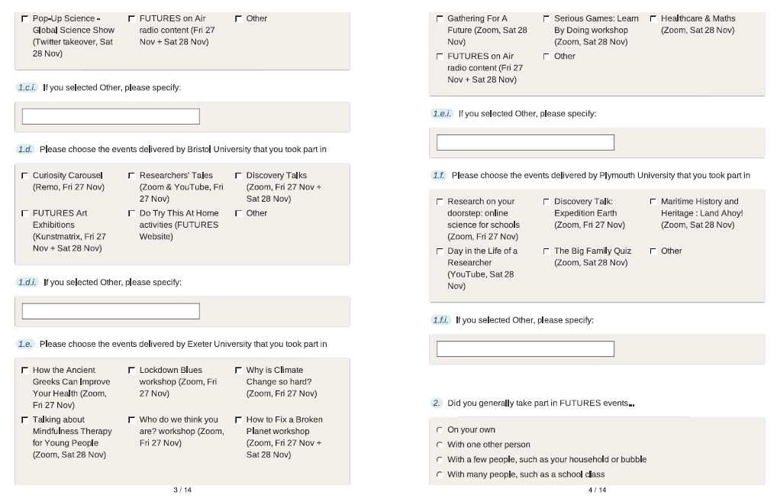
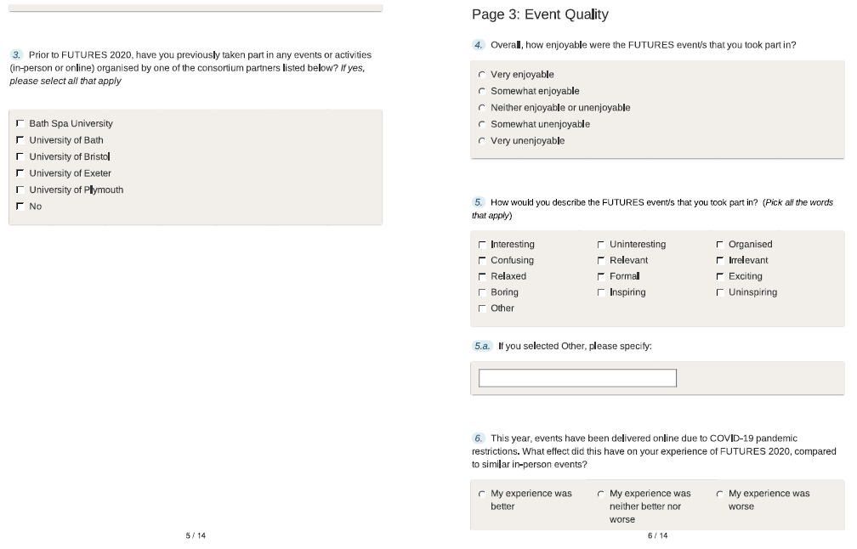
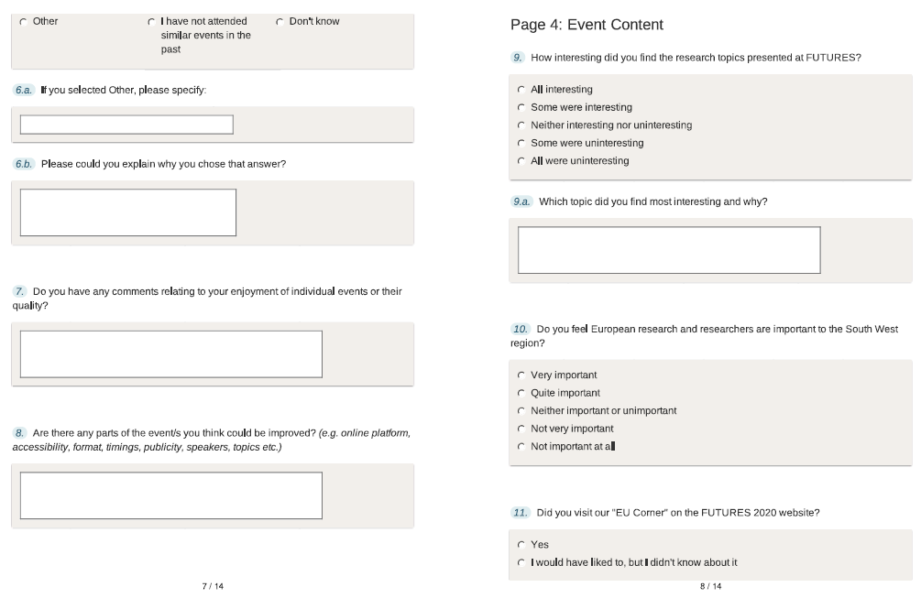
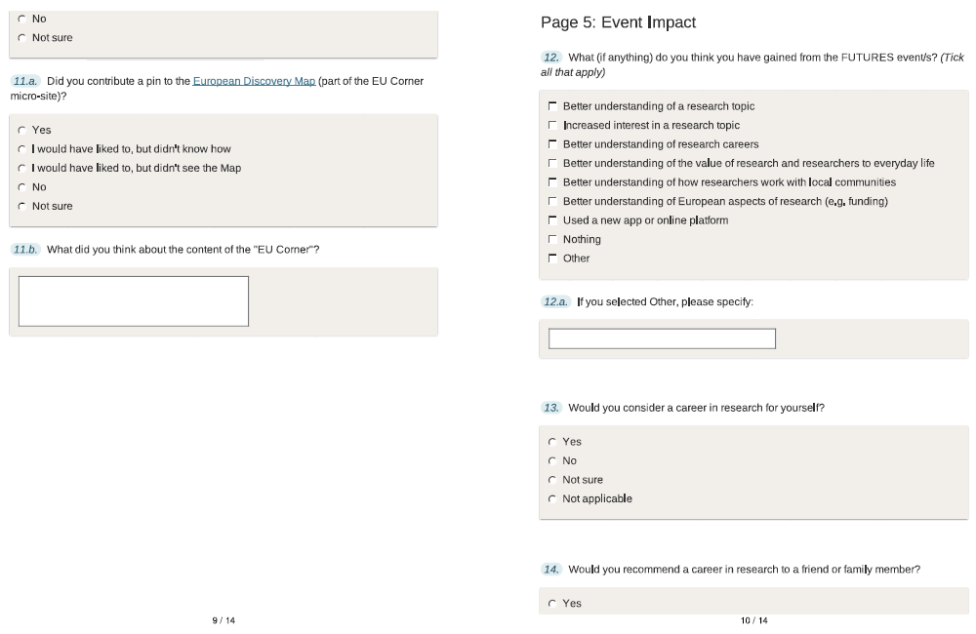
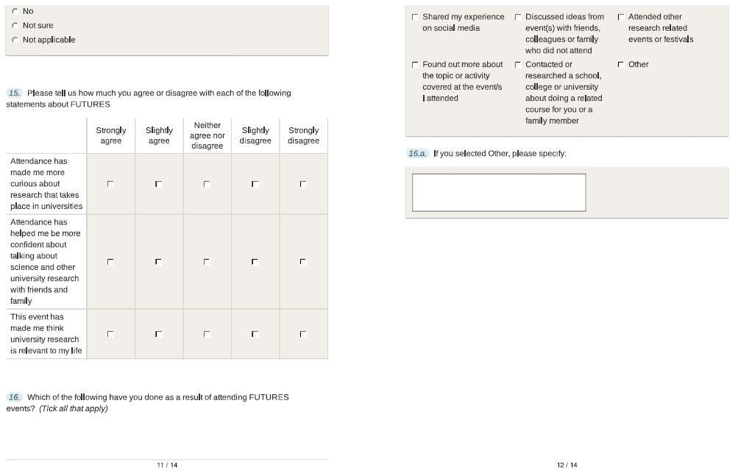
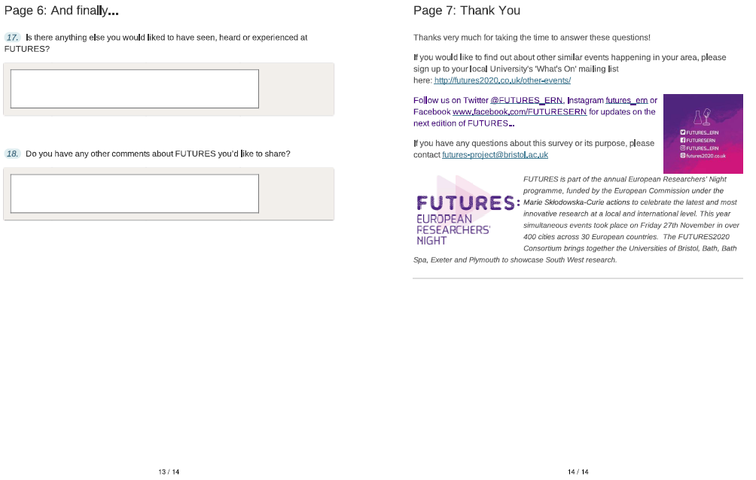
- Post-Event Researchers Survey
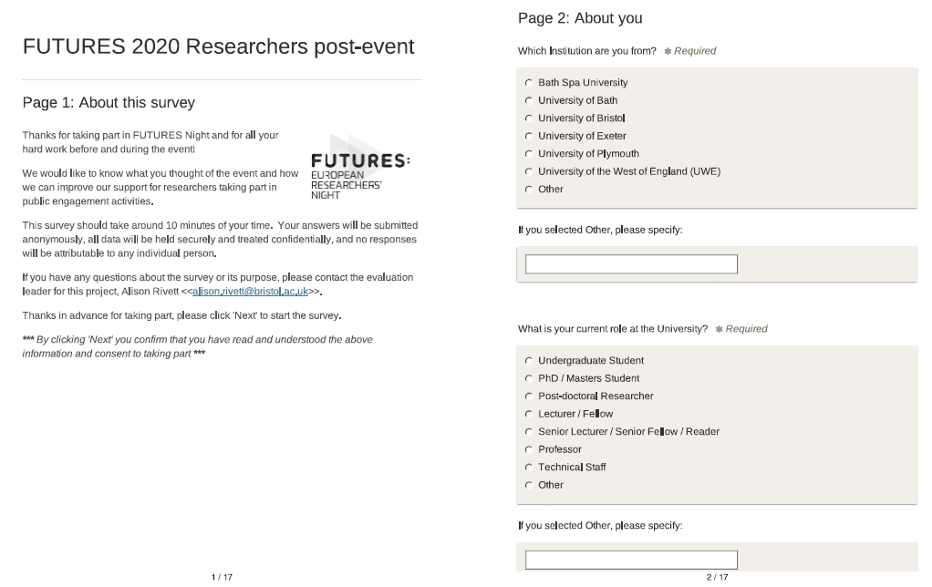
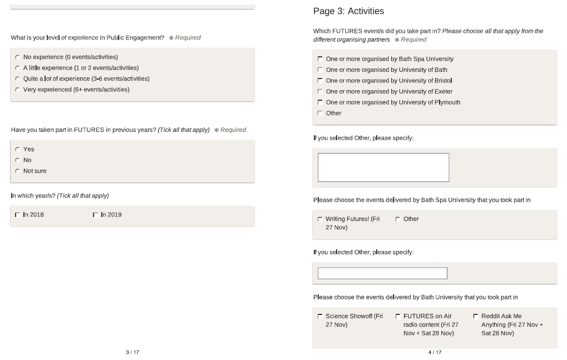
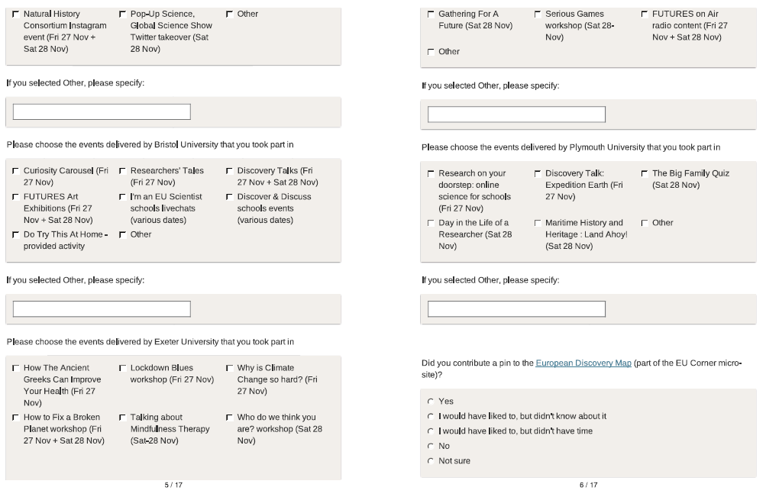
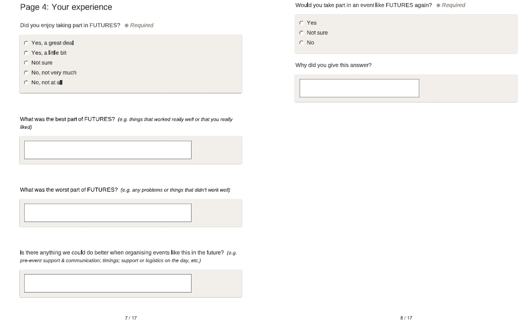
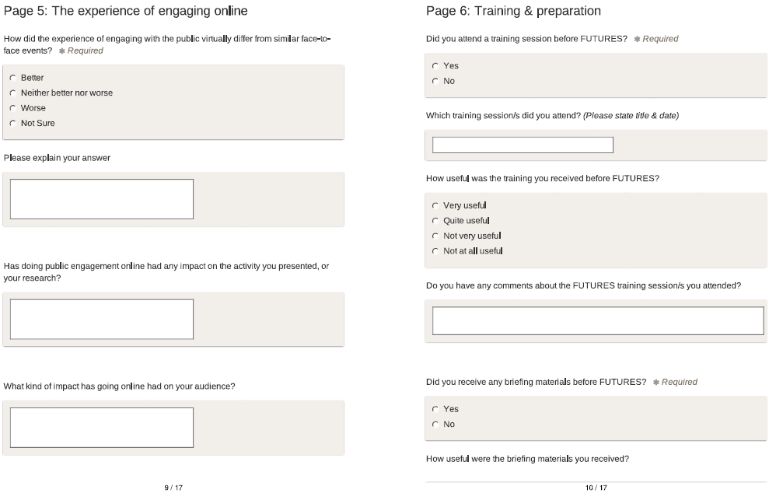
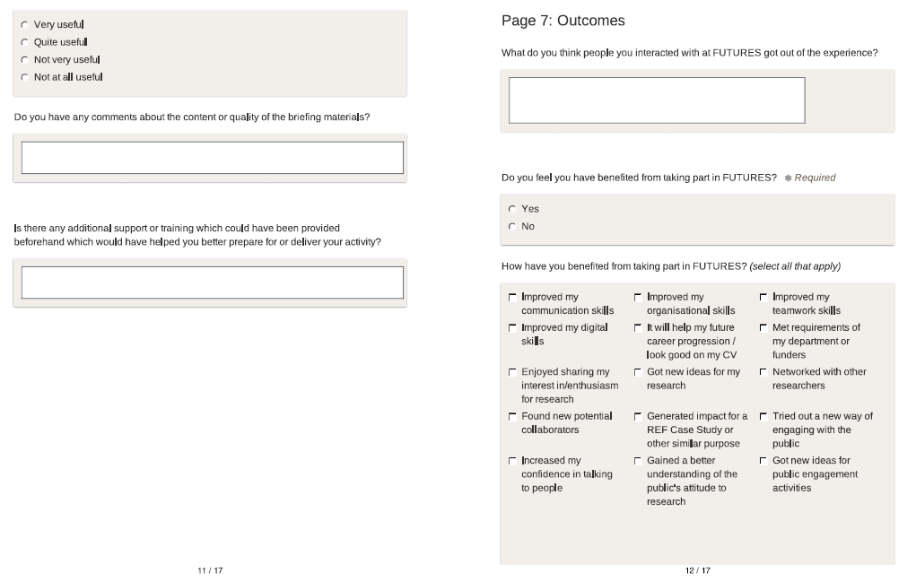
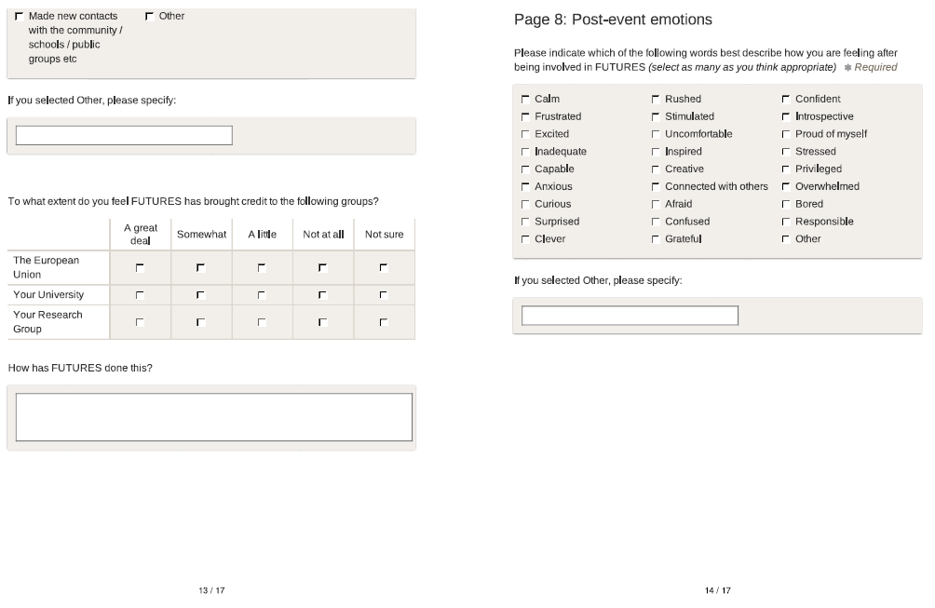
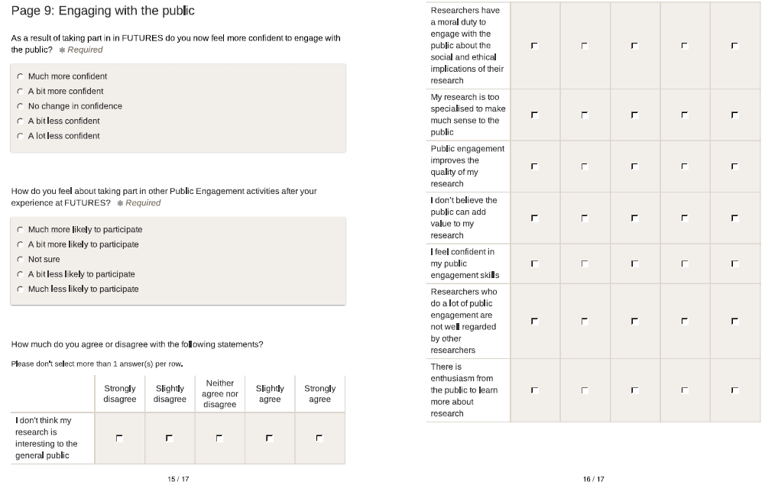
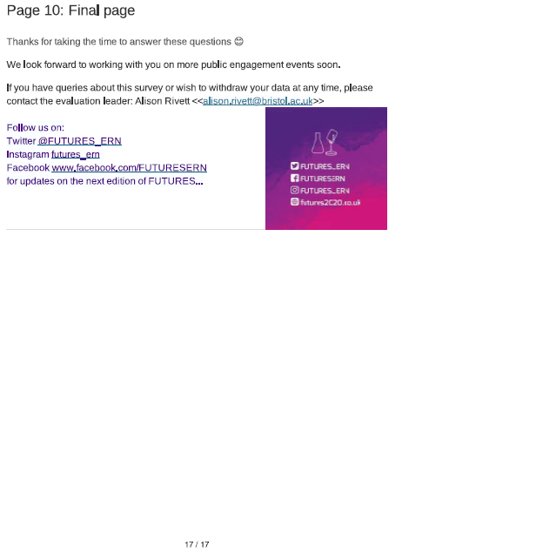

- Pop-up Poll Questionnaire

1. How many people watched the event on this device?
1
2
3 - 5
6 - 10
11 - 20
20 - 30
30+

2. Did you enjoy it?
Yes
No
Not Sure

3. Did you find out something new?
Yes
No
Not Sure

4. Did this feel relevant to you?
Yes
No
Not Sure

5. Have you attended an event organised by XXX University before?
Yes
No
Not Sure

- Teacher Questionnaire
- Pre-event Registration Form (Eventbrite)

Attendee Information
Note to registrant: We are asking these questions because we want to find out whether FUTURES events are of interest to a diverse audience.

Standard Information collected by Eventbrite
First Name …………………………..
Surname …………………………..
Email Address …………………………..

What is the first half of your postcode? (e.g. BS3, BA21) …………………………..
Or, if you are joining an online event from abroad, what country are you from? ………

How would you define your gender?

Female
Male
Prefer to self-define ……………………
Prefer not to say

Which of the following ethnicities do you most identify as?

White British / Irish
Black / Black British
Asian / Asian British
Mixed
Other (Please Specify) ………………
Prefer not to say

How many people will be joining this event?

1
2 – 5
6 – 10
11 – 20
21 – 30
31+

Please indicate the ages of all those joining the event

Under 16
16-20
21-25
26-35
36-45
46-55
56-65
65+
Prefer not to say

How did you hear about the event? (choose all that apply):

Social media: What channel? Facebook
Twitter
Instagram
Eventbrite
Email newsletter or similar Who from? …………………………..
Local press
Local radio
Friends / Family / Word of mouth
Web search
Poster or printed leaflet
University website
Other (Please Specify) …………………

Event listings (e.g. What’s On, venue’s listings etc.)

What made you want to attend the event? (choose all that apply):

I'm interested in the subject
I would like to pursue a career in this area
I want to learn something new
I’m interested in the venue
It sounds fun
I want to hear more about European research
I know someone involved
It sounds like it will be good for children
Other (Please Specify) …………………

NB. Questions regarding attendee’s accessibility requirements should also be included for individual events as appropriate.

In this report ‘interactions’ are used as a general term; with ‘engagements’ referring to social media, radio, and ‘at-home’ -type remote activities; and ‘participation’ for the bookable online live events (e.g. via Zoom), with audio-visual contact between participant & researcher. It is not possible to calculate how many of these interactions were ‘unique’ i.e. how many people interacted more than once, or with more than one activity.
As well as ‘drop-in’ events, engagements via activities taking place online and on the radio are not included in this demographic analysis as it was not feasible to collect such data.
Whether participants were from deprived households or not cannot be established from the available data
The lower the number the higher the level of deprivation, red indicates 10% most deprived, yellow indicates 30% most deprived. LSOA – Lower Layer Super Output Area

