Booking or cancelling your place on a course using Employee Self-Service (ESS)
Booking or cancelling your place on a course using Employee Self-Service (ESS)
1. Logging into ESS and accessing the Learning and Training tab
2. Booking a place on a course
3. Cancelling your place on a course

Logging into ESS and accessing the Learning and Training tab
- Log-in to Employer Self-Service.
- Click on the tab called ‘Learning and Training’ at the top of the home page. 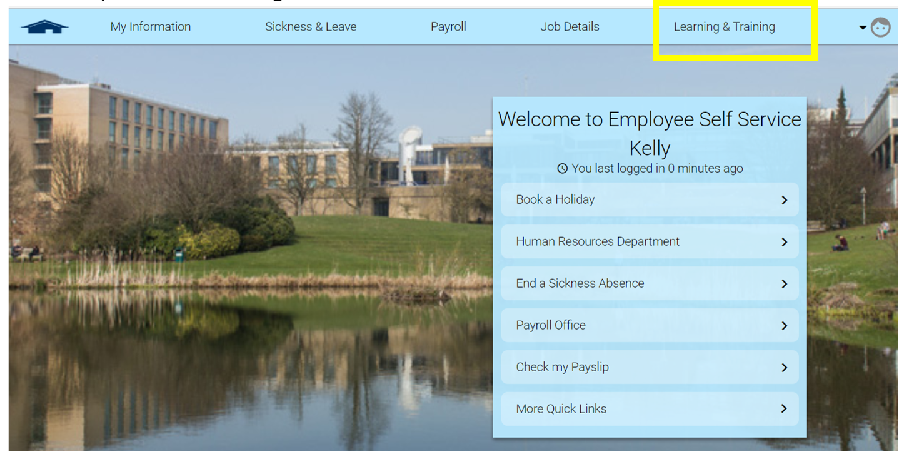

Booking a place on a course
- Click on the ‘Search learning activities’ button on the Learning and Training page

- Type the name of the course you wish to attend in the search bar and click the Search button. We recommend typing a few key words from the course name to help refine the search.
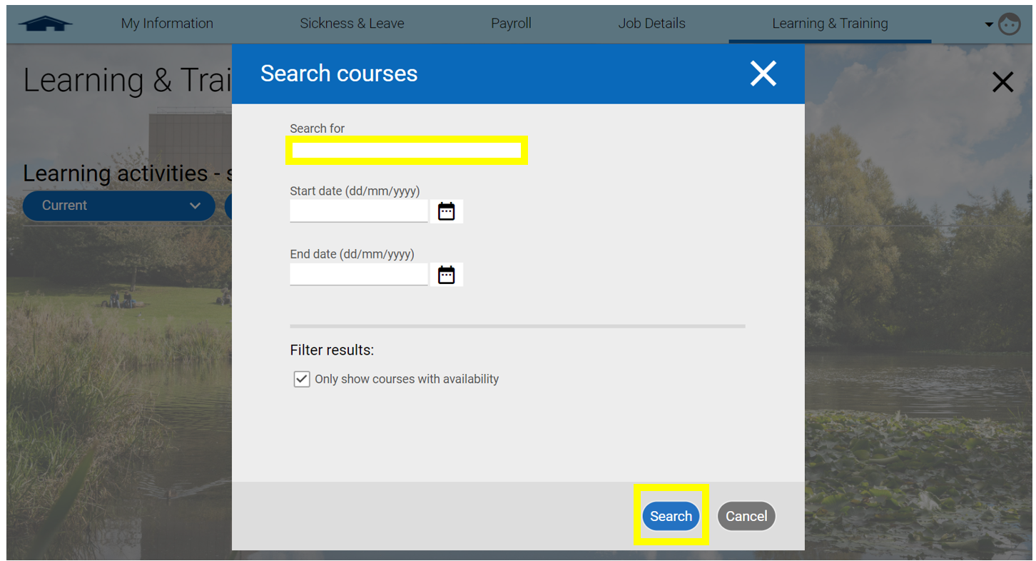

- Click on the course you wish to attend in the results section. If multiple dates are available these will be listed within the details.
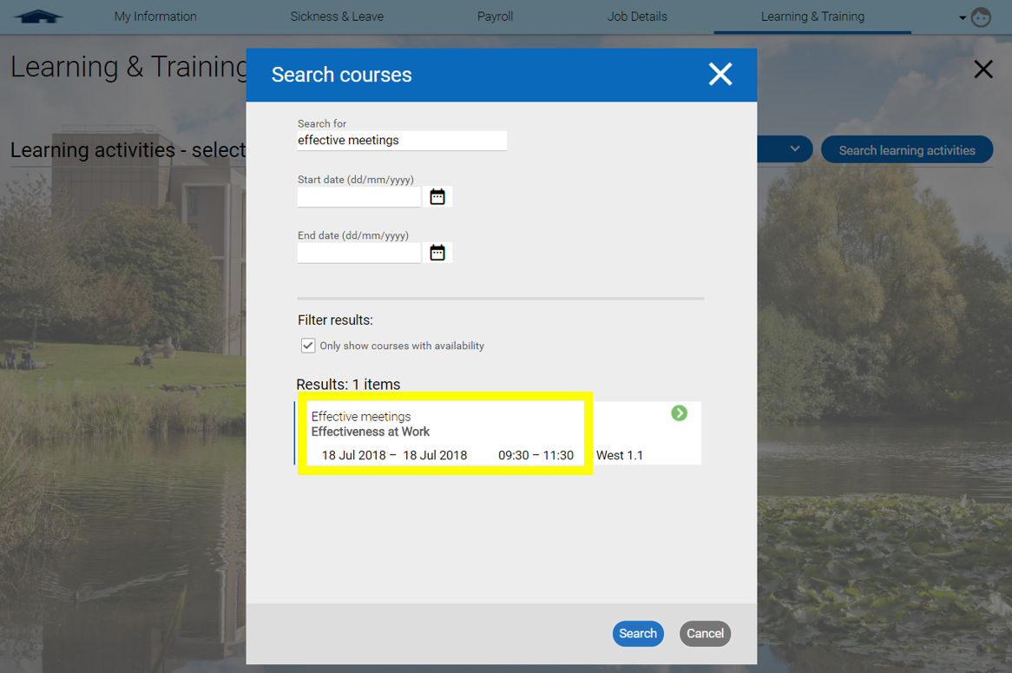

- Click on the course you wish to attend. If the course has multiple dates or times listed, click on your preferred date.
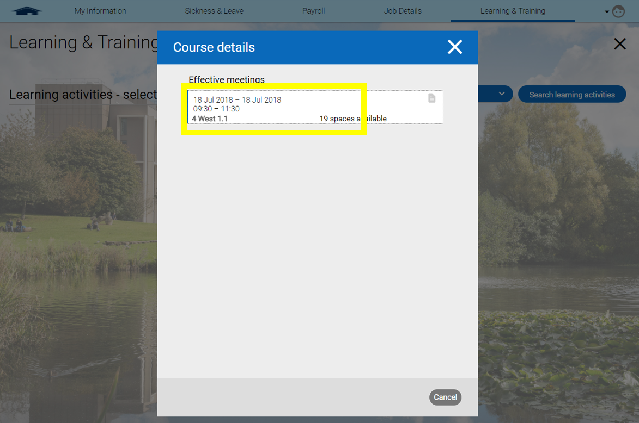
- Click save. It is optional to enter your personal learning objectives for attending the course – these will only be visible to you.
Please note: your mobility constraints (as noted in your ESS details) are shown under Other information. This is only visible to you.
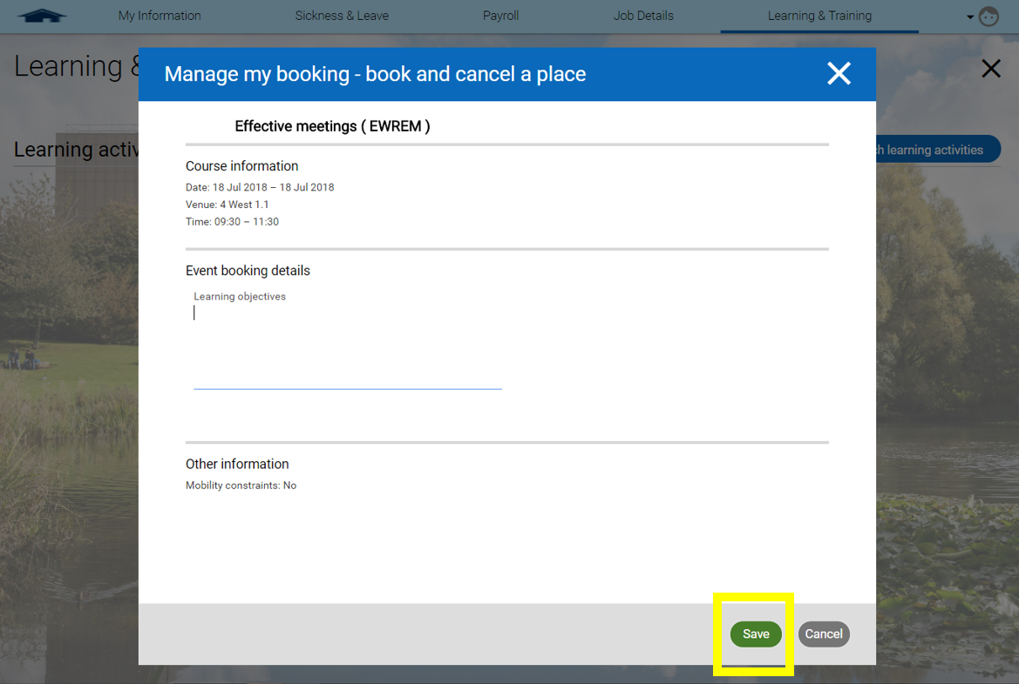

- The course should now show as a learning activity on your Learning and Training page. You have successfully booked your place.
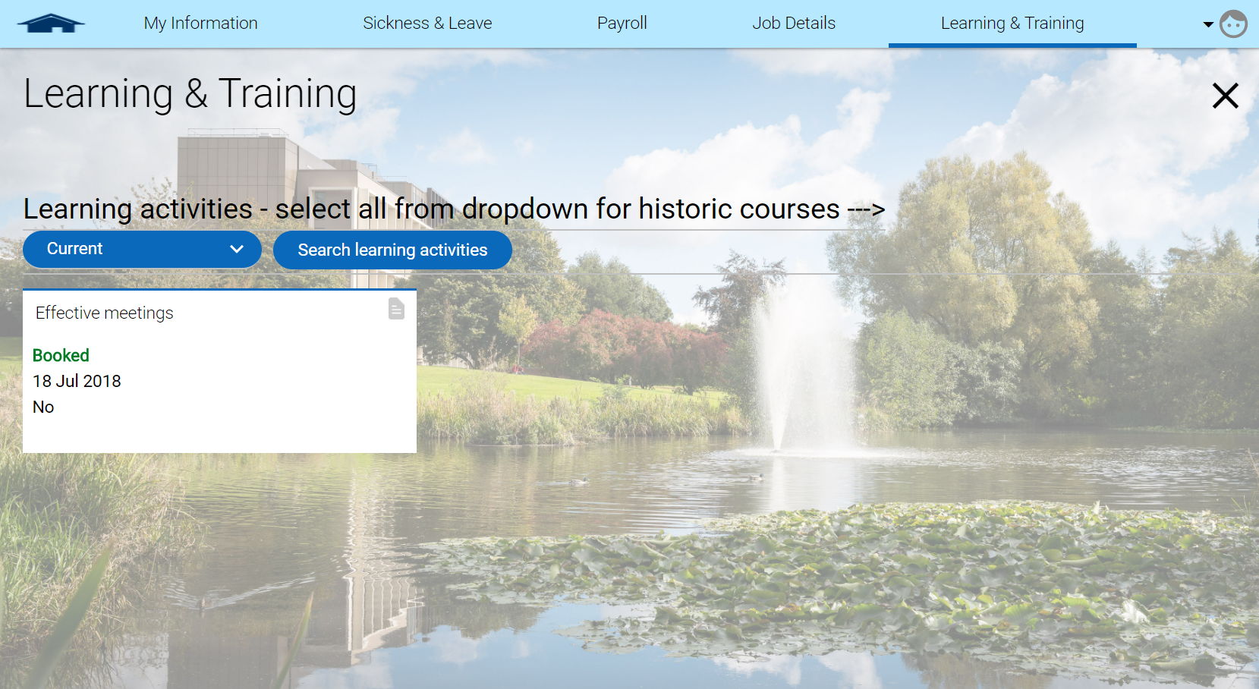

Cancelling your place on a course
- Select either ‘current’ or ‘booked’ from the drop down menu on the Learning and Training page so that your current learning activities are shown.
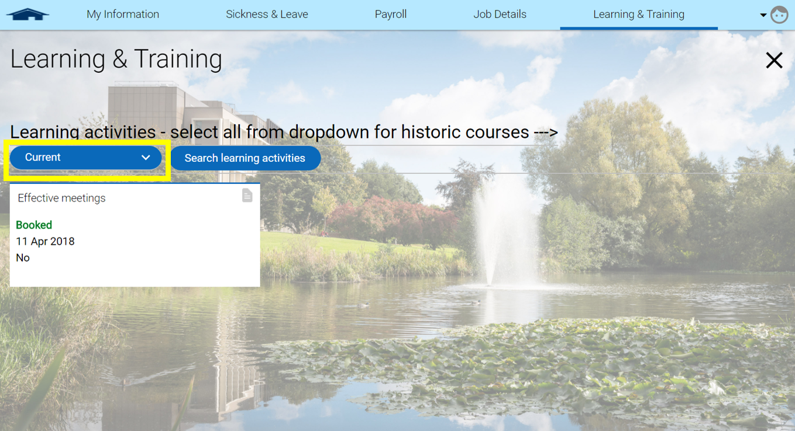

- Click on the activity which you wish to cancel your place for. You can only cancel a place for one activity at a time.
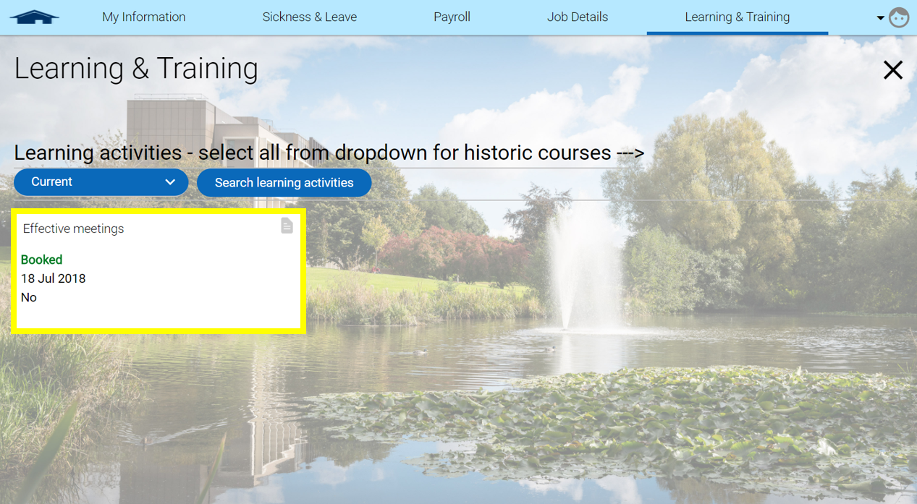

- Select your reason for cancelling your place from the drop-down menu called ‘cancel reason’ and click ‘Save’.
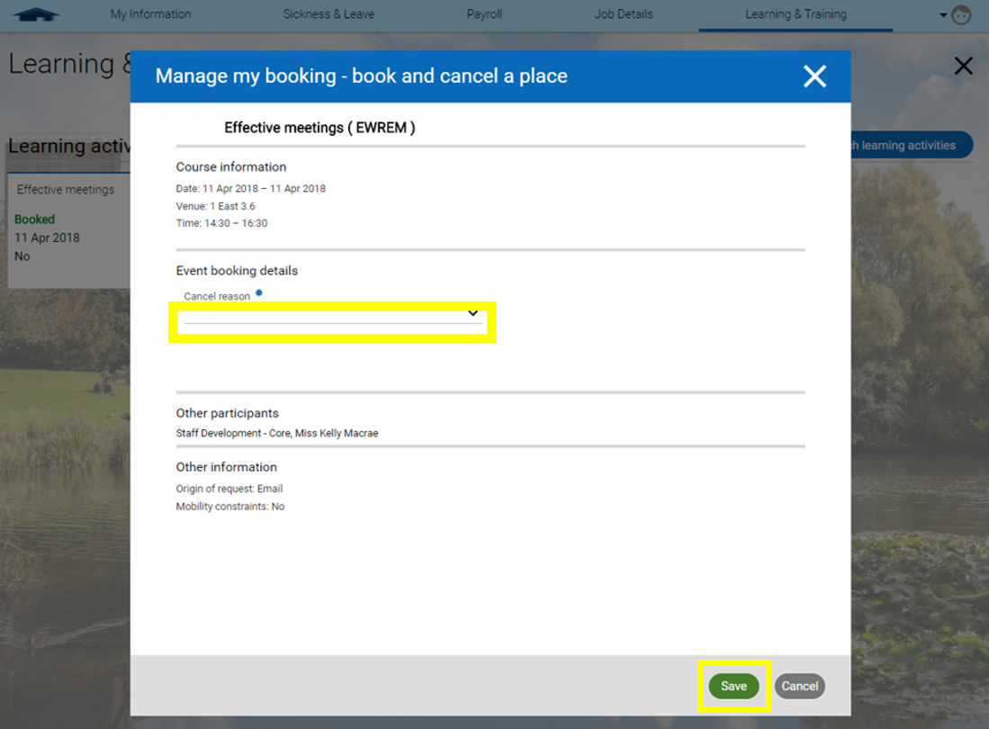
- Confirm you wish to cancel your booking by clicking ‘ok’ in the pop-up.

- The course will no longer be shown on your Learning and Training page under ‘current’ or ‘booked’ learning activities.

- You can double-check the cancellation has worked by selecting ‘cancelled’ from the drop-down menu on the Learning and Training page. The course you cancelled should now be shown on the page.
