When it comes up with a message of Insufficient Funds
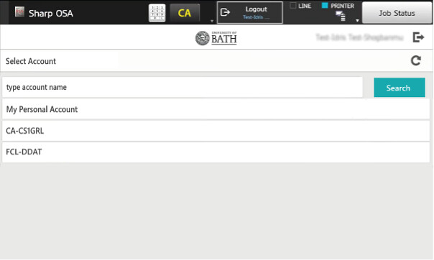
When you log into a printer, you are prompted to select an account to use if you do any photocopying. You are also prompted to select an account for each document you print.
Before the switch to PaperCut software in August 2024, the account you selected at login was used for printing. You no longer have to log out and in again if you need to charge print jobs to different accounts.
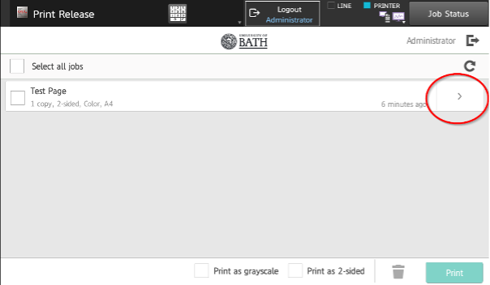

Make sure you select the correct account. If you select your personal account and it does not have any credit, you will see the message, ‘You do not have sufficient balance to release the job(s).’ If this happens, you will need to change the account associated with the print job using the following steps.
- From the list of print jobs, press the arrow next to the document name.


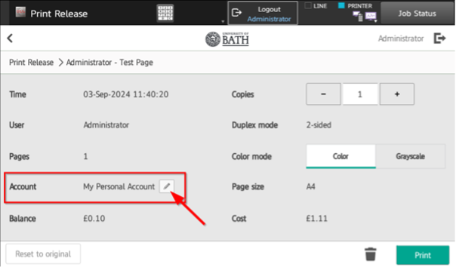
- Now, press the pencil to the right of the ‘Account’ name.


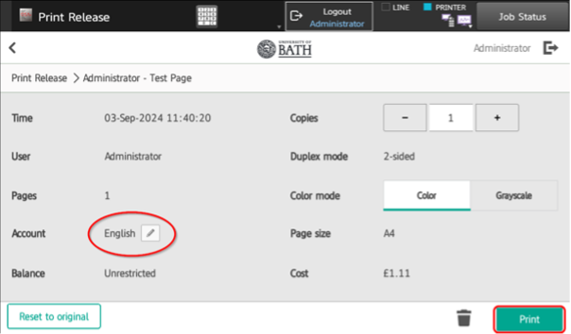
- Select a department or project code, then press the ‘Print’.



