Participate Grants – Outline Proposal

Name: |  | Email:
Organisation (or department if at University of Bath): |  | Role or Job Title:

What do you want to do? Don’t forget to tell us where the activities will be happening. (up to 200 words)

Who do you want to work with and how it will benefit all the people involved? (up to 200 words)

What is the name of your collaborator?

What organisation are they from?

Have they agreed to be named in this application?
☐ Yes ☐ No
How long do you think this work will take?

What level of funding do you want to apply for?
☐ Micro
☐ Medium
☐ Large
What do you anticipate spending the funding on (please note this is an indicative list and can be changed at full application)?
☐ Salary/time buy-out
☐ Training and professional development (incl. accreditation)
☐ Venue hire/use
☐ Travel
☐ Refreshments
☐ Caring expenses
☐ Access needs e.g. British Sign Language interpreter
☐ Disclosure and Barring Service checks
☐ ‘Thank You’ activities
☐ Counselling or other mental health support
☐ Other – please explain:

How would you rate your experience of working in a participatory / collaborative way? (Please use the check boxes below the descriptors that best describes your level of experience):
1 | 2 | 3 | 4 | 5
Not very experienced |  |  |  | Very experienced
☐ | ☐ | ☐ | ☐ | ☐

Please explain:

Where would you place your idea on the participatory spectrum ^{[1]}? Check the check box that best describes the purpose of your activity:
Informing | Listening | Involving | Working Together | Empowering
Activities that share and tell people about your research | Activities that gather perspectives and insight from people about your research | Activities that enable people to have meaningful roles to work with you in research | Activities that enable people to make decisions with you about research | Activities that enable people to have control over decisions made about research
☐ | ☐ | ☐ | ☐ | ☐

Please explain:

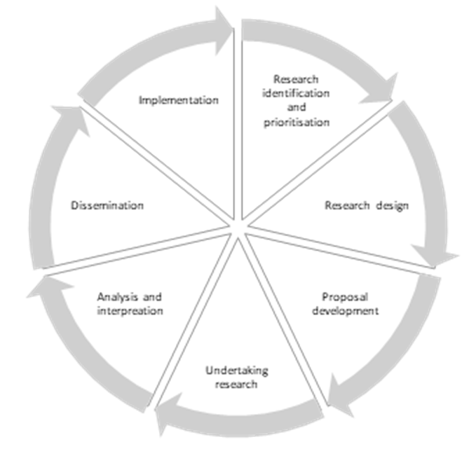

Where in the research cycle does your idea fall? (Please use the check boxes to indicate the part of the research life cycle):

Research identification - working out what questions need asking | ☐
Research prioritisation - working out which questions to ask in a specific project | ☐
Research design - deciding how to conduct the research | ☐
Proposal development – writing the idea down to ask a funder for money | ☐
Undertaking research - collecting and managing the data | ☐
Analysis – analysing the data | ☐
Interpretation – making sense of what the data means | ☐
Dissemination – letting people know what has been found out | ☐
Implementation – putting the research findings into practice | ☐
All of the above | ☐
Not sure | ☐

Please explain:

Please send completed application forms to public-engagement@bath.ac.uk by 4pm on Friday 23 February 2024 with ‘Participate Fund’ in the subject line.

^{[1]} Adapted from Vaughn, L. M., & Jacquez, F. (2020). Participatory Research Methods – Choice Points in the Research Process. Journal of Participatory Research Methods, 1(1)

