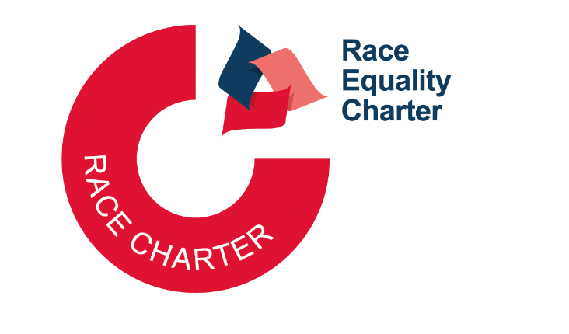

Race Equality Charter Bronze application form (REDACTED)

Applicant information
Name of university | University of Bath
Submission date | 29th July 2025
Level of previous award (if relevant) | N/A
Conferral date of previous award (if relevant) | N/A
Contacts: names | Dr Teslim Bukoye  Mrs Aiste Zubiniene
Contacts: emails | otb34@bath.ac.uk  as836@bath.ac.uk

Section | Words used
1 An overview of the university and its approach to race equality activity
2 An assessment of the university’s race equality context
3 Action plan*
Glossary
Appendix: Survey and consultation data, Data tables | Redacted
Overall word count | 8,739
*These sections and appendices should not contain any commentary contributing to the overall word limit.
Overall word limit: 8,000 + 750 (Covid word count allowance) = 8,750

Table of Contents
1.1 Letter of endorsement from the Head of the University 0
Section 1: An overview of the university and its approach to race equality activity 2
1.2 Governance and recognition of equality, diversity and inclusion work 2
1.3 Local involvement and accountability 4
1.4 Race Equality Charter self-assessment process 5
1.4.1 Future of REC-USAT 8
Section 2: An Assessment of the university’s race equality context 9
2.1 Description of the University and its context 9
2.1.1 Engagement with local community 10
2.1.2 Recruitment 11
2.2 Development, evaluation and effectiveness of policies 12
2.2.1 Equality Impact Assessment 12
2.2.2 Bullying and harassment 13
2.3 Culture, inclusion and belonging 15
2.3.1 Strategic commitment & key principles 15
2.3.2 Leadership and governance 15
2.3.3 Practices and behaviours 16
2.3.4 Traditions and community culture 17
2.3.5 Wellbeing support 20
2.3.6 Structural and cultural barriers 20
2.4. Staff context 21
2.4.1 Academic staff 21
2.4.2 Professional and support staff 23
2.4.3 Staff benchmarking with GW4 institutions and the Higher Education sector 24
2.4.4 Summary of findings from survey data analysis: staff 25
2.4.5 Summary of findings from REC Community Forum related to Staff 26
2.5. Student context 26
2.5.1 Distribution of students (UG, PGT and PGR) by ethnicity 27
2.5.2 Distribution of students in terms of UG continuation and completion rates 28
2.5.3 Distribution of students in terms of UG, PGT, PGR awards 29
2.5.4 Benchmarking against GW4 and Higher Education sector 30
2.5.5 Summary of finding from REC Community Forum related to students 30
2.6 Key priorities for future action 31
Section 3: Action plan 34

Glossary

AP – Action Plan
APP – Access and Participation Plan
AS – Athena Swan
ASC - Academic Staff Committee
AS-USAT – Athena Swan University Self-Assessment Team
Ass. Deans – Associate Deans
AY – Academic year
BA – Bronze action
BAME - Black, Asian and Minority Ethnic
BHM – Black History Month
B&H – Bullying and Harassment
C&I – Culture and Inclusion
CCI - Community, culture and inclusion
CIOSG - Community and Inclusion Operational Steering Group
D&R – Dignity and Respect
Dept - Department
DVC – Deputy Vice-Chancellor
E&D – Faculty of Engineering and Design
EDI - Equality, diversity, and inclusion
EDIC - Equality, diversity, and inclusion committee
EDIN - Equality, diversity, and inclusion network
EIA - Equality Impact Assessment
EMBA – Executive Master of Business Administration
EMG – Ethnic Minority Groups, including Black, Asian, Mixed, and Other ethnicities
ERC – Enhancing Research Culture
FAQs – Frequently asked questions
GW4 – University alliance between Bath, Bristol, Cardiff and Exeter.
HR – Human Resources
HSS – Faculty of Humanities and Social Sciences
HE – Higher Education
IWD – International Women’s Day
Intl – International
KPIs – Key Performance Indicators
LGBTQ+ - Lesbian, Gay, Bisexual, Transgender, Queer
MSA – Management, Specialist and Administration
NSS – National Student Survey
OfS – Office for Students
OFS – Operations, Facilities Support
PGR – Postgraduate Researcher
PGT – Postgraduate Taught
PhD – Doctor of Philosophy
Prof – Professor
PS – Professional services
PSS – Professional services staff, used internally instead of PTO
PTO – Professional, technical and operational staff, equivalent to internally used ‘PSS’
PVC – Pro-Vice Chancellor
REC – Race Equality Charter
REC-USAT – Race Equality Charter University Self-Assessment Team
REEG – Race Equality Enhancement Group
RET – Race Equality Taskforce
SMART – Specific, measurable, achievable, relevant, and time-bound
SoM – School of Management
STAR – Student Action for Refugees
STEM – Science, technology, engineering and mathematics
SU – Students’ Union
T&E – Technical and Experimental
TEF – Teaching Excellence Framework
TCM Group – An award-winning people, culture and leadership consultancy
ToR – Terms of reference
UEB – University Executive Board
UK – United Kingdom
UKDHM – UK Disability History Month
UG – Undergraduate
VP C&I - Vice President Community and Inclusion
WP – Widening Participation
A note on data categorisation:
In an institution-wide consultation that we conducted in 2024, the term Black, Asian and Minority Ethnic (BAME) was criticised for promoting a binary distinction that positions ‘White’ as the default or singularly distinct ethnic group, in contrast to all others grouped under BAME. This framing fails to reflect the full diversity of experiences, identities, and heritages between the ethnic groups described within that term.
We therefore are using a different approach which advocates that we should use more specific ethnic identities (or groups) whenever possible, especially internally. When a broader term is required (as it was often a case for this Race Equality Charter application due to low numbers and splits by faculty/domicile/grade required) we will use ‘Ethnic Minority Groups’, whilst acknowledging that this term refers to minority status within the UK context.
In addition, at UEB level leadership team has reflected that there was space for the University to move to the term equity instead of referring to equality. Our senior leadership team, led by the Vice Chancellor, aims to look further and focus on outcomes being ‘fair’ rather than ‘the same’. However, for the consistency, and being mindful that we are applying for a Race Equality Charter award, we will refer to ‘equality’ across the document and put plans in place to transition to the term ‘equity’ over the course of Bronze action plan implementation.

kliedtg

1.1 Letter of endorsement from the Head of the University
As a Vice Chancellor of the University of Bath, I am proud to endorse and champion our institutional journey towards race equality. This commitment reflects our core values as a university community as underscored by our 2021-2026 University Strategy and, in particular, our commitment to fostering inclusion, equality, diversity, and accessibility where the unique value of each individual is recognised as we build a community of trust and care by treating each other with respect. We recognise that achieving race equality is an ongoing process requiring courage, sustained reflection, and collective action.

In 2024, I had the privilege of formally launching our Race Equality Charter (REC) Bronze journey, an important milestone in our mission to become a more racially equal university. As part of this launch, I delivered a presentation at our Black History Month closing event, drawing on research I co-produced on addressing the barriers facing Black academics in the UK. This event set the tone for our REC efforts: evidence-based, inclusive, and led by lived experience.

Our work under the Race Equality Charter is grounded in transparency and inclusivity. We are engaging the full breadth of our university community, our students, staff and senior team, through a five-stage data collection and consultation approach, so that our action planning is not only data-informed but shaped by authentic dialogue. I was honoured to participate in the REC Community Forum, where I listened to the voices of our community, understanding more about the specific challenges our staff and students from Ethnic Minority Groups have faced and what solutions we could co-create together. Colleagues from across the University Executive Board, Senate, Council, and senior leadership including Faculty and School Deans, our Director of Human Resources, and others joined the Community Forum and follow-on conversations, emphasising our shared commitment to meaningful change.

To embed racial inclusivity into our strategic leadership, we have restructured and strengthened our senior team which now includes a Deputy Vice Chancellor (DVC) role with specific responsibility for equality, diversity and inclusion. Our new DVC has already made significant impact, opening the inaugural GW4 Forum on Race Equality, hosted
here at Bath, and bringing together REC Leads from across our other GW4 partners (Bristol, Cardiff, and Exeter) for collaborative learning and best-practice exchange.

Alongside this, we have invested in the infrastructure necessary to support systemic change. We established a Race Equality Lead (and Chair of REC University Self-Assessment Team), a Vice-President for Community and Inclusion, and expanded our central Community and Inclusion team with dedicated specialist staff, including a newly created Equality Charters Manager role, bringing all our charters work under a single umbrella. We have established a recurring annual REC operational budget and resourced both professional and administrative support for the delivery of our REC Bronze action plan. This investment reflects our institutional belief that advancing equality must be underpinned by appropriate resources, accountability, and leadership.

The REC self-assessment process so far has provided invaluable insight into what we do well and, most importantly, where there are opportunities to improve. While I am pleased to see staff and student surveys recognising our increased efforts to advance race equality, I am also aware of persistent challenges. These opportunities for improvement are a driving force behind our commitment to race equality and provide important areas of focus.

At every level, Departmental, Faculty, and School Executive Committees, University Executive Board, Senate, and Council, we are united in our vision for advancing equality, with a focus on examining different intersections of protected characteristics rather than solving individual issues in silos. But we also recognise that this journey is complex and ongoing. True inclusion requires not only policies and action plans but a deep cultural shift, sustained over time. I see it as our responsibility as institutional leaders to keep listening, keep learning, and to lead by example.

The University of Bath is committed to fostering a respectful, inclusive environment where all students and staff feel valued and empowered. Achieving this vision will take time and collaboration, but with shared purpose and a firm belief in equality, we are making meaningful progress.

Yours sincerely,
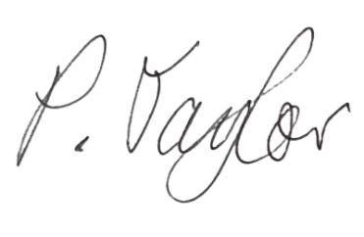
Professor Phil Taylor
Vice-Chancellor and President
University of Bath

Section 1: An overview of the University and its approach to race equality activity

1.2 Governance and recognition of equality, diversity and inclusion work
The University of Bath is committed to recognising and valuing the vital contributions of staff and students engaged in advancing equality, diversity, and inclusion (EDI). We have clear governance structures and workload allowances to ensure that this work is integrated into our institutional framework and recognised.
We aim to foster a culture where EDI is not only everyone's responsibility but also visibly supported and appropriately recognised. Faculty and School EDI Champions are allocated up to 250 workload hours, reflecting the strategic importance of their role in embedding inclusive practices. Academic members of the Race Equality Charter University Self-Assessment Team (hereinafter ‘REC-USAT’) are granted 20 workload hours, and secretarial assistance is provided by the Culture and Inclusion Team. The Chair of REC-USAT receives a 0.3 FTE workload allocation, in recognition of the leadership and coordination responsibilities required. This role is also centrally supported by the Equality Charters Manager, Deputy Director for Culture and Inclusion, and the EDI Coordinator.
Contributions of professional services staff and student members of REC-USAT are recognised through formal letters of recognition, issued upon completion of the Race Equality Charter submission. Student members are additionally thanked with Bath city vouchers at the end of their term. Participation in REC-USAT is also acknowledged as part of the appraisal and promotions process through the ‘Leadership and Management’ pathway further embedding EDI work as a valued component of professional growth and institutional leadership.

Figure 1. Decision making structure – from grassroots to the governing body of the university

Staff & student
networks
REC
-
USAT
ED&IC
UEB
Council
Figure 2. EDI infrastructure – key committees and bodies with specific responsibility to EDI
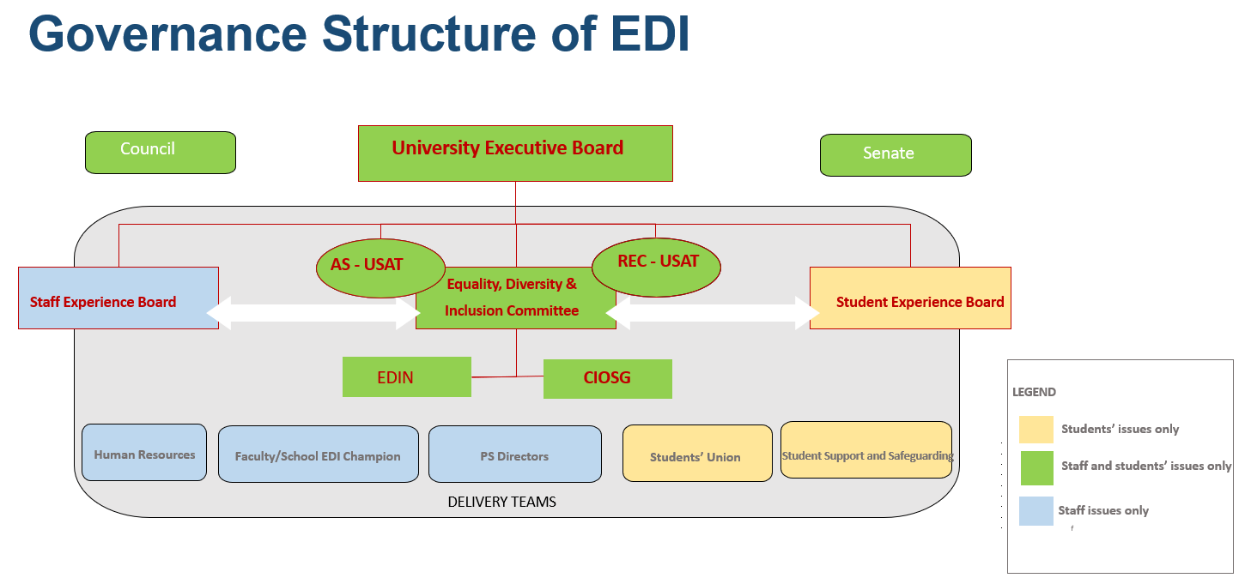

EDI work is supported by and embedded within the governance structure of the University in several ways:
Since 2023, all governance papers (i.e., all papers going to UEB, Senate, Council, Finance, and other key decision-making committees) include a mandatory section on EDI impact analysis.
Since 2021, papers submitted to key university committees (e.g., Council, Senate, Finance, EDI) have been required to include a section on EDI implications. This requirement was strengthened in 2024 by moving the EDI section to the top of each paper to emphasise its importance and reduce omissions. The Governance Team, in collaboration with the Culture and Inclusion Team, also issued guidance for committee members on their EDI responsibilities. Between 2021 and 2024, 486 papers were submitted to Council and 393 to Senate across 31 and 24 meetings respectively. Authors receive annual training, and ‘n/a’ is not accepted as a standard response, ensuring EDI is meaningfully considered in all submissions.

1.3 Local involvement and accountability
Since the University’s first Athena Swan (AS) institutional bronze award in 2009, solid structures have developed within Faculties, School, and Departments to embed gender equality work.

Figure 3. Athena Swan awards at the University of Bath
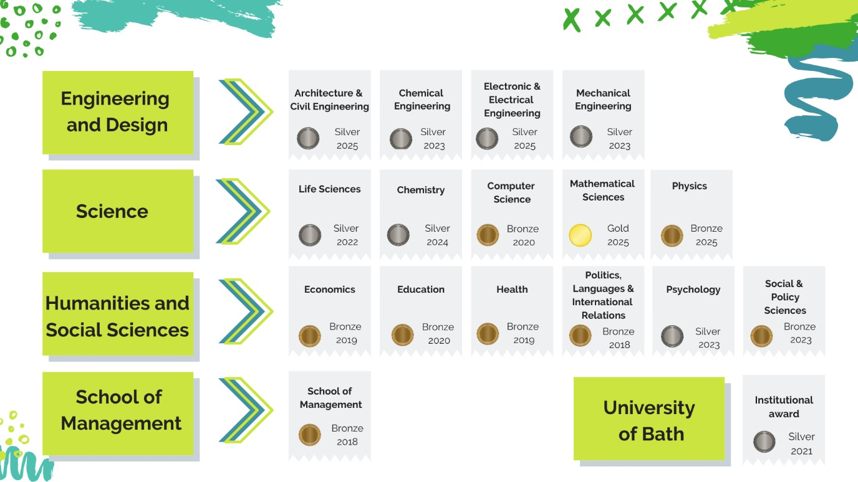

Those AS-related structures have evolved over the years to address EDI more broadly. All three Faculties and the School of Management now have EDI structures (through four dedicated EDI Champions, who are further supported by EDI committees/groups) heading up work strands, such as gender, race, disability, caring, LGBTQ+, etc.
Strategic accountability for EDI resides with the Deans but, it is the Faculty/School EDI Champions who oversees the implementation of EDI/Race related activities in each of the Faculties/School. The EDI Champion monitors and where appropriate supports Departmental EDI Committees and subsequently feeds into their respective Faculty/School Executive teams. The latter are responsible for identifying Faculty/School priorities and feeding into EDIC and CIOSG (Community and Inclusion Operational Steering Group), as well as receiving and sharing information with the REC-USAT.
REDACTED – sensitive information

REC-USAT, CIOSG, EDIC, Faculty/School EDI Champions, PS Departments, reps from academic and PS Departments to EDIN, and Mosaic network (for staff from Ethnic Minority Groups) are all supported by the HR Culture and Inclusion team via 121 advice and guidance sessions, training, and operational support from ECM. Mosaic, through the co-Chairs, provides a link between the University’s formal committees and colleagues with an interest in experiences of staff from Ethnic Minority Groups. Mosaic co-Chairs are also permanent members of the REC-USAT.

1.4 Race Equality Charter self-assessment process
The University’s work towards its REC Principles submission began in 2021, when the Vice President for Community and Inclusion, (at the time Prof Rajani Naidoo) commissioned a Race Equality Taskforce (RET) with the vision to guide the University in a responsible and sustained manner in institutionalising an understanding of racial diversity as contributing to excellence in research, teaching, the student and staff experience and impact. As well as being an important foundation for the REC work, its aim was also to identity gaps in knowledge and data in advance of the REC Bronze application.
RET was comprised of over 70 academics, professional services, and student members and advisors. Focus advisory groups were drawn linking to six workstreams.
- Enhancing the recruitment, experience and progression of staff of colour
- Enhancing the recruitment, experience and progression of students of colour
- Decolonising the curriculum
- Reporting racism and gaining support
- Inclusivity and anti-bias training
- Developing inclusive institutional cultures

The work of RET consisted of three phases:
- The first phase focussed on listening and building trust with students and staff of colour who were initially reluctant to participate in the taskforce. This phase also consisted of targeted actions to maintain trust.
- The second phase consisted of an appraisal of structures and processes which included sharing individual students’ journeys of reporting racism and gaining support; and then working with the students to suggest enhancements. Rather than waiting for the work of the taskforce to be complete and a set of final recommendations to be set out, some actions were taken forward immediately.
- The third phase was to identify innovations so that the recommendations of the taskforce could develop synergies with ongoing work.

In addition, news, resource updates, cultural events such as film screenings and five seminars were organised to maintain momentum. Research England funding was gained to interview PhD students from Ethnic Minority Groups in each of the Faculties and the School of Management. From this, a series of PhD films have been developed to inspire prospective students of colour to consider the University of Bath as an inclusive, supportive and high performing doctoral environment.
In total, 107 volunteers enlisted and 11 x 1.5 hour meetings were conducted. Staff joined RET on voluntary basis. Students received financial remuneration for providing their input. RET concluded its work in 2022. There were over 40 recommendations noted in the RET report, published in 2023. Some actions were taken up immediately after the publication of the report. Most recommendations were aimed at laying foundations for REC Bronze and were picked up by the Chair of REC-USAT to ensure they are embedded in our key priorities.
In 2024, an open call for the position of Race Equality Charter Lead (Chair of REC-USAT) was issued. Following the appointment of Dr Bukoye, a subsequent open call and a series of personal invitations were extended to recruit members to the REC-USAT. A total of 26 members were appointed to the core REC-USAT, comprising a representation of 50% White and 50% ethnic minority individuals, with 65% female and 35% male participation (See Appendix, A6 REC USAT membership). Notably, 19% of members identify as experiencing intersectional inequalities (i.e., ethnic minority women or ethnic minority staff with disabilities).
The REC-USAT includes both undergraduate and postgraduate students, as well as staff from academic and professional services job families. Members span a range of grades and roles from Grade 5 to Professor and include individuals selected for their relevant skills, expertise, or interest in advancing race equality across the institution.
All REC-USAT meetings in 2024 achieved over 90% attendance. Terms of Reference were formally agreed and published publicly. A timeline of activities and meetings was agreed at the first monthly meeting of the year and a public-facing webpage was launched.
To support a robust and inclusive submission, a five-phase approach to data collection and analysis was initiated. This process ensured broad engagement with relevant stakeholders and enabled the development of a comprehensive and evidence-informed REC application. This approach includes:
- Phase 1 – Institutional data (including mandatory datasets)
- Phase 2 – Survey data (staff and students)
- Phase 3 – University-wide open community forum (focus group)
- Phase 4 – Networks feedback (focus groups)
- Phase 5 – GW4 and external/critical friends

The findings from our university-wide cultural survey (phase 2), coupled with recommendations handed over from RET, have informed several strategic initiatives that we will continue to build upon. These include:
- Launching mandatory anti-racism training for all staff.
- Development of race equality training for senior leaders and line managers.
- Review and simplification of Support and Report reporting processes for discrimination and harassment.
- A new inclusive curriculum review framework to support decolonisation.
- Strengthening staff and student EDI networks and improving institutional support.
- Sustaining REC-USAT to monitor progress and ensure senior oversight.

Members of REC-USAT were responsible for particular sections of the application and once the final draft has been produced, it went to EDIC, and, ultimately, UEB for endorsement. Following feedback internally and externally, draft REC application has been further revised (extensively) in an open and transparent way via a REC USAT Teams page, with tracked changes visible and accessible to all.
Staff and student REC survey (more info and detail is provided in the Appendix A1 & A2):
- Staff 776 responses (20% response rate of overall; White: 22%, Ethnic Minority Groups: 13%)
- Students 308 responses (approx. 1% response rate of overall population, with approx. 50/50 of responses coming from White and Ethnic Minority Groups students). Response rate for Ethnic minority group students was higher compared to White students – 1.85% vs 1.13%.
The low student response rate came as a surprise and, upon further reflection, was likely due to a combination of factors, including the survey being newly introduced, overlap with the National Student Survey schedule, limited promotion time, and its release coinciding with the winter holiday period. Thus, we undertook further consultation throughout May and June including engagement via a community forum, outreach through staff and student networks, and discussions with the Equality, Diversity and Inclusion Network (EDIN), which includes reps from all student equality groups and the Students’ Union Community Officer, on the draft REC application.
We will run the REC staff and student surveys biennially, aligning them with the University’s broader survey schedule to maximise participation (BA1.1f). To enhance student engagement, we plan to introduce a prize draw- three vouchers – following the completion of the student REC survey, and we will collaborate with the University’s Social Media Manager to develop targeted campaigns aimed at tripling the student survey response rate (BA1.1f).
Figure 4: Race equality programme and timeline in the run up to submitting the REC application
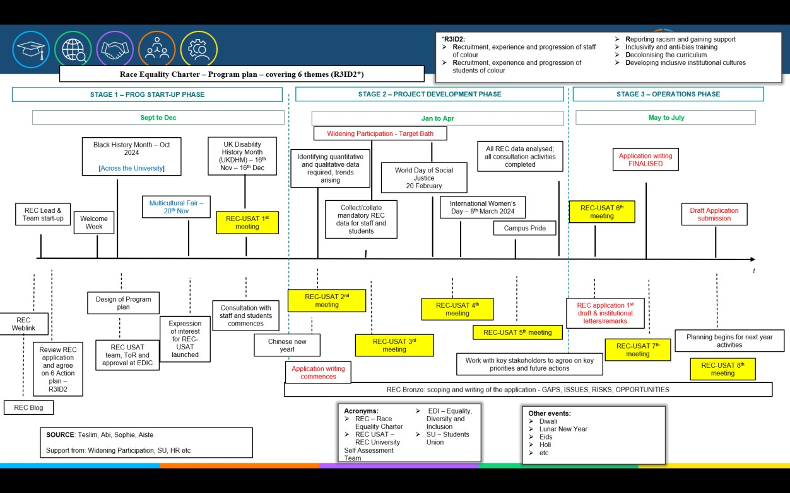

1.4.1 Future of REC-USAT
The REC-USAT will continue to be chaired by Race Equality Lead, with meetings held every quarter to review the action plan and identify changes required.
As set out in Terms of Reference for REC-USAT, we will issue an annual call for members to maintain ongoing engagement and ensure that the student voice remains actively embedded in our work. Race Equality Lead will provide annual updates to EDIC, a joint sub-committee of Council and Senate, on progress to date; to mirror the proven approach we have in place for Athena Swan.
A communications plan will be developed, accompanied by a one-page ‘explainer’ booklet outlining our REC activities and priorities. This will offer a more accessible and digestible summary of our five-year REC plans, and will be shared across all Faculties, Schools, and Professional Services departments.
Progress against REC Actions will be reported by Race Equality Lead to EDIC and by the Champions/Directors in pertinent areas. Annually, EDIC will review progress against the REC Bronze action plan. Information to evaluate progress will be obtained from the REC-USAT who will conduct an annual review of core student and staff data and the biennial surveys to monitor success measures.
Quantitative data will be examined using the newly created PowerBI data dashboard, which will host all race equality data under a single platform (BA1.3b). A biennial REC survey is planned to enable continual monitoring of experiences across different populations on topics such as belonging, aligning it with Athena Swan and University Mental Health Charter questionnaires under a single Staff Culture survey umbrella (BA1.1f). Meanwhile, questions pertaining to connectedness and transitions across existing internal annual student satisfaction surveys will feed into REC-USAT via annual reports submitted by PVC Student Experience and relevant teams (BA 1.1c). Results from various engagement activities related to race equality will be shared with the REEG, REC-USAT, CIOSG, and subsequently EDIC (as part of annual progress report). (BA1.1d). Through our self-assessment, we identified a gap in the central collection of undergraduate student data by tariff point (see Appendix A9.1.13). To address this, we are exploring the use of an equivalent and meaningful metric to support ongoing monitoring and progress tracking (BA1.1c).

Section 2: An Assessment of the university’s race equality context

2.1 Description of the University and its context

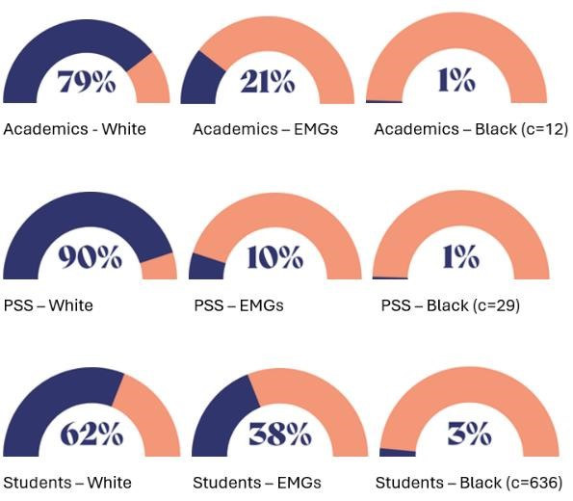
Figure 5. Ethnicity at a glance: snapshot in 2024 (some data redacted due to small numbers presented)

The University of Bath is a predominately STEM-focused Top 10 leading UK University (ranked 7th best University in the UK, and 5th for career after 15 months, by the Guardian University Guide 2025) with an international reputation for teaching and research excellence with 3,706 staff and 21,340 students. 38% of our students come from outside the UK, representing 152 nationalities. We have: 15,955 undergraduates, 5,385 postgraduates, 9,780 female students (46%), 11,425 male students (54%), and 95 students who identify as non-binary (0%).
Our 2021-2026 strategy is to drive excellence in education and high-impact research, foster an outstanding and inclusive community, and enhance our strategic partnerships. As a main pillar of the University’s strategy, supporting a successful and inclusive community has been a catalyst in pushing forward EDI-related activities, including achieving Disability Confident Leader status, introducing several Inclusion leadership roles (Digital Accessibility Lead, LGBTQ+ Lead, and Race Equality Lead among others), and launching race equality work. The race equality work has had 43 writing contributions, demonstrating a true pan-University effort and commitment to advance race equality.
We are located on a single campus on the outskirts of the World Heritage City of Bath, with an Innovation Centre (Carpenter House) and a small student hub and professional services building (Virgil Building) in the city centre.

Figure 6. Aerial view of the University and its environment

We have four Faculties, Engineering & Design (E&D), Science, Humanities & Social Sciences (HSS) and School of Management (SoM), incorporating 17 departments.

Figure 7. University management structure
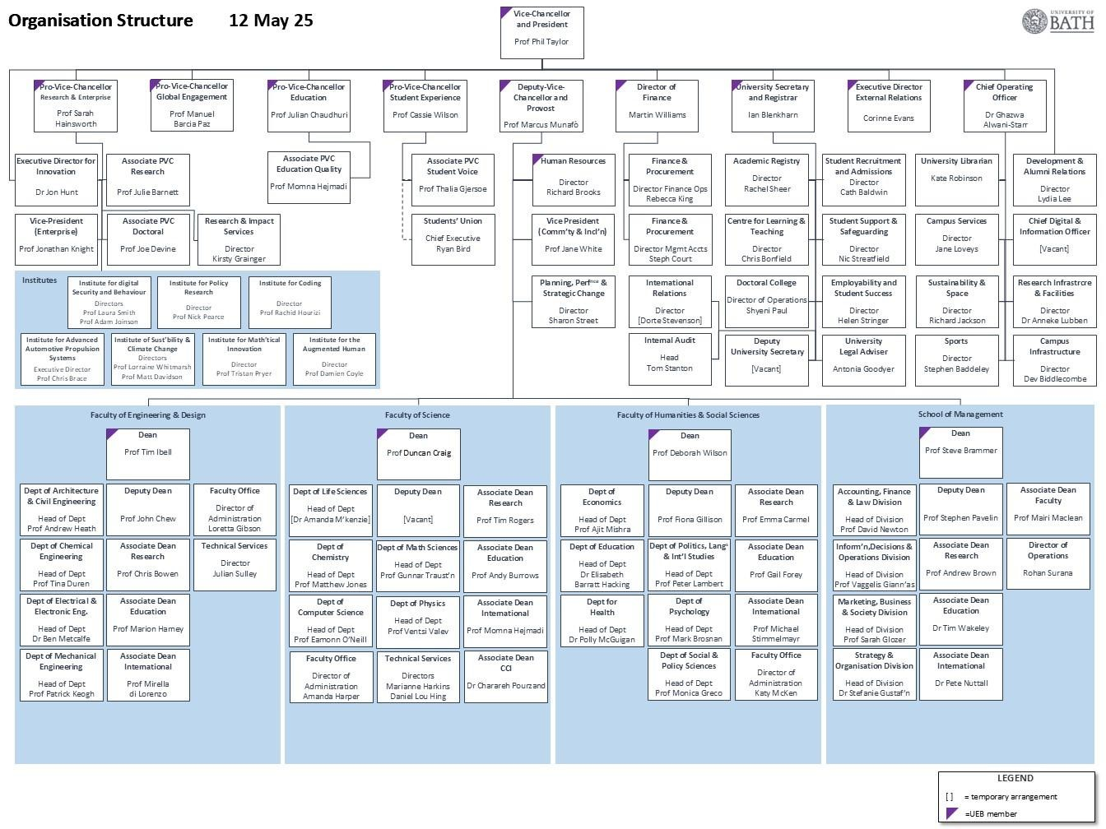

2.1.1 Engagement with local community
Our ‘University of Sanctuary’ status underpins our work with local organisations to support refugees. Initiatives under this scheme include summer schools for pupils in the local area, language courses, funded tuition fees, and the provision of accommodation and financial support for those in need.
In widening participation and access to higher education, our Student Recruitment and Admissions team engages with schools across the Wessex region particularly those with high numbers of pupils on free school meals or pupil premium support. This is done through the Wessex Inspiration Network and the newly launched Wessex Education Initiative. These efforts support both policymakers and young people in overcoming key barriers to accessing higher education, such as transport challenges in rural areas in the local region and ease the transition from school to University.
According to the latest 2021 census, the population in Bath and North East Somerset (BANES) is predominantly White (92.2%), with Ethnic Minority Groups representing the remaining 7.8% of the population (See Appendix, A5 Benchmarking). In England more broadly the portion of the population that is White is 81%. These trends are evident in our data, discussed further below. A larger proportion of our PTO staff are recruited locally, reflecting our decision not to outsource services such as cleaning or facilities support. In contrast, academic staff are typically recruited more widely. The University maintains strong relationships with key stakeholders across BANES, including the City Council and the Royal United Hospital (RUH), the city’s single largest employer. Together with the City Council, RUH, local police office and other community partners, University co-delivered (and was the main sponsor) a Black History Month program of events for BANES taking place both in the city and campus, aimed at strengthening ties with members of local community and opening conversations around race equality. The planning group behind the event maintained strong ties afterwards, continuing to meet regularly until Covid-19 pandemic.
University has also brought local faith leaders together under Interfaith Forum, aiming to work together to bridge university and city faith communities together. This includes interfaith student socials, marking Holocaust Memorial Day or celebrating Diwali together with members of our wider community.

2.1.2 Recruitment
Our recruitment data reveals distinct patterns across four key job families: Education and Research (E&R), Management, Specialist and Administration (MSA), Operations and Facilities Support (OFS), and Technical and Experimental (T&E) roles. It highlights variations in local, national, and international applicant engagement as follows:
Education and Research (Academic): A significant proportion of applicants in this category (38%) are international, indicating that academic and research roles continue to attract a global pool of candidates which highlights the University's strong international. 16% of UK applicants are from the local BANES area suggesting that the University's recruitment reach is primarily national or international in academic and research-focused roles.
Management and Professional Services: 90% of applications are from within the UK and, in consequence, these roles are predominantly filled by UK-based applicants.
Operations and Facilities: Positions within this category attract a higher proportion of local applicants, with 51% of UK applicants coming from the surrounding area. This is likely due to the on-campus and often location-specific nature of these roles, making them particularly accessible to those living nearby. We note that since we do not outsource cleaning and facilities support roles, lot of these positions are at a lower grade and consequently people are unlikely to relocate to take these roles. We find that outside of academic roles, the lower the grade, the greater the proportion of local applicants.
Technical and Experimental Roles: These roles receive a relatively low volume of applications overall, with approximately 80% from UK-based candidates and 20% from international applicants. The smaller applicant pool is primarily attributed to the specialised and niche expertise required for these positions.
Across all job families, the patterns reflect a strategic emphasis on attracting global academic talent while also maintaining a commitment to offering employment opportunities within the local community.

2.2 Development, evaluation and effectiveness of policies

The University has a collaborative and consultative approach to developing its institutional policies. This includes working with staff and student self-organised groups and external groups in developing policy and consulting with our trade unions as we develop, revise and improve our policies and practice. The development and improvement of our Dignity & Respect Policy and Procedure, which covers staff, students and all other members of the University community is a good example of this.
Since 2019, the policy has been reviewed and revised on 6 separate occasions (with complete re-writes on two occasions) as we have made a series of comprehensive improvements to our practice in this area for staff, students and all other members of the community. This has included important work with our Race Equality Taskforce, student network and our Staff of Colour Network (now re-named as Mosaic) in developing our practice around tackling and preventing racial harassment and discrimination.

2.2.1 Equality Impact Assessment

We use Equality Impact Assessments (EIA) to put equality, diversity, and inclusion at the heart of everything we do, right from the start of a new policy/procedure writing stage. Since the EIA process was re-launched in 2023 following a revamp to ensure it was supportive, constructive and user-friendly (including a new online form, infographics and FAQs), we receive between REDACTED – sensitive information & low numbers EIAs annually, out of which REDACTED – sensitive information & low numbers identify race or ethnicity as a potential characteristic to be affected more than others (the template lists all protected groups under Equality Act 2010 and asks the author based on the evidence they collected, which equality groups might this policy affect more than others). The template requires identification of potential negative, positive, and neutral impacts on different protected groups and that actions, with timescales and responsibilities, are proposed to address any negative implications. The form is submitted to the central Culture and Inclusion (C&I) team who review the evidence and present an annual amalgamated report on EIAs to EDIC.

To support staff completing EIAs, advice and guidance are provided by the C&I team. In addition, EIA authors are linked with relevant staff and student networks to consult further with groups potentially impacted, to ensure the EIA process is co-creating solutions with affected groups. We have consulted with Mosaic, the student race equality group, and EDIN four times as part of the EIA process since 2023.

2.2.2 Bullying and harassment
Since 2018, the University has undertaken a wide range of actions to tackle and prevent racial harassment and discrimination. This was an integral part of #NeverOK, our comprehensive campaign and plan of actions to build dignity and respect, and tackle and prevent all forms of harassment, bullying, hate crime and discrimination.



Figure 8: The #NeverOK campaign represents our commitment to creating a community which never tolerates hate, harassment and assault, to ensure all students, staff and visitors feel safe and valued - including in online spaces. It provides training, resources and marketing materials to empower people to speak out against harassment.

The University has a single joint Dignity and Respect Policy for all members of the University community that integrated with staff and student disciplinary processes and has its own Support & Report portal which provides secure and confidential way for staff, students, alumni and third parties raise reports of behaviour that breaches individuals’ dignity and respect. On introduction these increased the speed and consistency of the University’s response to reports in relation to dignity and respect.
There is a Professional Boundaries Working Group incorporating a diverse group of academic staff to create a range of peer-to-peer guidance for academic staff in their relations with students, focusing on ensuring healthy professional boundaries and preventing harassment, bullying and discrimination, including addressing racism or race related cases
In September 2022, a Dignity and Respect Liaison Officer role was created to work closely with HR across staff and student issues. This role helped develop a joint approach to triaging all reports received through the #NeverOK Support & Report portal or directly and expanding the range of informal interventions for staff and students to focus on bringing about behavioural change where this is an appropriate action. This approach has been fundamental to improving our practice, increasing awareness and trust in these processes and to increasing the level of reporting. The Support and Report team continually looks at lessons learned to improve its practice.
In 2023, a programme of mandatory training for staff and students was introduced, initially under the title of #BeTheChange, that sets out the expectations and explains how to be a proactive bystander and how to report concerns about behaviour of staff, students, contractors and other visitors. In 2023-24, in response to RET recommendations, the University also introduced bespoke training for academic advisors (personal tutors) to improve their understanding of reporting processes.
The University has worked with the highly experienced TCM Group to design and introduce its own Resolution Framework, training a group of staff in facilitation, mediation and dispute resolution to give better early intervention tools for changing behaviour and attitudes. There are 16 facilitators and mediators trained to use these inventions with staff and students to help change their understanding and behaviour. An Employee Relation & Resolution Specialist role was introduced in 2023 to lead on Support and Report involving staff respondents and ensure a rapid response to reports involving staff.
The University has strengthened both informal and formal pathways for addressing discrimination and harassment, with recent updates to student complaints and disciplinary procedures ensuring clearer guidance on reporting racism, accessible language, and options for early resolution where appropriate. These changes are reinforced by updates to our webpages and communications, designed to be more inclusive and trauma-informed.
REDACTED – sensitive information & low numbers
The Support & Report team have also worked closely with our Security team to support staff who have suffered racial harassment and discrimination.
REDACTED – sensitive information & low numbers
As evidenced in surveys, there are some disparities among White and Ethnic Minority Group staff and students around their perception of bullying and harassment, in particular their confidence levels in calling out racism.
REDACTED – sensitive information & low numbers
Thus, we’ll audit and streamline our reporting processes, develop mandatory bystander and anti-racism training, and ensure this is meaningfully embedded at school/faculty levels, making it a shared responsibility of every stakeholder (BA 2.1-2.3).

2.3 Culture, inclusion and belonging

2.3.1 Strategic commitment & key principles
The University of Bath is committed to creating a culture where all students and staff feel a genuine sense of belonging and inclusion. We prioritise embedding EDI across all areas of University life, with a clear focus on tackling systemic and structural barriers that affect racially minoritised individuals. This commitment is reflected in our institutional strategic pillar of fostering an outstanding inclusive community, Dignity and Respect Policy, Statement of Equality Objectives (i.e., our EDI strategy), and the development of our Bronze REC AP.
Key principles underpinning the commitment include:
- Respect for diversity: Recognising and valuing the richness that racial and cultural diversity brings to academic and social life.
- Commitment to equality: Addressing structural inequalities and barriers faced by Ethnic Minority Groups.
- Transparency and accountability: Using data, staff/student feedback, and performance frameworks to track progress on racial equality.

2.3.2 Leadership and governance
The University’s leadership, from the Vice Chancellor to line-managers, play a crucial role in shaping inclusive practices. Senior leaders are expected to model behaviours that promote racial equality, including:
- Embedding EDI in strategic decisions (e.g., recruitment, curriculum development, and staff promotion via inclusive recruitment toolkits, the curriculum transformation project, a review of staff promotion criteria and guidance currently under way)
- Listening to diverse voices, particularly from underrepresented racial groups (through all-staff and students community forums, all-staff meetings, team away-days, staff networks, and departmental surveys for EDI and Athena Swan)
- Reporting and accountability mechanisms (e.g., annual EDI reports from key functions, i.e. annual reports on staff/student demographics tracking through EDIC for review and discussion).
Data in appendix A 8.9 on key decision-making committees shows that 11 Committees (out of 23) have zero ethnic minority group voices represented despite 10% of all PSS are from Ethnic Minority Groups and 21% Ethnic Minority Groups among academics.

Both staff and student free text comments in REC surveys call for more ethnic minority group voices in governance and leadership (Appendix: A2.1-A2.4, p. 20-22; A1.6, p.18). We note that this was the most commonly raised issue across feedback gathering forums and focus groups and we will take it seriously. We will address this as part of priority 5, with a commitment to:
- onboard and develop ethnic minority group committee members (BA 5.2);
- launch a committee Diversity Dashboard (BA 5.3);
- incorporate committee diversity KPIs into Faculty/School/PSS Dept annual performance objectives (BA 5.4a);
- recognise and reward via newly launched Governance Inclusion Award (BA 5.4b).

Based on feedback from EDIN, Race Equality Charter Community Forum, and Faculty/School EDI Leads, there are wide-spread calls for more diverse ethnic representation on university decision making committees.

2.3.3 Practices and behaviours
2.3.3.1 Formal practices
Inclusive Recruitment: Efforts to ensure hiring panels are trained in unconscious bias and that job descriptions encourage diverse applications via targeted, mandatory training for panel chairs and members, optional inclusive recruitment modules, job descriptions going through Textio (which checks for inclusive language), and job advertisements placed on Diversity Jobs Group (see Figure 9 below).

Figure 9: All our roles are published on the Diversity Jobs Group job boards since Jan’2025

Curriculum Diversification: Through the Curriculum Transformation initiative, we focus on transforming the curriculum and ensuring course content reflects diverse global perspectives.
Training and Development: We have explored and trialled various workshops addressing race awareness, challenging white privilege and the danger of a single story, inclusive teaching, allyship, however there is gap identified by staff and students when it comes to dedicated anti-racism training (Appendix: A2.1 - A2.4, p.20-22; A1.6, p.18), which we will address under Priority 2, actions BA 2.2a-c.

Support Services: Since 2022, our Student Support and Safeguarding team made several changes to their provision, ensuring culturally responsive counselling and representative counsellors, launch of mentoring schemes and support groups, and tailored academic support for minoritised students. In response to student feedback, we will further improve reporting processes (BA 2.1a-b), commission an internal audit of harassment-case handling and outcomes (BA 2.3a), embed KPIs around B&H into Faculty ops (BA 2.3b) and commit to hosting a REC Forum to share progress to date and gather feedback (BA 2.3c).

2.3.3.2 Informal practices and culture
Student societies and networks: Student and staff networks like the African and Caribbean Society, Student Race Equality Group and Mosaic provide safe spaces for community building, advocacy, and peer support.
Everyday interactions: Posters across campus focussed on advertising the Support and Report tool and #NeverOK campaigns, and various informational posters and sessions on advancing racial equality advertised on digital screens on campus aim to ensure issues are proactively addressed. A wide range of student societies and initiatives support individuals from diverse cultural and national backgrounds. The SU proudly hosts five student-led liberation groups - LGBTQ+, Feminism and Gender Equality, Disability Action Group, Race Equality Group, and Mature Students Group - which represent a broad spectrum of identities and experiences. These groups organise targeted events and activities to promote inclusion and awareness across campus.
Many of the SU’s other groups, including sports clubs, have dedicated Welfare and Inclusivity Officers to ensure that all student activities are welcoming and accessible. In addition, Bath Student Action for Refugees (STAR) works actively to support refugees and asylum seekers both locally and nationally through volunteering, fundraising, and advocacy.

2.3.4 Traditions and community culture
Over the years, we have developed traditions that celebrate diversity and foster a sense of belonging. These include:
- Annual EDI-focused events such as Black History Month celebrations (we started hosting University-wide Black History Month celebrations in 2021 when we signed up to REC), Race Equality Week, cultural and religious festivals, and public lectures on race and justice. REC Student survey free text comments singled out University’s BHM celebrations as one of the most positive developments (Appendix, A2.3, p.21)
- Peer mentoring schemes, particularly for students from underrepresented backgrounds, help with transition and retention.
- Collaborations with the SU, which plays an active role in advocating for race equality and inclusive student representation.

Nevertheless, the University acknowledges the persistence of traditional academic norms and hierarchical structures that can inadvertently ethnic minority group voices particularly in research recognition, student voice mechanisms, and curriculum design and will map and better diagnose specific barriers for advancing intersectional race equality issues with a focus on gender, disability, LGBTQ+ and socio-economic status (BA1.1a-1.1f).
Figure 10 (see below) – a selection of pictures and visuals from the BHM, IWD, and Pride events since becoming members of REC and beginning our race equality work at Bath, with a focus on intersectionality and diversity of voices and styles we want to showcase

 |  | LGBTQ+ rights activist and champion of diversity, equality and inclusion, founder of conferences such as ‘Pride in Education’ and ‘Educating Out Racism’ hosted a session at the University during LGBT History Month for staff and students.
An interactive, online IWD seminar delivered by Toluwa Oyeleye focused on what self-worth, self-love and self-confidence look like for students of colour, with practical tips and well-being techniques provided. |  | 
 |  | Celebrating our early career researchers during International Day of Women and Girls in Science – amplifying diverse voices and unique career paths to inspire students of all backgrounds to consider academia as a career path for them.

Annual Athena Swan Lecture on exploring intersectional inequalities in sexism, sexual harassment and violence in HE with Prof Vanita Sundara
 | The School of Management EMBA Candidate Ouida Duncan takes over University’s EDI Blog to highlight why she chooses to challenge inequality, call out bias, question racial stereotypes, and help forge an inclusive world.

To celebrate some of the amazing Black women we have working and studying at the University of Bath, the Culture and Inclusion team and Team Bath put together a series of interviews "Saluting our sisters" on our EDI webpages. These success stories celebrate the pride we have in the diversity of our University (left to right - Kodi Andrew, Wellbeing Practitioner, Caroline Thomas, Marketing Officer; Aleeya Sibbons with coaches Coral Nourrice and Maureen Egbe).


Inspiration, Courage and Change: Jason Arday in Conversation with Rajani Naidoo on growing up on a council estate in Clapham, South London navigating autism (Asperger’s syndrome and global development delay), the shock of his first encounters of racism as a child, fundraising and the impact of popular culture and music on his life.
 | For Black History Month, University of Bath C&I team, Library team, and Kaleidoscope together with Bath Spa University, co-hosted a speaker event involving members of staff in conversation with Polari Prize shortlisted author and LGBTQ+ activist Andreena Leeanne.
 | As part of our 5-phase approach to data and consultation, we brought together REC Leads from Bath, Bristol, Exeter and Cardiff for a first ever GW4 Forum on Race Equality, opened up by our DVC. The Forum aimed to connect and identify collaborative projects to advance race equality across the GW4 alliance over the next five years.
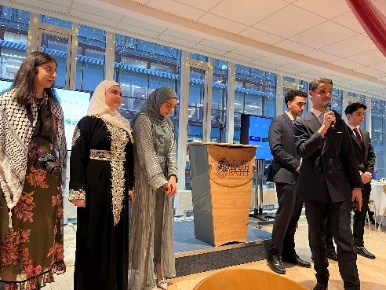
Diwali and end of Ramadan 2024 celebrations on campus

2.3.5 Wellbeing support
The University actively promotes race equality and an inclusive culture through a range of training, support services, and policy interventions. Student-led societies, such as the African and Caribbean Society, play a vital role in fostering community and celebrating cultural heritage, offering events and support networks for students of African, Caribbean, and mixed heritage backgrounds. Additionally, the Black Students Network has offered a wellbeing programme specifically designed for Black students, featuring workshops facilitated by Black wellbeing experts and coaches, focusing on themes such as resilience, identity, and mental health.

The University partners with the Cowrie Scholarship Foundation to offer full scholarships to Black British students from disadvantaged backgrounds, covering tuition fees and providing a substantial contribution towards living costs. The University provides multicultural shops, cafes, and places of worship on campus, helping students maintain cultural practices and access familiar goods and services, all conveniently located on a Multicultural outlets webpage.

The SU has established ‘213 The Salon', an on-campus hairdressing service that includes stylists specialising in Afro-Caribbean hair. REDACTED – sensitive information.

Our student induction training modules set clear expectations around respectful behaviour, providing definitions of harassment and discrimination, and introducing students to concepts such as microaggressions, including racialised examples and microaffirmations. In-person allyship training further supports students to understand their role in challenging discrimination.

2.3.6 Structural and cultural barriers
Despite some progress, challenges remain, including:
REDACTED – sensitive information and low numbers

2.4. Staff context

2.4.1 Academic staff

Key issues:
- Most data presented is stable over time with little indication of change.
- The Faculty of Humanities and Social Sciences is consistently the least ethnically diverse
- Small % increase in Professors from Ethnic Minority Groups over time. This is similar to their White counterparts
- The number of Ethnic Minority Professors is similar across Faculties/School despite the Faculty of Science and Humanities and Social Sciences being larger in size.
- Very few Ethnic Minority Group staff apply for promotion. Success rate fluctuates over the years, but appears to be similar to White counterparts

2.4.1.1 Distribution of academic staff by grade type
- Slight increase in overall % of academics from Ethnic Minority Groups, from 16% to 18%.

Figure 11: Academic pipeline showing representation of Ethnic Minority Groups by role, 2021-22 to 2023-24
The representation of Ethnic Minority Groups among academic staff varies with contract function and role. There is a clear “leaky pipeline” with Ethnic Minority Groups representation falling with increasing seniority. Among teaching and research academic roles, representation falls from 26% among lecturers in 2023-24 to 12% among professors.
The proportion of academics who are at Grades 8 and 9 has fluctuated between approximately 43% and 53%, while the representation of Ethnic Minority Group academics in this category has remained constant at 10% (Appendix A8.0.4). For these categories, the percentage of international Ethnic Minority Group recruits has increased from 15% to 21%. In contrast, the percentage of UK recruits for these categories has remained low and within the range of 3-4% (Appendix A8.0.5-6).
The percentage of academics who are professors rose from 16% in 2021-2022 to 18% in 2023-2024. During the same period, the percentage of ethnic minority group academics at the professorial level has increased from 9% to 12% (see Figure 11 above). For this category of staff, the percentages of UK-based ethnic minority group recruits are slightly lower than international ethnic minority group recruits during for the same period.
REDACTED – sensitive information & low numbers

2.4.1.2 Distribution of academic staff by contract type
Over the past three academic years, the distribution of ethnic minority group academics by contract type has remained unchanged. The percentage of both fixed-term and open-ended contracts for ethnic minority group academics remains very low, within 7-8% and 10-12% of the total academic staff, respectively.
On average, the percentage of ethnic minority group academics on fixed-term contracts is higher among international recruits compared to UK recruits, mostly due to more international postdocs as a larger proportion of those than among UK employees will belong to Ethnic Minority Groups. By setting faculty-level targets, we’ll aim to address loopholes in talent pipelines BA 4.2a-b.

2.4.1.3 Distribution of academic staff by contract function
In 2023-24, 27% of research staff, 15% of teaching staff and 17% of teaching and research staff were from Ethnic Minority Groups, with year on year rises across different contract functions except for research-only, which remained static for the last five years (at around 26%) Appendix A8.2.1.

2.4.1.4 Distribution of academic staff at different recruitment stages
Overall, Ethnic Minority Groups applicants are less likely to be appointed than White applicants (Appendix, A8.1, p. 90-104). In 2023-24 there were some changes with numbers of international Ethnic Minority Groups candidates falling. Thus, there are issues in the recruitment process that need investigating. As a result, we’ll develop a diagnostic and baseline setting tool to better understand recruitment and progression data at a more granular ethnicity level, including reviewing existing (i.e., Textio) and new (i.e., Rooney’s rule) recruitment tools and tactics (BA 4.1a-b).

2.4.1.5 Distribution of academic staff across promotions process
Figure 12: Academic promotion: application, promotion, and success rates

REDACTED – sensitive information & low numbers

Due to the low and varying number of applications for promotion from ethnic minority group colleagues, it is challenging to provide firm conclusions.

REDACTED – sensitive information & low numbers

Thus, we’ll pro-actively address this through actions BA 4.1a & 4.3a-b, establishing an ethnic minority group Promotion Mentoring Network (facilitated using WHEN etc.), offering 1:1 coaching and application-review clinics, and requiring each panel to include at least one member who has completed race equality training (BA 2.2a) and an Unconscious Bias Refresher prior to shortlisting/interviews.

2.4.2 Professional and support staff

Key issues:
- Representation of ethnic minority group employees is slowly increasing (Appendix A8.5.3)
- Although White staff are the largest group, Ethnic Minority Groups representation has seen steady increases across all job families (Appendix A8.5.3)
- The data covering three academic years (2021/22, 2022/23, 2023/24) showed that ethnic minority group staff are less likely (19% Ethnic Minority Groups on fixed term vs 11% White in 2023/24) to have open-ended contracts compared to their white colleagues, which might suggest fewer long-term job opportunities and career stability (Appendix A8.5.4-6).
- REDACTED – sensitive information & low numbers
- We do not observe strong indications of a leaky pipeline, bearing in mind numbers at Grades 2 and 3 are small. However, Ethnic Minority representation among UK MSA staff is low (Appendix A8.5.3.1), which we attribute to local context and talent pool in BANES area being predominantly White (see 2.1.2).

2.4.2.1 Distribution of PSS: recruitment and progression

A. MSA

REDACTED – sensitive information & low numbers
Between 2021-22 and 2023-24, 34% of applicants for MSA roles were from Ethnic Minority Groups, of these 15% were shortlisted compared to 35% of White applicants. Of those shortlisted, 30% of White candidates were appointed compared to 26% of Ethnic Minority Groups candidates (Appendix A8.7.4).

Patterns are different for UK and Internationally domiciled applicants. For UK candidates, overall, 9% of applicants are from Ethnic Minority Groups and of these 29% are shortlisted compared to 37% of White candidates (Appendix A8.7.5). Overall, 15% of White applicants were appointed compared to 10% of Ethnic Minority Groups candidates. For international candidates, overall, 71% of applicants are from Ethnic Minority Groups and of these 12% are shortlisted compared to 26% of White candidates (Appendix A8.7.6). Overall, 8% of White applicants were appointed compared to 2% of Ethnic Minority Groups candidates.

REDACTED – sensitive information & low numbers

In addition to BA 2.2a focussed on dedicated training on anti-racism, BA 4.1a will produce a consolidated Diagnostic Report and conduct a review of recruitment policies. We will also introduce a PSS development programme (e.g., fast-tracked) for high potential Ethnic Minority Group professional services colleagues (BA 4.2b).

B. OFS
In 2021-22, Ethnic Minority Group applicants represent 21% of the total applications, with 12% shortlisted and 9% appointed. Again, there is a notable drop-off. In 2022-23 and 2023-24 data indicated that Ethnic Minority Group applicants’ representation was 37% and 33% for both years respectively, with 15% shortlisted and 14% appointed in 2022-23 and 19% shortlisted and 15% appointed in 2023-24 (Appendix A8.7.7-8.7.9) While this presents a somewhat improvement with shortlisting and appointment rates compared to the previous years, the overall proportion appointed (15%) is lower than White applicants and the drop-off from application will be investigated (BA 4.1a-b).
C. T&E
Our data for T&E shows the most significant progress in all job families, with a clear improvement in both shortlisting and appointments.
It was noticed that Ethnic Minority Group representation in T&E has increased substantially, with a higher proportion of ethnic minority candidates shortlisted and appointed (Appendix A8.7.10-12). We reflect this could be due to the impact of University signing ‘Technicians’ Commitment’ Charter in 2018 to support the career development of technicians and the ambitions action plan for 2019-2022 bearing fruits.

D. Progression across PTO job families

REDACTED – sensitive information & low numbers

2.4.3 Staff benchmarking with GW4 institutions and the Higher Education sector

2.4.3.1 Staff data – Bath vs GW4
Bath has slightly fewer Black academic staff (1.1%) than the GW4 average (1.5%), and less ethnic minority group staff in PSS roles, with White PSS staff making up 89.2% at Bath compared to 86.4% across GW4.

2.4.3.2 Staff Data – Bath vs HE Sector
Bath demonstrates low numbers in Black academic staff representation (1.1% at Bath vs 3.1% sector-wide) and has higher White PSS staff proportions (89%) compared to the sector (79%). We do appreciate the local context with Bath being in the South West and over half of Black people in the UK living in London, however, we will proactively look for solutions available to us, such as:
- mapping and better diagnosing specific barriers by examining data at more granular level (BA 1.1a)
- conducting four lived-experience workshops (BA 1.1b)
- producing Belonging Diagnostic Report (BA 1.1c)
- listening to our existing and prospective staff and students (BA 1.1d-f) and acting.

2.4.4 Summary of findings from survey data analysis: staff

This analysis underscores the complexity of race equality within the University, with varied experiences and perceptions across Ethnic Minority Groups (see Appendix A1 REC Survey data: Staff). While some progress has been made since the launch of RET, significant challenges remain, particularly in the areas of racial discrimination, lack of representation, and training on race equality.
REDACTED – sensitive information & low numbers

Looking at experiences of White and Ethnic Minority Groups staff, tables A1.2 and A1.3 (Appendix, p.3) demonstrate that colleagues from Ethnic Minority Groups show lower feelings of respect and connection, are more likely to experience race-related uncomfortable situations and demonstrate lower confidence levels in leadership’s ability to address racial issues.

When asked what we as a University could do to advance race equality, staff said (Appendix A1.6, p.18):
- Ensure staff and students understand ongoing race equality efforts (proposed more often by Ethnic Minority Groups staff) – we are addressing this with BA 1.1, 1.2 and 1.4.
- Provide more mandatory training for staff on race and inclusion (proposed more often by White staff) – we are addressing this with BA 1.3 and 2.2.
- Strengthen processes for reporting and addressing racial discrimination (proposed more often by Ethnic Minority Groups staff) – we are addressing this with BA 2.1, 2.2, 2.3, 3.4.
- Increase representation of diverse backgrounds in decision-making roles (proposed more often by Ethnic Minority Groups staff) – we are addressing this with BA 5.1, 5.2, 5.3 and 5.4.

2.4.5 Summary of findings from REC Community Forum related to Staff
Staff attending the in-person forum emphasised the need for inclusive institutional decision-making structures, more diverse representation, and transparent support systems. Key concerns include underrepresentation in decision-making bodies and the inconsistency of support provided to ethnic minority staff across departments, which we’ll tackle with BA 1.1-1.4 and BA 5.1-5.4.
There is a call for embedding race equality into faculty and/or departmental culture, not just centralised strategies. Staff highlighted the importance of self-policing mechanisms within departments, more effective communication between institutional levels, and visible accountability through key performance indicators, which we’re addressing with BA 2.3b, 4.2a and 5.4a.
On recruitment and progression, feedback stressed reviewing job rejection data with an equality lens and diversifying the staff pipeline, including part-time and fixed-term roles that we’ll aim to tackle with BA 4.1 and 4.2. Additionally, fostering inclusive research environments is seen as vital. This includes incorporating inclusive research criteria in promotion cases, providing seed funding for racial equality projects, and increasing representation through initiatives like ring-fenced PhD studentships, which we are addressing with BA 3.3b, 3.3c and 3.3d. There was also strong support for training to address microaggressions that we commit to deliver as part of BA 2.2a-c.

2.5. Student context
Figure 13: UG, PGT, PGR student cohorts split by ethnic group over the last three academic years

Key insights:
- Undergraduate (UG) and Postgraduate Taught (PGT) cohorts remain predominantly White, with Asian students as the largest ethnic minority group, while Postgraduate Research (PGR) student numbers are lower overall and show a particularly small Asian and Black representation.
- Over one-third of all students across UG, PGT, and PGR identify as Asian, Black, or Mixed heritage, a proportion that has steadily increased since 2021-22.
- UK students’ ethnic minority group representation is highest among those identifying as Asian or British–Indian at UG and PGT levels, whereas Black or Black African students form the largest minority group at PGR level.
- Among international cohorts, Chinese students dominate UG and PGR ethnic minority group headcounts, though recent years show growth in those identifying as Asian or British–Asian Indian at PGT.
- While White students continue to achieve first-class and upper-second awards at higher rates than most Ethnic Minority Groups, international ethnic minority group students secure firsts at double the rate of their UK counterparts, and overall completion gaps between White and ethnic minority group students are minimal (under 1%).
- Black students REDACTED – sensitive information & low numbers across Faculties, and although their continuation and completion rates have improved in some areas, targeted interventions will be essential to prevent drop-off particularly through PGR, which is crucial for diversifying the academic pipeline.

2.5.1 Distribution of students (UG, PGT and PGR) by ethnicity
Over the past three academic years, about 70% of undergraduate students have been White, with about 80% among of UK-domestic and 43% of international students, with only small increases in ethnic minority group representation (Appendix A9.1.1-A9.1.12). The proportion of Asian students has been consistently high at the UG and PGT levels, but notably lower at the PGR stage.
Overall, across Faculties and study levels White students form the majority, followed by Asian students, many of whom are international. UK Black students, by contrast, are the smallest cohort in nearly every faculty and at most levels, with the sole exception of PGT in the Faculty of Science (Appendix A9.1.1 - A9.1.12). Thus, as part of our APP work, we’ll investigate conversion funnels (app/off/accept/enrol), aiming to raise Black UK UG enrolment to ≥ 3% (BA 3.1). Given that doctoral study is a critical pipeline for diversifying academia, we’ll aim to prevent attrition of UK Black students as they progress through successive stages of study (BA 3.3a-d and 3.4a-d). Thus, we’ll strive to increase PGR Black completions by +30% (BA 3.1).

2.5.2 Distribution of students in terms of UG continuation and completion rates

On average, continuation rates hover around 97% across Faculties, with Black and ‘Other’ students registering the lowest averages (Appendix, A9.1.14). SoM records the highest continuation rates for every ethnicity except Mixed heritage, where it falls to its lowest level (Appendix A9.1.15-17).
Over the past three years, the continuation gap between UK and International students has averaged just 0.87 percentage points, while the gap between White and combined Ethnic Minority Groups stands at 0.60 points (Appendix A9.1.15). Encouragingly, the number of Black students continuing in the Faculties of Science and E&D has improved year on year (the gap between White and combined Ethnic Minority Groups stands at 0.60 points (Appendix A9.1.14). Faculty-specific trends reveal that in E&D, continuation rates for Asian, Mixed heritage, and White students are declining while Other groups remain steady; in HSS, Black, ‘Other’, and White rates are down as Mixed heritage rates rise and Asian rates hold steady; in Science, all groups except Black show decreases; and in SoM, Asian students maintain a 100% rate, Mixed heritage group students improve slightly, and White rates remain broadly unchanged (Appendix A9.1.14). Overall, Asian students fare best in HSS and SoM, Black students in E&D, Mixed heritage students in HSS, and ‘Other’ and White students in E&D or SoM.

2.5.2.1 Comparing White students and combined Ethnic Minority Groups
Over the past three years, the percentage-point gap between White and Ethnic Minority Group completion rates across all Faculties has been 0.4, –1.1 and –0.4, respectively, indicating that Ethnic Minority Group students are marginally more likely to complete their studies than White students (Appendix A9.1.17). This pattern holds consistently within individual Faculties, though the SoM’s data for Ethnic Minority Group cohorts is very small and should be interpreted with caution.
Across the full dataset, White students in the Faculty of Science have the lowest average completion rate (95.6%), while White students in SoM achieve the highest (98.8%). For Ethnic Minority Groups students, lowest average completion rate (93.3%) is observed in E&D, with a highest (100%) demonstrated in SoM, similar to White students (Appendix A9.1.19). In terms of lowest scores among White and Ethnic Minority Groups cohorts, we find a range of around 2 percentage points. Through BA 3.4a-d, we’ll aim to enhance student experience and retention, halving the continuation gap between White and Ethnic Minority Groups students.

2.5.3 Distribution of students in terms of UG, PGT, PGR awards

2.5.3.1 UG awards
Figure 14: Proportion of first-class awards within each ethnic background

Under 20% of first-class degrees are awarded to students from Ethnic Minority Groups in 2023-24, declining from 18% in AY 2021/22 to 16% in AY 2022-23 (Appendix A9.1.20, A9.1.21 and A9.1.22). International ethnic minority group students achieved first-class honours at a rate of 36–38% over the last three years, compared with just 12–14% for UK Ethnic Minority Group students (Appendix A9.1.20, A9.1.21 and A9.1.22).
Across the undergraduate cohort, White students outperform other groups: they achieve higher proportions of First and Upper Second Class degree classifications, and a smaller share of Third Class awards (Figure 14 and Appendix A9.1.20, A9.1.21 and A9.1.22). By faculty, the Faculties of Engineering and Design, Management, and Science award a higher proportion of first-class degrees than the Faculty of Humanities and Social Sciences (Appendix A9.1.23, A9.1.24 and A9.1.25).
In all Faculties and the School, although small sample sizes in some Ethnic Minority Groups limit the strength of these conclusions.
REDACTED – sensitive information & low numbers

2.5.3.2 PGT awards
For PGT awards, outside of Asian or White groups, numbers are so low that it's hard to comment on the strength of any noticeable trends (Appendix A9.1.27). In general, it appears that achievement at Distinction for both UK and International Ethnic Minority Group students has increased over the period shown. UK students appear more likely to be awarded a Distinction than International students, whilst International students are more likely to be awarded a Pass than UK students. Awards for Merit are broadly balanced between UK and International students.

2.5.3.3 PGR awards
REDACTED – sensitive information & low numbers

2.5.4 Benchmarking against GW4 and Higher Education sector

2.5.4.1 Student data: Bath vs GW4
At UG and PGT levels, Bath has a lower proportion of White students (62.5% UG and 36% PGT) compared to GW4 (66% UG and 40% PGT). However, Bath has proportionally fewer Black and Mixed heritage students at both levels, with Black students comprising just 1.8% (UG) and 2.9% (PGT) at Bath, versus 2.0% and 1.6% across GW4.

2.5.4.2 Student Data: Bath vs HE Sector
Bath has lower representation of Black students at UG level (1.8%) compared to the wider HE sector (6.9%). Similarly, White student representation is higher at Bath (62%) than sector-wide (58%). Based on feedback from RET focus groups, Black students indicated that they prefer to study closer to home and this applies to a greater extent for all Ethnic Minority Groups students when compared with White. While we appreciate that to see significant changes in distributions of Ethnic Minority Groups, and Black students specifically, within the UK will take time, we will do a deep dive into internal data to take into account distances from home and get a feel for whether there is scope of improvement in Ethnic Minority Groups representation (BA 3.1c). We will also promote community-led outreach and marketing, co-designing “Bath: Your Safe, Inclusive Home” marketing tools for students and their parents (BA 3.2a). Finally, we’ll be more proactive in deploying student ambassador campaigns in key regions (BA 3.2b).

2.5.5 Summary of finding from REC Community Forum related to students

REDACTED – sensitive information & low numbers
We’ll further improve reporting processes (BA 2.1) and ensure work around B&H is embedded into the fabric of the institution (BA 2.3).
On student attraction and support, participants stressed the importance of equitable outreach strategies, not just numerical diversity. Suggestions included engaging prospective students' families, particularly from underrepresented regions (e.g., Africa, the Middle East, London Boroughs), and showcasing the University’s inclusive culture (BA 3.2a, 3.2b).
Forum attendees also called for more visibility of inclusive research and teaching practices and proposed the introduction of community forums, to measure and drive change (BA 2.3c).

2.6 Key priorities for future action

Our analyses across sections 2.1-2.5 have identified several key issues, which we have grouped into five priority areas. All five priorities are integral to the action plan, though current strategic efforts are concentrated on Priorities 2 and 3 due to their impact, urgency, and feasibility; with annual planning and incremental progress on Priorities 1, 4, and 5 developed as part of a longer-term approach.

Priority 1. Remove barriers to racial inclusivity and sense of belonging amongst staff and students

Rationale:
- Quantitative institutional and survey data: REDACTED – sensitive information & low numbers
- Qualitative survey responses and feedback from REC Community Forum: REDACTED – sensitive information & low numbers
- Based on anecdotal feedback received from REC-USAT, senior management (e.g., EDIC, University Executive Board), networks (EDIN, Mosaic etc.) and forums (from University REC community and GW4 race equality/EDI representatives), there are calls for more racial equality conversations and embedded inclusive research practices across the University.

Relevant actions: BA 1.1-1.4

Priority 2. Address bullying and harassment issues specific to Ethnic Minority Groups

Rationale:
Quantitative: REDACTED – sensitive information & low numbers

- REDACTED – sensitive information & low numbers
- Qualitative:
- REDACTED – sensitive information & low numbers
- Based on focus group feedback received via RET, there are calls to address issues relating to bullying and harassment (confidence in reporting, trust in process, training) affecting Ethnic Minority Groups.
Relevant actions: BA 2.1-2.3

Priority 3. Improve student recruitment and outcomes from under-represented Ethnic Minority Groups

Rationale:
- UG recruitment and awards: REDACTED – sensitive information & low numbers
- PGR Outcomes: REDACTED – sensitive information & low numbers.
- Student survey: REDACTED – sensitive information & low numbers
- There are wider calls for more diverse ethnic representation and satisfactory experience of Ethnic Minority Groups within the student community through the SU, Student Race Equality Group, EDIN.

Relevant actions: BA 3.1-3.4.

Priority 4. Review and address the disparity in staff recruitment and career progression from under-represented ethnic groups:

Rationale:
- Shortlisting and appointment: MSA funnel drop-off of 17 percentage point for Ethnic Minority Group applicants in 2023–24; OFS shows 33% Ethnic Minority Group applications to 15% appointed.
- Representation: Academic Ethnic Minority Group share rose from 16% to 18% over three years; Professorial Ethnic Minority Group at 12%.
- Promotion and progression: REDACTED – sensitive information & low numbers Promotion success rate for ethnic minority groups lower than White (83% vs 95% in 2021-22, 84% vs 86% in 2022-23), except for 2023-24 where 100% of Ethnic Minority Groups were promoted compared to 92% White academics.

Relevant actions: BA 4.1-4.3

Priority 5. Increase representation of Ethnic Minority Group colleagues on decision-making committees across the University

Rationale:
- 11 Committees (out of 23) have zero Ethnic Minority Group voices represented despite 10% of all PSS are from Ethnic Minority Groups and 21% Ethnic Minority Groups among academics.
- Survey narratives call for more ethnic minority group voices in governance and leadership (66% of Ethnic Minority Group survey comments).
- Based on feedback from EDIN, Race Equality Charter Community Forum, and Faculty/School EDI Leads, there are wide-spread calls for more diverse ethnic representation on University decision making committees.

Relevant actions: BA 5.1-5.4.

Figure 15: REC Bronze AP implementation flowchart

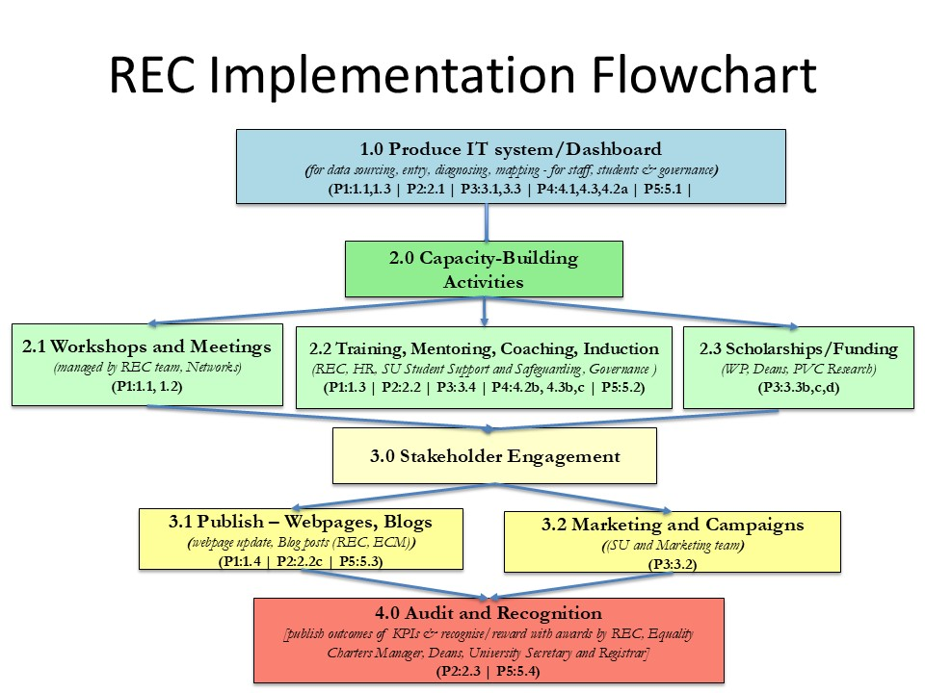

Section 3: Action plan
PRIORITY 1 - Remove barriers to racial inclusivity and sense of belonging amongst staff and students
Key data and quotes (rationale):
REDACTED – sensitive information & low numbers

No. | Objectives | Planned tasks | Timeline | Potential Ownership pending consultation | Success Measures: Outputs and Outcomes
1.1 | Map and better diagnose specific barriers for advancing intersectional race equality issues with a focus on gender, disability, LGBTQ+ and socio-economic status | 1.1a. Analyse quantitative survey data by different intersections of ethnicity × role/grade/ (UG/PG, academic/PSS) to pinpoint specific continuation, belonging and awareness gaps (e.g. 35% ethnic minority group staff belonging vs 55% W). | Dec 2025 - Jun 2026 (Yearly) | Equality Charters Manager | Quantitative analysis completed
1.1 |  | 1.1b. Conduct 4 lived-experience workshops with focused group/survey responses (2 ethnic minority group only, 2 mixed i.e. ethnic minority group and White) to highlight hidden race equality barriers (with a focus on intersectional analysis) | Jan 2026 – Jun 2026 (Yearly) | Chair of REC-USAT | Four workshops completed with at least eight participants in each workshop. Finding analyses and written up.
1.1 |  | 1.1c. Collate findings into a “Belonging Diagnostic Report”, including sourcing of UG student data by tariff point or equivalent data that is currently not collected. Consultation on the content of the report held with stakeholder groups, i.e. annual student satisfaction survey analysis submitted by PVC Student Experience | Jul 2026 to Nov 2026 | EDI Coordinator and PVC Student Experience | Detailed analytical report produced collating findings from quantitative analysis and workshops and delivered at REC-USAT, with areas of concern and opportunities highlighted and actions proposed. ≥ 60% of identified barriers validated by ≥ 2 stakeholder groups.
1.1 |  | 1.1d Establish the practice of the Chair of REC-USAT advertising regular monthly slots for 1-2-1 meetings with staff/students to raise any issues. Chair of REC-USAT to collect and share results from various engagement activities related to race equality. | Dec 2025 – Dec 2026 (Yearly) | Chair of REC-USAT | Chair of REC-USAT regular slots for 1-2-1 meetings
1.1 |  | 1.1e Identified actions added to Action Plan and implemented. | Dec 2026 – Dec 2029 | Equality Charters Manager | Identified actions added to Action plan and resources in place to implement them.
1.1 |  | 1.1f Access the effect of the action taken through the staff and student REC surveys run annually. To enhance student REC survey engagement, we will run a survey prize draw and work with Comms team to develop targeted survey campaigns aimed at tripling the student response rate. | Jan 2027 - Dec 2029 | Equality Charters Manager | Ethnic minority group staff belonging scores in REC annual survey improve by 5% in 2027 and 10% in 2029. Student REC survey response rate triples to 4% by 2030.
1.2 | Empower staff and students to hold confident and open conversations about race | 1.2a. Empower existing groups (e.g. Mosaic and Student Race Equality Group) by co-creating “Race Equality Peer Support Network” (mixed UG, PG, PSS, academics) across campus, securing administrative support and a ring-fenced operational budget (same allowance as available for staff networks) for REC-related activities. Effectiveness survey carried out on network members. | Feb 2026 – Mar 2027 | Deputy Director (Culture and Inclusion) | Race Equality Peer Support Network established, secretarial support identified and operational budget standard for a staff network assigned.  In an effectiveness survey, ≥ 60% members of the network (both champions and peers) agree this is useful.
1.2 |  | 1.2b. Race Equality Peer Support Network to appoint and train at least 7 ethnic minority group Community Champions (from the SU, Doctoral College, Faculties, PSS) to support new staff and student peer-support networks. At least 4 new community champions subsequently trained each year. | Sep 2026 to Sep 2028 | C&I Project Officer, HR | In first year, at least 7 ethnic minority group Champions trained to mentor peers (i.e., 4 in Faculties/School, 2 PSS, 2 SU, 1 governance and 1 HR). Programme in place to train at least 4 hew champions each year.
1.2 |  | 1.2c. Race Equality Peer Support Network and REC-USAT to establish co-hosting Race Equality Ally Workshops each academic year to share best practice and case de-briefs. | Sep 2026 to Sep 2028 | Chair of REC-USAT | Two Race Equality Ally Workshops held each academic year. Feedback from workshops is that at least 65% of attended feel the workshops are worthwhile.
1.2 |  | 1.2d. Staff REC survey used to assess changes to staff & students’ confidence and openness to hold conversations about race. | Jan 2029 to Dec 2029 | Equality Charters Manager | Increase ‘Completely’ and ‘Quite a bit’ responses from staff to question on ‘How confident they are that colleagues at the University can have an open and honest conversation with each other about race?’ REDACTED – sensitive information & low numbers
1.3 | Improve staff and student support and training on race equality | 1.3a. Develop an across-institution “Race Equality Toolkit” webpage (guidance on mentoring, peer networks, reporting). | Apr 2026 - Jun 2028 | / Director of Student Support and Safeguarding Team and Deputy Director (C&I) | “Race Equality Toolkit” developed and downloaded/used by ≥ 60% of School/Faculties.
1.3 |  | 1.3b1. Review mandatory training uptake by ethnicity and determine if there are any disparities arising. Take action to address disparities.  1.3b2. Upon completion of the review, launch PowerBI data dashboard, which will host all equality charters data (REC, AS, Disability Confident) under a single platform. | Apr 2026 - Jun 2028 | Equality Charters Manager  Senior Data Analyst, HRMI team | Review of mandatory training uptake carried out and any disparities in take up addressed through Actions as necessary. Subsequent review show that there are no significant ethnic group disparities of e-modules take up by target groups.
1.3 |  | 1.3c. Design and launch a dedicated “#NeverOK” campaign around racial harassment and microaggressions | Apr 2026 – Apr 2027 | PVC Student Experience | “#NeverOK” campaign around racial harassment and microaggressions designed and launched.
1.3 |  | 1.3d Assess the effects of the toolkit and training by using the REC Survey that will be run biennially for staff and students. | Jan 2027 to Dec 2027 | Equality Charters Manager | Halve the ‘Not so much’ and ‘Not at all’ responses from REC Survey on ‘How comfortable would you feel calling out a person showing racist behaviours at the University?’ REDACTED – sensitive information & low numbers
1.4 | To improve race-related communications and visibility for conversations around race within and outside the University | 1.4a. Set up a process, including assigning responsibility, to ensure that existing Race Equality Communications (i.e., web pages, induction content) are regularly updated and embed race-equality highlights in senior leadership presentations where appropriate. | May 2025 - July 2027 | Head of Internal Comms and  Head of Governance | Process and responsibility in place to update Race Equality Communications at least annually.  - Webpage views >250 a year.  - Annual dashboard views ≥ 150.  Race-equality highlights embedded in senior leadership presentations and highlighted updated regularly.
1.4 |  | 1.4b. Publish annual “Belonging and Equality” dashboards (membership stats, initiative uptake). | May 2025 - July 2027 | Equality Charters Manager | Annual “Belonging and Equality” dashboards published.
1.4 |  | 1.4c Assess the effect of changes on staff and students’ awareness around the university’s work to tackle racial inequalities through: 1) inviting PS Directors to join REEG; 2) REEG to produce a joint report annually to REC-USAT and EDIC detailing REC progress to date. | Jan 2027 to Dec 2027 | Chair of REC-USAT | A reduction in Not at all/Not so much responses to a REC survey question on ‘How much do you understand about what the University is doing to tackle racial inequality impacting people who work and study here?’ REDACTED – sensitive information & low numbers
PRIORITY 2 - Address bullying and harassment issues specific to Ethnic Minority Groups
Key data and quotes (rationale):
REDACTED – sensitive information & low numbers

No. | Objectives | Planned tasks | Timeline | Potential Ownership pending consultation | Success Measures: Outputs and Outcomes
2.1 | To further improve reporting processes | 2.1a. Identify barriers to reporting (anonymity, fear of reprisal) via staff and students’ surveys add-on (target n=70 Ethnic Minority Group respondents).  2.1b. Revise process to include a user-friendly online confidential portal, clear timelines and named case-owners. | March 2026 - April 2028 | Deputy  Director,  Student  Policy and  Safeguarding  Deputy  Director HR  Operations  PVC Student Experience | Success output:  - At least 70 respondents from Ethnic Minority Groups provide feedback on identifying barriers, with the report shared at EDIC for next steps.  Success outcome:  - REDACTED – sensitive information & low numbers  % Students currently state ‘Completely’ or ‘Quite a bit’ when asked How much do you understand about what the University is doing to tackle racial inequality impacting people who work and study here?
2.2 | To develop mandatory bystander and anti-racism training. | 2.2a. Develop a modular training package covering micro-aggressions, systemic racism, de-escalation and bystander intervention, with a focus on understanding the (crucial) difference about enacting equity rather than equality.  2.2b. Pilot with all line managers to roll out relevant training(s) to staff and students as part of supplementary EDI training.  2.2c. Introduce annual refreshers, embed scenario-based e-simulations, and publish blog posts on Departments achieving highest % training completions to encourage others. | January 2026 - December 2028 | Deputy  Director (Culture and  Inclusion)  PVC Student Experience | Success outputs:  - 60% of managers complete training by Dec 2029  - Post-training quiz scores ≥ 70% on key learning outcomes.  Success outcome:  - Staff and student REC survey results show reports of experiencing/witnessing race or ethnicity related harassment drop from REDACTED – sensitive information & low numbers
2.3 | Embed work around bullying and harassment into the fabric of the institution so it’s seen as a responsibility of everyone | 2.3a. Commission an internal audit of harassment-case handling and outcomes (with ethnic minority group rep as part of audit team).  2.3b. Embed Key Performance Indicator targets into School and Faculties performance reviews (e.g. report rate, resolution time, satisfaction).  2.3c. Host Race Equality Forum every 2 years to publish progress on our race equality journey, lessons learned and next steps. | Sept 2026 - March 2028 | Faculty  Deans  Deputy  Director HR  Services  Equality  Charters  Manager  Chair of  REC-USAT | Success outputs:  - Audit grades process ≥ “satisfactory” or above.  - Each Faculty and School meets ≥ 70% of its harassment KPIs.  - Forum attendance ≥ 50 staff with ≥ 70% rating it “useful.”  Success outcomes:  - Raise ‘Completely’ or ‘Quite a bit’ responses from  REDACTED – sensitive information & low numbers for students when asked ‘How much do you understand about what the University is doing to tackle racial inequality impacting people who work and study here?’  - Staff-survey reports of experiencing/witnessing race or ethnicity related harassment drop from  REDACTED – sensitive information & low numbers
PRIORITY 3 - Improve recruitment and awarding outcomes for students from under-represented Ethnic Minority Groups
Key data and quotes (rationale):

REDACTED – sensitive information & low numbers

No. | Objectives | Planned tasks | Timeline | Potential Ownership pending consultation | Success Measures: Outputs and Outcomes
3.1 | To develop a diagnostic and Target-Setting Plan, further strengthening APP workstream | 3.1a. Map conversion funnels  (apply→offer→accept→enrol) for key groups (i.e. Black, Mixed heritage) and agree on benchmarks.  3.1b. Identify specific reasons for lower awarding rates of 1st awards for Ethnic Minority Groups through a dedicated APP workstream with representatives across University and commit to ambitious, yet achievable year on year improvements to reduce the awarding gap by 50% in 5 years’ time.  3.1.c Review the distances from home for White vs Ethnic Minority Groups students to understand what differences arise and if there are any insights arising, all shared in a report to REC-USAT. | Sept 2026 - November 2028 | Head of WP  Head of  Registry  Services  PVC Education | Success outputs:  - Diagnostic report published.  - Official targets agreed and approved by EDIC and UEB  Success outcome:  - Raise Black UK UG enrolment to ≥ 3% by 2029; increase PGR Black completions +30% by 2029.  - Halve awarding gap for UG 1st awards between ethnic minority group and White students from 26% to 13% by 2030.
3.2 | To promote community-led outreach and marketing | 3.2a. Co-design with SU and local ethnic minority group community groups a marketing toolkit (e.g., “Bath: Your Safe, Inclusive Home”) for parents and students.  3.2b. Deploy student ambassador campaigns in key regions (Africa, Middle East, London Boroughs) using current ethnic minority group students and international staff as home country ambassadors. | December  2025 - Feb  2028 | Director of Admissions  Director of  Marketing &  Comms  PVC Global | Success output:  - Survey sent out to parents (as part of toolkit) showcase agree/strongly agree ≥ 60% for inclusivity question.  Success outcome:  - 10% increase in qualified UG enquiries from targeted regions in Y1
3.3 | To support contextual admissions and financial support | 3.3a. Extend contextual offers (two grades lower than standard A-level grades) to underrepresented ethnic minority group applicants must come from households in the lowest 20% income bracket (i.e., the bottom fifth nationally).  3.3b. Launch dedicated bursary/scholarship pot (10 awards per level: UG, PGT, PGR) for Black UK and Mixed heritage students. Promote via pre-offer webinars and peer mentors.  3.3c. Put a bid for Research England's Enhancing Research  Culture (ERC) Fund for a ≥ £40k seed-corn fund to pilot inclusive research, with a priority consideration given to ethnic minority group-led teams, projects across 3 Faculties and the School.  3.3d Secure internal funding for two PhD studentships for home ethnic minority group candidates. | September 2026 - November  2027 | Head of  Admissions  Head of  Widening  Participation  /Target Bath | Success outputs:  - ≥ 60% take-up of contextual offers by target groups.  - ≥ 70% Scholarships subscribed each year.  - 2 studentships awarded and taken up  Success outcomes:  - Enrolment rate of awardees ≥ 70%.  - Seed corn fund established, with at least 25% of seed-corn awards given to ethnic minority group-led teams.
3.4 | To enhance student experience and retention | 3.4a. Establish “Starter Cohorts” for first-year ethnic minority group UG/PGT/PGR students with dedicated peer mentors and academic coaching.  3.4b. Support race equality initiatives (e.g. “We all belong at Bath”) at 6 weeks and end of term (survey + focus groups) to act on emerging issues.  3.4c. Provide a “One-Stop Belonging Hub” on campus with drop-in support.  3.4d. Through a dedicated cross faculty/school task and finish group, we will explore ways in which we support development of social capital within ethnic minority group students (see more under priority rationale above). | April 2026 - December 2027 | SU Student  Support and Safeguarding  PVC Student  experience  VP C&I | Success outputs:  - Starter Cohort retention ≥ 60% at end Y1.  Success outcomes:  - Overall continuation gap (White vs EM) narrows from 2 to ≤ 1 percentage point by AY 27/28.

PRIORITY 4 - Review and address the disparity in staff recruitment and career progression from under-represented Ethnic Minority Groups
Key data and quotes (rationale):

REDACTED – sensitive information & low numbers

No. | Objectives | Planned tasks | Timeline | Potential Ownership pending consultation | Success Measures: Outputs and Outcomes
4.1 | To develop a diagnostic and baseline setting to better understand recruitment and progression data at a more granular ethnicity level | 4.1a. Produce a consolidated  Recruitment and Progression  Diagnostic Report: Race  Equality, within it identify baseline metrics to track.  4.1b. Conduct a review of the impact of anonymous shortlisting policy, incorporating consideration of other approaches that we could take alongside this, specifically regarding race and ethnicity (e.g., Rooney rule). | January 2027 - December  2029 | Equality  Charters  Manager  Head of  Recruitment  Chair of  REC-USAT | Success outputs:  - Report published. Baseline metrics approved by VP C&I and HR Director.  - Review of inclusive recruitment practices completed.  Success outcome:  - ethnic minority group appointment rate within ± 5 percentage point of ethnic minority group application rate in each job family by 2029
4.2 | To ensure representation targets are met and address loopholes in talent pipelines. | 4.2a. Set Faculty/School-level  ethnic minority group representation targets for Academic and PSS staff at each grade, with each faculty/school Exec determining about how this will be facilitated/rewarded (or how the burden will be minimised).  4.2b. Introduce a PSS development programme (e.g. fast-tracked) for high potential ethnic minority group professional services colleagues. | Targets: December  2025 - December  2029  Fellowships:  September 2026 - November 2028  Fast-Track:  January 2026 - Sept 2027 | DVC  Dean/Ass.  Deans EDI of  Faculties/School  Chair of  REC-USAT  Equality  Charters  Manager | Success outcomes:  - By 2030: 2% year on year increases in each faculty/school of academic and PSS staff from Ethnic Minority Groups on current baselines, with an 8% increase achieved in 4 years’ time.  - Fast-Track cohort promotion rate ≥ 10 within 5 years (by 2030), as evidenced in an increase in PTO progressions for Ethnic Minority Groups staff from 6% to at least 15%.
4.3 | To support promotion transparency | 4.3a. Establish an ethnic minority group Promotion Mentoring Network (facilitated using WHEN etc.) offering 1:1 coaching and application-review clinics.  4.3b. Require each panel to include at least one member who has completed race equality training (action 2.2a) and an Unconscious Bias Refresher prior to shortlisting/interviews. | Dashboard:  April 2026 - May 2027  Network: October  2026 - January  2027  Panel membership: October 2025 - August 2028 | Chair of ASC  Dean/Ass.  Deans EDI of  Faculties/School  Deputy  Director for Workforce  Development  Equality  Charters  Manager  Chair of  REC-USAT | Success outcomes:  - Promotion applications from Ethnic Minority Groups to increase annually at 2% increments from 16% applications coming from Ethnic Minority Groups in 2024 to 22% in 2028  - Ethnic Minority Groups promotion success rate comparable with White success rate (e.g., within ± 5 percentage point where margin is about 13% difference, for instance using above rationale REDACTED – sensitive information & low numbers

PRIORITY 5 - Increase representation of Ethnic Minority Group colleagues on decision-making committees across the University
Key data and quotes (rationale):
REDACTED – sensitive information & low numbers

No. | Objectives | Planned tasks | Timeline | Potential Ownership pending consultation | Success Measures: Outputs and Outcomes
5.1 | To audit and baseline current committee membership  across University | 5.1a. Compile a master list of all University-level and  School/Faculty/PSS Dept-level decision-making bodies (e.g., Senate, Faculty Boards, Exec, Managers’ meetings etc), recording current ethnic minority group membership disaggregated by ethnicity, gender, and disability alongside total membership and compare to overall staff profile  5.1b. Publish a “Committee Representation Baseline Report” at REC-USAT and EDIC. Shared with Faculty/School EDI Leads to be discussed at Faculty/School Execs.  5.1d. Ensure a minimum of 1 ethnic minority group rep or observer for all major governing and operational bodies across University, ensuring this commitment is embedded into ToR | November 2027 - April 2030 | University  Secretary and  Registrar  Senior  Executive  Officer, Vice Chancellor’s  Office  Equality  Charters  Manager  Faculty/School  Deans and  Directors of  PSS Depts | Success output:  - Report published and discussed at REC-USAT, EDIC, Faculty and  School Execs  Success outcome:  REDACTED – sensitive information & low numbers
5.2 | To onboard and develop ethnic minority group committee  members | 5.2a. Design and deliver an Inclusive-Leadership Induction for all new ethnic minority group appointees/observers, covering governance processes, role deliverables and expectations, insights into the process.  5.2b. Pair each new appointee/observer with a senior “Governance Mentor” for shadowing and support.  5.2c. Offer an annual “Governance Skills” workshops/training (chairing meetings, report writing, effective actions). | Induction by  September 2027  Mentoring and workshops  November 2027 - April 2030. | University  Secretary and  Registrar  Committee  Chairs  Senior  Executive  Officer, Vice Chancellor’s  Office  Equality  Charters  Manager | Success outputs:  - 60% of new ethnic minority group members’ complete induction.  - Workshop attendance ≥ 75% of ethnic minority group members per year.  Success outcomes:  - ≥ 60% of ethnic minority group appointees rate mentoring as “valuable.”  REDACTED – sensitive information & low numbers  .
5.3 | To provide transparency via regular reporting | 5.3a. Launch a committee  Diversity Dashboard showing live ethnic minority group membership percentages by committee.  5.3b. Publish yearly updates in the University newsletter, REC-USAT blog and EDIN highlighting progress, vacancies and success stories. | Dashboard go-live  January 2028  Yearly updates from  Q1 2027 | University  Secretary and  Registrar  Dean/Ass.  Deans EDI of  Faculties/School  Directors of PSS, Chair of  REC-USAT | Success outputs:  - Dashboard page views ≥ 200/year.  - Newsletter page views ≥ 200/year  Success outcome:  - Raise ‘Completely’ or ‘Quite a bit’ responses from REDACTED – sensitive information & low numbers for staff when asked ‘How much do you understand about what the University  is doing to tackle racial inequality impacting people who work and study here?’
5.4 | To embed  accountability and incentives | 5.4a. Incorporate committee diversity KPIs into Faculty/School/PSS Dept annual performance objectives for Deans, Heads of Departments and Committee Chairs.  5.4b. Recognise and reward committees exceeding targets via an annual “Governance Inclusion Award.” | Feb 2027- March 2028  Dec 2028-  Aug 2029 | University  Secretary and  Registrar  Dean/Ass.  Deans EDI of  Faculties/School/Committee Chairs  DVC | Success outputs:  - 100% relevant leaders have diversity KPIs in their Faculty/School/Dept objectives for the year  - At least 2 committees receive the Inclusion Award/Recognition each year.  Success outcomes:  - Raise ‘Completely’ or ‘Quite a bit’ responses REDACTED – sensitive information & low numbers for staff when asked ‘How much do you understand about what the University is doing to tackle racial inequality impacting people who work and study here?’  - Raise ‘Completely’ or ‘Quite a bit’ responses from REDACTED – sensitive information & low numbers for staff when asked ‘How confident are you that colleagues at the University can have an open and honest conversation with each other about race?’

Appendix A– culture survey data
REDACTED

Appendix B– mandatory datasets
REDACTED

Appendix C – additional data
REDACTED

https://blackacademia.co.uk

