Frequently Asked Questions (FAQ)
UNISON – University of Bath - Higher Education (HE) Ballot
This FAQ is here to explain the upcoming UNISON ballot. It explains what the ballot is, why it matters, and what happens if members vote for industrial action. You do not need to have any prior knowledge of unions or industrial action to read this.

1. What is the Higher Education (HE) ballot?
The HE ballot is a vote asking UNISON members at the University of Bath whether they are willing to take industrial action (strike) due to unfair pay offers for 2025/2026.
After years of low pay, and below inflation pay offers, members need to stand up together to demand more – you deserve better!
Industrial action (striking) is a way for staff to put pressure on an employer when negotiations have not been successful.
By law, UNISON must run a ballot (vote) before any industrial action (strike) can happen.

2. Why are we being balloted again?
We held a ballot before, but not enough people voted for the result to count under UK law even though a big majority (86%) voted fort strike action.
The law says that:
- At least 50% of eligible members must return their ballot, and
- More people must vote YES than NO
Because we did not reach the 50% turnout last time, we need to ballot again so members can have another chance to vote.

3. Who can vote?
You can vote if you:
- Are a UNISON member
- And work at the University of Bath
If you are unsure, or if you have recently changed address or job role, please contact the UNISON branch on unison@bath.ac.uk so we can advise on how to check your details.

4. Why does my vote matter?
Every single vote matters.
Even if you are unsure about industrial action (striking), returning your ballot paper is really important.
If you do not vote, it makes it harder to reach the 50% turnout.
If we do not reach that turnout, the result will not count – even if most people vote YES.
If we do not reach turnout the University will see that as you accepting the unfair pay offer. And it weakens our position for any future issues that might affect you and your colleagues.

5. What will the ballot paper look like?
The ballot (vote) is done by post and sent to your home address.
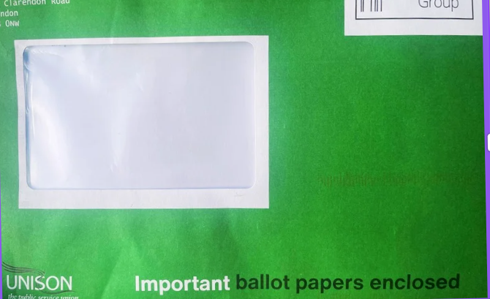
The ballot paper will:
- Be an official UNISON document
- Ask simple YES or NO questions
It will also include clear instructions on what you need to do, and a prepaid return envelope.

6. How do I vote?
- Read the ballot papers when they arrive
- Put an X in the box next to your answer(s)
- Put the paper in the prepaid return envelope provided
- Post it back as soon as you can
📮 Do not wait until the last minute – posting it early really helps.

7. When is the deadline?
Your ballot paper must be posted by:
Monday 23rd March
So that it arrives in time for the closing of the ballot on Friday 27th March.
If it arrives after this, it cannot be counted.

8. What happens if the ballot (vote) is successful?
If at least 50% of members vote, and most people vote YES, then UNISON is allowed to call industrial action (a strike).
This does not mean action will start straight away.
A successful ballot does not mean automatic strike action. Any strike action will be decided by you and your elected representatives.
Members will always be told in advance and given clear information about what is being asked of them.

9. What is industrial action (strike)?
Industrial action means staff taking action together to support a dispute with their employer.
Strike action
Strike action usually means:
- Not coming into work on specific strike days
- Not doing any work on those days
Whatever decision is made, UNISON will explain clearly what you should and should not do.

10. Do I have to take part in industrial action (strike)?
Taking part in industrial action (strike) is a personal choice.
However, strike action is most effective when members act together.
UNISON encourages members to support collective action so that our concerns are taken seriously.

11. What money support is there if I go on strike?
UNISON provides strike pay to help members who lose pay while taking official strike action.
By law, employers do not pay staff when they are on strike. However, UNISON has a strike fund to cover part of your wages, with your University of Bath branch being able to support the rest.
This means you should not loose any pay whilst you are on strike.
To receive strike support, in general:
- You must be a paid-up UNISON member
- You may need to sign in with the union on strike days
Full details and instructions will be shared before any strike action takes place.

12. Will my pay be affected?
If you take strike action, the employer will deduct pay for each strike day.
This is often around 1 day’s pay for each day on strike, though exact amounts can vary.
However, as mentioned in point 11 – UNISON and your local branch have funds to support you, so you should not loose out on any pay whilst you are on strike.

13. Is it safe to take industrial action (strike)?
Taking part in lawful industrial action (strike) is a legal right.
You should not be disciplined or dismissed for taking part in official action covered by a legal ballot. By law Managers cannot stop you from voting or taking part in strike action.
If you have specific worries (for example about visas, probation, or fixed-term contracts), please contact the branch on unison@bath.ac.uk for confidential advice.

14. What if I don’t get a ballot paper?
If you have not received a ballot paper by:
Friday 6th March
Please contact the UNISON branch or the UNISON helpline as soon as possible so a replacement can be sent.
0800 0857 857
- Opening Hours: Generally, the hotline operates Monday to Friday, 8 am to 8 pm.
- Accessibility: Members with hearing difficulties can use the textphone number 0800 0 967 968.
- Preparation: Have your membership number ready to speed up the process.

15. Where can I get more information?
- Speak to a UNISON rep – you can either email the Branch on unison@bath.ac.uk or look up a Committee Member here: UNISON Committee Reps
- Contact your local UNISON branch on unison@bath.ac.uk
- Attend member meetings: Tuesday 3rd March, 9.30-10.30am, CB 4.16 - email unison@bath.ac.uk to receive an online joining link.
- Read emails and updates from UNISON – which will include drop-in sessions for IT support.

If you are unsure about anything, please ask – there are no silly questions.

Myths and Facts about the HE Ballot and Industrial Action
Myth: “If I don’t want to strike, I shouldn’t return my ballot.”
Fact: Returning your ballot paper is important whatever your view.
The law says at least 50% of members must vote for the result to count. If people don’t return their ballot paper, the vote fails – even if lots of members vote YES.
You can return your ballot and vote NO if that is how you feel, but not voting makes it harder for everyone’s voice to be heard. Not voting means that the University is safe to ignore what UNISON members think on pay and conditions. Voting now, even if you vote NO, makes you and your colleagues safer for the future.

Myth: “My vote won’t make a difference.”
Fact: Every single vote really does matter.
Previous ballots have failed because a small number of members did not return their papers. One vote can be the difference between reaching the legal turnout or not.

Myth: “If the ballot is successful, we will automatically go on strike.”
Fact: A successful ballot does not mean an automatic strike.
It simply gives UNISON permission to call industrial action (strike) if needed.
Members will always be told in advance and given clear information before any action happens.

Myth: “Industrial action means walking out for weeks.”
Fact: Industrial action can take many forms.
It may involve:
- One or more strike days
- Action short of strike, such as working to contract
Any action would be planned carefully by you and your elected representatives and explained clearly to all members.

Myth: “I could lose my job for taking industrial action (strike).”
Fact: Taking part in official, legal industrial action (strike) is a protected legal right.
If action is covered by a lawful ballot, you should not be disciplined or dismissed for taking part.

Myth: “Industrial action only helps some staff.”
Fact: Industrial action is about improving conditions for all staff.
Issues like pay, workload, job security, and respect at work affect everyone. Acting together gives staff more power than acting alone.

Myth: “I can’t afford to take part in industrial action.”
Fact: UNISON provides financial support.
Strike pay and hardship support are available to help members who lose pay while taking official strike action.
Details will be shared clearly before any action takes place.

Myth: “I’m not very active in the union, so this isn’t really for me.”
Fact: The ballot is for every UNISON member.
You don’t need to attend meetings or be a union activist. Simply returning your ballot paper is one of the most important ways you can take part.

Please return your ballot paper.
Taking part is the most important thing you can do.

