
University of Bath Unison Annual General Meeting 2026
Date: Thursday 19th March 2026, 10-11.45am
Venue: 3 West North, 3.7 and via Teams

Attendees
- Wendy Brooke
- Lily Blackmore
- Cameron Malone
- Shane Edwards
- Julie Samways
- Colin Brestrich -Sciones
- Neal Scotcher
- David Roberts
- Steve Nicolson
- James Evemy
- Rob Cooper
- Nicola Lloyd
- Alison Borgelin
- Bentley Crudgington
- Caroline Thomas
- Rachel Sherring-Lucas
- Sara Barrett
- Simone Osborn
- Tracey Stenson Jukes
- Alison Mayes
- Guest: Stuart Melvin
Apologies
- Paul Bisby
- Rachel Willis
- Angela Harrington

- Welcome
RC welcomed members in the room and online
- Minutes of the 2025 AGM
The minutes were accepted as an accurate record of the meeting
- National HE Pay Ballot Information
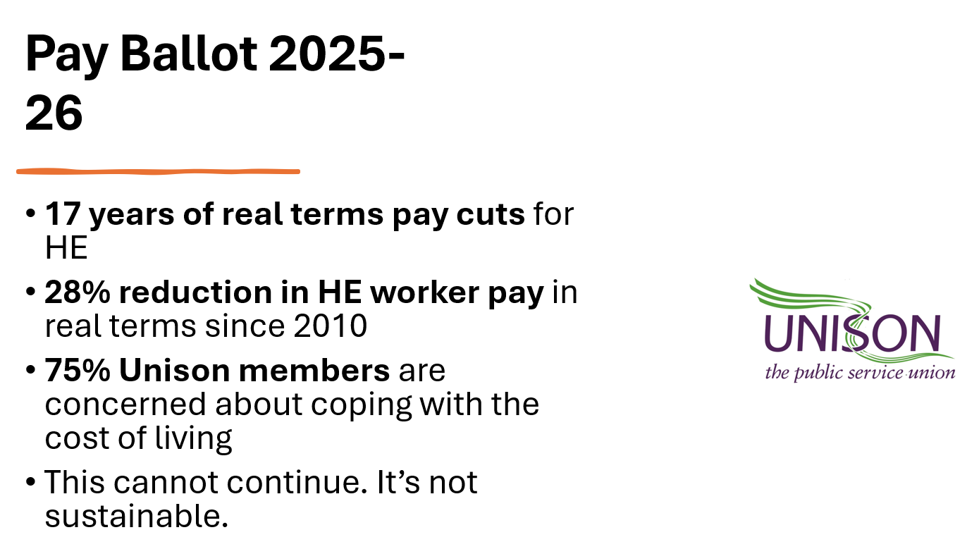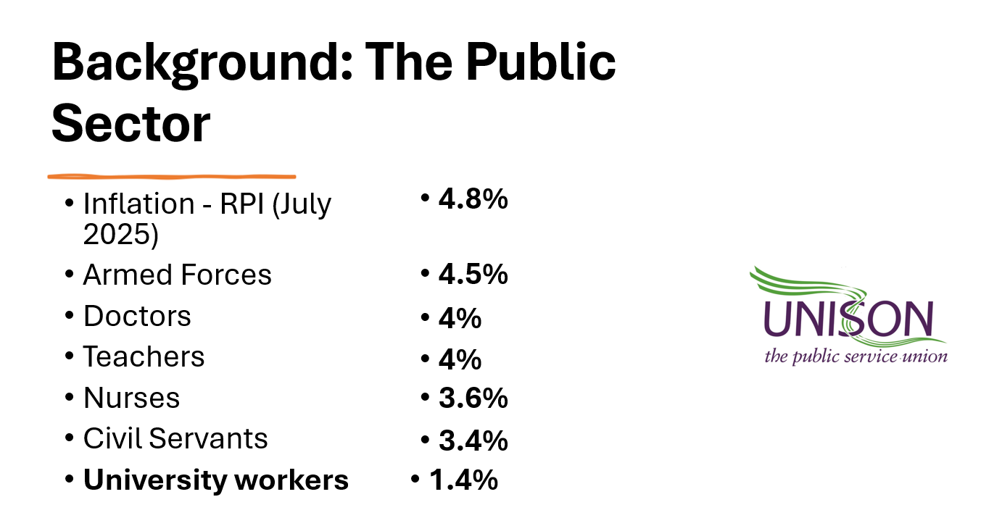
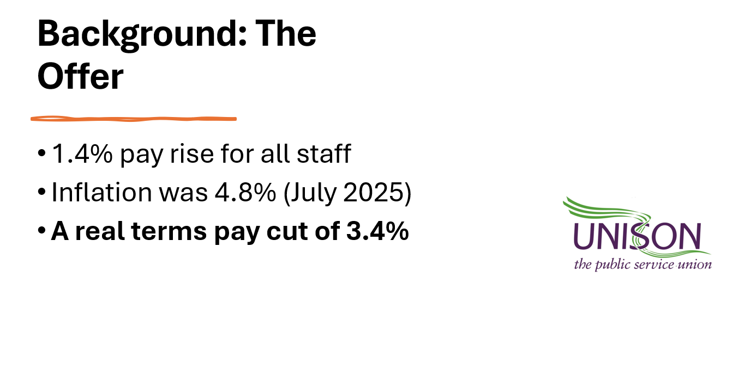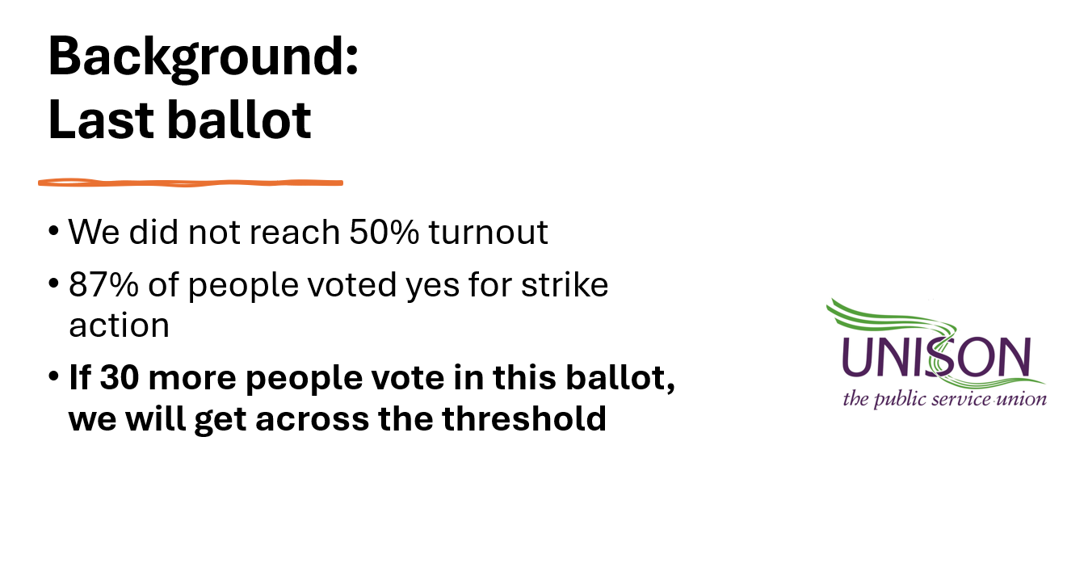
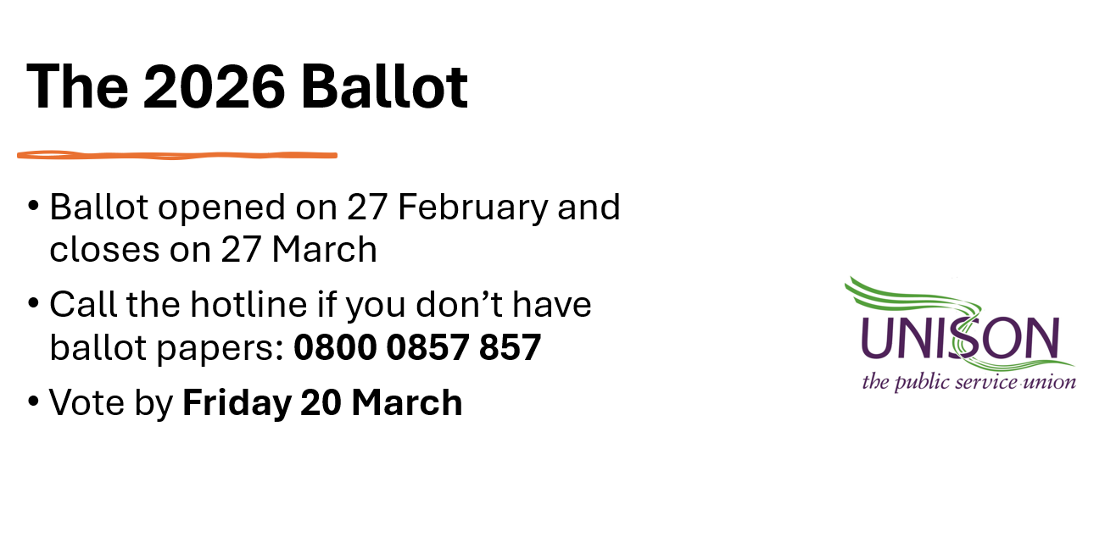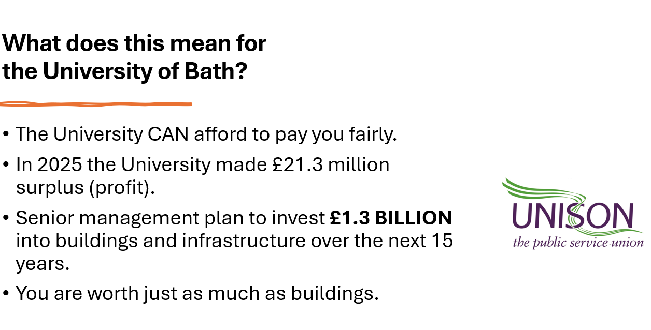
- Presentation of Annual Report on Branch Activities including Financial Report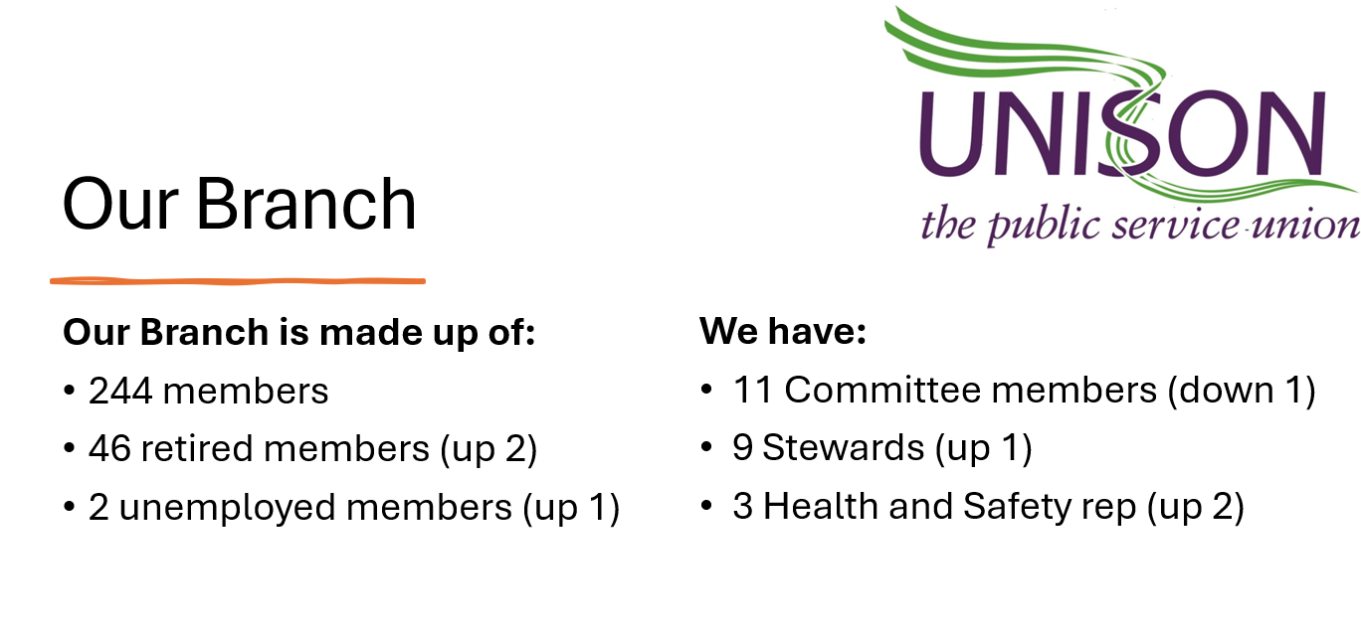
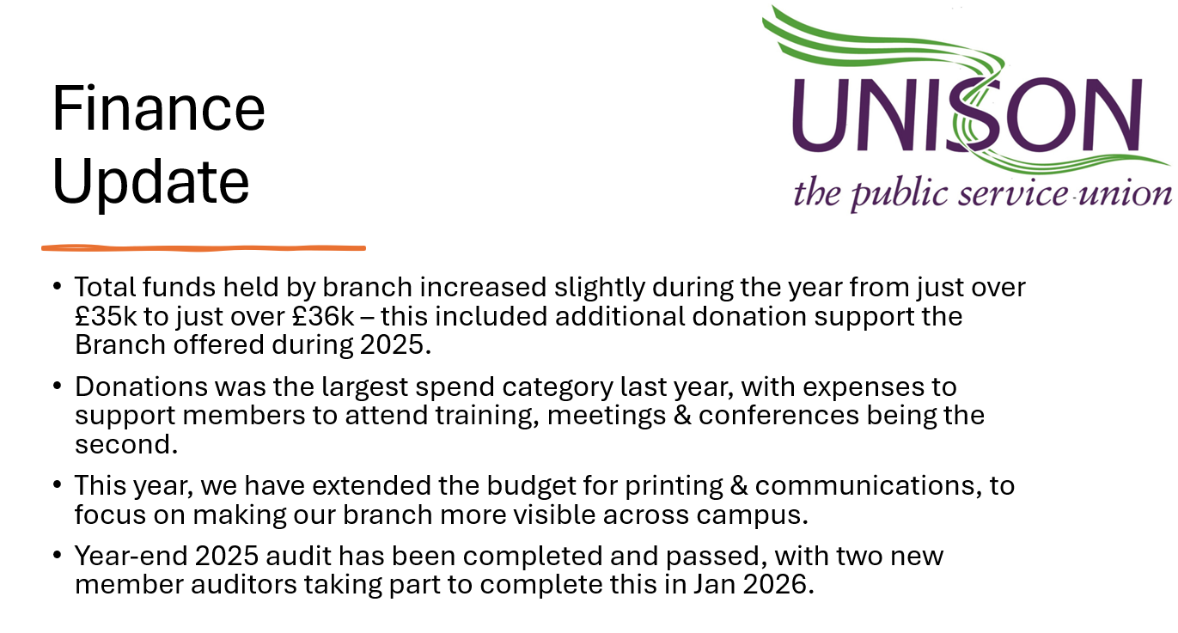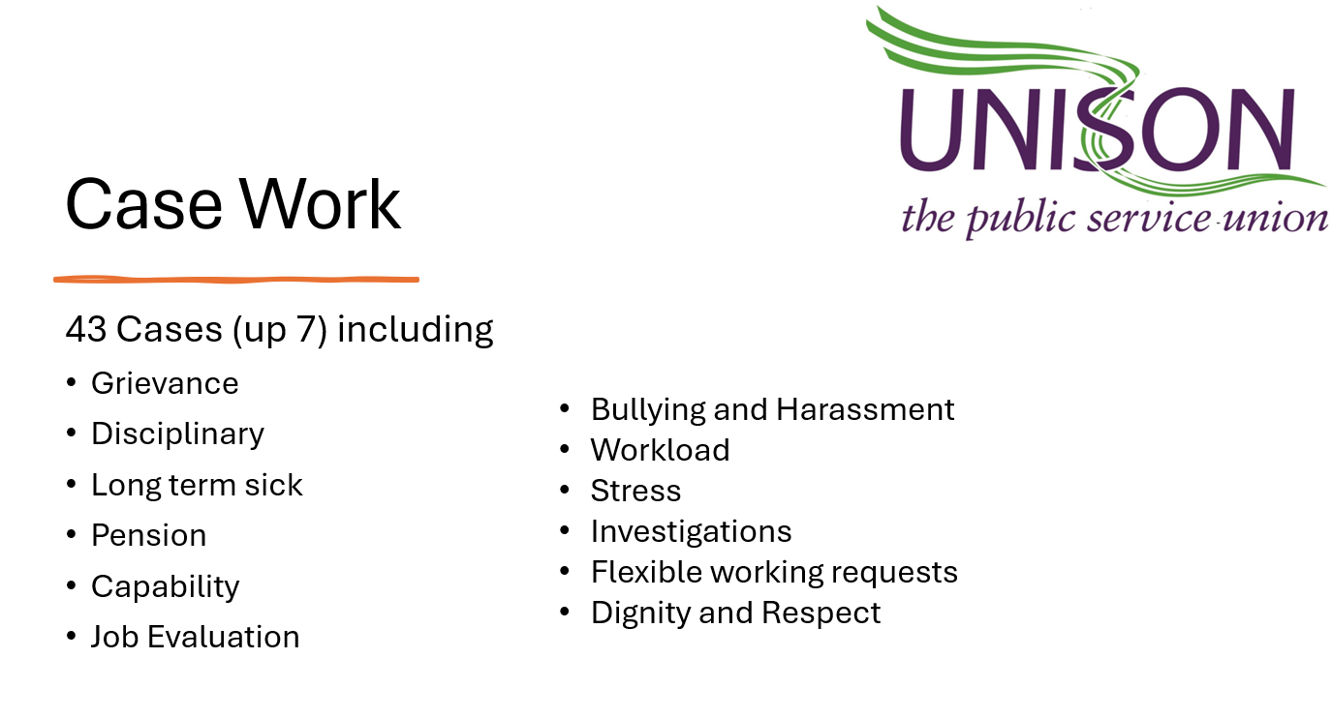
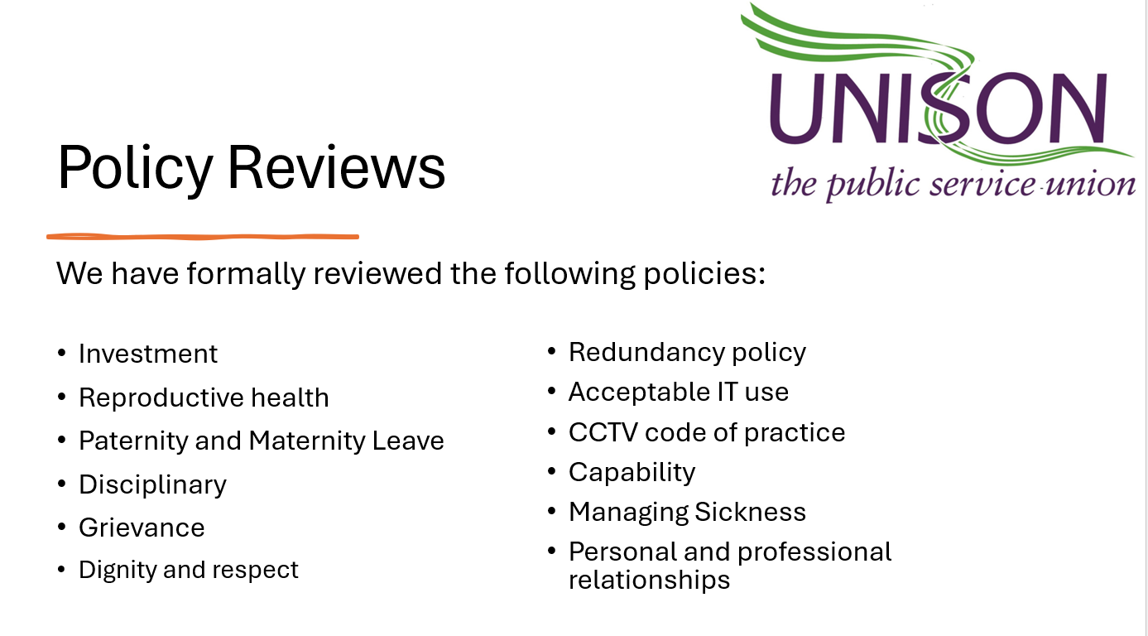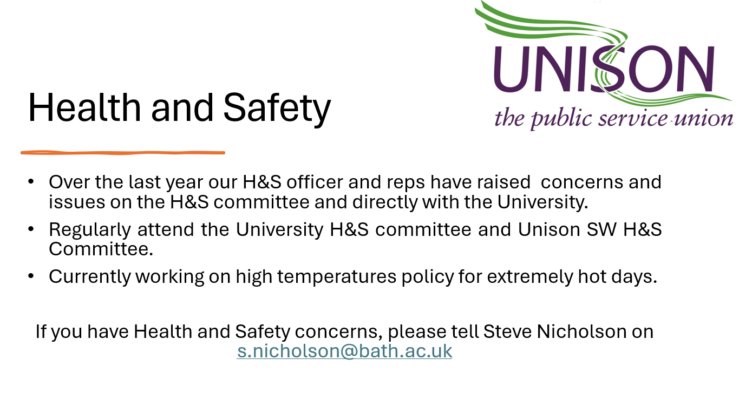
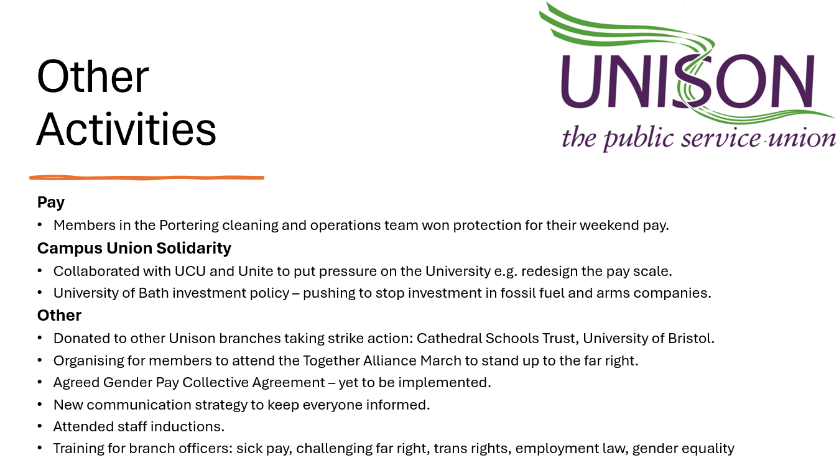

- Ratification of elected stewards
- Alison Borgelin​
- Rob Cooper​
- Bentley Crudgington
- James Evemy​
- Beck Freeman​
- Nicola Lloyd​
- Julie Samways​
- Tracey Stenson Jukes​
- Rachel Willis

- Election of Officers
- Chair: Rachel Willis
- Secretary: Rob Cooper
- Treasurer: Nicola Lloyd
- Membership Officer: Julie Samways
- Education Coordinator: Tracey Stenson Jukes
- Environment Officer: Alison Borgelin
- Communications Officer: Nicola Lloyd and Lily Blackmore (job share)
- Health and Safety Officer: Steve Nicholson
- LGBT+ Officer: Bentley Crudgington
- Pensions Officer: Steve Nicholson
- Casework Officer: Julie Samways
- Learning Representative: Tracey Stenson Jukes
- Equality Representative: Bentley Crudgington, Alison Borgelin and Lily Blackmore
- Health and Safety Representatives: Steve Nicholson, Julie Samways and James Evemy
- Workplace contacts: Sara Barret and James Evemy
- SW HE Committee Reps: Rob Cooper and Lily Blackmore

- Affiliation to Bath Trades Council
Agreed by all to continue affiliation with the Bath Trades Council.

- Branch Action Plan
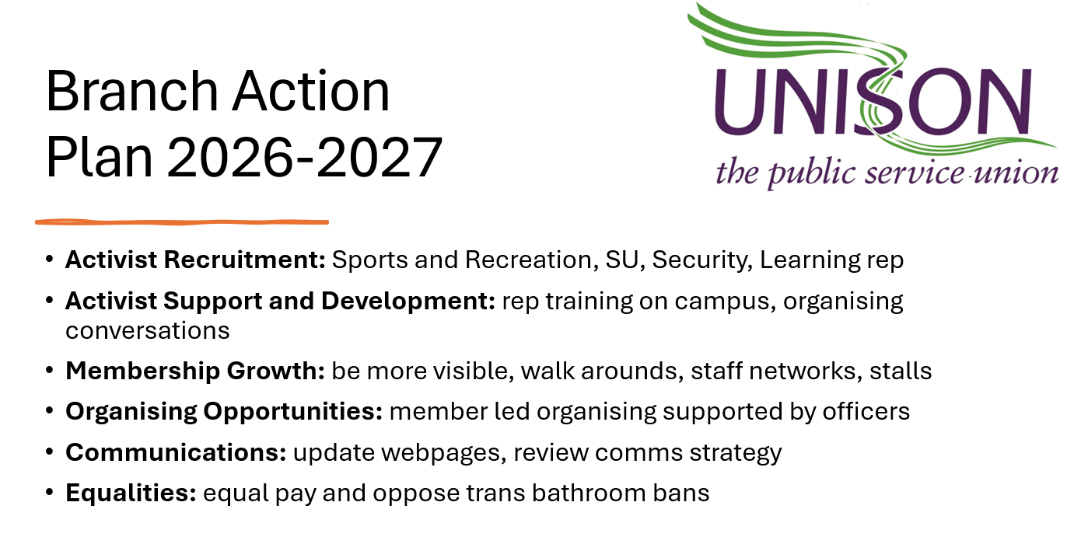

- Address from Stuart Melvin, Area Organiser for Cathedral Schools Trust.

Meeting Closed 11.15am

