SDPR Uploading

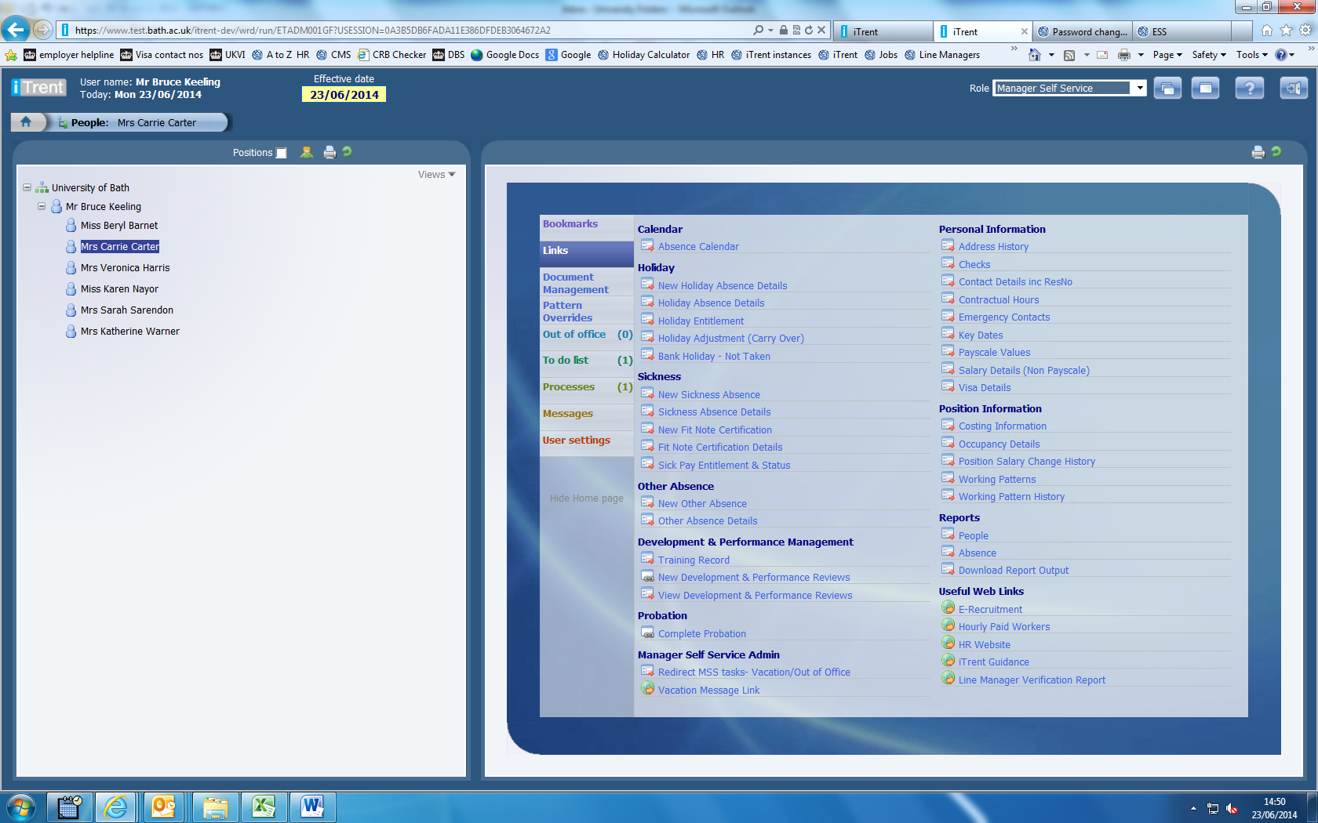
Login to Manager Self Service, select the person, then choose “New Development & Performance Reviews”
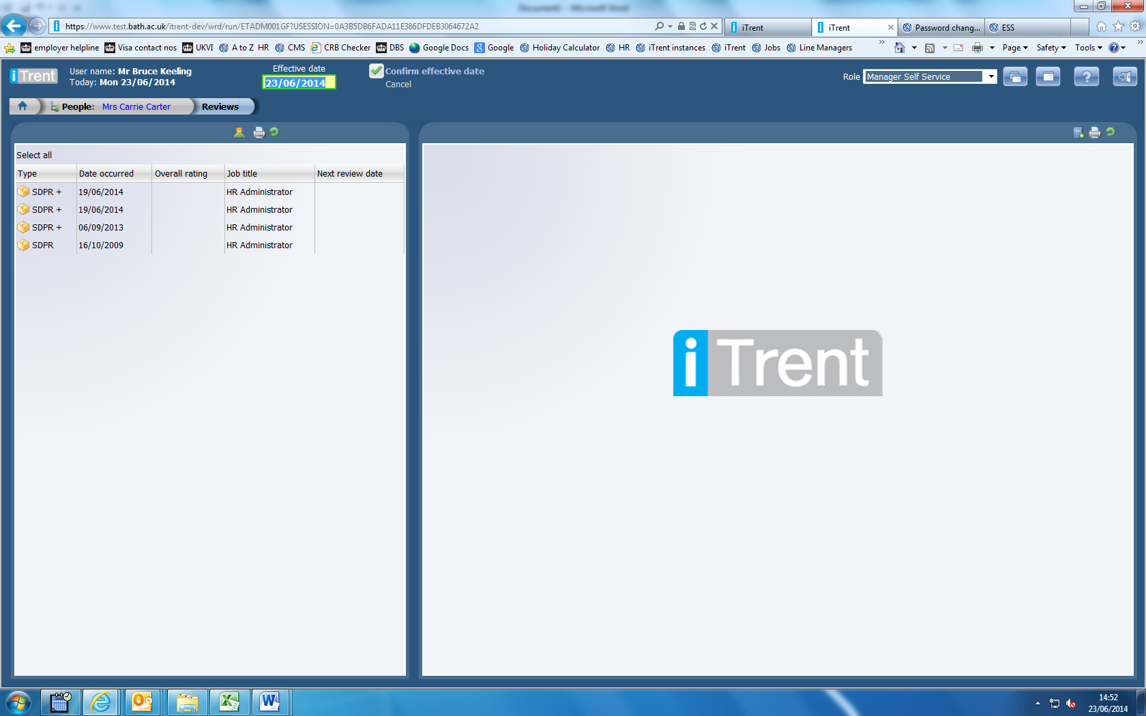
Confirm the effective date (you can leave it on today’s date)

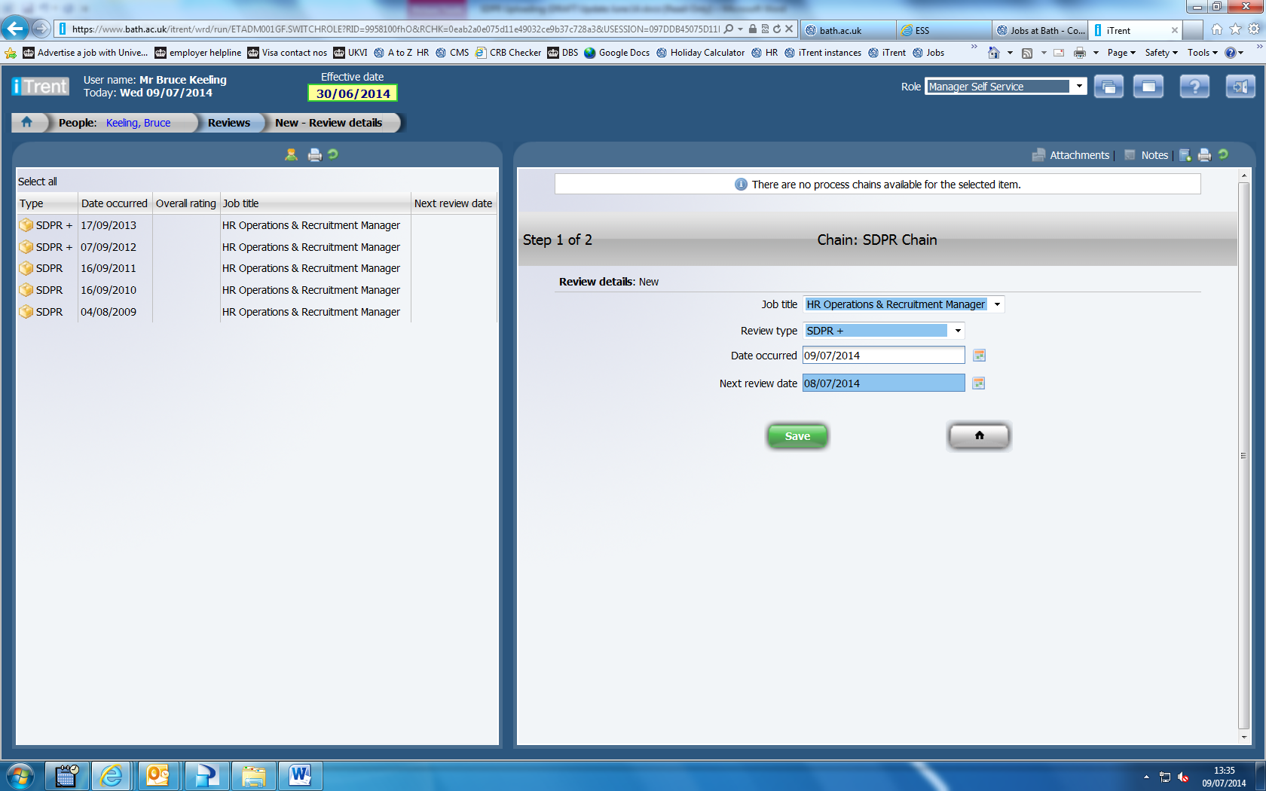
Select the Review Type and input the date it took place (you can type it in, or use the calendar date picker).
Input a “Next Review Date” typically this will be one year ahead (this date will be used a basis for future automated reminders) then click “Save”
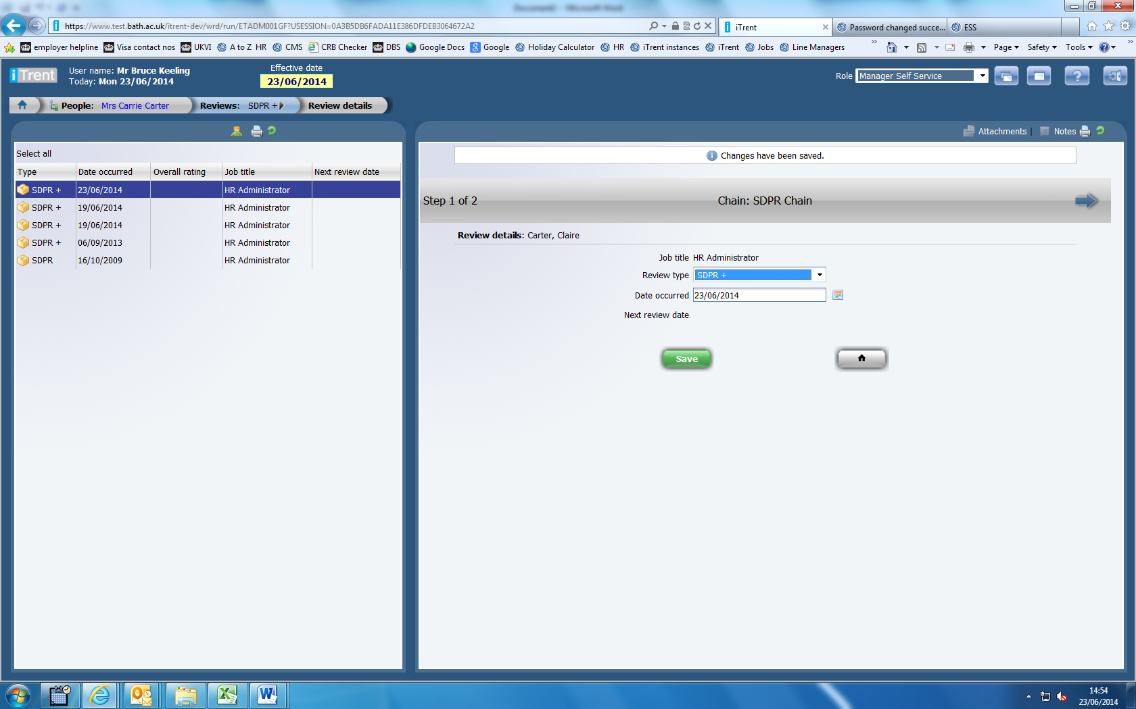
Click the blue arrow on the right hand side of the screen.

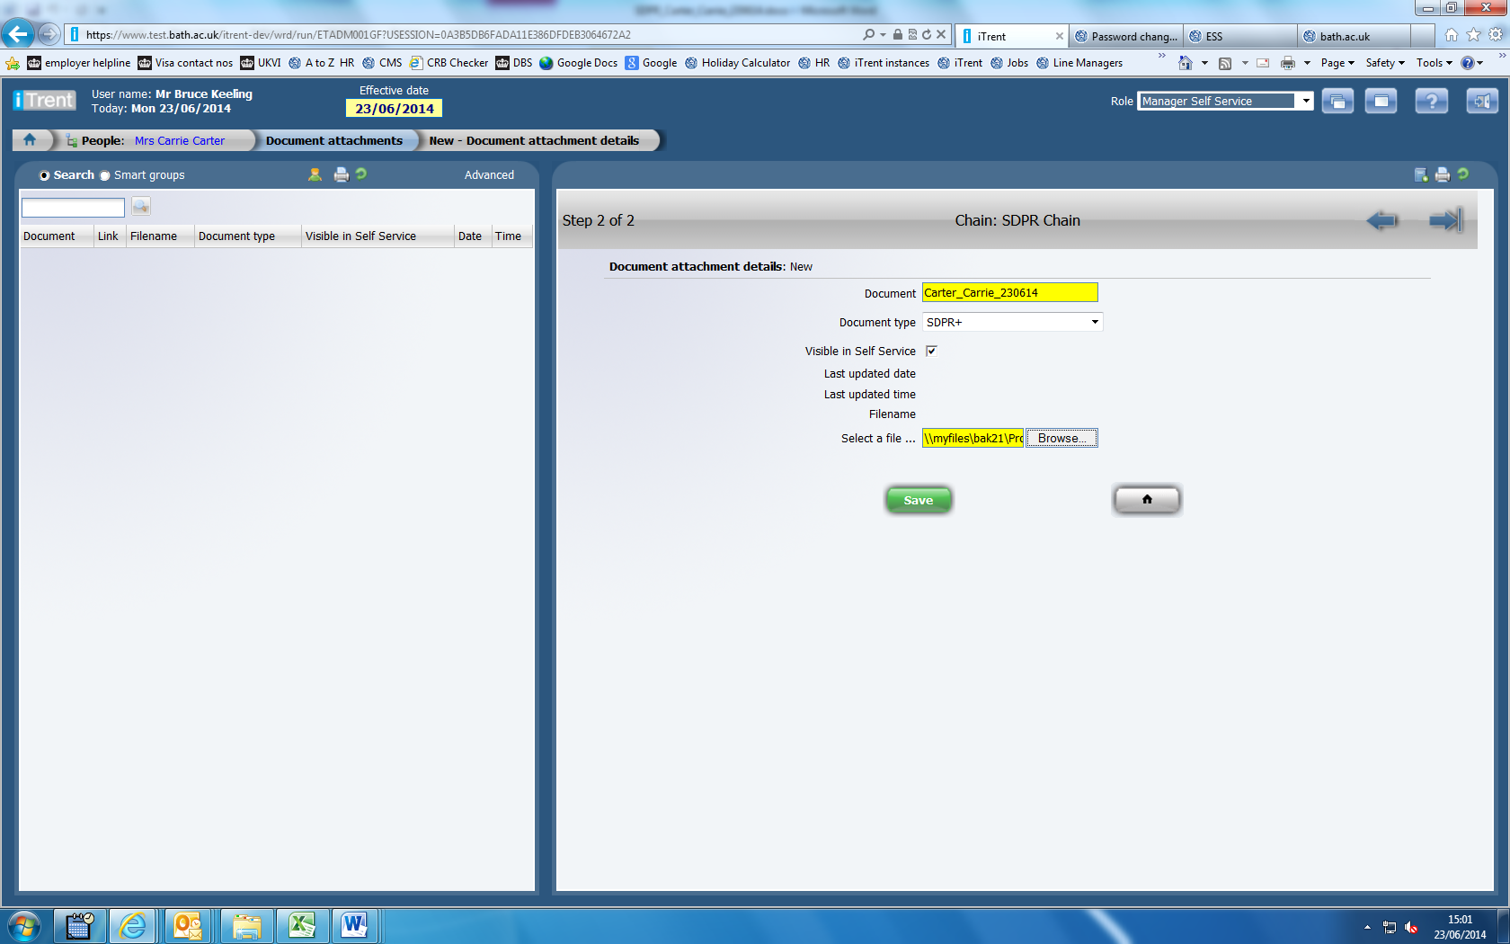
Input a name for the document - a standardised naming format will help users to identify the document more easily once it has been uploaded, so please enter a name for the document using a standard naming convention: Surname_First name_SDPR_date of the meeting e.g. Wogan_Johnny_SDPR_200614
The filename of the file you are uploading is held ‘behind the scenes’ in iTrent, so the document name you enter is the one that is most visible in Trent.
Select the relevant Review Type
Tick the Visible in Self Service box (this will enable the employee to view it via Employee Self Service).
Browse to the file and click Save (Please note that if you are using Firefox, the screen can display incorrectly, the software supplier is aware and this is scheduled for fix by August)
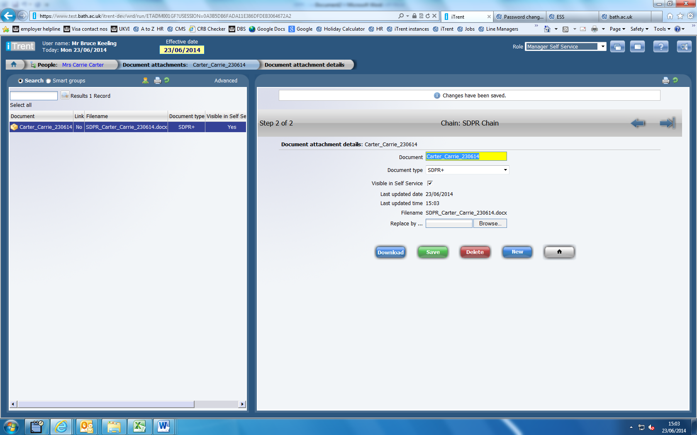
The document is now uploaded and you can return to the Home Page.
You can click on the icon of the person and this will return the screen to enable you to select another person.

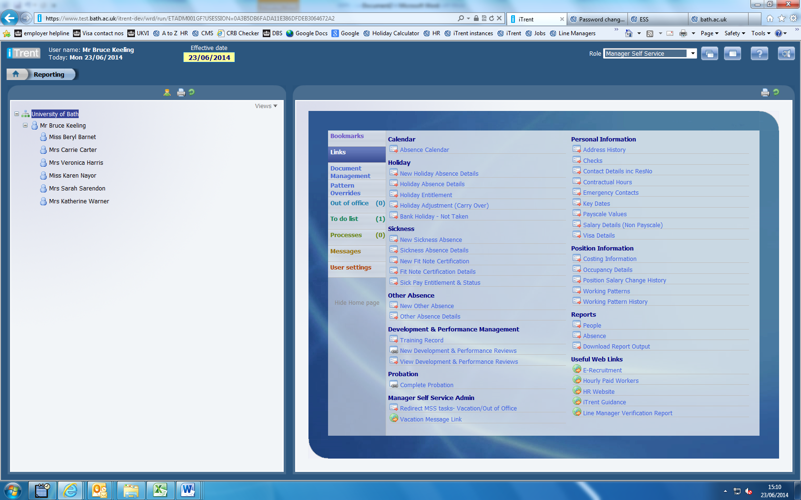
The review details are now saved on iTrent.
When you have completed and saved your review (s), please inform the Head of Department / Senior Reviewer by email. Please ensure to include the name(s) of the reviewees within the email.

Please note, you will only be able to view documents that have been uploaded to iTrent. Documents that have previously been emailed to Staff Development will not automatically appear, though you may also choose to upload them via this method.

