Viewing SDPR Documents (Manager Self Service)
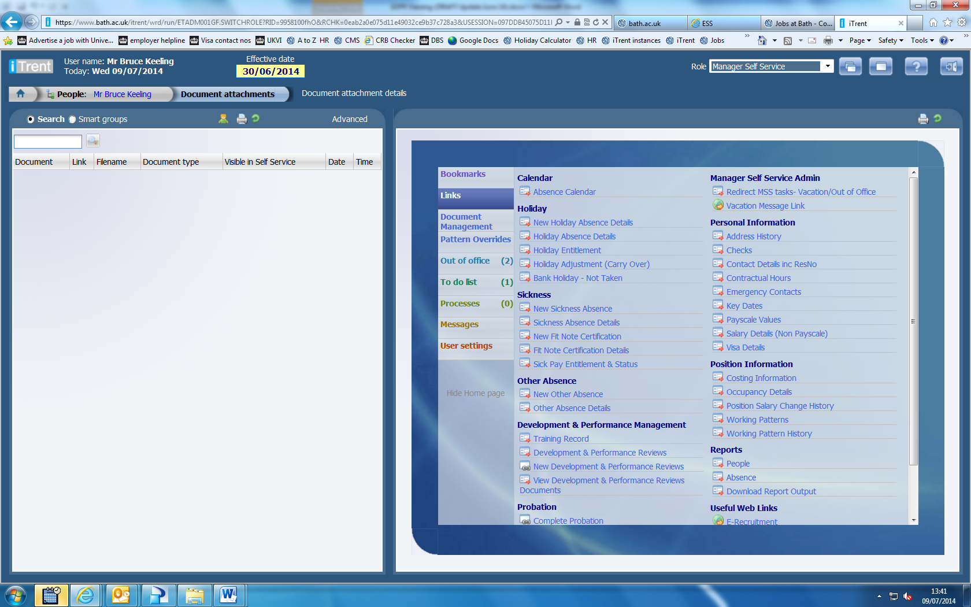
Login to Manager Self Service, select the person, then choose “View Development & Performance Reviews Documents”

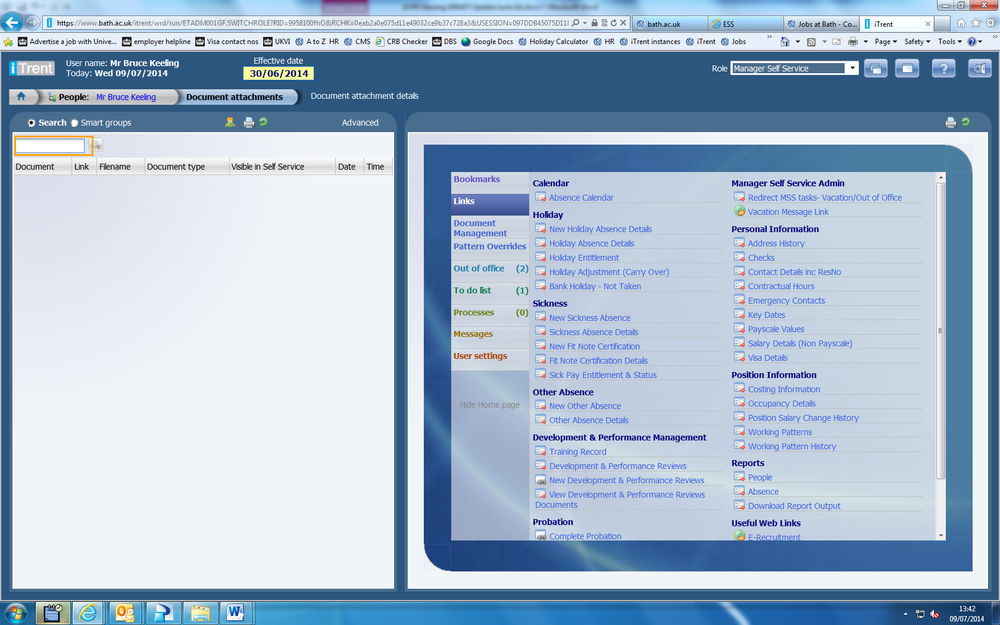
Click on the magnifying glass

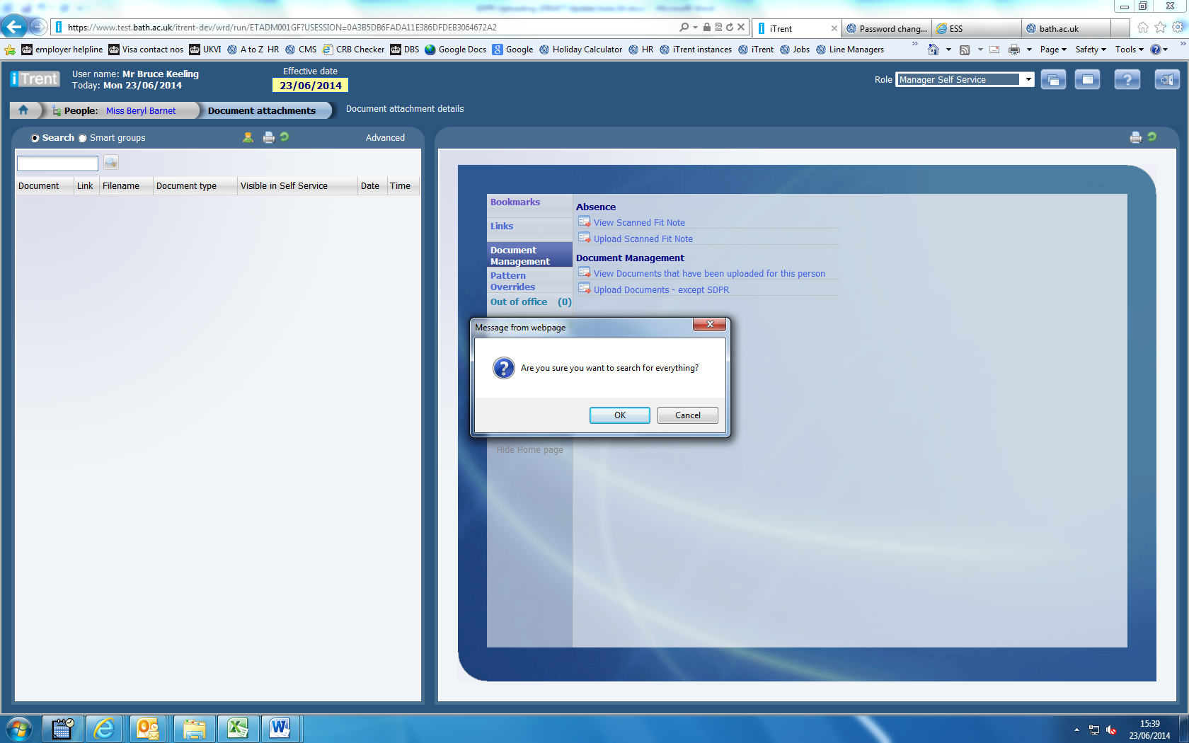
Click OK

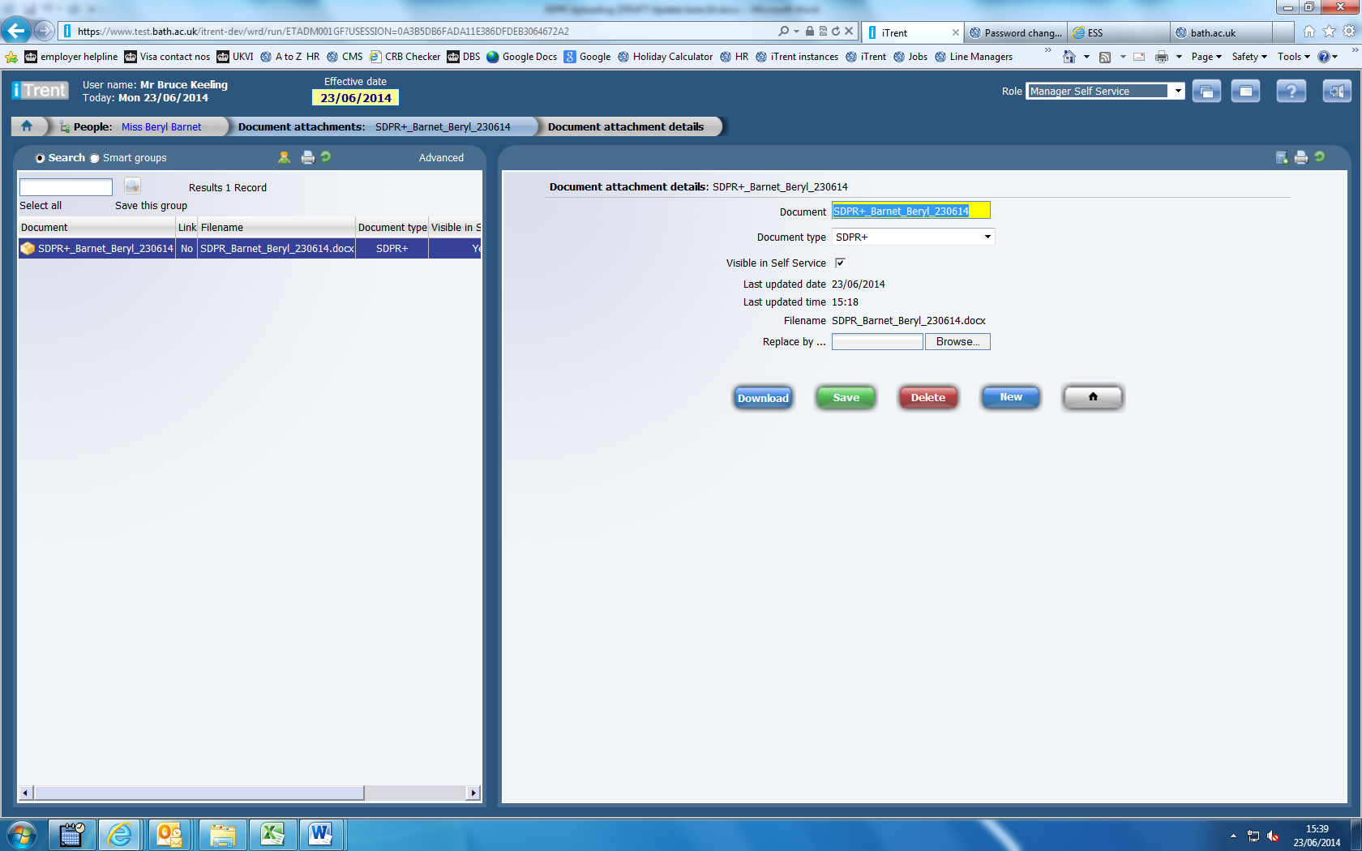
Select the relevant document and click download to open the document.

