SDPR Viewing ESS

Login to Employee Self Service
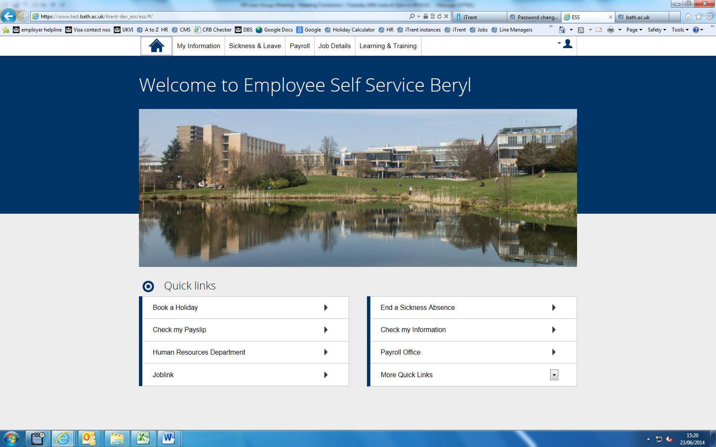

Click on My Information

Click on the Paperclip icon within the Personal Details box.
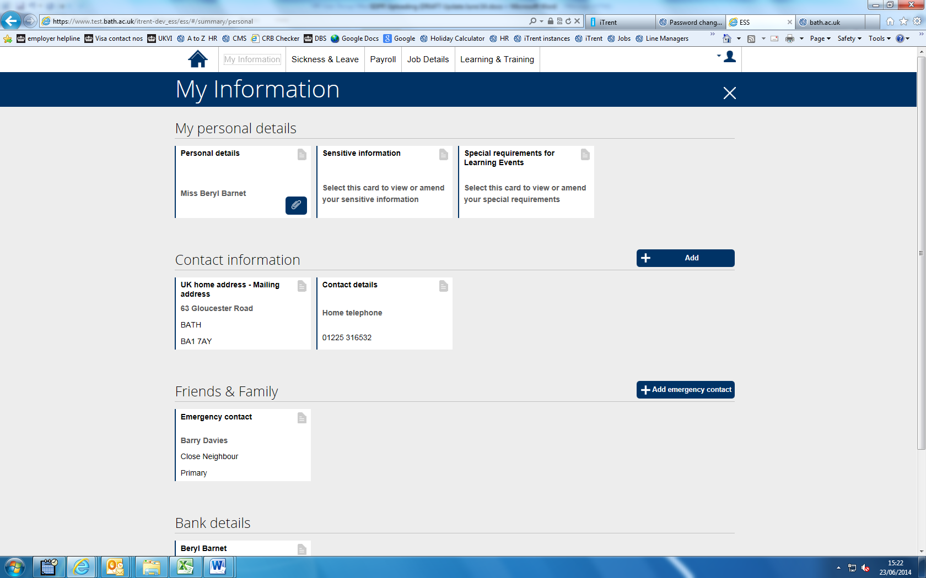

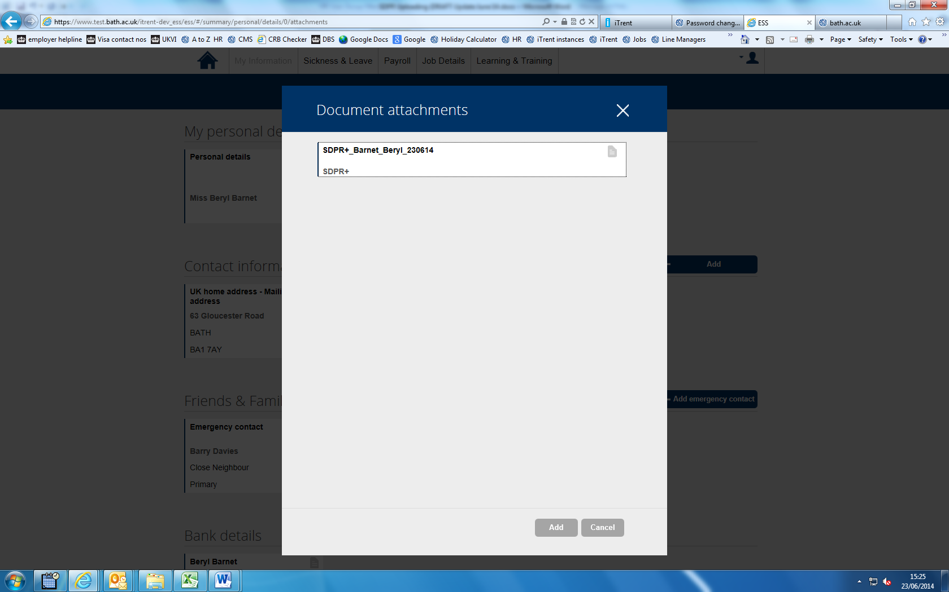
Click on the white box

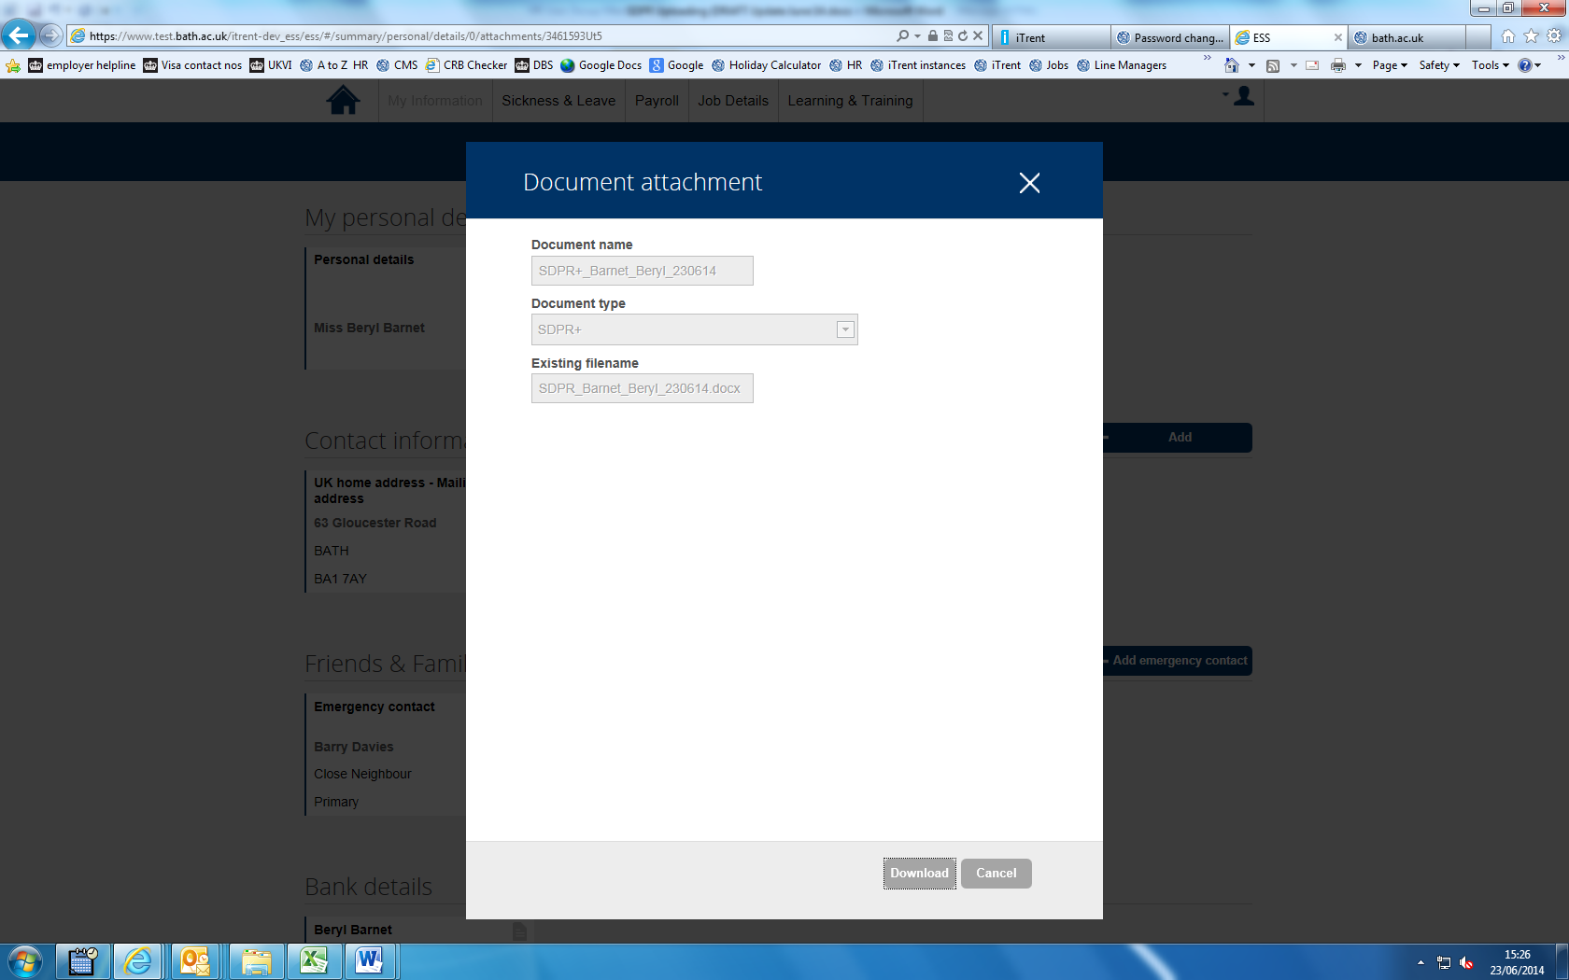
Click on the “Download” button and this will enable you to open up the document.
We are working with the software supplier to enable any documents loaded onto iTrent prior to July 2014 accessible via Employee Self Service.

