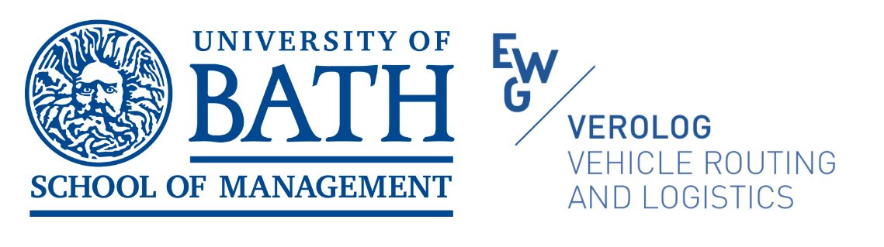

VeRoLog 2026, PhD summer school:

Metaheuristic Algorithms for Routing and Logistics
3rd, 4th and 6th July 2026
PhD school teachers:
- Dr Diego Cattaruzza (University of Udine)
- Professor David Pisinger (Technical University of Denmark)
- Dr Roberto Roberti (University of Padova)
- Professor Anand Subramanian (Federal University of Paraíba)
 | 3rd July | 4th July | 6th July
8:30-9:00 | Registration
9:00-9:30 | Opening session
9:30 -11:00 | Classical Heuristics for Vehicle Routing and Basics of Metaheuristic Optimization | Large Neighbourhood Search and Adaptive Large Neighbourhood Search | Basics of Modelling Vehicle Routing Problems
11:00-11:30 | coffee break | coffee break | coffee break
11:30-13:00 | Diego Cattaruzza | David Pisinger | Roberto Roberti
13:00-14:00 | lunch | lunch | lunch
14:00-15:30 | Iterated Local Search | Genetic algorithms
15:30-16:00 | coffee break | coffee break
16:00-16:30 | Anand Subramanian | Diego Cattaruzza
16:30-17:30 | Anand Subramanian | Diego Cattaruzza | Plenary:  Anand Subramanian

All classes will be held in room of the 10E0.18, 10E building - School of Management, University of Bath (https://www.bath.ac.uk/publications/school-of-management-welcome-pack/attachments/som-general-welcome-pack-2025.pdf).

