Introduction to the Workplace Wellbeing Wheel
As part of our approach to health and wellbeing, we have a range of tools, techniques and interventions to enable you to be at your best and thrive. These resources can be used to help create a healthy and supportive environment in which everyone can be successful.
One of the tools we use is the Workplace Wellbeing Wheel.
Wellbeing and resilience vary from person to person. They can be affected by fluctuations in physical, mental and emotional wellbeing as well as by the personal demands we experience from outside the workplace. The Wellbeing Wheel is based on this premise, as well as the evidence based Health and Safety Executive (HSE) Management Standards.
The HSE standards are associated with good health and wellbeing. They have been established to support employees and employers and define measures that help to effectively manage wellbeing at work.
The six key areas covered by the HSE standards are:
- Role
- Demands
- Control
- Relationships
- Change
- Support
In addition to these, we have included an area of our own ‒ Personal ‒ because it’s important to also consider the connection between our professional and personal lives.

Using the wheel
The wheel can be used to reflect on what's working well and highlight any areas for improvement.
Identifying areas of concern and adopting strategies that make a positive difference can help manage pressure and improve wellbeing.
The Wellbeing Wheel is intended to be a dynamic tool that can be referred to ‒ for example when circumstances at work or in your personal life change.
Next, have a go at scoring your own wheel.

Step one: evaluate how satisfied or content you are with each area
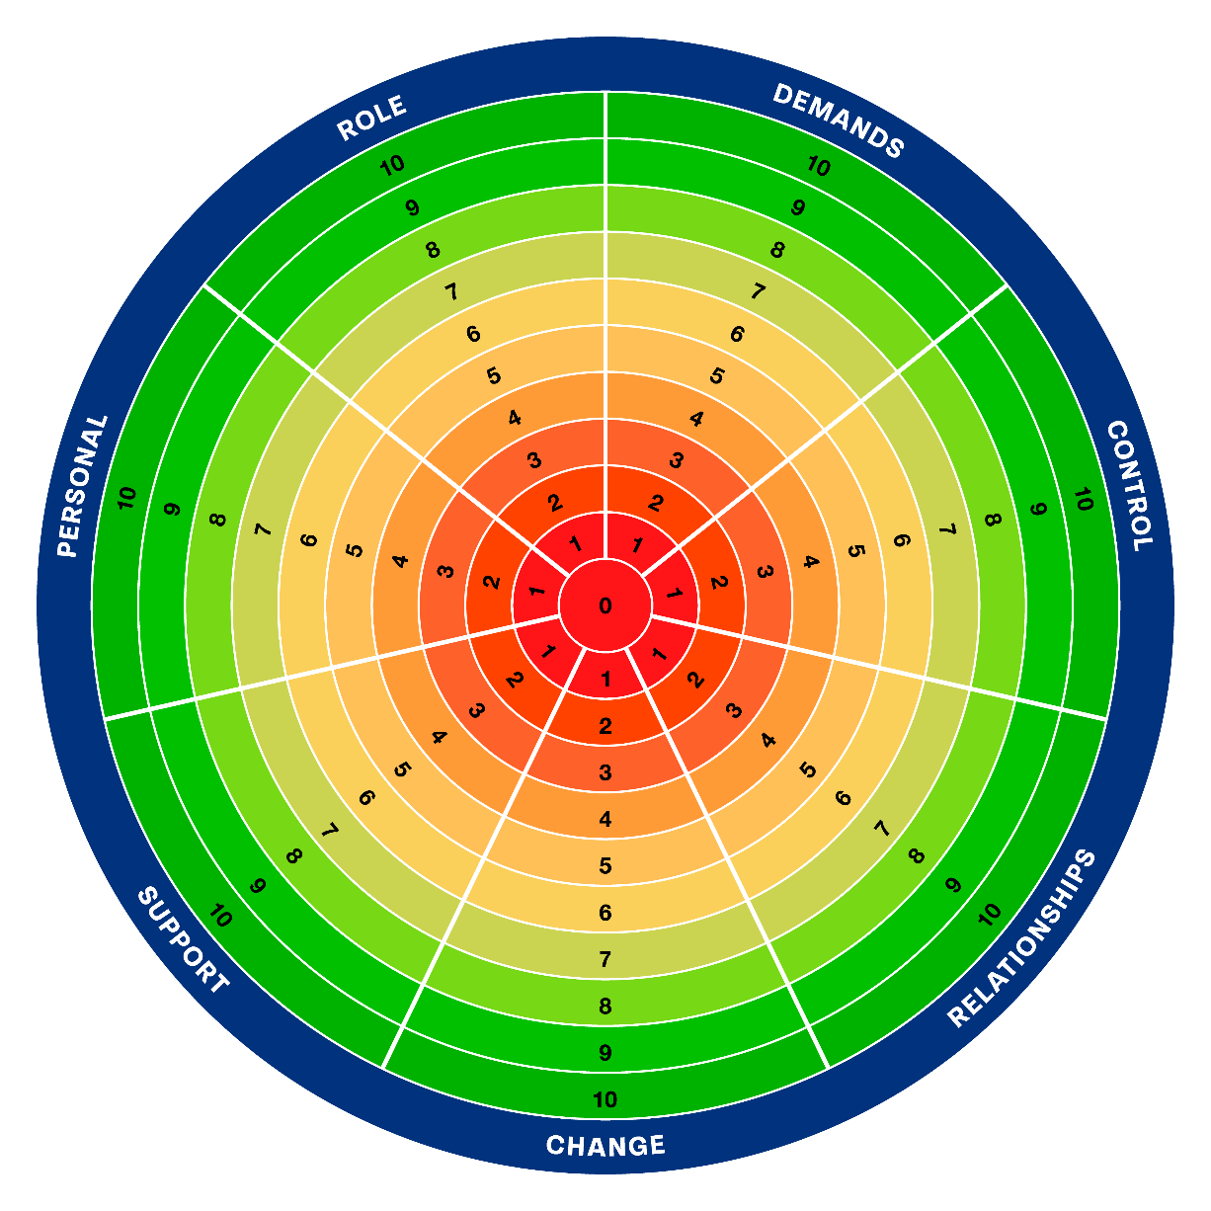

The purpose of examining the areas in the wheel is to:
- recognise what areas are effective and working well
- identify causes of concern
The centre of the wheel is 0: totally dissatisfied or discontent.
The outer edge is 10: totally satisfied or content.
Mark how content you are and/or the level of satisfaction you feel for each of the seven areas.
Consider reasonable and practical actions that can be taken to ensure you can maintain those things that are working well and manage concerns effectively.

There isn’t an easy answer to fix everything. However, using the Workplace Wellbeing Wheel provides a framework for us to break down any concerns and identify the gap between what is happening now and how we would like it to be. This enables us to consider what actions can be taken to close the gap.
There are often a variety of factors in either the person or the environment that can be adapted or changed to make a positive difference. Improving scores is not about trying to reach 10s in all areas. It's about focusing on areas you can increase your score to make a difference. For example, what would be required to move a 5 to a 7?

As you reflect on your scores it can be valuable to ask yourself some questions:
- What’s working well?
- What is happening that means this area is effective?
- What’s not working well?
- How do I feel about this?
- What is causing me to feel this way?
- What might improve the situation?
- What action could I take to feel better?
- What is within my control, and what is without?
- What is the smallest step I could take right now that would be of benefit?
- Who could I speak to about my concerns?

Step two: develop your plan
Once you’ve been through and scored your wheel, use the table on the following page to note down your key findings.

You can use this to start a conversation with a line manager or coach, for the opportunity to consider together where improvements can be made to support your wellbeing.

You can also use this to feed into your Individual Wellbeing Action Plan.

Standard | What is working well? What do you want to continue with? | What is not working well? What are your concerns? | What could I do? Who could I speak with? What support is available? | Identify actions  What, who and by when
Role

Demands

Control

Relationships

Change

Support

Personal Factors

