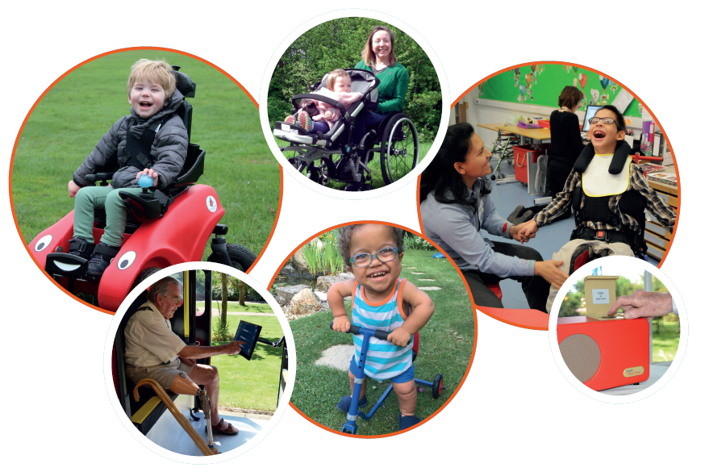

Trustee Recruitment Pack
November 2021

Welcome
I am delighted that you are interested in becoming a trustee of Designability.
We are at an exciting time in our development – we recently celebrated 50 years of designing and making products for people with disabilities and long term health conditions. We appointed a new Chief Executive in 2019 and she and our Board of Trustees have created a new strategy putting the focus firmly on expanding our range of products to help more people with disabilities to live with greater independence.
We are a national charity with a board of trustees who have a wide variety of backgrounds and careers from across the country, with meetings taking place virtually and at our headquarters in Bath.
Our Trustees share a passion and commitment to helping people with disabilities to enjoy independence through the design and provision of life-changing products.
If you have any questions, or would like to have an informal conversation, please email the CEO Catharine Brown in the first instance at catharinebrown@designability.org.uk
Thanks again for your interest in Designability,

Jerry Marwood
Chair of Trustees

Our story
For over 50 years, we have created products that increase dignity, confidence, independence, safety and empowerment for users and their loved ones.

Designability is an independent charity first set-up by famous inventor and engineer,
Bevan Horstmann, and local consultant surgeon, Kenneth Lloyd-Williams. It was the birth of Mr Horstmann’s daughter Nicola that made him personally aware of the severe lack of suitable medical products available to professionals. Kenneth Lloyd-Williams shared this concern and was aware that some of his colleagues were already designing some of their own surgical equipment as a result. The pair embarked on a mission to create a platform for engineers and clinicians to design and develop medical equipment. They aimed to draw on the expertise and resources of as many individuals as possible to ensure their products really worked.
Supported by the University of Bath and the local health board, the two set up the charity with an Executive Director, a Projects Committee, and a Board of Governors which included our first President, Sir Barnes Wallis.

We were first situated at St Martin’s Hospital in Bath. Placed so closely to an NHS hospital meant clinical experts could be consulted and trials could be easily organised. It was in 1987 that we moved our offices to our current base, at the Royal United Hospital (RUH) in Bath, where we’ve been ever since.

We are now a charity with a vibrant programme of product innovation and development, providing products to children and adults with disabilities across the UK and internationally.

For more information about key dates, milestones and product successes, please visit Our Story.

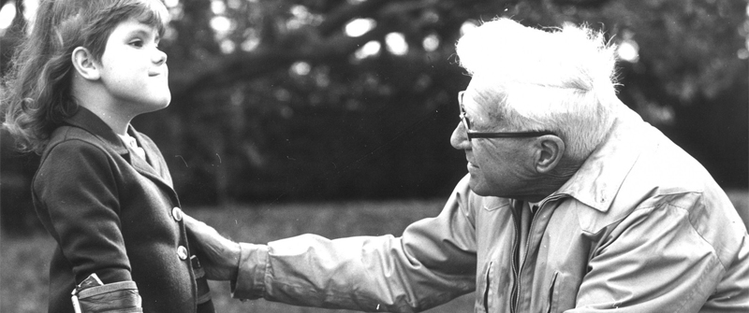

Designability: now and in the future

Designability is a UK charity transforming the lives of people with disabilities. Our team of designers and engineers creates products to help people who are facing challenges every day through life-changing assistive technologies.

We want products and technology to be more accessible to everyone. Our team follow the principles of human-centred design which means that everything we develop is done in response to what people tell us they need. Our aim is for people to achieve greater independence and happiness in their lives – goals that benefit all of society.

Our most well-known product is the Wizzybug, a powered wheelchair which we designed especially to provide children under 5 with independence, freedom of movement and fun. We provide them to families across the UK through our award-winning loan scheme which means that children can have one for as long as needed completely free of charge.

Our team have designed and developed a wide variety of products over the years, including technology which benefits people living with dementia, as well as a range of adapted products for children and adults with restricted growth. Some of our most popular creations solve typical day-to-day challenges, such as our bottom wiper which gives people greater dignity and independence in their personal hygiene.

We are a local charity with a surprisingly broad reach – people with disabilities use our products around the world - across the UK (and as far north as the Shetland Islands) and internationally, in France, Norway, Israel and Australia to name just a few.

Our turnover is around £2million a year, our team numbers 30 staff and we have recently completed a strategic review which sets objectives under three areas of work: insight and engagement; product development; provision of products and services.

The focus of our work is now on:
- Product development, directly through our own products and indirectly by advising others
- Helping adults and children who have primarily physical disabilities
- Providing solutions for disabled people’s mobility challenges in our new product development.
In our planning we will focus on projects which deliver impact for people with disabilities within a five year horizon and which build financial sustainability for our organisation.

Our strategy and values

Vision
Our vision is a future where every person with a disability has the products they want to live the life they choose.

Mission
We will create and provide products which enable people with disabilities to live with greater independence.

Values
The values we hold as an organisation when delivering our work are:
Creative We aim to be innovative, inspiring, dynamic, imaginative yet simple
Inclusive We aim to be honest, open, welcoming, listening, friendly, informed
Practical We aim to be pragmatic, down to earth, evidenced, direct, professional, have a can-do attitude and deliver on our promises

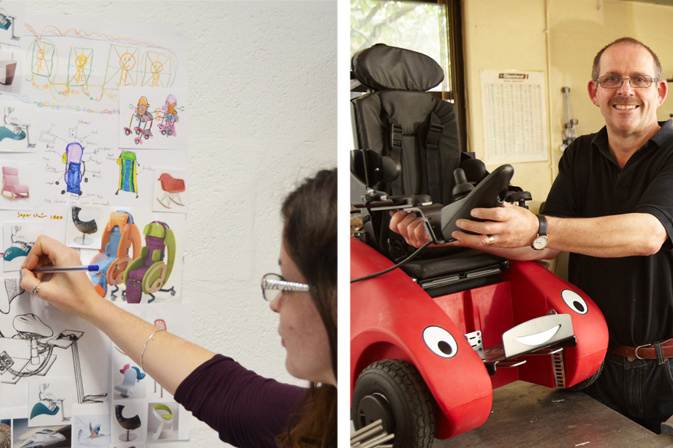

Role of a trustee
Becoming a trustee can be rewarding in many ways – being part of a talented and committed team, sharing the responsibility of ensuring the charity is well run and making a difference to the lives of people with disabilities.
Working as a team, trustees have three main responsibilities:

- To set a clear direction for Designability
- To make sure that the charity’s plans are being carried out appropriately
- To ensure that the charity meets its legal responsibilities

The role and responsibilities of trustees are governed by charity law and further information is available from the Charity Commission, in particular The Essential Trustee publication. All new trustees take part in an induction programme with the Chief Executive and senior managers and are offered ongoing training and support.

The duties of a trustee are to:

- Ensure that the charity complies with its governing documents, charity law, company law and any other relevant legislation or regulations
- Ensure Designability pursues its objects defined in its governing document
- Ensure that the charity applies its resources exclusively in pursuance of its objects
- Contribute actively to the Board of Trustees by giving firm strategic direction to Designability, setting overall policy, defining goals, setting targets, and evaluating performance against agreed targets
- Safeguard the good name and values of the charity
- Ensure the financial stability of the charity

Being a trustee is a voluntary role and as such, trustees receive no remuneration. However reasonable expenses can be claimed, for attendance at board meetings and other related events.

Trustees are appointed for up to three terms of office of three years and are expected to have a commitment to the mission of Designability and the ability to meet the time requirements. These are four two-hour Board meetings a year plus an annual Away Day.

Trustees are also invited to join one of two sub committees – the Products & Impact Committee or Finance & Governance Committee, which also meet for four two-hour meetings a year.

Time should also be allowed for reading papers (normally distributed one week before meetings) and for attending ad hoc events.

Person specification
In addition to the duties listed above, trustees should use any specific skills, knowledge or experience they have to help the Board of Trustees reach sound decisions.

This may involve leading discussions, identifying key issues, providing advice and guidance on new initiatives, and evaluating or offering advice on other areas in which the trustee has particular expertise.

The skills needed to be an effective trustee include:

- Independent judgement and a willingness to speak their mind
- Able to work effectively in a team and take decisions for the good of the charity
- Strategic thinking as well as the ability to understand performance reports
- Understanding and acceptance of their legal responsibilities and liabilities
- Understanding of the difference between nonexecutive and executive responsibility
Having reviewed the skills, experience and diversity of current trustees, we would welcome candidates with experience in the following areas:

- Lived experience of disability
- Design and creative industry
- Charity leadership
- Manufacturing or engineering
- Finance or accountancy
- Commercial or business
- Health or social care

In particular, we are seeking Board members who have the skills and experience to join the Finance & Governance Committee, which has responsibility for finances, people, premises, systems, safeguarding and governance.

We encourage applications from people with lived experience of disability, people of BAME heritage and women, who are currently underrepresented on our board.

Further information
To find out more about Designability, please visit www.designability.org.uk
If you have any questions, or would like to have an informal conversation, please contact Jerry Marwood, Chair of Trustees or Catharine Brown, CEO at ceo@designability.org.uk

Further information sources which might be useful:
- Read our latest Annual Report and Accounts
- Read our latest Impact Report
- Find out more about our current trustees

