FUTURES2020: European Researchers’ Night
Work Package 1: Awareness Raising Campaign report
Authors:
Dean Veall, Deputy Head of Public Engagement, University of Bath
Joel Morley, FUTURES2020 Project Coordinator, University of Bristol

The FUTURES2020 awareness raising campaign successfully met its objectives and promoted this European Researchers’ Night event in circumstances that evolved several times during the lifetime of the campaign as a result of the COVID-19 emergency. The success of the campaign is a result of the project now being in its third year, with a strong visual identity, clear messages and having significant experience of how best to reach the target groups across the region. The campaign utilised a mix of traditional and social media channels as well as well-placed adverts that reached nearly 1.9 million people in total.

Contents
Management of awareness raising campaign 2
Target audience 2
Objectives 2
Key messages 2
Visual identity 2
Ensuring compliance with guidelines 3
Communications tools 3
Website 3
Marketing and communications materials 5
FUTURES Film 5
Digital assets 5
Social media 6
Twitter 6
Facebook 7
Instagram 8
Press, broadcast and online media 8
Promotional paid adverts 10
Direct mailings 11
Booking 11
Summary of reach of awareness raising campaign 11

Management of awareness raising campaign
The awareness raising campaign for FUTURES2020 European Researchers’ Night was coordinated by the University of Bath (UoBa), supported by marketing consultant Natalie Hewlett, social media executive Callie Rice and the public engagement and press teams at the University of Bristol (UoB), University of Exeter (UoE) and University of Plymouth (UoP).

Target audience
The target audiences for FUTURES2020 were:
- Independent adults in Bristol, Bath, Exeter and Plymouth with an interest in science.
  - Subgroups: young adults 16-24, 25-45, 45+
- Independent adults in Bristol, Bath, Exeter and Plymouth with an interest in art and culture
  - Subgroups: young adults 16-24, 25-45, 45+
- School children (age 11–18)
- School teachers
- Families

Objectives
The FUTURES2020 raising awareness campaign aimed to:
- raise the profile of the FUTURES2020 events across the South West of England
- encourage people from the target audiences to attend FUTURES2020 events online
- raise the profile of Marie Curie Fellows and European Commission funding

Key messages
The messages conveyed through the awareness raising WP all had an embedded ‘call to action’ resulting in meaningful and effective communications and encouraging participation to attend FUTURES activities.
- The South West of England is a hub for outstanding EU research and innovation – find out how it’s making your daily life better.
- EU researchers live near you – come and meet them at FUTURES2020.
- You can be a researcher – talk with researchers to find out more about what it’s like to be a researcher and the routes into research life.
- Being a researcher is a rewarding career – find out more so you can support friends and family as they consider future life goals.

Visual identity
The FUTURES: European Researchers’ Night branding was created for the project that ran between 2018 and 2019 and to build on this well-established visual identity it was used across all FUTURES2020 activities. Action was symbolised with the ‘play’ icon, which also suggests looking to the future. This logo was used across all digital marketing materials and used as placeholders for digital events on platforms such as Zoom.
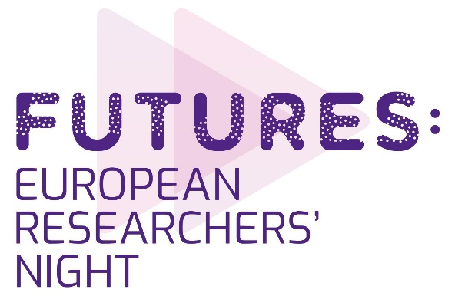
Figure 1: The FUTURES: European Researchers’ Night logo created for all awareness raising materials

Ensuring compliance with guidelines
The European Commission logo was included on all marketing materials produced for the events. The required text ‘This European Researchers’ Night project is funded by the European Commission under the Marie Skłodowska-Curie actions,’ was displayed on all marketing materials. The additional text ‘FUTURES2020 is part of European Researchers’ Night, a programme funded by the European Commission with the aim of engaging the public in celebrating the latest and most innovative research at a local and an international level. FUTURES2020 is one of over 300 events taking place in cities spanning 27 European countries’ was also displayed on the FUTURES2020 website, event sign up forms and post-event videos.

Communications tools

Website
The FUTURES: European Researchers’ Night website proved successful for hosting the FUTURES event listing for the 2019 programme. Building on this successful digital space, and to meet the needs of the transition from an in-person to a digital programme, the FUTURES2020 website was repurposed to showcase all FUTURES2020 related content such as events listings, blogs, social media content, images and videos created as part of the awareness raising campaign. The website address is futures2020.co.uk. The website went live at the beginning of the FUTURES2020 awareness raising campaign and over the course of the campaign 16,992 pages were viewed on the website and the website was visited by 7,092 unique visitors.

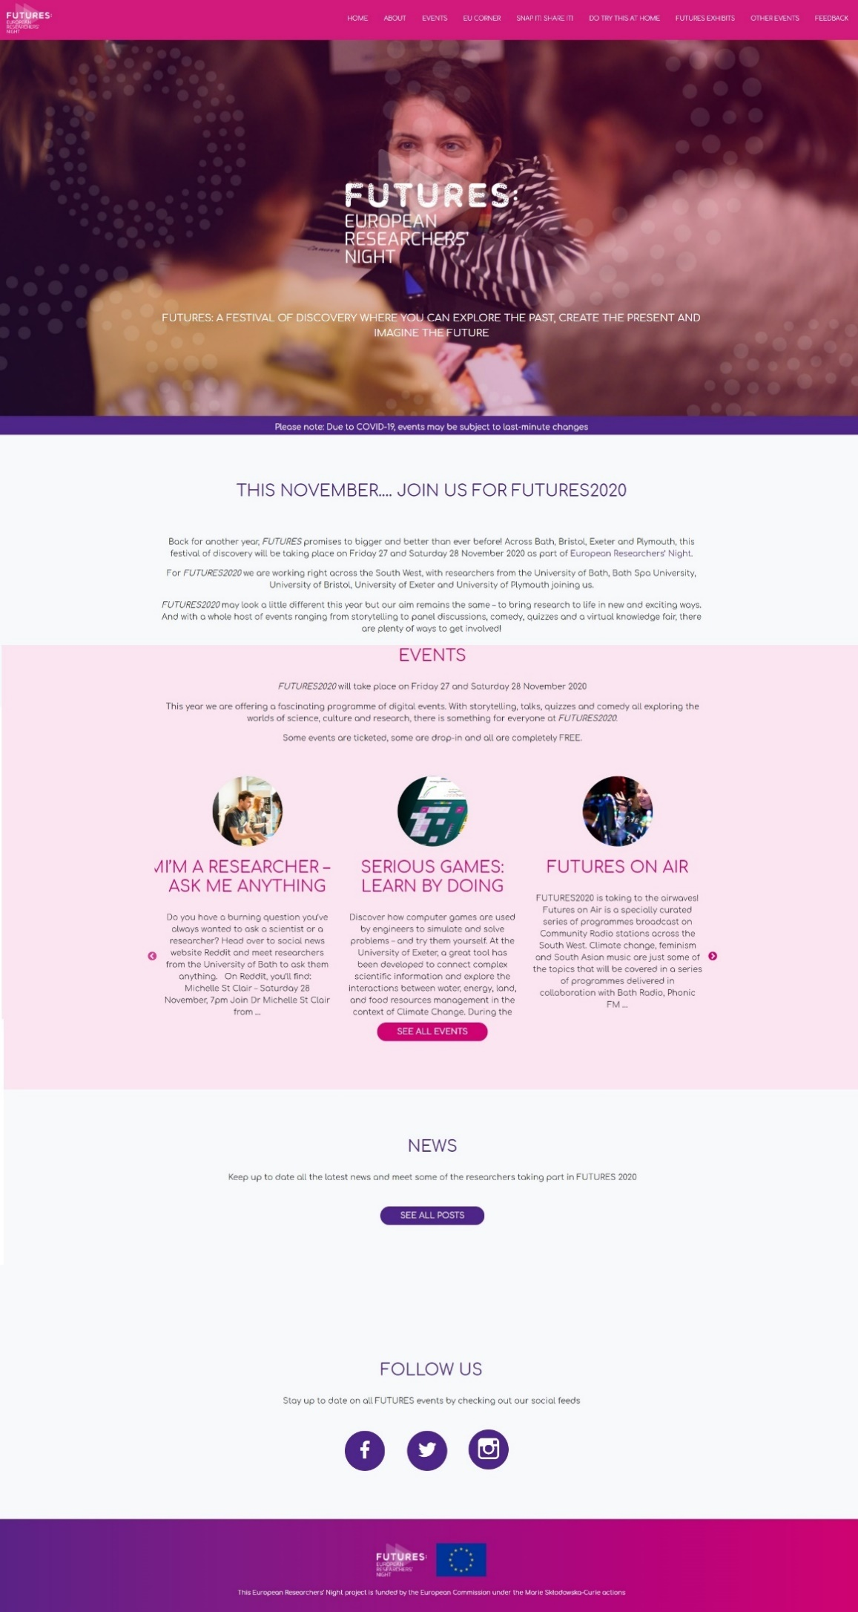
Figure 2: future2020.co.uk landing page.

Marketing and communications materials

FUTURES Film
The FUTURES: European Researchers' Night film was commissioned at the end of the 2019 project. This film was used in the awareness campaign before and during the events, and was shared on Facebook, Twitter and Instagram. The video was viewed 1,275 times on Vimeo.

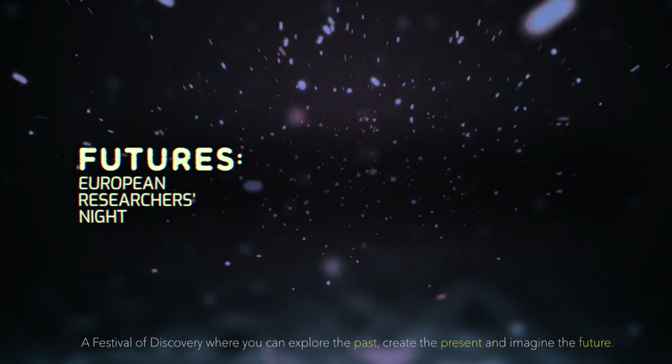
Figure 3: The FUTURES film on Vimeo

Digital assets
We worked with a graphic design team to create a number of digital assets that were used on social media to promote FUTURES2020.
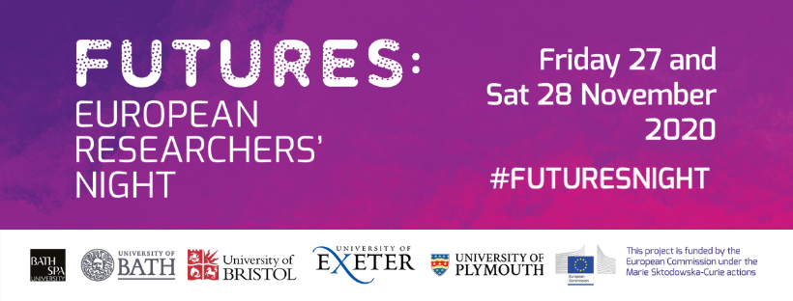

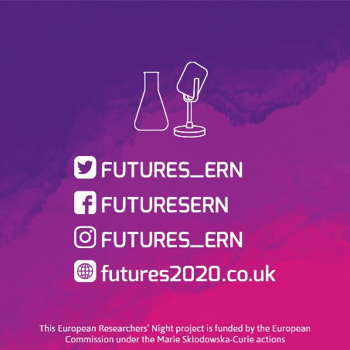
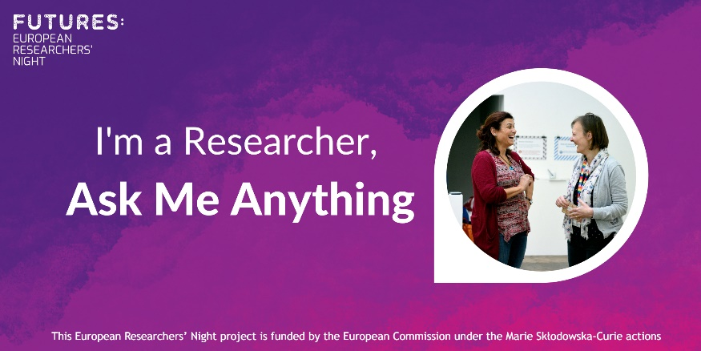

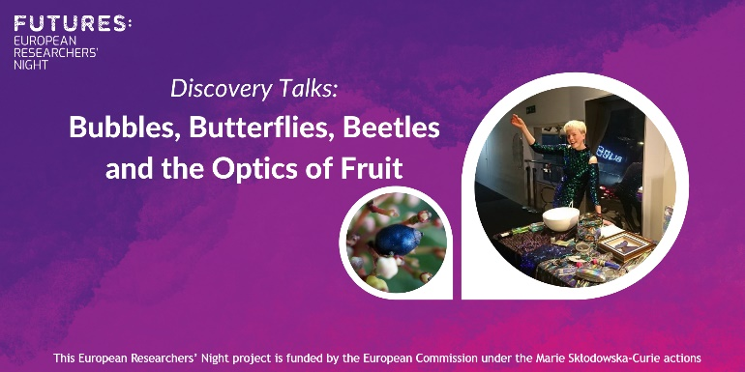

Figure 4: Examples of digital assets created for use on social media

Social media
The social media strategy to raise awareness of FUTURES2020 builds on the success of the FUTURES: European Researchers’ Night strategy over our two core social media platforms, Twitter and Facebook, and with the addition of a third in Instagram. Each platform was used to serve a different purpose.

Twitter
During the campaign the Twitter account (@FUTURES_ERN) posted 194 tweets reaching 101,996 users. Over the time of the campaign the account gained 104 new followers and the posts received 1,548 engagements including Likes, Retweets and link clicks. Demographic data from Twitter also reveals that 57% of people who engaged with content were female and 72.7% were aged 18-34. The two hashtags #FuturesNight and #Futures2020 were used 896 times during the campaign with an estimated reach of 302,589 users and generated 971 engagements.

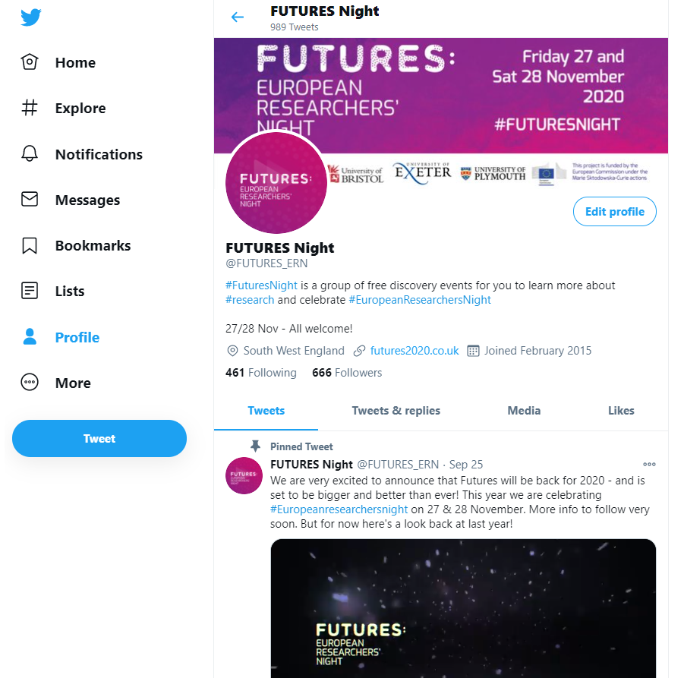
Figure 5: A screenshot of the FUTURES2020 Twitter page

Facebook
Through the FUTURES Facebook page the awareness raising campaign used a mixed methods approach, posting FUTURES2020 related content and running a series of paid-for adverts directed at regional and local community interest groups and pages. During the course of the campaign the FUTURES page gained 80 likes and the 82 posts reached 100,734 Facebook users and gained 3,304 engagements including Likes, Shares, Comments, media views and link clicks.

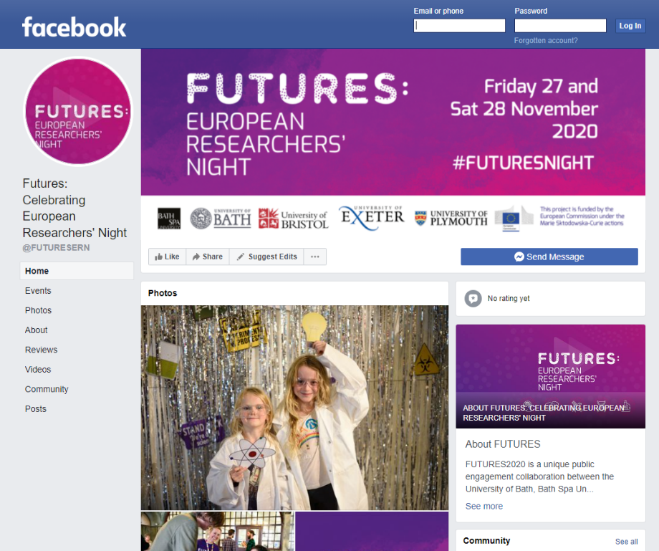
Figure 6: A screenshot of the FUTURES2020 Facebook page

Instagram
For FUTURES2020 we added a third social media platform, Instagram, to the portfolio of communications tools. A six-week campaign was launched through the FUTURES Instagram account reaching 2,881 Instagram users, with the account acquiring 116 followers and the 60 posts gained 147 Engagements including Likes, Comments and Saves. Demographic data from Instagram also reveals that 74% of people who engaged with content were female and 61.4% were aged 18-34, 28.6% aged 35-44, 7.1% aged 45-54 and 2.9% aged 55-64.

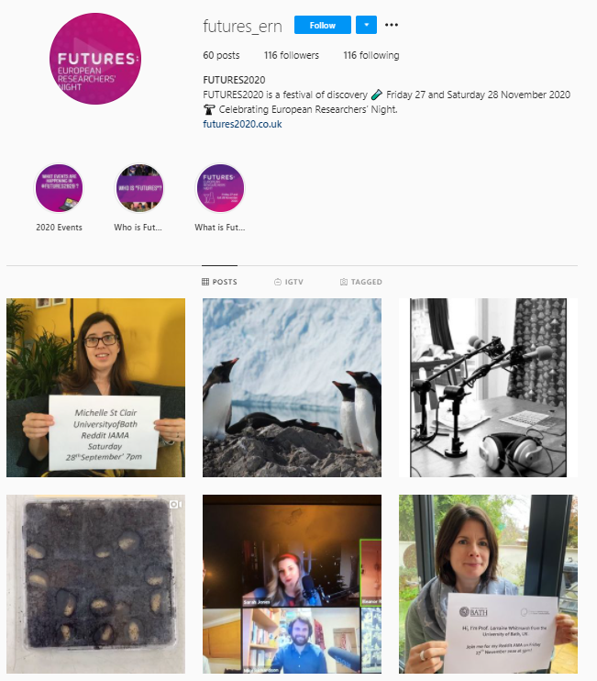
Figure 7: A screenshot of the FUTURES2020 Instagram page

Press, broadcast and online media
The Marketing and Communications team worked with regional, local and hyperlocal press to raise awareness of FUTURES2020. At the end of the previously funded FUTURES: European Researchers’ Night project a promotional film was commissioned from roderickandco.com. The FUTURES: European Researchers' Night film is hosted and can be viewed on the University of Bath Vimeo channel. This film was released with a long lead press release and a short lead press release.

Project staff took part in broadcast radio interviews on BBC Radio Bristol and Bristol based local radio station Ujima Radio promoting FUTURES2020.

FUTURES2020 achieved press coverage in the following:
- Exeter Daily
- Bath: In your Areas
- Bath Magazine
- Bath Echo
- Mirage News
In total the FUTURES2020 press and broadcast activities reached 340,000 people across the South West of England.

Working with destination management organisations and local tourism boards the Marketing and Communication team created content to be showcased on the websites Visit Exeter, Visit Bath, Visit Bristol and Visit Plymouth. FUTURES2020 content hosted on these websites reached an estimated 550,000 visitors.

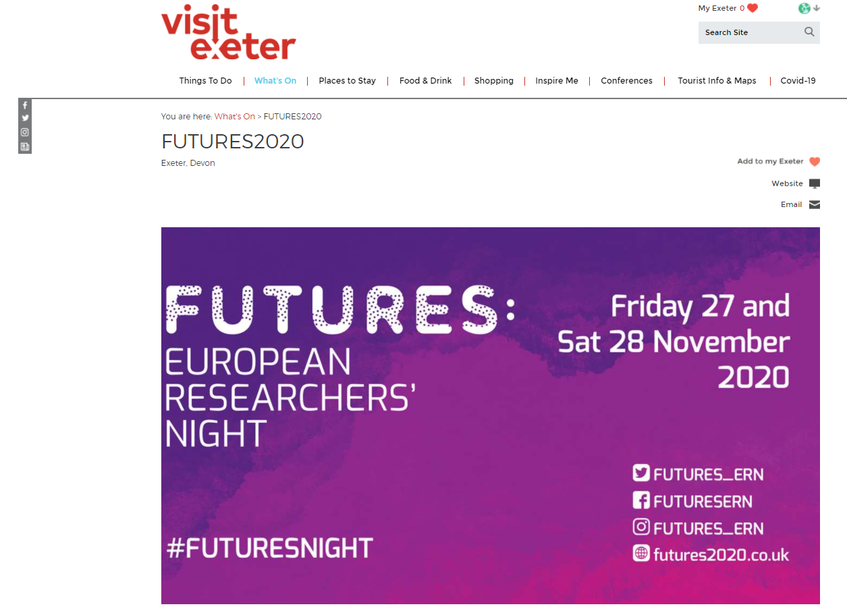
Figure 8: A screenshot of the Visit Exeter website.

FUTURES2020 also received coverage in a number on online blogs/listings and was promoted via their social media. This in total reached 127,000 people across the South West of England.
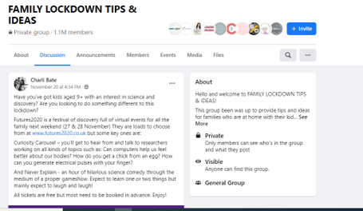
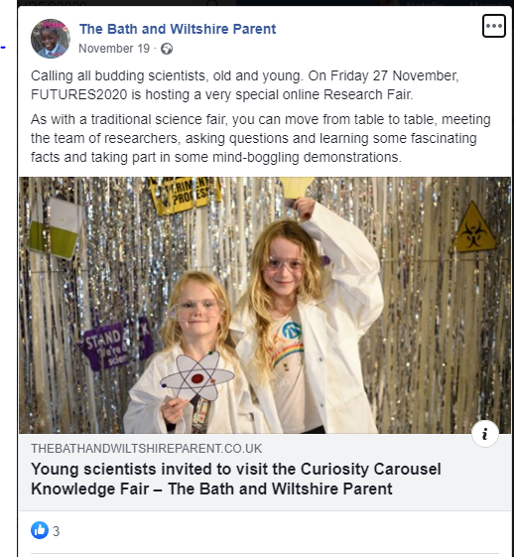

Figure 9: Screenshots of blog and online listings promoting FUTURES2020.

Promotional paid adverts
As a result of COVID-19 emergency and the emergency restrictions that were re-imposed during the awareness raising campaign, it was necessary to change elements of the campaign as a result of significant reduction in footfall. Instead, taking advantage of the increased traffic to local news websites and local radio, several paid adverts were taken out with companies to promote FUTURES2020 on these platforms.

Paid ‘advertorials’ were taken out with Reach Plc. that manages the Live suite of local news websites (Bristol Live, Somerset Live, Devon Live, Plymouth Live) across the South West of England. These paid adverts reached 205,955 readers and 6,577 users engaged with the associated Facebook campaign.
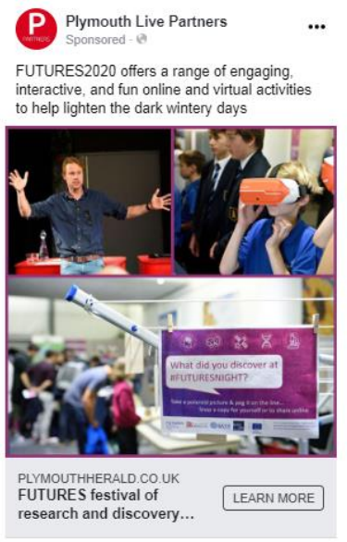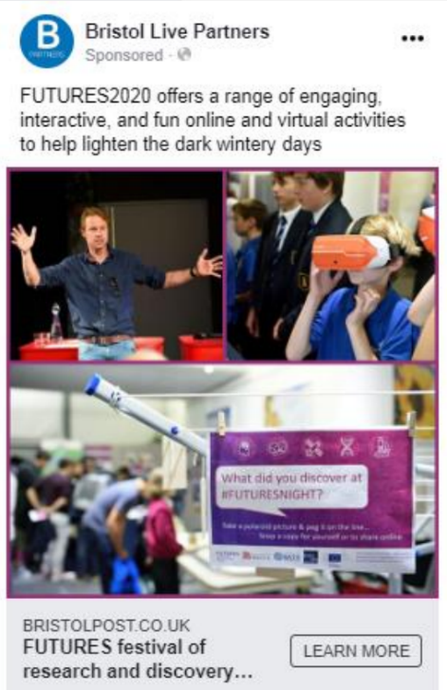
Figure 10: Screenshots of Reach PLC. Social media campaign promoting FUTURES2020
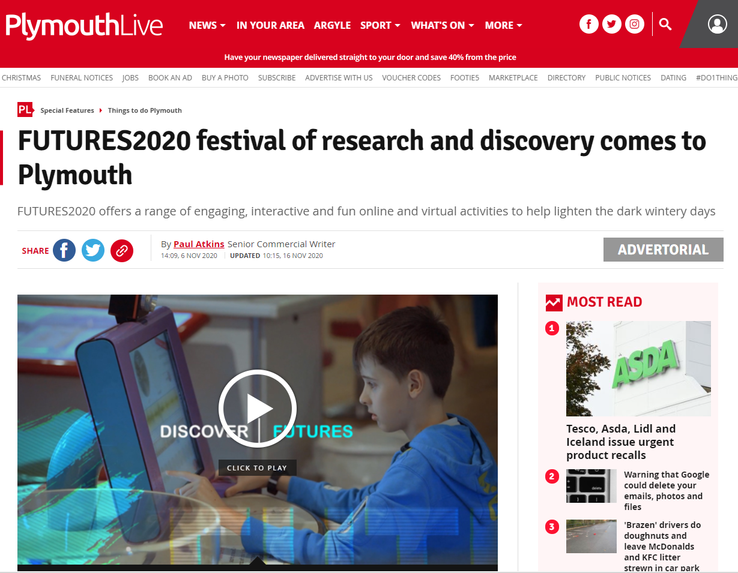

Figure 11: Screenshots of Plymouth Live promoting FUTURES2020

Working with Global Radio the Marketing and Communications team also produced a 30 second advert that was broadcast 150,000 times on digital Heart Radio across the South West of England online and on smart speakers reaching 50,000 listeners.

Direct mailings
Each of the consortium partners and partner organisations that were part of FUTURES2020 utilised direct contacts to promote the programme. In total, 150 community and interest groups such as schools, scout groups, local authorities, libraries and community centres were contacted by email with FUTURES2020 content that had a reach of 74,314 people.

Booking
Several activities had limited capacity so an Eventbrite booking system was used to guarantee visitors a place at the event. It also served an additional promotional purpose as all events were listed publicly. A total of 10,170 viewed the page and 2,008 people pre-booked tickets through Eventbrite.

Summary of reach of awareness raising campaign
All elements of WP1: Awareness Raising, when compiled, achieved a total reach of 1,888,863 people across the South West. This is broken down as follows:
Social media reach of FUTURES2020 content: 508,200
Social media engagement (Followers, Likes, Shares, Comments, media viewed and link clicks and Retweets) of FUTURES2020 content: 6,272
Website traffic: 7,092
Eventbrite booking reach: 12,178
FUTURES Film Vimeo views: 1,275
Media coverage: 340,000
Online listings: 677,000
Community and interest email newsletters: 74,314
Paid advertisements: 262,532

