Being A Trans Ally
A guide to help create a more supportive and inclusive world for trans and non-binary people at the University of Bath

Contents
Click or tap below to go straight to that section
What is trans 1
What is non-binary 2
What is gender expression? 3
What’s in a pronoun? 4
What is pride? 5
Genderbread explainer 6
What is an ally? 8
Why be a trans ally? 9
What does it mean to be a trans ally? 10
What can you do? 11
Further information 12
Further support and guidance 13
Glossary of terms 14
Should you require this in an alternative format, such as large print or a coloured background, please contact lgbt-staff@bath.ac.uk.

What is trans?
Trans, or transgender, is a term used for people whose gender identity or expression is different from their assigned sex at birth. For example, a person who was born male and raised male may identify and/or express themselves as female.

Trans is actually an umbrella term often used to include people who identify outside the gender binary of male and female, such as a person who is non-binary or genderqueer, including bigender*, pangender*, genderfluid*, or agender*.

*Note: please refer to the glossary of terms for the meaning behind these words and others.

⚧
Trans Symbol Trans Pride Flag

What is non-binary?
Non-binary, or genderqueer, are the terms given to people who do not sit on either end of the gender spectrum.

Male
Female

The gender spectrum is where a person’s gender identity sits. With male and female at either end, trans people may fit at either end or somewhere in between. Some people however don’t feel they fit within the spectrum.
Male
Female

It is important to remember that not all non-binary people identify as trans.

Non-binary Pride Flag

What is gender expression?
Gender expression is a way in which a person may
express their gender through their behaviour, actions, interests and appearance.

A person’s gender expression may be subject to change and is up to them to decide in order for them to feel more comfortable in who they are.

You should not gauge a person’s gender based on their expressions and should you be unsure, ask.

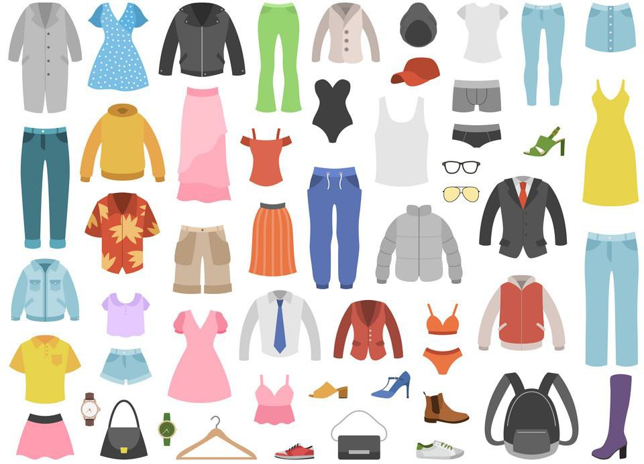

What’s in a pronoun?
A pronoun is a simple identifier for people, like "he", "her, or "they". Pronouns are the basic terms we use to refer to somebody when we are talking to someone else. However, while they are simple, to trans and non-binary people they are significant and important, so take care when using them.

There is an extensive list of gender pronouns but the most common examples include:

Male Identifier | Female Identifier | Gender Neutral  Identifier
He, Him, His | She, Her, Hers | They, Them, Their

It’s ok to make a mistake, it happens. We all slip up now and again. Just be conscious of your mistake, apologise, correct yourself and make an effort to get it right the next time.

If you realise your mistake later, you may wish to apologise to the person in private and remember their pronouns in the future.

It’s important to remember that it’s okay not to know everything, to admit vulnerability and to ask questions sensitively. We’re all human and that’s how we learn.

What is pride?
Pride is a time of positive self-affirmation and a way for people from underrepresented and discriminated groups to promote dignity, equality and increased visibility.

The purpose is to raise awareness of the indignities and abuse faced by people across the world and to bring about social, cultural and political change.

Pride is also a time to encourage and empower people to be who they are in society. These are not just annual events. To some people, pride is a way to express themselves daily.

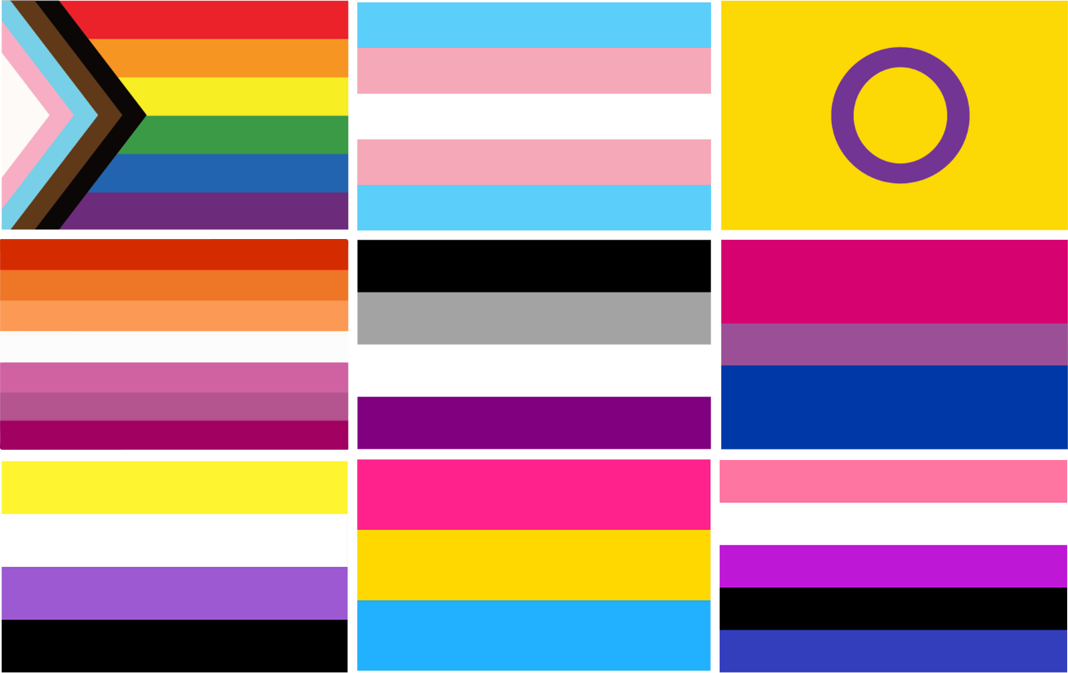

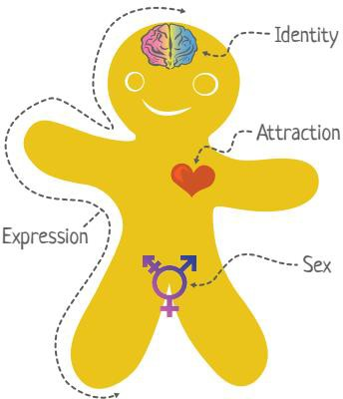
Gender identity, gender expression, biological sex, and sexual orientation exists independent of one another. Below is the Genderbread person from Genderbread.org

Genderbread Explainer
Gender Identity
How someone defines their gender psychologically.
Woman-ness
Man-ness
Gender Expression How someone demonstrates themselves.
Femininity
Masculinity
Biological Sex
The physical sex characteristics you are born with and develop.
Female-ness
Male-ness

Sex Assigned at Birth
Female
Intersex
Male

which demonstrates where elements of a person’s gender and sexuality come from.

It is important to note that gender identity and sexual identity (sexual orientation) are separate. A person’s gender identity does not necessarily define their sexual identity

Genderbread Explainer

Sexual identity, who you are romantically and sexually attracted to, is also on a spectrum and is something which is experienced physically, emotionally and spiritually. People can be attracted to one, multiple or no (asexual) gender/gender characteristic.

Romantic / Sexual Attraction
Nobody Women/Females/Femininity Men/Males/Masculinity
A persons sexuality is a deeply personal thing and you should not make assumptions or question someone’s sexual identity.
Identity ≠ Expression ≠ Sex Gender ≠ Sexual Orientation

What is an ally?
Allies are people, groups and organisations who are not part of an underrepresented group but who take positive action to support that group and actively make a change for the better.

As an ally you will be standing for what is right. It is a basic human right for a person to be their true self however they identify.

As an ally you are encouraged to respond to any form of discrimination or injustice and seek positive cultural and political change.

Why be a trans ally?
Being trans is not easy. Unfortunately, many trans and non-binary people fear ridicule, rejection, abuse and worse. This can happen at home, in the workplace and in the wider community.

As an ally, you too may experience resistance and abuse but the University is here to support you and will take this matter seriously should you report it.

By supporting trans people you are helping to create a safe environment and a more progressive world. You will be making a positive impact on the way society views diversity and encouraging diversity in general.

Your support will also have a personal impact on the many individuals who feel excluded at work and in society. By promoting trans rights, speaking openly about trans issues and creating a safe space, you will be changing lives for the better.
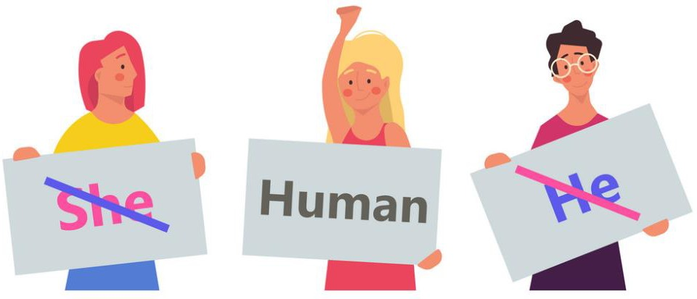

What does it mean to be a trans ally?
Being a trans ally is:
- Showing support.
- Actively challenging transphobic language, behaviour and actions.
- Recognising systemic inequalities.
- Realising the impact of microaggressions.
- Believing in the experiences of underrepresented people.
- Listening, supporting, self-reflecting and changing.
- Being aware of gendered terms.

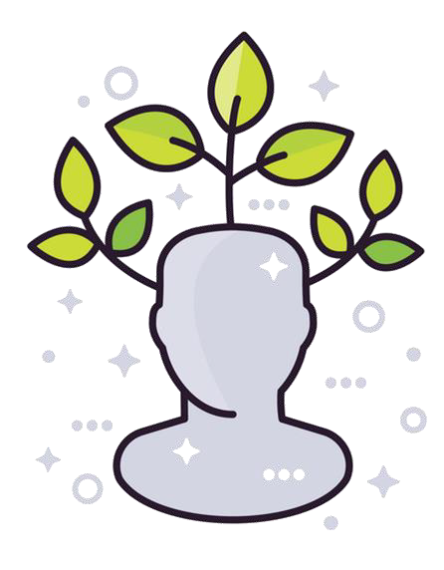
Being a trans ally is not asking you to change all that you are or do, it’s about personal growth. It means you’re doing the right thing to create a diverse and inclusive environment for everyone.

There are plenty of ways you can make a positive impact for trans and non-binary people:
- When meeting someone new, tell them your pronouns and ask them what pronouns they use.
- When writing an email, instead of saying ‘Dear sir or madam’ say ‘Dear Mx’, an indicator which does not denote gender.
- Add your pronouns to your email signature.
- When addressing a group, try to use inclusive language such as ‘Hey everyone/team/folks.
- Listen to someone who has experienced transphobia and do not dismiss what they have to say.
- Celebrate key dates and events such as pride and awareness days.
- Encourage open conversations about diversity within culture from race to gender.
- Support local organisations.
- Educate yourself further by completing The Safe Zone Project online course and make use of their catalogue of resources and encourage others to do so.

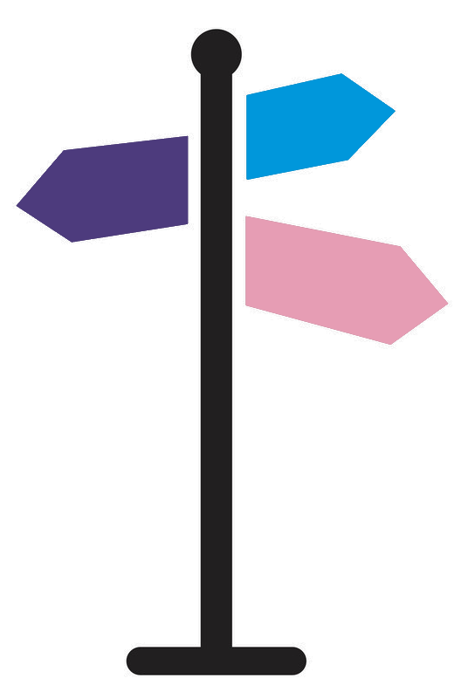
For more information, you can check out these sites:
- Stonewall – a lesbian, gay, bisexual and transgender rights charity.
- TransWhat? – a trans allyship guide.
- Genderbread – information and resources on gender identity.
- It Gets Better Project – stories from around the world from lesbian, gay, bisexual and trans people to inspire change.
- It’s Pronounced Metrosexual – resources educating on issues of identity, sexuality, gender, privilege, and oppression.
- LGBT Foundation – supporting the needs of the diverse range of people who identify as lesbian, gay, bisexual and trans.
- Non-Binary Wiki – a hub of information of non-binary resources.

Further support and guidance
For further support, guidance and information, you
can:
  - Contact the Gender Identities rep for Kaleidoscope who will support you where possible and signpost you to other available support and information.
  - Subscribe to the Kaleidoscope mailing lists and follow their blog for updates on training, news, events, social gatherings and more.
  - Contact your HR Advisor for support and advice about yourself and others. If you are trans and working for the University of Bath, your HR advisor can help you and ensure you are being treated fairly and with dignity and respect.

Thank you for taking the time to read this and we look forward to you supporting the University as we create the best possible place to work and study.

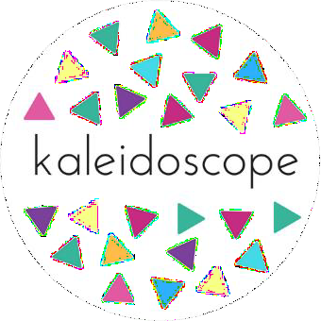

A small glossary of terms which have (mostly) been taken directly from Stonewall.org.uk. For a full list visit their site.

Agender
noting or relating to a person who does not have a specific gender identity or recognizable gender expression.

Ally
A (typically) straight and/or cis person who supports members of the LGBT community.

Bigender
denoting or relating to a person whose sense of personal identity encompasses two genders.

Butch/Masc
Butch/Masc are terms used in LGBT culture to describe someone who expresses themselves in a typically
masculine way. You shouldn’t use these terms about someone unless you know they identify with them.

Cisgender or Cis
Someone whose gender identity is the same as the sex they were assigned at birth. Non-trans is also used by some people.

Coming Out
When a person first tells someone/others about their orientation and/or gender identity.

Deadnaming
Calling someone by their birth name after they have changed their name. This term is often associated with trans people who have changed their name as part of their transition.

Femme
Femme is a term used in LGBT culture to describe someone who expresses themselves in a typically feminine way. You shouldn’t use these terms about someone unless you know they identify with them.

Gender
Often expressed in terms of masculinity and femininity, gender is largely culturally determined and is assumed from the sex assigned at birth.

Gender Dysphoria
Used to describe when a person experiences discomfort or distress because there is a mismatch between their sex assigned at birth and their gender identity.
This is also the clinical diagnosis for someone who doesn’t feel comfortable with the sex they were assigned at birth.

Gender Expression
How a person chooses to outwardly express their gender, within the context of societal expectations of gender. A person who does not conform to societal expectations of gender may not, however, identify as trans.

Genderfluid
This is when a person’s gender varies over time. A genderfluid person's identity may change constantly and they will tell you how they identify to avoid any mistakes.

Gender Identity
A person’s innate sense of their own gender, whether male, female or something else (see non-binary below), which may or may not correspond to the sex assigned at birth.

Gender Reassignment
Another way of describing a person’s transition. To undergo gender reassignment usually means to undergo some sort of medical intervention, but it can also mean changing names, pronouns, dressing differently and living in their self-identified gender.
Gender reassignment is a characteristic that is protected by the Equality Act 2010, and it is further interpreted in the Equality Act 2010 approved code of practice.

Gender Recognition Certificate (GRC)
This enables trans people to be legally recognised in their affirmed gender and to be issued with a new birth certificate. Not all trans people will apply for a GRC and you currently have to be over 18 to apply.
You do not need a GRC to change your gender markers at work or to legally change your gender on other documents such as your passport.

Intersex
A term used to describe a person who may have the biological attributes of both sexes or whose biological attributes do not fit with societal assumptions about what constitutes male or female.
Intersex people may identify as male, female or non- binary.
Stonewall works with intersex groups to provide its partners and stakeholders information and evidence about areas of disadvantage experienced by intersex people but does not, after discussions with members of the intersex community, include intersex issues as part of its current remit at this stage.

Non-Binary
An umbrella term for people whose gender identity doesn’t sit comfortably with ‘man’ or ‘woman’. Non- binary identities are varied and can include people who identify with some aspects of binary identities, while others reject them entirely.

Orientation
Orientation is an umbrella term describing a person's attraction to other people. This attraction may be sexual (sexual orientation) and/or romantic (romantic orientation). These terms refer to a person's sense of identity based on their attractions, or lack thereof.
Orientations include, but are not limited to, lesbian, gay, bi, ace and straight.

Outed
When a lesbian, gay, bi or trans person’s sexual orientation or gender identity is disclosed to someone else without their consent.

Pan
Refers to a person whose romantic and/or sexual attraction towards others is not limited by sex or gender.

Pangender
Pangender refers to a person whose gender identity is not limited to one gender and may encompass all genders at once.

Passing
If someone is regarded, at a glance, to be a cisgender man or cisgender woman.
This might include physical gender cues (hair or clothing) and/or behaviour which is historically or culturally associated with a particular gender.

Person With A Trans History
Someone who identifies as male or female or a man or woman, but was assigned the opposite sex at birth.
This is increasingly used by people to acknowledge a trans past.

Pronoun
Words we use to refer to people’s gender in conversation - for example, ‘he’ or ‘she’. Some people may prefer others to refer to them in gender neutral language and use pronouns such as they/their and ze/zir.

Queer
Queer is a term used by those wanting to reject specific labels of romantic orientation, sexual orientation and/or gender identity. It can also be a way of rejecting the perceived norms of the LGBT community (racism, sizeism, ableism etc). Although some LGBT people view the word as a slur, it was reclaimed in the late 80s by the queer community who have embraced it.

Questioning
The process of exploring your own sexual orientation and/or gender identity.

Sex
Assigned to a person on the basis of primary sex characteristics (genitalia) and reproductive functions. Sometimes the terms ‘sex’ and ‘gender’ are interchanged to mean ‘male’ or ‘female’.

Sexual Orientation
A person’s sexual attraction to other people, or lack thereof. Along with romantic orientation, this forms a person’s orientation identity.

Trans
An umbrella term to describe people whose gender is not the same as, or does not sit comfortably with, the sex they were assigned at birth.
Trans people may describe themselves using one or more of a wide variety of terms, including (but not limited to) transgender, transsexual, gender-queer (GQ), gender-fluid, non-binary, gender-variant, crossdresser, genderless, agender, nongender, third gender, bi-gender, trans man, trans woman,trans masculine, trans feminine and neutrois.

Transgender Man
A term used to describe someone who is assigned female at birth but identifies and lives as a man. This may be shortened to trans man, or FTM, an abbreviation for female-to-male.

Transgender Woman
A term used to describe someone who is assigned male at birth but identifies and lives as a woman. This may be shortened to trans woman, or MTF, an abbreviation for male-to-female.

Transitioning
The steps a trans person may take to live in the gender with which they identify. Each person’s transition will involve different things. For some this involves medical intervention, such as hormone therapy and surgeries, but not all trans people want or are able to have this.
Transitioning also might involve things such as telling friends and family, dressing differently and changing official documents.

Transphobia
The fear or dislike of someone based on the fact they are trans, including denying their gender identity or refusing to accept it. Transphobia may be targeted at people who are, or who are perceived to be, trans.

Transsexual
This was used in the past as a more medical term (similarly to homosexual) to refer to someone whose gender is not the same as, or does not sit comfortably with, the sex they were assigned at birth.
This term is still used by some although many people prefer the term trans or transgender.

Two-Spirit
A term used by some Indigenous North Americans to describe Native people in their communities who fulfil a traditional third-gender (or other gender-variant) ceremonial and social role in their cultures.

